UNIVERSAL UNIT CONVERTER
Internship Project Report

Submitted by: Akhinesh Nair
Intern ID: CITS6205
Organization: CodTech IT Solutions

Acknowledgement

Thank you CodTech IT Solutions for providing me the opportunity for completing this internship project. This project allowed me to gain more knowledge in python programming. Through this project I understood basics of web development using Flask framework, how to design web pages using HTML5, CSS for styling the web pages, and javascript for responsive web pages and input validation, how to connect the frontend with the backend using Flask and other important topics.

Introduction

The Universal Unit Converter is a web-based application developed using Python, Flask, HTML, CSS, and JavaScript. It is designed to provide a simple, fast, and accurate way to convert values between different units of measurement through an easy-to-use interface.
The application supports conversions for Length, Weight, Temperature, Speed, Time, Area, and Volume. Users simply select a category, choose the "From" and "To" units, enter a value, and the application instantly displays the converted result. It also includes features such as dynamic unit selection, input validation, a swap units button, and an About page, making it user-friendly and efficient.
This project demonstrates the integration of frontend and backend technologies using Flask. It also enhances practical knowledge of Python programming, web development, and responsive user interface design while providing a useful tool for everyday unit conversions.

Objectives
- Develop a responsive web application.
- Perform accurate unit conversions.
- Provide a simple and attractive user interface.
- Improve programming skills using flask.
- Demonstrate web development concepts.

Technologies used

Technology | Purpose
Python 3.12 | Programming Language.
Flask | Web Framework.
HTML5 | Web Page Structure.
CSS3 | Styling.
Javascript | Dynamic Functionality.
VS Code | IDE.
Github | Version Control

Project Structure

Unit-Converter/
app.py
converter.py
README.md
requirements.txt
templates/
index.html
about.html
static/
style.css
script.js
screenshots/
documentation/

File description:
- app.py – Main Flask app that handles routes, user, requests, and display the web pages.
- converter.py – Contains the conversion logic and formulas.
- templates/index.html – Home page providing user interface for performing conversions.

- templates/about.html – Displays information about the project.
- static/style.css – Defines the layout, colors and responsive styling of the web application.
- static/script.js – Implements dynamic dropdowns, input validation, and the swap button feature.
- requirements.txt – Lists the required Python packages.
- README.md – Contains project information and instructions.
- screenshots/ – Stores screenshots of the application's output.
- documentation/ – Contains the project report and related documents.
- gitignore – Specifies files and folders that git should ignore whrn uploading the project.

Working

Application Startup

The Flask server starts by running app.py.

The home page (index.html) is loaded in the user's web browser.

Category Selection

The user selects a conversion category such as Length, Weight, Temperature, Speed, Time, Area, or Volume.

JavaScript dynamically updates the From and To dropdown menus with the relevant units for the selected category.

User Input

The user enters a numerical value to be converted.

The user selects the source unit (From) and the destination unit (To).

Input Validation

JavaScript checks that the input field is not empty.

It verifies that the entered value is a valid number.

It ensures that the source and destination units are different before allowing the conversion.

Conversion Process

When the Convert button is clicked, the form data is sent to the Flask application.

The app.py file receives the user input and passes it to the converter.py module.

The appropriate conversion formula is applied based on the selected category and units.

Displaying the Result

The converted value is returned to app.py.

Flask sends the result back to index.html.

The converted value is displayed clearly on the webpage.

Swap Units Feature

The Swap button allows users to exchange the selected From and To units with a single click.

This makes reverse conversions faster and more convenient.

Reset Function

The Reset button clears the entered value and restores the form to its default state, allowing the user to start a new conversion.

About Page

The About page provides information about the application, its features, and the technologies used to develop it.

Responsive Design

The application is designed to work smoothly on both desktop and mobile devices, ensuring a consistent user experience across different screen sizes.

Features

Length converter

Weight converter

Temperature converter

Speed converter

Time converter

Area converter

Volume converter

- Dynamic dropdowns

- Swap unit feature

- Input validation

- Responsive design

- About page

Screenshots
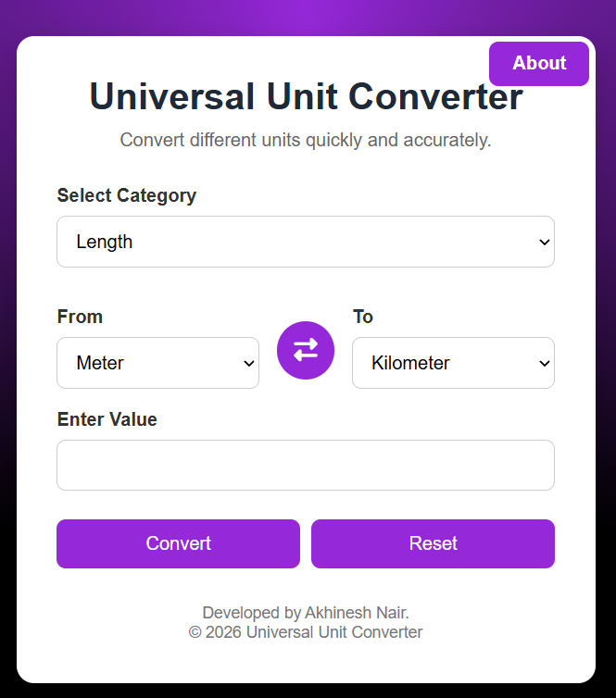
Home page:-

Length conversion:-
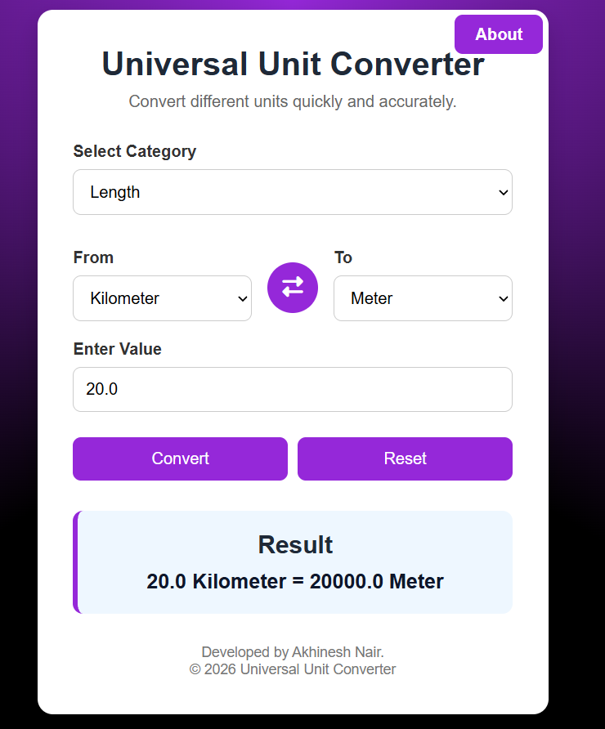
\\\

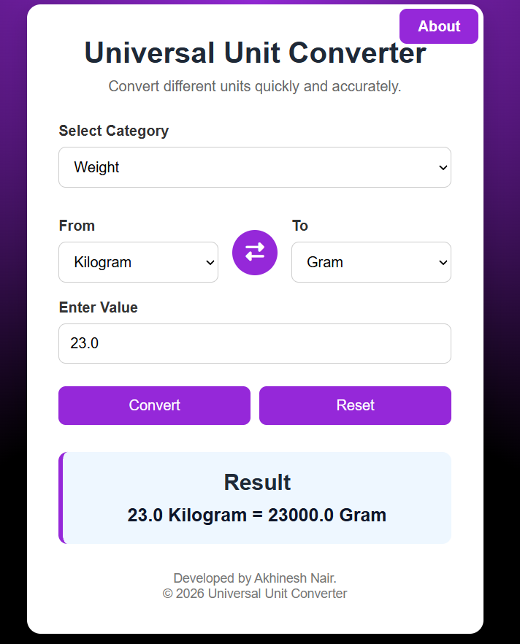
weight conversion:-

about page:-
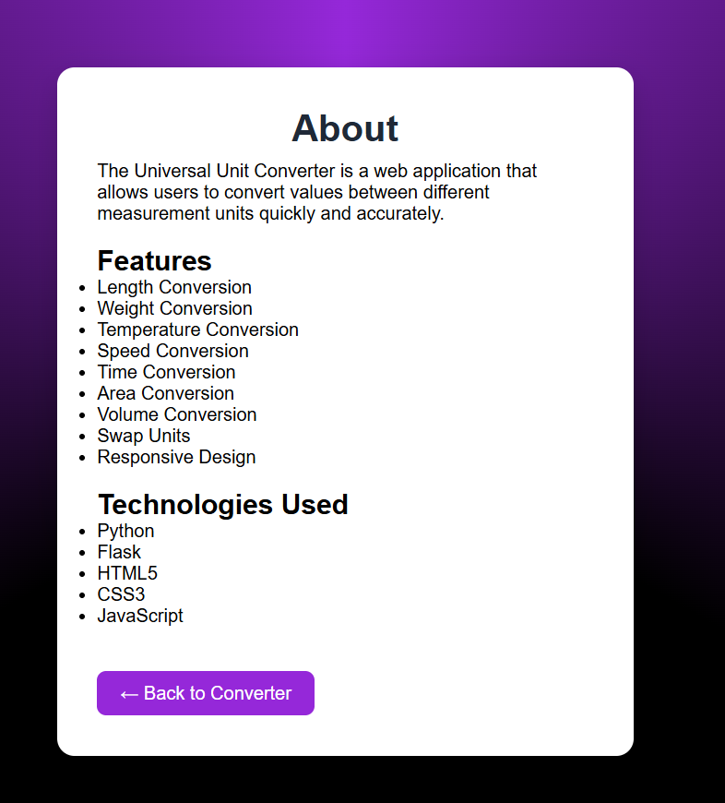

Before Swapping from and to units:-
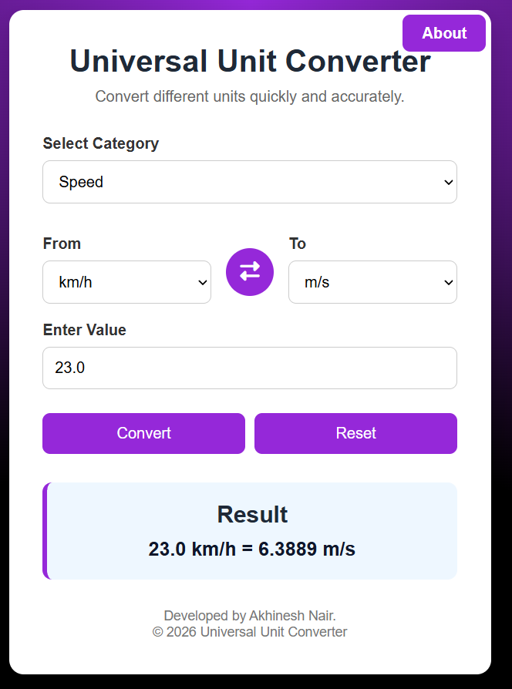

After Swapping:-
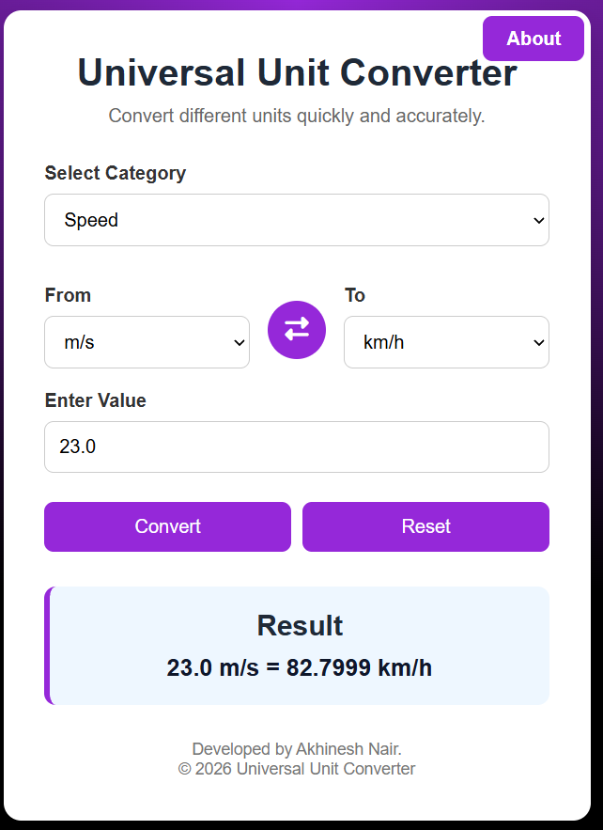

Testing

Test case | Expected Result | Status
Valid Input | Correct conversion | Pass
Invalid Input | Error Message | Pass
Swap Button | Unit Swapped | Pass
Responsive Design | Layout Adjusts | Pass
Category Change | Units Updated | Pass

Future Enhancements

- Currency converter
- Conversion History
- Copy Result Button
- More Unit categories
- Multiple Language Support
- Voice Input
- Scientific Calculator

Conclusion

The Universal Unit Converter was successfully developed using Python, Flask, HTML, CSS, and JavaScript. The application provides a simple, responsive, and user-friendly interface for converting values across multiple categories, including Length, Weight, Temperature, Speed, Time, Area, and Volume. Features such as dynamic unit selection, input validation, the swap function, and an About page enhance the overall user experience and make the application practical for everyday use.
Developing this project provided valuable hands-on experience in both frontend and backend web development. It strengthened my understanding of Flask, JavaScript, responsive web design, and project organization while improving my problem-solving and debugging skills. Overall, this project demonstrates the successful integration of multiple web technologies to create a reliable and efficient application.

References

- Python documentation
- Javascript documentation
- HTML5 documentation
- Flask Documentation
- ChatGPT
- Font Awesome

