WEATHER CLI APPLICATION
Internship Project Report

*
Submitted by: Akhinesh Nair
Intern ID: CITS6205
Organization: CodTech IT Solutions

Acknowledgement
Thank you CodTech IT Solutions for providing me the opportunity for completing this internship project. This project allowed me to gain more knowledge in python programming. Through this project I understood about API integration , file handling and other important topics.

Introduction
Weather forecasting is the application of technology and science to predict future state of the atmosphere in a specific location. It involves gathering data such as temperature, humidity, and wind speed, and using atmospheric physics, statistical models, and supercomputers to anticipate weather conditions like rain, storms, and cloud cover. Accurate weather forecasting is essential for protecting lives and property, as it provides early warnings for life-threatening events like tornadoes, floods, hurricanes and so on. Other than safety it also optimizes economic sectors like agriculture, aviation, and energy management. The use of weather applications are that they provide instant, hyper-local atmospheric data directly to your phone.
The purpose of this project is to build a Python-based Weather CLI Application that retrieves real-time weather information using the OpenWeatherMap API. It demonstrates API integration, modular programming, file handling, and exception handling while providing users with an easy-to-use menu-driven interface for searching weather by city name or PIN code.

Objectives
- Develop a menu-driven CLI application.
- Fetch weather using OpenWeatherMap API.
- Learn Python modules.
- Learn file handling.
- Learn API integration.
- Store search history.

Technologies used

Technology | Purpose
Python 3.12 | Programming Language.
Requests | API Communication.
OpenWeatherMap API | Weather data.
VS Code | IDE
Github | Version Control

Project Structure

Weather-CLI-APP/
main.py
weather.py
config.py
README.md
requirements.txt
history.txt
screenshots/
documentation/

File description:
- main.py – Contains the main menu and controls the flow of the application
- weather.py – Fetches weather data from the API and manages search history.
- config.py – Stores the API key and API URL.
- history.txt – Stores the user's weather search history.
- requirements.txt – Lists the required Python packages.
- README.md – Contains project information and instructions.
- screenshots/ – Stores screenshots of the application's output.
- documentation/ – Contains the project report and related documents.

Working

- Program Execution
  - The application starts by running main.py.
  - A menu is displayed with options to search weather by city, search by PIN code, view search history, view the About section, or exit.
- User Input
  - The user selects an option from the menu. Depending on the selected option, the user enters either a city name or a PIN code.
- API Request
  - The application calls the appropriate function in weather.py. The function sends an HTTP request to the OpenWeatherMap API using the stored API key from config.py.
- Receiving Weather Data
  - The API returns weather information in JSON format.
  - The application extracts important details such as city name, country, temperature, humidity, pressure, weather description, and wind speed.

- Displaying Results
  - The extracted weather information is displayed in a clear and organized format on the command line.
- Saving Search History
  - Every successful search is recorded in history.txt along with the date, time, and search type (City or PIN code).
- Viewing Search History
  - If the user selects the history option, the application reads history.txt and displays all previous searches.
- Error Handling
  - If the user enters an invalid city name, PIN code, or menu option, the application displays an appropriate error message instead of crashing.
- Program Exit
  - The application continues displaying the menu until the user selects the Exit option, after which the program terminates gracefully.

Features

Search Weather by City

Search Weather by PIN Code

Search History

About Menu

Error Handling

Menu Driven Interface

Screenshots
Main Menu:-
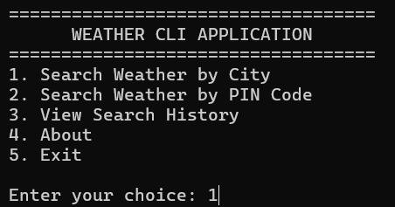
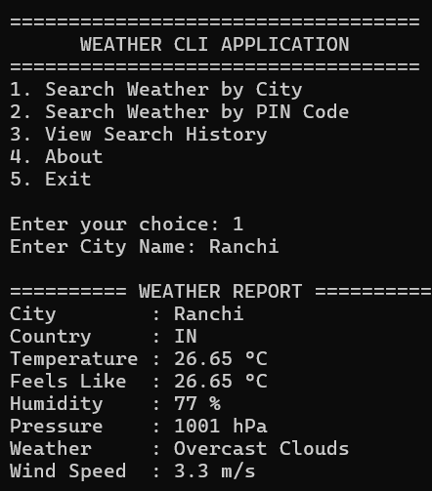
Search by city

PSearch by pin code:-
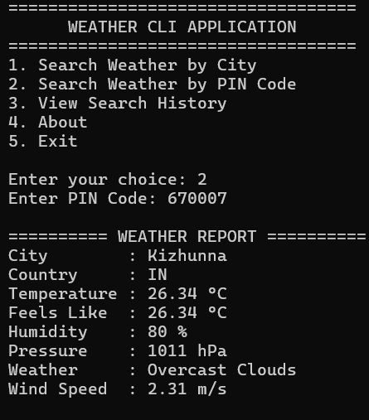

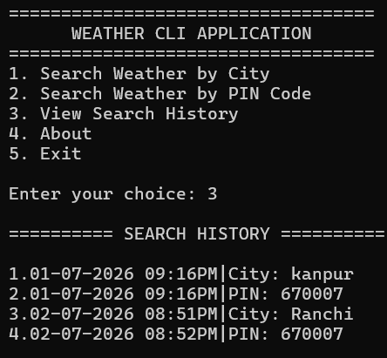
View Search history:-

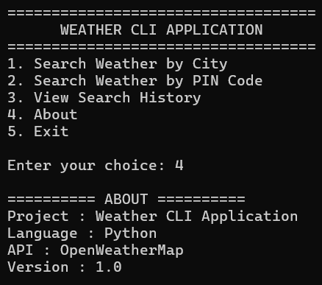
About:-

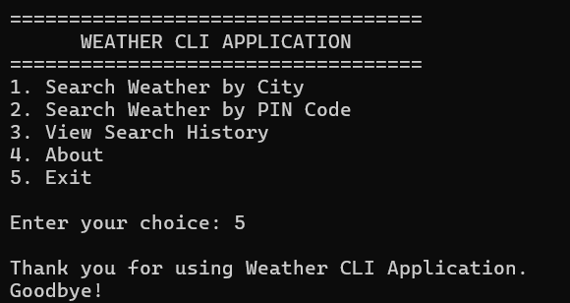
Exit:-

Testing
Test case | Expected Result | Status
Valid City | Weather Displayed | Pass
Invalid City | Error Message | Pass
Valid PIN | Weather Displayed | Pass
Invalid PIN | Error Message | Pass
Exit Option | Program Closes | Pass

Future Enhancements
- Search Weather by City
- Search Weather by PIN Code
- Search History
- About Menu
- Error Handling
- Menu Driven Interface

Conclusion
The weather application (CLI) successfully meets its objective of providing real-time weather forecast. It provides all the weather information in a user-friendly command line interface. With the help of OpenWeathermap API, the application allows user to search weather details using city name and PIN code, and also maintains a history of previous searches.
This project helped in gaining valuable practical experience with python programming, API integration, exception handling, file handling, and modular programming. It also helped in demonstrating how external APIs is used to build real-world application. Overall this project helped in gaining hands-on experience in developing python based CLI application.

References
- Python documentation
- OpenWeatherMap documentation
- Requests documentation
- ChatGPT

