Data Pre-Processing:

1)Label Encoder/One Hot Vector: In our dataset, are there are categorical variables and to apply the ML models, we need to transform these categorical variables into numerical variables. And this problem in solved in feature engineering section.

2)Normalization:
There are two columns i.e CompetitionDistance, Customers whose values are not in standard range with comparision to overall dataset.
In this project, these two features are normalized using MinMaxScaler method (sklearn library) instead of standardization (StandardScaler) because on standardization, most of features values are negative that impact bad on model.

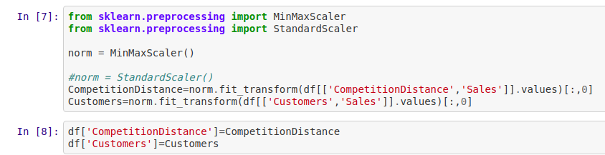

Feature Selection:
During Feature Engineering, lots of new feature are created but all feature are not required or all features are not important.

The Sklearn library SelectFromModel is used for feature selection and base estimator is LassoRegression which will return 20 features are have impact on target variable.
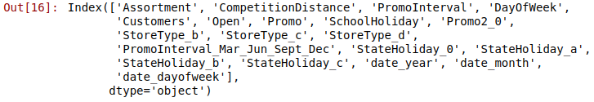

Split Dataset: In this process, 80% of the data was split for the train data and 20% of the data was taken as test data.

Models:

1) Lasso Regression: LASSO stands for Least Absolute Shrinkage and Selection Operator.

Lasso regression is one of the regularization methods that creates parsimonious models in the presence of large number of features, where large means either of the below two things:
1. Large enough to enhance the tendency of the model to over-fit. Minimum ten variables can cause overfitting.
2. Large enough to cause computational challenges. This situation can arise in case of millions or billions of features.
Feature Importance Graph:
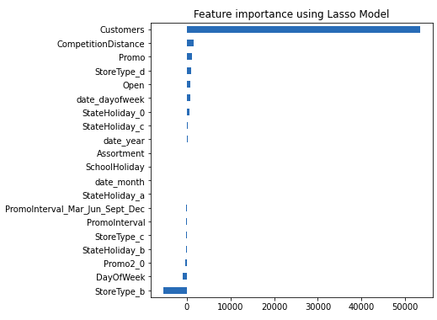
Result:
Adj. R2 Score (Training) | 0.8955 or 89.55%
Adj. R2 Score (Testing) | 0.8967 or 89.67%

2) Random Forest Regressor:
The random forest regressor consisting of many decision trees as a base estimator. It uses bagging and feature randomness when building each tree to try to create an uncorrelated forest of trees whose prediction by committee is more accurate than that of any individual tree.
In our model, 150 decisions are created with max_depth 20.
Feature Importance graph:
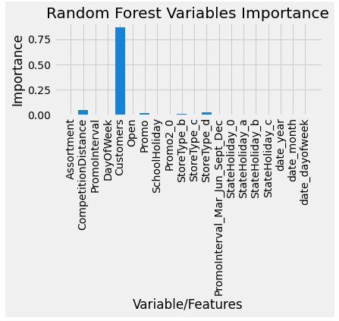

Result:
Adj. R2 Score (Training) | 0.9921 or 99.21%
Adj. R2 Score (Testing) | 0.9812 or 98.12%

3) Deep Neural Network:
A deep neural network (DNN) is an artificial neural network (ANN) with multiple layers between the input and output layers. The DNN finds the correct mathematical manipulation to turn the input into the output, whether it be a linear relationship or a non-linear relationship.
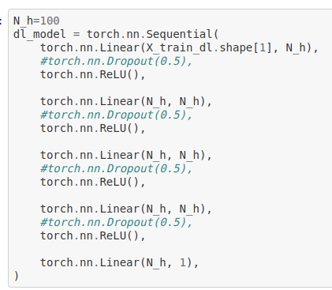

In our DNN, There is one input layer then 4 hidden layers and each layer consist of 100 neurons. At the end there is one linear layer that gives final output.
Optimization algorithm : Adam is an optimization algorithm that can be used instead of the classical stochastic gradient descent procedure to update network weights iterative based in training data. Adam is an adaptive learning rate optimization algorithm that's been designed specifically for training deep neural networks.
Loss Function: Mean Squared Error (MSE) loss function is used for this DNN.
Loss Graph per epoch (max 1000): DNN is training 1000 times i.e 1000 epoch and result show in below graph.

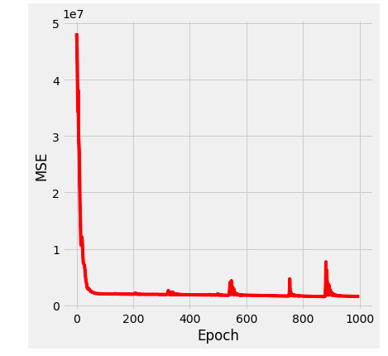

Result:
Adj. R2 Score (Training) | 0.8816 or 88.16%
Adj. R2 Score (Testing) | 0.8956 or 89.56%

Over Evaluation:
The below graphs shows that Random Forest Regressor perform better as compare to other models.
For DNN, we have done hyperparameter tuning manually, but these are not the optimal values due to the hardware limitations we have not reach to that.
