Week 2 Report: Implementing Security Measures in Node.js Application
1. Introduction
In Week 2, the focus was on strengthening the security of the Node.js authentication system. The main objective was to eliminate common vulnerabilities, secure user credentials, enhance authentication mechanisms, and protect HTTP communication.
The application was tested using Postman to verify secure user registration and login functionality.
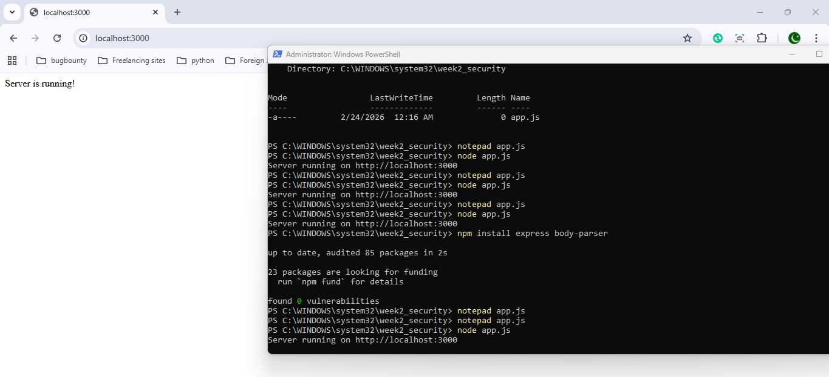
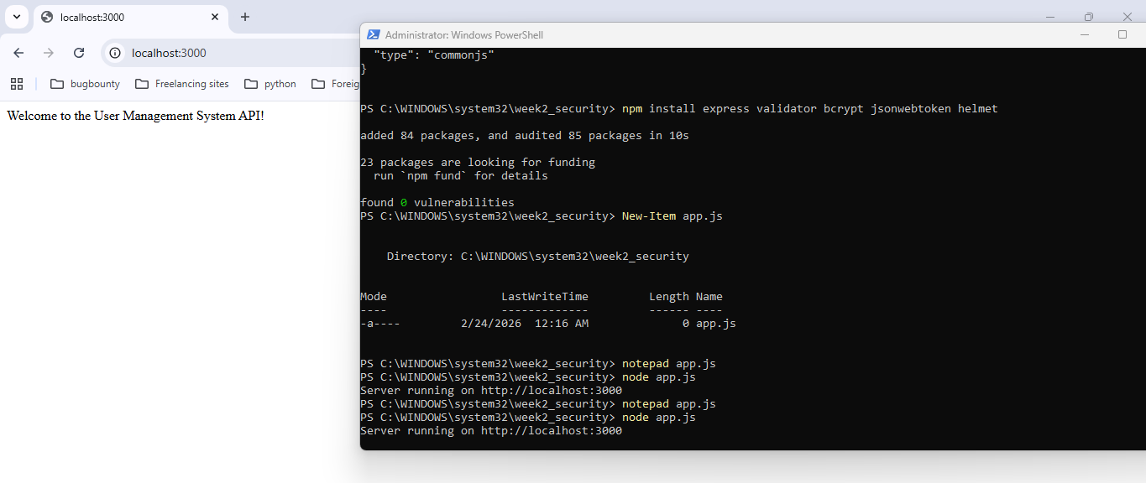
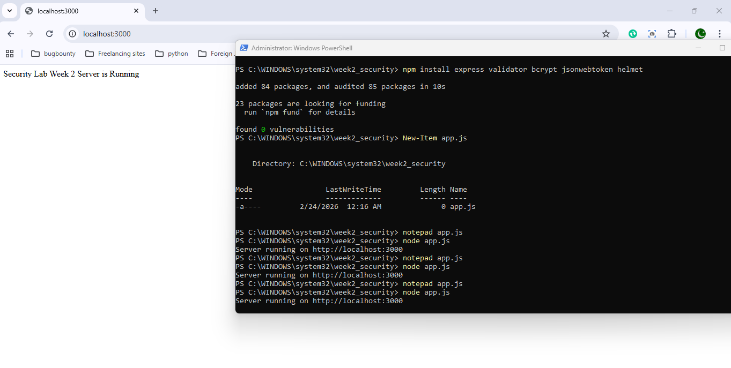

2. Fixing Vulnerabilities
2.1 Input Validation and Sanitization
User inputs are a primary attack vector in web applications. To prevent malicious data injection, input validation was implemented using the validator library.
Installation:
npm install validator
Implementation:
const validator = require('validator');
if (!validator.isEmail(email)) {
return res.status(400).send('Invalid email');
}
Purpose:
- Ensures only properly formatted emails are accepted
- Prevents malformed or malicious input
- Reduces risk of injection attacks
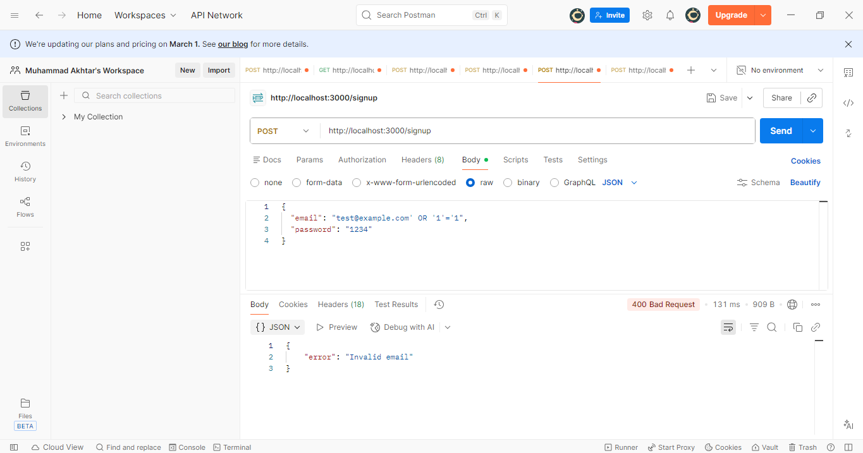
2.2 Password Hashing with bcrypt
Storing plain-text passwords is a critical security flaw. To secure passwords, bcrypt was implemented for hashing before storage.
Installation:
npm install bcrypt
Implementation:
const bcrypt = require('bcrypt');
const hashedPassword = await bcrypt.hash(password, 10);
Security Benefits:
- Protects passwords even if database is compromised
- Uses salting mechanism to prevent rainbow table attacks
- Makes brute-force attacks computationally expensive

3. Enhancing Authentication
3.1 Token-Based Authentication with JSON Web Token (JWT)
To implement stateless authentication, jsonwebtoken (JWT) was integrated.
Installation:
npm install jsonwebtoken
Implementation:
const jwt = require('jsonwebtoken');
const token = jwt.sign({ id: user._id }, 'your-secret-key');
res.send({ token });
Benefits:
- Enables secure, stateless authentication
- Token contains user ID for verification
- Eliminates need for server-side session storage
- Can be used in protected routes via middleware

4. Securing Data Transmission
4.1 Securing HTTP Headers with Helmet.js
To protect against common HTTP vulnerabilities, Helmet.js was added.
Installation:
npm install helmet
Implementation:
const helmet = require('helmet');
app.use(helmet());
Protection Includes:
- Hides X-Powered-By header
- Prevents clickjacking
- Mitigates MIME-sniffing attacks
- Adds secure HTTP headers automatically

5. API Testing Results (Postman Verification)
5.1 User Registration (/signup)
- Endpoint: POST /signup
- Status: 201 Created
- Response:
{
"message": "User registered successfully",
"token": "JWT_TOKEN"
}
The response confirms:
- Input validation working
- Password hashing successful
- JWT token generated upon registration
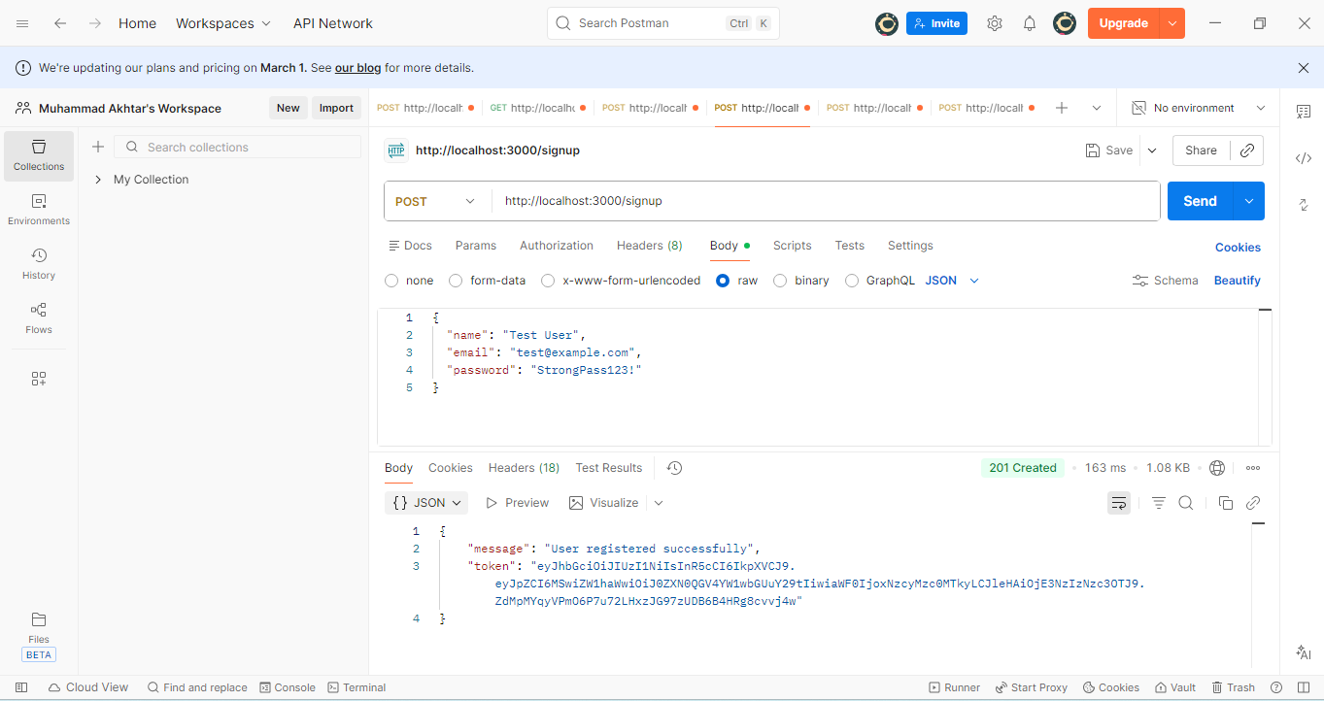
5.2 User Login (/login)
- Endpoint: POST /login
- Status: 200 OK
- Response:
{
"message": "Login successful",
"token": "JWT_TOKEN"
}
This confirms:
- Credentials validated
- Password comparison using bcrypt successful
- Token generated correctly
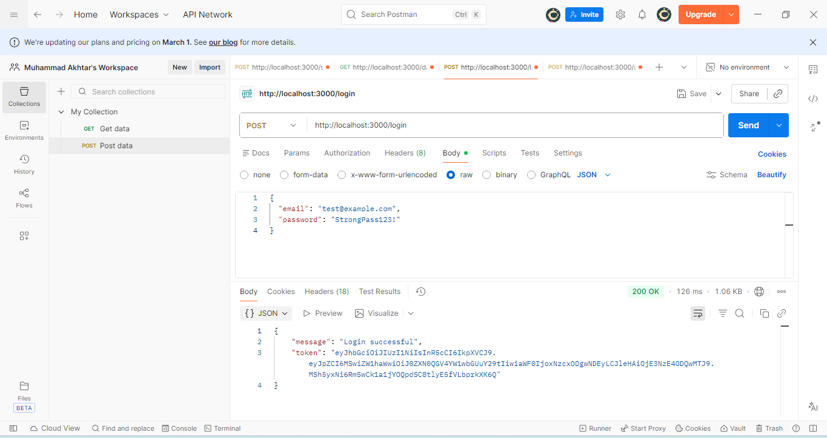
6. Security Improvements Achieved
Security Area | Improvement
Input Handling | Email validation implemented
Password Security | bcrypt hashing added
Authentication | JWT-based token system
HTTP Security | Helmet middleware enabled
API Testing | Verified using Postman

7. Conclusion
During Week 2, significant security improvements were successfully implemented in the Node.js authentication system. The application now:
- Validates user inputs
- Stores passwords securely using hashing
- Uses JWT for authentication
- Secures HTTP headers
- Successfully passes API testing in Postman
These enhancements significantly reduce common vulnerabilities such as:
- Plain-text password storage
- Invalid input exploitation
- Session hijacking
- Header-based attacks
The application is now more secure, scalable, and production-ready.
