Week 3 Report: Advanced Security Testing, Logging, and Final Validation
1. Introduction
In Week 3, the project transitioned from implementing security features to validation and auditing. The primary objectives were to perform basic penetration testing to verify the defences built in Week 2, implement a robust logging system to monitor security events, and establish a best-practice checklist for final deployment.
Testing was conducted using Postman to simulate common attack vectors, specifically focusing on SQL Injection (SQLi) and credential enumeration.

2. Basic Penetration Testing
To ensure the application can withstand malicious attempts, manual penetration testing was performed on the authentication endpoints.
2.1 SQL Injection Simulation
An attempt was made to bypass the registration logic by injecting a classic SQL logical bypass into the email field.
- Payload Used: test@example.com' OR '1'='1
- Observed Result: The server returned a 400 Bad Request with the message "Invalid email".
- Security Analysis: This confirms that the validator library implemented in Week 2 is successfully intercepting malformed strings before they can be processed by the database layer.
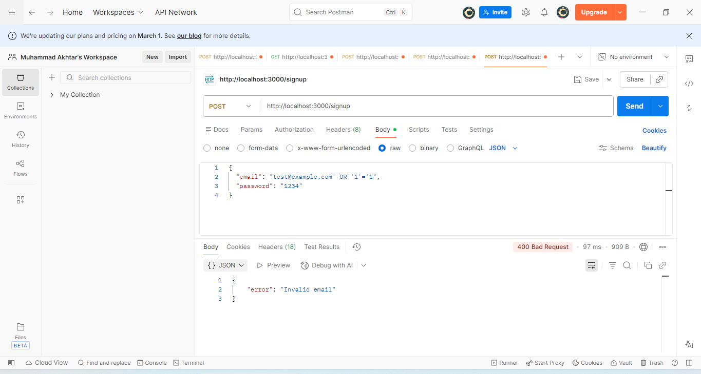
2.2 User Enumeration Testing
The /login endpoint was tested with non-existent credentials to observe the server's verbosity.
- Observed Result: The server responded with "User not found".
- Security Recommendation: While functional, future iterations should use generic messages (e.g., "Invalid credentials") to prevent attackers from mapping valid usernames.
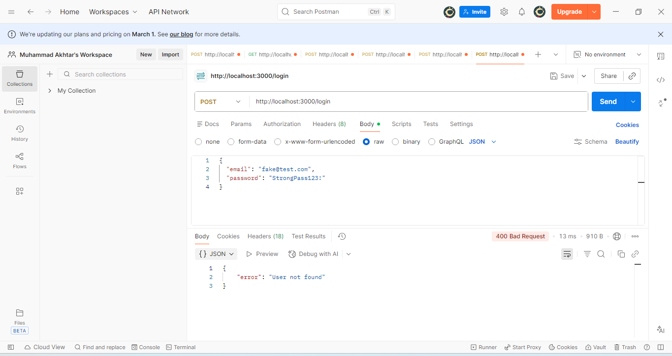
3. Implementing Security Logging
Monitoring is a critical pillar of security. To track application behavior and detect potential attacks in real-time, the Winston library was integrated.
3.1 Setup and Configuration
Installation:
npm install winston
Implementation:
JavaScript
const winston = require('winston');

const logger = winston.createLogger({
level: 'info',
format: winston.format.json(),
transports: [
new winston.transports.Console(),
new winston.transports.File({ filename: 'security.log' })
]
});

// Example Usage in Auth Middleware
logger.warn(`Failed login attempt from IP: ${req.ip}`);

3.2 Purpose of Logging
- Audit Trail: Maintains a permanent record of who accessed the system and when.
- Incident Response: Provides data to investigate the scope of a breach if one occurs.
- Anomaly Detection: Allows developers to see spikes in "400" or "401" errors, which may indicate a brute-force attack.

4. Security Best Practices Checklist
As part of the final validation, the following checklist was used to ensure the application meets industry standards:
Best Practice | Status | Implementation Detail
Input Validation | ✅ | Using validator.isEmail() and length checks.
Password Security | ✅ | Using bcrypt with a salt factor of 10.
Data in Transit | ⚠️ | Prepared for HTTPS/TLS (Localhost tested).
Security Headers | ✅ | Helmet.js integrated to prevent Clickjacking/XSS.
Logging & Monitoring | ✅ | Winston configured for security.log output.

5. Final Results (Postman Verification)
5.1 Blocked SQL Injection (/signup)
- Endpoint: POST /signup
- Status: 400 Bad Request
- Evidence: The application correctly identified the SQL syntax as an invalid email format, preventing the payload from executing.
5.2 Logging Verification
- Action: Attempted login with wrong credentials.
- Result: A new entry was generated in security.log containing the timestamp, the error type, and the associated IP address.

6. Conclusion
Week 3 successfully validated the security measures from the previous weeks. By simulating attacks and implementing logging, the application has moved from "securely built" to "securely monitored."
Summary of Achievements:
- Confirmed that Input Validation successfully stops SQL Injection.
- Established a Logging System to capture security-sensitive events.
- Created a Standardized Checklist for production readiness.
The application is now prepared for final submission, featuring a multi-layered defense strategy including validation, hashing, header protection, and audit logging.

