**COMSATS University Islamabad,  
 Abbottabad Campus**

**ProjectProposal  
 (SCOPE DOCUMENT)**

**Easy Buy With 3D Augmented Reality**

**for  
  
*By***

**Muhammad Akhlaq CIIT/SP21-BSE-056ATD**

**Huzaifa Sajjad CIIT/SP21-BSE-012ATD**

**Rimsha Muneer CIIT/SP21-BSE-082ATD**

***Supervisor  
 Umair Mujtaba***

***Bachelor of Science in Computer Science (2021-2024)***

|  |  |  |
| --- | --- | --- |
| **No.** | **Comment** | **Action** |
|  |  |  |
|  |  |  |
|  |  |  |
|  |  |  |
|  |  |  |
|  |  |  |

**SCOPE DOCUMENT REVSION HISTORY**

**Supervisor Signature**

**Date:**

Table of Contents

**Abstract** 4

**Introduction** 4

**Problem Statement** 5

**Problem Solution for Proposed System** 5

**Related System Analysis/Literature Review** 6

**Advantages/Benefits of the Proposed System** 6

**Scope** 7

**Modules** 8

**System Limitations/Constraints** 10

**Software Process Methodology** 11

**Tools and Technologies** 11

**Team Members Individual Tasks/Work Division** 13

**Data Gathering Approach** 15

**Concepts** 15

**Gantt chart** 17

17

**Mockups** 17

**Conclusion** 19

**References** 20

**Project Category: (Select all the major domains of proposed project)**

|  |
| --- |
| **A-Desktop Application/Information System B-Web Application/Web Application based Information System C- Problem Solving and Artificial Intelligence D-Simulation and Modeling E- Smartphone Application F- Smartphone Game G- Networks H- Image Processing Other (specify category) ______________________** |

# **Abstract**

The "Easy Buy with 3D Augmented Reality" app is designed to make shopping for home decor easier and more fun. It has lots of cool features to help users find what they want and make purchases easily. You can sign up, browse through different home decor items, and even see how they would look in your home using augmented reality. The app also lets you add items to your cart, pay securely, and track your orders.

Behind the scenes, there's smart technology that helps make pictures clearer by removing distracting stuff. Users can give feedback and leave reviews, and the app's admin tools make it easy to manage everything. We're focused on making sure the app is safe, works well, and keeps getting better based on what users tell us.

While you can use augmented reality to see how home decor items fit in your space, you can only change the size of clothes, not try them on virtually. Also, right now, the app can only remove one thing from one picture at a time, not from multiple pictures together.

# **Introduction**

Welcome to "Easy Buy with 3D Augmented Reality" - the mobile app designed to revolutionize your home decor shopping experience! With our app, shopping for home decor has never been easier or more exciting. We've packed it with features to make browsing, buying, and decorating your space a breeze.

Imagine being able to browse through a wide selection of home decor items from the comfort of your own home. With our app, you can do just that! Whether you're looking for furniture, lighting, or decorative accessories, our comprehensive product catalog has something for everyone.

But we don't stop there. We take your shopping experience to the next level with augmented reality (AR) visualization. With just a tap of your finger, you can see how a piece of furniture or a decorative item would look in your own living space. It's like trying before you buy, right from your smartphone or tablet!

And when you find the perfect piece, our secure checkout and payment processing ensure that your transactions are safe and protected. You can track your orders every step of the way and even leave reviews and ratings to help other shoppers make informed decisions.

Behind the scenes, our app is powered by advanced AI technology that enhances the visual clarity of product images by removing distracting elements. Plus, our admin dashboard makes it easy for us to manage the app and ensure that everything runs smoothly.

We're committed to providing you with a seamless and enjoyable shopping experience, and we're constantly working to improve our app based on your feedback and suggestions. So why wait? Transform your home decor shopping experience today with "Easy Buy with 3D Augmented Reality"!

# **Problem Statement**

**1. Lack of Confidence in Online Purchases:** Traditional e-commerce platforms fail to provide users with a clear understanding of how home decor items will look and fit within their living spaces, leading to hesitancy and high return rates.

**2. Need for AR Integration:** Existing solutions lack augmented reality (AR) technology integration, which is crucial for enabling users to visualize decor items in their own environments before making a purchase, thereby reducing uncertainty in online shopping.

**3. Limited Focus on Home Decor:** While some AR-enabled shopping apps exist, they may not specifically cater to the home decor niche, resulting in a gap in the market for a specialized platform tailored to the needs of decor enthusiasts.

**4.Incomplete Feature Set:** Current solutions may lack comprehensive features for managing orders, inventory, and user interactions, highlighting the need for a platform that provides a seamless end-to-end shopping experience for users.

**5. Skill Enhancement Opportunity:** The project presents an opportunity for developers to enhance their skills in mobile app development, AR integration, cloud services management, user experience design, and backend system administration, contributing to their professional growth and expertise in emerging technologies.

# **Problem Solution for Proposed System**

The proposed system, "Easy Buy with 3D Augmented Reality," offers a comprehensive solution to the challenges faced by home decor enthusiasts when shopping online.

1. **Augmented Reality Integration:** By integrating AR technology into the mobile application, users gain the ability to visualize decor items within their own living spaces before making a purchase, thus increasing confidence and reducing returns.
2. **Streamlined Shopping Experience:** The system provides a user-friendly interface with features like product search, filtering options, and a secure checkout process, ensuring a seamless journey from product selection to delivery.
3. **Comprehensive Features:** Inclusion of functionalities such as shopping cart, order management, and inventory tracking ensures a hassle-free shopping experience for users.

**Implementation Approach**

The re-implementation of such a system aids in learning by providing developers with hands-on experience in implementing AR technology, integrating with cloud services like Firebase, and developing a robust backend system.

1. **Hands-on Experience:** Developers enhance their skills in mobile app development, user experience design, and system administration, gaining valuable insights into building a modern e-commerce platform.
2. **Cutting-edge Technologies:** Leveraging AR technology, cloud services, and best practices in software development, the system aims to set a new standard for the industry and provide a seamless shopping experience for decor enthusiasts worldwide.

# **Related System Analysis/Literature Review**

The related system analysis provides insights into existing applications within the home decor shopping domain, highlighting their strengths and weaknesses. By comparing these systems with the proposed project, it becomes evident that while existing applications offer certain functionalities, they may lack comprehensive features or fail to address specific user needs effectively. The proposed project aims to bridge these gaps by offering a more extensive product catalog, integrating AR technology for enhanced visualization, and prioritizing user-friendly design principles. Through this analysis, the contribution of the proposed project becomes clear in offering a solution that combines the best aspects of existing systems while addressing their shortcomings to deliver a superior shopping experience for home decor enthusiasts.

Table 1 Related System Analysis with proposed project solution

|  |  |  |
| --- | --- | --- |
| Application Name | Weakness | Proposed Project Solution |
| Houzz - Home Design & Remodel | Lack of AR Integration | The proposed project integrates augmented reality (AR) technology, allowing users to visualize decor items in their living spaces before purchase. This feature addresses the limitation of Houzz by providing a more immersive shopping experience. |
| IKEA Place | Limited Product Catalog | The proposed project offers a more extensive product catalog, catering to a wider range of home decor items beyond furniture. Additionally, it provides robust backend management tools for inventory tracking and order processing. |

# **Advantages/Benefits of the Proposed System**

**Advantages/Benefits of the Proposed System:**

**1. Enhanced Visualization:** The integration of augmented reality (AR) technology allows users to visualize home decor items in their own living spaces, providing a realistic preview of how products will look and fit before making a purchase. This enhances confidence and reduces the likelihood of returns, leading to higher customer satisfaction.

**2. Expanded Product Catalog:** The proposed system offers a comprehensive product catalog encompassing a wide range of home decor items beyond furniture, catering to diverse tastes and preferences. Users can explore an extensive selection ofproducts, ensuring they find items that perfectly match their aesthetic and functional needs.

**3. Streamlined Shopping Experience:** With features like intuitive product search, filtering options, and a secure checkout process, the system streamlines the entire shopping journey for users. They can easily browse, select, and purchase items with minimal effort, resulting in a more efficient and enjoyable shopping experience.

**4. Improved Decision Making:** By providing detailed product descriptions, images, reviews, and ratings, the system empowers users to make informed decisions. They can assess product quality, suitability, and customer satisfaction levels, helping them choose the right items that meet their requirements and preferences.

**5. Seamless Integration:** The proposed system seamlessly integrates with cloud services like Firebase for real-time data storage and syncing, ensuring data consistency and reliability across devices. This enables users to access their accounts and order information from multiple devices, enhancing convenience and accessibility.

**6. Continuous Improvement:** Through features like user feedback collection and analytics, the system facilitates continuous improvement and optimization. By analyzing user behavior, preferences, and feedback, developers can iteratively enhance the platform, ensuring it remains responsive to evolving user needs and market trends.

# **Scope**

The scope of the project encompasses the development of a mobile application, "Easy Buy with 3D Augmented Reality," aimed at transforming the home decor shopping experience. The main functionalities of the proposed project include user authentication and registration, a comprehensive product catalog, augmented reality (AR) visualization, shopping cart management, secure checkout and payment processing, order management, inventory tracking, user reviews and ratings, admin dashboard for backend management, customer support and communication tools, reporting and analytics features, social media integration, user accounts and profiles management, and feedback and reviews management. Our AI-driven technology enables precise removal of specific objects from images, ensuring enhanced visual clarity and focus. The application will empower users to register and create accounts, browse through a diverse catalog of home decor items, visualize products in their living spaces using AR technology, add items to their shopping cart, complete secure transactions, track order history, leave reviews and ratings, and engage with customer support. Admins will have access to backend tools for managing products, orders, users, inventory, analytics, and application to enhance customer support and facilitate real-time communication between users and support representatives. The scope also includes features for data security, scalability, usability, reliability. The project will focus on delivering a user-friendly interface, robust backend infrastructure, and continuous improvement through feedback and analytics, ensuring a seamless and engaging shopping experience for home decor enthusiasts while maintaining efficiency, security, and compliance with industry standards. The AR visualization feature will allow users to resize and virtually place home decor items within their living spaces for visual assessment. However, for wearable items such as clothes, the application will limit functionality to resizing only. Users will be unable to visualize themselves wearing the clothing items due to technical constraints. It's important to note that our AI technology currently has limitations it can only remove a single specific object from a single image at a time, rather than removing objects from multiple images simultaneously.

# **Modules**

**Module 1: User Authentication and Registration**

This module is responsible for managing the authentication and registration processes for users accessing the application. Users can create accounts securely by providing necessary information such as email, password, and personal details. The module includes features for password hashing, email verification, and two-factor authentication to ensure account security. Existing users can log in using their credentials to access the application's features. User authentication and registration are crucial for providing personalized experiences, managing user accounts, and ensuring data security. This module lays the foundation for user interaction and access control throughout the application, contributing to a seamless and secure user experience.

**Module 2: Product Management**

This module enables administrators to manage the product inventory within the application. Admins can add new products, update existing product information (such as descriptions, prices, and images), categorize products into different sections, and remove products that are no longer available. Additionally, this module includes features for inventory tracking, ensuring that stock levels are accurate and up-to-date. By effectively managing the product catalog, administrators can ensure that users have access to a diverse range of home decor items to browse and purchase.

**Module 3: 3D Augmented Reality**

The Augmented Reality module integrates AR technology into the application, allowing users to visualize home decor items in their real environment. Through the use of the device's camera, users can place virtual representations of products within their living spaces, enabling them to assess how items will look and fit before making a purchase. This module enhances the user experience by providing a more immersive and interactive shopping experience, leading to increased confidence and satisfaction with purchases. Augmented reality technology adds a novel and engaging dimension to the application, setting it apart from traditional e-commerce platforms and offering users a unique way to shop for home decor.

**Module 4: Order Management**

The Order Management module oversees the lifecycle of orders placed by users within the application. It includes functionalities such as order tracking, order history, and order confirmation emails. Users can monitor the status of their orders, track shipments, and receive notifications about order updates. The module also facilitates communication between users and sellers regarding order inquiries, changes, or cancellations. Order management ensures transparency and accountability throughout the purchasing process, helping users stay informed and facilitating efficient order fulfillment.

**Module 5: User Reviews and Ratings**

The User Reviews and Ratings module enables users to provide feedback and rate home decor items based on their experiences. Users can leave reviews detailing their opinions, experiences, and suggestions regarding products they have purchased. Additionally, they can rate products on various criteria, such as quality, design, and value for money. The module also includes features for moderating and managing user-generated content, ensuring that reviews are authentic and relevant. User reviews and ratings serve as valuable sources of information for other users, helping them make informed purchasing decisions and fostering trust and transparency within the community.

**Module 6: Admin Dashboard**

The Admin Dashboard module provides administrators with a centralized platform for managing various aspects of the application. It includes features such as product management tools, order tracking and processing functionalities, user management capabilities, and analytics dashboards. Administrators can monitor key performance indicators, track sales and revenue, and generate reports to gain insights into the application's performance. Additionally, the module supports features for content moderation, user support, and communication with sellers. The admin dashboard empowers administrators to oversee and optimize the application's operations, ensuring efficiency, reliability, and compliance with policies and regulations.  
**Module 7: Chat System Integration**

The Chat System module integrates real-time communication capabilities into the application, allowing users to engage in chat-based interactions with sellers, customer support representatives, and other users. It includes features such as private messaging, group chats, and chatbot assistance. Users can communicate with sellers to ask questions about products, seek assistance with orders, or resolve issues effectively. Additionally, the module supports automated chatbot responses to frequently asked questions, improving response times and user satisfaction.

**Module 8: Payment Gateway Integration (Stripe)**

The Payment Gateway Integration module integrates the Stripe payment gateway into the application, allowing users to securely make online payments for purchases. It includes features such as tokenization for card data security, support for various payment methods, and seamless checkout experiences. Users can safely provide payment information during the checkout process, with transactions processed securely through Stripe's payment infrastructure. Additionally, the module supports features for managing refunds, disputes, and subscription billing, providing flexibility and convenience for both users and administrators.

**Module 9: Email and Notification Services**

The Email and Notification Services module manages communication with users through email and notifications, providing updates, alerts, and promotional messages. It includes features such as email templates, scheduling, and delivery tracking. Users receive notifications about order confirmations, shipment updates, and promotions, keeping them informed and engaged throughout their interaction with the application. Additionally, administrators can send targeted messages to specific user segments based on their preferences and behaviors, enhancing marketing effectiveness and user engagement.

**Module 10: Background Removal through AI**

The Background Removal module leverages artificial intelligence algorithms to automatically remove backgrounds from product images uploaded to the application. It includes features such as image segmentation, background substitution, and image enhancement. Sellers can upload product photos with complex backgrounds, and the module automatically isolates the product, creating professional-looking images with transparent backgrounds. This feature enhances the visual appeal of product listings, improving user engagement and facilitating a more immersive shopping experience.

**Module 11: Recommendation System With AI**

the Recommendation System will continuously learn and adapt to evolving trends and user preferences, thereby improving its accuracy over time. Through advanced algorithms, it will personalize product recommendations for individual users, thereby increasing the likelihood of successful transactions and overall customer satisfaction. This integration will not only enhance user engagement but also contribute significantly to the platform's revenue generation by promoting high-quality and relevant products effectively.

# **System Limitations/Constraints**

**internet Connectivity:** The seamless operation of the proposed system relies heavily on internet connectivity. Users must have access to a stable internet connection to browse the product catalog, visualize items using AR, complete transactions, and receive order updates. Limited or unreliable internet connectivity may hinder the user experience and affect the overall usability of the application.

**Hardware Requirements:** The effectiveness of the AR feature may also be constrained by the hardware capabilities of users' devices. Devices with low processing power or inadequate camera quality may struggle to render AR content smoothly, impacting the quality of visualizations and user experience.Data Privacy and Security: As the application deals with sensitive user information such as personal details, payment data, and browsing history, ensuring robust data privacy and security measures is paramount. Compliance with data protection regulations and industry standards is essential to safeguard user data from unauthorized access, breaches, or misuse.**AI Technology Limitations:** While our AI-driven technology enables precise removal of specific objects from images, it currently has limitations. It can only remove a single specific object from a single image at a time, rather than removing objects from multiple images simultaneously. This constraint may impact the efficiency of background removal processes, especially in scenarios where bulk image editing is required.**Wearable Item Visualization Constraints:** However, for wearable items such as clothes, the application will limit functionality to resizing only. Users will be unable to visualize themselves wearing the clothing items due to technical constraints. This limitation arises from technical challenges associated with accurately overlaying clothing items onto user images in real-time, which may affect the overall user experience for this particular category of products.

**Software Process Methodology**

For the development of the proposed project, we have chosen the Agile software development methodology. Agile emphasizes iterative development, collaboration between cross-functional teams, and delivering working software in short, incremental cycles. We have selected Agile because it allows for flexibility and adaptability to changing requirements, which is crucial for a project like ours that involves continuous feedback and integration of new features. Additionally, Agile encourages active involvement of stakeholders throughout the development process, ensuring alignment with user needs and business goals. This methodology also complements our team's expertise in collaborative development and aligns well with the dynamic nature of mobile app development.

# 

# **Tools and Technologies**

Table 2 Tools and Technologies for Proposed Project

|  |  |  |  |
| --- | --- | --- | --- |
| **Tools**  **And**  **Technologies** | **Tools** | **Version** | **Rationale** |
| Flutter | Latest | Cross-platform mobile app development framework chosen for its performance, flexibility, and extensive library of widgets. |
| RESTful APIs | Latest | Standardized APIs utilized for communication between frontend and backend components, ensuring interoperability and scalability |
| Firebase | Latest | Google's cloud services utilized for real-time data storage, authentication |
| Django | Latest | Framework for Backend Development And Database Management,  Also, We will implement Inventory Management. |
| MS Word | Latest | Documentation |
| Github | Latest | Collaboration |
| Ms Power point | Latest | Presentation |
|  | ClickUp |  | For Project Management |
|  | VSCODE | Latest | IDE |

**Project Stakeholders and Roles**

**Write down the project stakeholders and their roles.**

Table 3 Project Stakeholders for Proposed Project

|  |  |
| --- | --- |
| **Project Sponsor** | **COMSATS University, Islamabad ATD** |
| **Stakeholder** | * **Students** HUZAIFASAJJAD  RimshaMuneer   MuhammadAkhlaq * **Project Supervisor Name:**   Mr Umair Mujtaba  **· Final Year Project Committee: Evaluation of project**   * Dr. Rab Nawaz Jadoon * Maleeha Khalid * Sana Malik * Javed Raza |

# **Team Members Individual Tasks/Work Division**

As the Project Supervisor, will play a crucial role in overseeing our team's progress and ensuring the successful completion of tasks.

**M-Akhlaq:**

Project Management and Task Distribution:

* + Coordinate with team members for task assignments and deadlines.
  + Schedule regular team meetings for progress updates.
* Backend Development (Django):
  + Database Design:
    - Define database schema based on project requirements.
  + Views and REST APIs:
    - Develop backend views and REST APIs for data retrieval and manipulation.
  + AR Technology Implementation (using Flutter):
    - Integrate AR functionality into the Flutter app.
    - Collaborate with team members for seamless integration with backend services.
* Integration and Testing:
  + Oversee the integration of different system components.
  + Coordinate with team members to ensure smooth integration and functionality testing.

**Huzaifa Sajjad :**

* Django Development & AR Assistance:
  + Support Akhlaq in Django backend development tasks as required.
  + Help in AR.
* Communication Implementation:
  + Develop communication(Chat System) features using Python or Flutter as needed.
  + Notifications
* Frontend Design Assistance:
  + Assist Rimsha in front-end design tasks, providing input and feedback.
* Requirement Changes and Implementation:
  + Collaborate with Akhlaq and Rimsha to implement changes in project requirements.
  + Payment method

**Rimsha Muneer:**

* Frontend Development (Flutter):
  + Implement UI components and screens based on design specifications.
  + Integrate RESTful APIs into the Flutter app for data retrieval and updates.
* Design Frontend Assets:
  + Create logos, banners, and other graphical assets for the front end.
  + Collaborate with Huzaifa for feedback and iterations.
* Quality Assurance (QA):
  + Conduct testing on front-end components to ensure functionality and usability.
  + Collaborate with the team to perform comprehensive system testing.

Table 4 Team Member Work Division for Proposed Project

|  |  |  |
| --- | --- | --- |
| **Student Name** | **Student Registration Number** | **Responsibility/ Modules** |
| HUZAIFA SAJJAD | SP21-BSE-012 | Overall Chat System $Payment Method  Collaborate In Frontend  Assist in Augmented Reality Handle Overall Requirements |
| Rimsha Muneer | SP21-BSE-082 | Frontend  FrontEnd APIs  Logo Banners  QA |
| Muhammad Akhlaq | SP21-BSE-056 | Backend Server  Augmented Reality  Integration And Testing  Project Management |

# **Data Gathering Approach**

For gathering information and requirements for the proposed project, we will employ a combination of approaches to ensure comprehensive coverage and accuracy. This includes conducting interviews with stakeholders such as potential users, administrators, and vendors to gather insights into their needs, preferences, and pain points. Additionally, we will distribute questionnaires to a broader audience to collect quantitative data and gather feedback on specific features and functionalities. We will also analyze existing market research, competitor analysis, and industry trends to gain a deeper understanding of user expectations and market demands. Finally, we will organize focus groups or workshops to facilitate brainstorming sessions and ideation, allowing stakeholders to collaboratively explore and prioritize requirements for the project.

# **Concepts**

**Concept-1: Augmented Reality (AR) Integration**

Augmented Reality (AR) Integration is a core component of our project, "Easy Buy with 3D Augmented Reality," aimed at revolutionizing the home decor shopping experience. AR technology overlays virtual objects onto the real world, enabling users to visualize home decor items within their living spaces. By integrating AR into our application, users can interact with virtual representations of products, assess their suitability and fit in real-time, and make informed purchasing decisions. Understanding the principles of computer vision, 3D modeling, and spatial tracking is essential for creating immersive and realistic AR experiences that enhance user engagement and satisfaction.

**Concept-2: Database Management for Efficient Data Handling**

Database Management plays a crucial role in ensuring the efficient organization, storage, and retrieval of data within our application. With a comprehensive product catalog, user accounts, order history, and feedback management, effective database management is essential for maintaining data integrity, optimizing performance, and facilitating scalability. Concepts such as database normalization, indexing, and query optimization will be employed to design and implement a robust backend database system. By leveraging database management principles, we can provide users with seamless access to product information, personalized experiences, and reliable transaction processing.

**Concept-3: User-Centric Design for Enhanced User Experience (UX)**

User Experience (UX) Design is integral to creating a user-friendly interface and enhancing the overall usability and satisfaction of our application. With features such as user authentication, product visualization, shopping cart management, and customer support tools, prioritizing user-centric design principles is essential for optimizing the user journey and maximizing engagement. By employing UX design methodologies such as user research, wireframing, prototyping, and usability testing, we can create intuitive navigation flows, visually appealing interfaces, and interactive features that resonate with our target audience. Focusing on UX design ensures that our application meets the needs and expectations of users, resulting in a seamless and enjoyable shopping experience.

**Concept-4: Continuous Improvement Through Feedback and Analytics**

Continuous Improvement through Feedback and Analytics is a key aspect of our project's strategy for enhancing user satisfaction and driving business growth. By collecting and analysing user feedback, app usage data, and performance metrics, we can gain valuable insights into user behaviour, preferences, and pain points. Leveraging reporting and analytics features, we can identify areas for improvement, prioritize feature enhancements, and refine our application to better meet user needs. Through iterative development cycles and a commitment to continuous improvement, we can ensure that "Easy Buy with 3D Augmented Reality" evolves over time to deliver a seamless and engaging shopping experience for home decor enthusiasts.

**Concept-5: Background Removal Using AI Technology**

Background Removal Using AI Technology enhances the visual appeal of product listings within our application. By employing AI algorithms, users can remove distracting backgrounds from images, ensuring clear and focused visuals. This feature improves the overall aesthetics of the product catalog and contributes to a more immersive shopping experience. While the technology is currently limited to removing backgrounds from single images, it enhances the presentation of home decor items and aids users in making informed purchasing decisions. Integrating background removal functionality aligns with our goal of leveraging advanced technologies to enhance user satisfaction and engagement within the application.

# **Gantt chart**

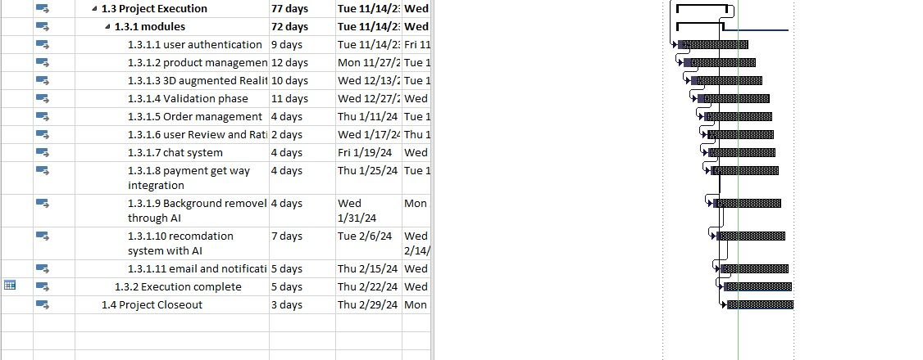

Figure 1

# 

Figure 2

# **Mockups**

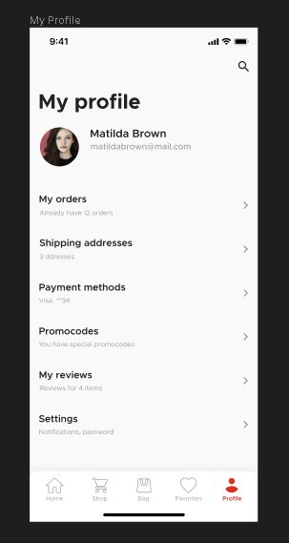

Figure 3 PROFILE

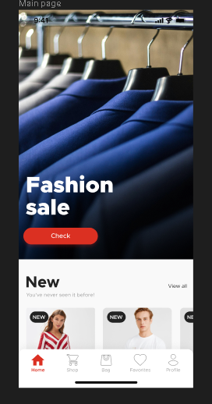

Figure 4 HOMESCREEN

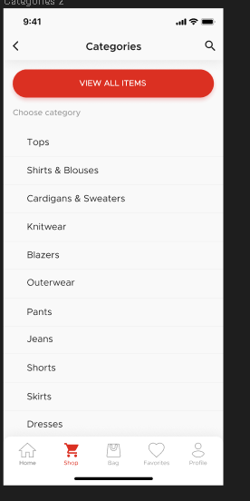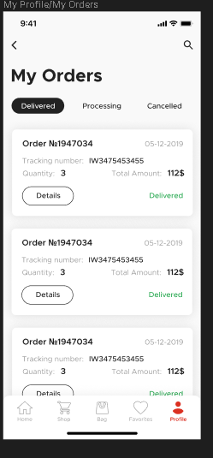

Figure 5 Categories

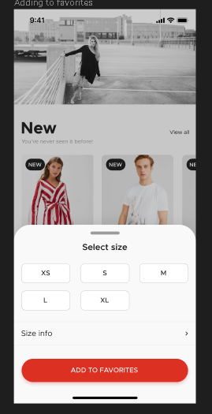Figure 7 Order

Figure 6Product

# **Conclusion**

In conclusion, the proposed project aims to revolutionize the home decor shopping experience by leveraging innovative technologies such as augmented reality and robust e-commerce functionalities. Through the implementation of user-friendly interfaces, comprehensive product catalogs, and secure payment systems, we strive to deliver a seamless and immersive shopping experience for users. By adopting Agile methodologies and actively involving stakeholders in the development process, we are poised to create a dynamic and responsive application that meets the evolving needs of home decor enthusiasts. This project represents a significant step towards bridging the gap between traditional retail and digital innovation in the home decor industry, ultimately enhancing user satisfaction and driving business growth.

# **References**

Augmented Reality: Principles and Practice" by Dieter Schmalstieg and Tobias Höllerer

"E-commerce Evolved: Essential To Master E-commerce Business, Online Retail, Amazon Selling and Shopify" by Matthews S. Adams