Report
Akhmet Zhaksybay
Group: Se-2416
Link to GitHub: https://github.com/AkhmetZh/Patterns3.git

This program demonstrates the Adapter structural design pattern in Java. The main idea of the pattern is to make incompatible interfaces work together without modifying existing code. In this case, the mobile application expects to use a simple PaymentProcessor interface, but the third-party service (Stripe) uses a different method. The Adapter is used to translate between them.

Target Interface (PaymentProcessor)
Defines a single method processPayment(BigDecimal amount) that the mobile app uses.
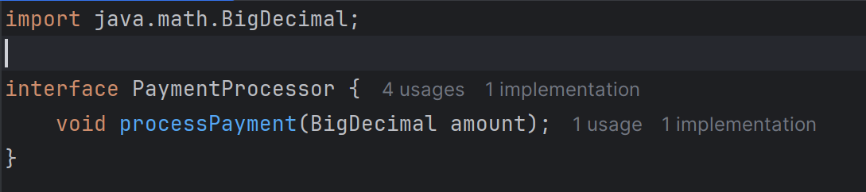

Adaptee (ThirdPartyStripe)
Represents an external Stripe service.Provides the method makeCharge(int cents), which only works with integer cents.
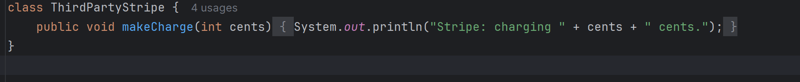

Adapter (StripeAdapter)
Implements the PaymentProcessor interface.Converts the BigDecimal amount into cents and calls makeCharge() of ThirdPartyStripe.Adds simple validation so negative or zero amounts are not allowed.
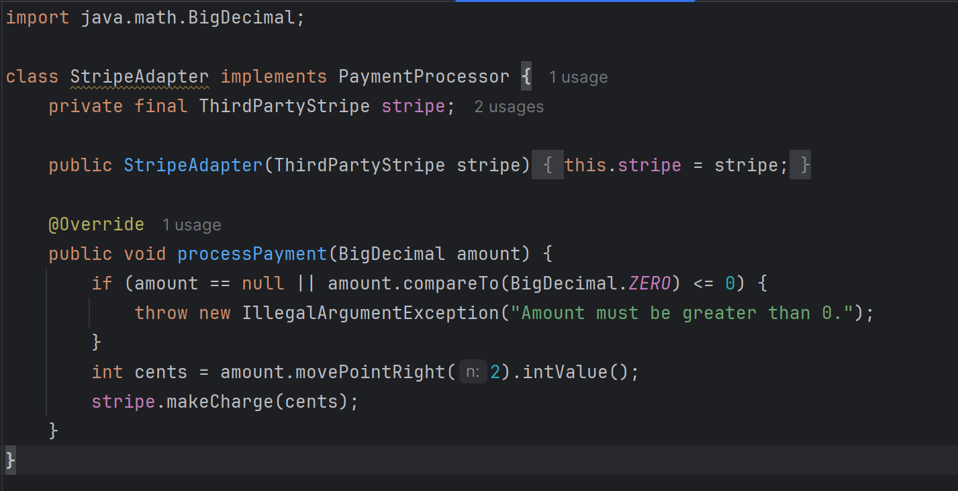

Client (MobileApp)
Uses only the PaymentProcessor interface.Calls checkout() to process payments.Shows both successful and failed payment scenarios in the console.
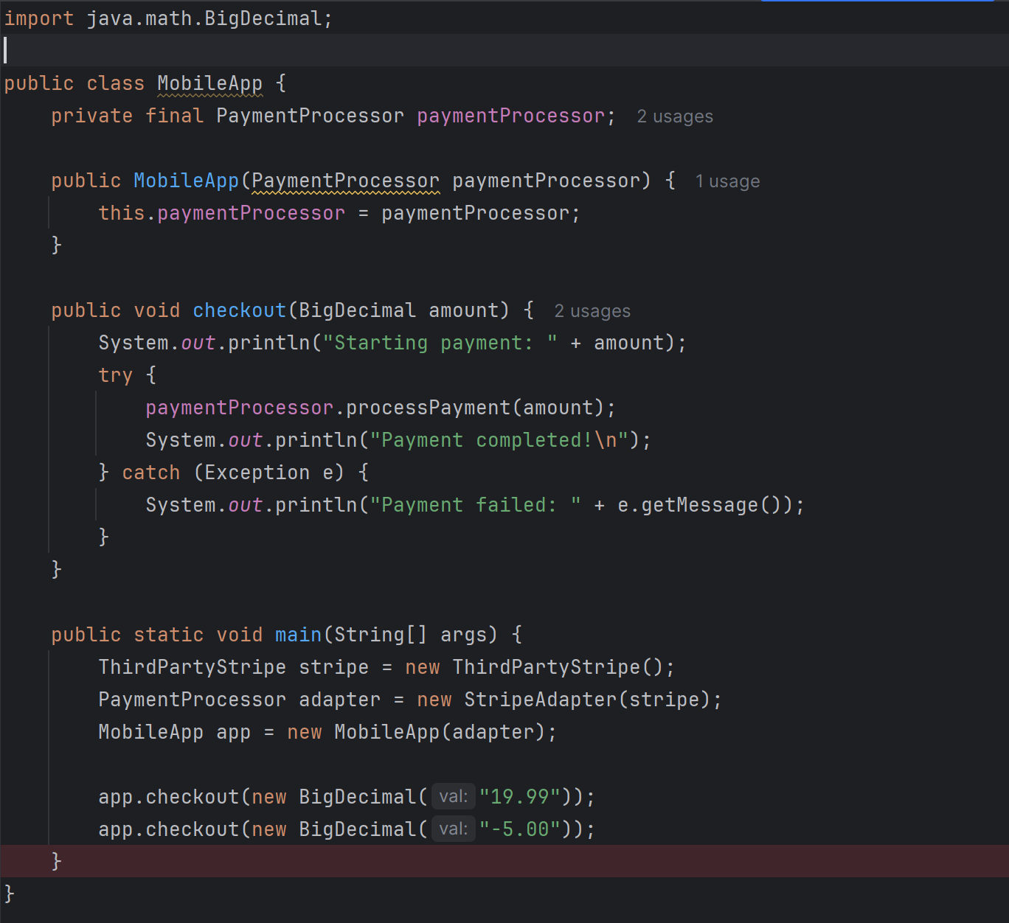
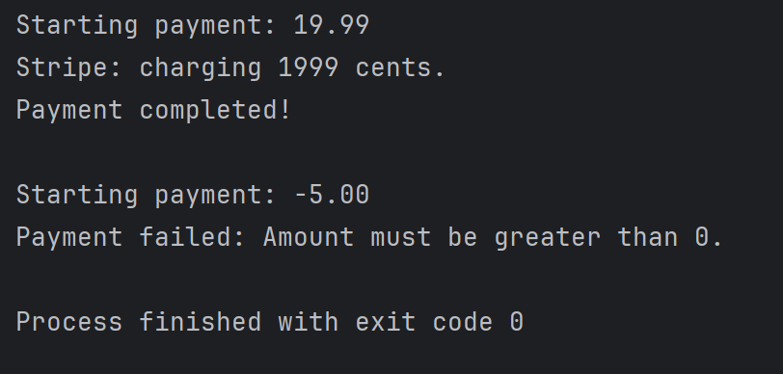

Conclusion
This project shows how to apply the Adapter Pattern in Java using clean coding practices. The code is short, easy to read, and demonstrates how an application can integrate with external services through adapters. It is flexible, so more payment systems can be added in the future with minimal changes.

