## Due Date (See **M**y**C**ourses **ASSIGMENTS)** Assignment Box **HW02**

## **Name: Please put Last name (Lastname, Firstname)_________Khorramrouz, Adel________**

**Submit this document to the Homework #2 assignment folder, edited to include your answers AND submit the script file, and TEE file created for Part 3. Attach your script as HW02_Lastname.sql The TEE file named HW02_Lastname.txt**

**Part 1**

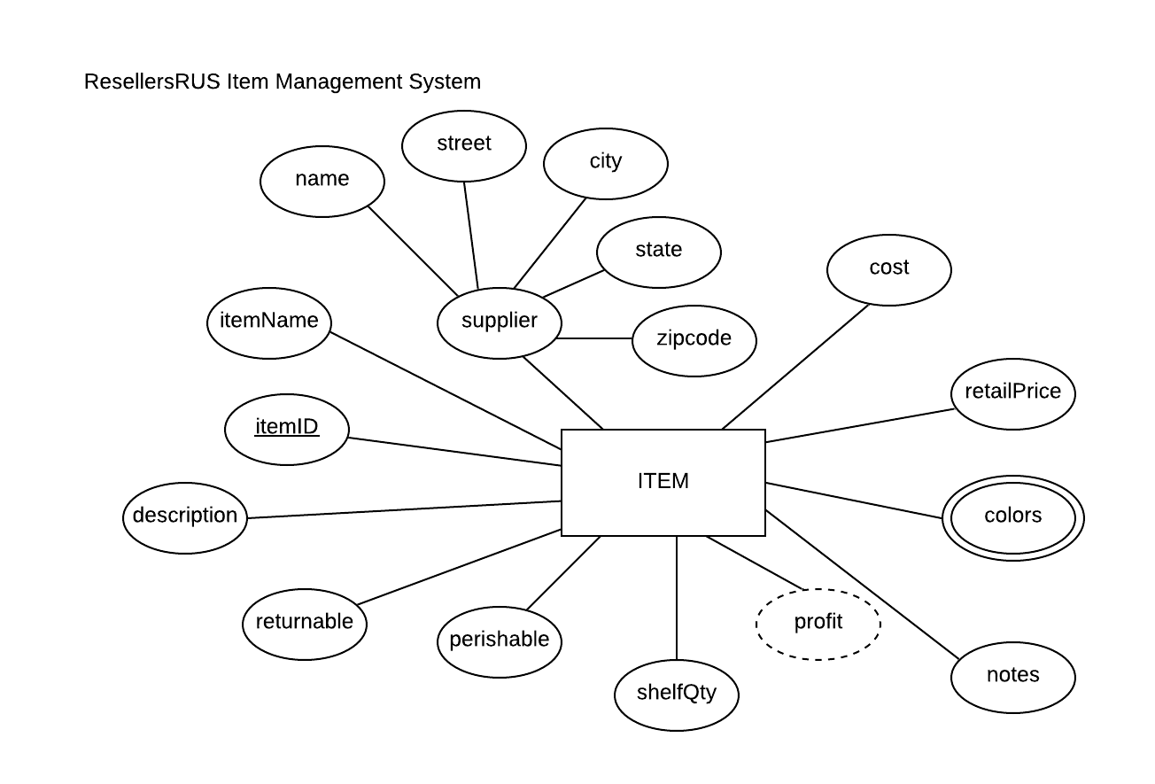

For the table below, please classify each attribute specified based on the E-R diagram above. Please place the best answer for each column that best describes the attribute.

| **Attribute** | **Composite**  **or**  **Simple** | **Single-valued**  **or**  **Multi-valued** | **Stored**  **or**  **Derived** | **Identifier ?**  **(Yes or no)** |
| --- | --- | --- | --- | --- |
| profit | **Simple** | **Single-valued** | **Derived** | **no** |
| street | **Simple** | **Single-valued** | **Stored** | **no** |
| itemID | **Simple** | **Single-valued** | **Stored** | **Yes** |
| supplier | **Composite** | **Single-valued** | **Stored** | **no** |
| colors | **Simple** | **Multi-valued** | **Stored** | **no** |

**Part 2 Question is about Relational Schema Please learn that term. I will explain the term.**

Transpose the E-R diagram below into a **relational schema**. You do not need to normalize the relation.

*NOTE:* The transposed ITEM relation includes a 'colors' attribute, therefore it would not pass the 1NF (the criteria for a relation). Although the ITEM relation is not in 1NF, there is an approach that we will learn next week.



**Your Answer (relational schema):**   
ITEM(**itemID**, itemName, name, street, city, state, zipcode, cost, retailPrice, *colors*, notes, profit, shelfQty,perishable, returnable, description)

**Part 3 Before you start do some research** <https://www.w3schools.com/sql/sql_datatypes.asp>

Create a script.  
See Appendix A (page4) for suggested coding standards, when to use caps, when to use camel case, etc  
Every Company will have a different set of codding standards.

Create a script. Your script will include the statements that will create a database called “HW2” that includes a table for ITEM(Previous page), Use the relation above in Part 2 and the specifications in the table below. Use LOGICAL AND CORRECT DATA TYPES for this part (CHAR, VARCHAR, INT, DECIMAL, MEDIUMTEXT, TINYINT and DATE and others). Can you think of other valid data types that are appropriate.

Create a TEE file

After you create your script, create a TEE file. Source your script in the TEE file. Upload your SCRIPT, TEE file and this document (filled-in) to the drop box/assignment box.

Example: salary DECIMAL(5,2) Would store salary like 999.99 or -999.99

| **Attribute(s)** | **Data type description** |
| --- | --- |
| itemID; itemName; name; street; city; colors | Variable-length string up to 25 characters |
| state | Char Fixed-length string of 2 characters |
| zipcode | A variable-length string that could accommodate either of the formats below: ‘#####-####’ or ‘#####’ |
| cost; retailPrice  Make retail Price one digit larger left of the decimal point compared to cost | Decimal(P,D)  The DECIMAL(P,D) means that the column can store up to P digits with D decimals.  For example, salary DECIMAL(5,2) would store 999.99 or -999.99 |
| notes | Variable-length string up to 255 characters |
| longDescription | Research the sizes of MEDIUMTEXT and LONGTEXT |
| returnable; perishable | Tinyint Will store one character so does BOOL |
| shelfQty | A whole number between 0 and 50,000 for shelfQty.  Is the data range for shelfQty to large for a tinyint?  Can we use data type UNSIGNED SHORTINT for shelfQty?  First, read about UNSIGNED SMALLINT at the website below  <https://mariadb.com/kb/en/smallint/>  That website states what the range of an  UNSIGNED SMALLINT is . . . .  What is that range? |

**Appendix A Coding Standards for company A.**

**Coding Standards**

Any place that you work in the technology industry typically has standards for how code is written, which you are expected to follow. This course is no different.

In this homework we would like you to try to adhere to the following coding standards.

Implementation (Coding) Standards:

* One clause per line (SELECT, FROM, WHERE, etc.)

Example:

SELECT univID, firstName, lastName

FROM student

WHERE city = “Rochester” AND state = “NY”;

* Keywords must be in UPPERCASE
* Double quotes for a string literal
* Double quotes for any alias that includes a space

Example:

SELECT univID, firstName AS “First Name”, lastName AS “Last Name”

FROM student;

* Script submission must include a syntactically correct comment with student’s name and a syntactically correct comment identifying each task number
  + Comment options include:
    - -- single line comment (a space MUST be included after --)
    - # single line comment
    - /* block comment (can span multiple lines) */
* Script submission must be an executable script file (i.e. only comments and SQL statements).
  + Common violations:
    - Submitting a log file
    - including the MySQL prompt along with the statement
    - including an uncommented resultset
* Table names and attribute names that would otherwise include as space or an underscore as a separator must be in camelCase
  + ID exception: ID is commonly used as an abbreviation for ‘identifier’. Attributes that include ‘ID’ can be stated as attrID, instead of the strict camelCase of attrId