Develop a signup and sign in mechanism as follows:

1. There should be a default super user (instructor) who can create instructors accounts.

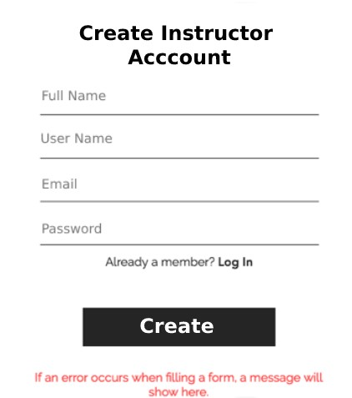

1. Candidates can register themselves for this platform.

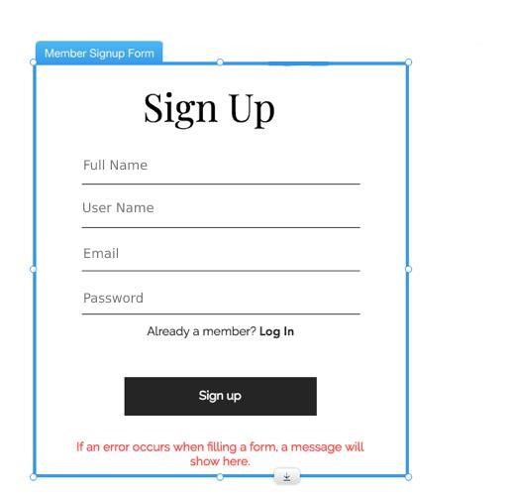

1. There should be login page where users (Instructors and Candidates) can log into the platform.

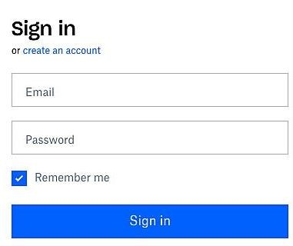

1. The landing page should have the list of posts created by the Instructors.

1. Instructor can create a new post for announcement or initiating a discussion on a topic.
2. Candidate can add comments under posts.

Note:

# Project should be done in .NET Core MVC Code First Approach Using Entity framework.Raw project (begiiner sample code)of this project is attached refrence video is also shared below.

# <https://www.youtube.com/watch?v=dNWl-vdZRfQ>

# github link of sample-code

# https://github.com/Akhtar-Noon/PostProject-ChatHub.git