What we use:

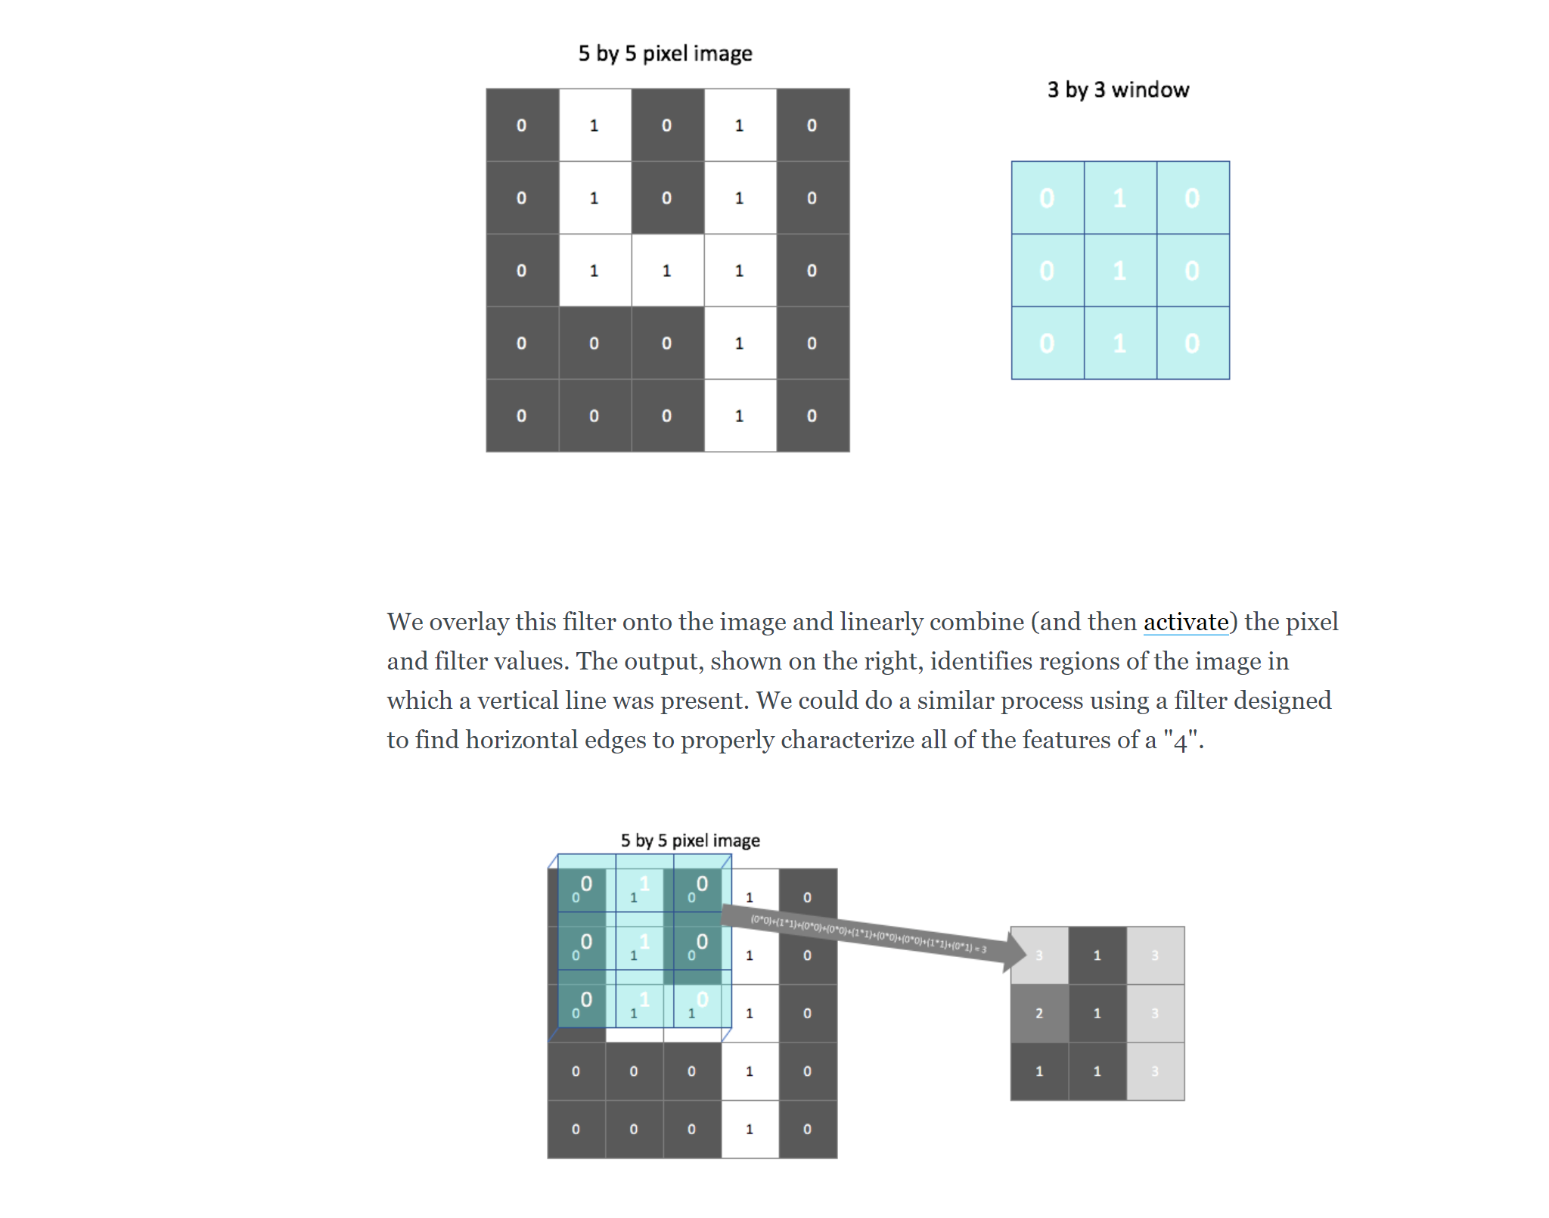

Multiclass classification

Convolutional neural network

Terms:

Feed forward network = series of fully connected layers

A feed-forward network connects every pixel with each node in the following layer, ignoring any spatial information present in the image.

Cnn is better than ffn bcause CNN is capable of considering locality of features

a convolutional architecture looks at local regions of the image. In this case, a 2 by 2 filter with a stride of 2 (more on strides below) is scanned across the image to output 4 nodes, each containing localized information about the image.

<https://github.com/jeremyjordan/dog-breed-classifier/blob/master/dog_app.ipynb>

<https://www.jeremyjordan.me/convolutional-neural-networks/>

<http://www.asimovinstitute.org/neural-network-zoo/>

<https://machinelearningmastery.com/overfitting-and-underfitting-with-machine-learning-algorithms/>

<https://towardsdatascience.com/machine-learning-multiclass-classification-with-imbalanced-data-set-29f6a177c1a>

<https://stats.stackexchange.com/questions/255364/fine-tuning-vs-joint-training-vs-feature-extraction>

image faces cite:

@InProceedings{Huang2012a,

author = {Gary B. Huang and Marwan Mattar and Honglak Lee and

Erik Learned-Miller},

title = {Learning to Align from Scratch},

booktitle = {NIPS},

year = {2012}

}

<https://stackoverflow.com/questions/29726738/sqldependency-onchange-event-always-firing-without-data-change>