Demographic pyramid of the Russian Federation:

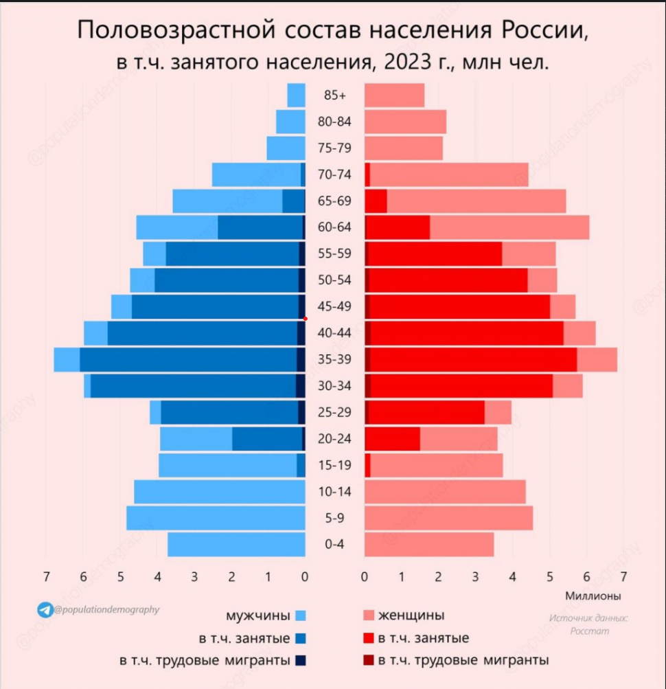

1. Indicators of demographic pyramid breakdown:
Indicators:
- Gender;
- Age;
- Population;
- Employment.

The purpose of creating a demographic pyramid:
Goal:
A graphical representation of the population structure, allowing the study of trends in birth rates, mortality, migration, and forecasting demographic changes, as well as economically related processes.

Type of decomposition of the demographic pyramid:
Decomposition type:
Structural - as the system is divided by criteria (indicators).

About decomposition:
Main levels of decomposition: 4 main levels of decomposition.
Levels:
- Gender - (male / female);
- Age - (0 ~ 85+);
- Population - (0 ~ 7 million);
- Employment - (0 ~ 7 million);
Criteria for decomposition:
- Age groups.
- Gender.
- Population.
- Employment.

- Determine the order of construction of the demographic pyramid:

- First, data on the population by age and gender is collected.
- Then, a vertical axis with age groups and a horizontal axis representing population size are created.
- For each age group, the number of men and women is displayed, forming the visual structure of the pyramid.
- The employed population is marked with a dark shade, and labor migrants with a darker shade.

