# Types of decomposition:

#### Decomposition from the task:

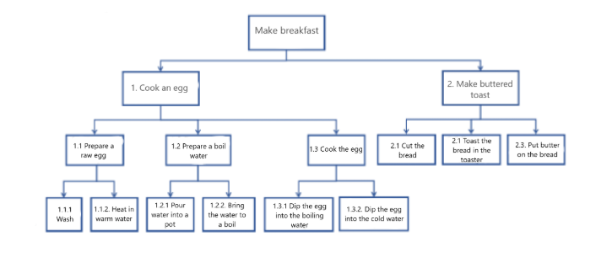

**Tasks:**

1. State the purpose and type of decomposition;

2. State the number of decomposition levels;

3. Find decomposition errors and list them;

4. Correct the errors in the decomposition and apply the corrected version to the next task.

5. Develop an object decomposition of breakfast based on the refined decomposition in the paragraph above:

5.1. State the purpose of the decomposition;

5.2. Build the decomposition up to level 2;

5.3 Specify the partitioning criteria for each level of the decomposition built.

### Specify the purpose and type of decomposition:

**Purpose of decomposition:**

Analysis and structuring of components of breakfast preparation

**Decomposition type:**

Functional - What does/should the system do? What does/should the system provide?

### Specify the number of decomposition levels:

4 levels of decomposition (0-1-2-3).

### Find the decomposition errors, list them and correct them:

**Level 0 item 0:** – incorrect block numbering.

**Level 2 item 1.3:** – “Boiled egg” - “Boil an egg”.

**Level 3 item 1.1.1:** – “Wash” - “wash a raw egg”.

**Level 3 items 1.3.1 and 1.3.2:** – incorrect decomposition block number.

**Level 2 item 2.2:** – “Toasted bread” - “Toast bread in a toaster”.

**Level 2 item 2.3:** – correct decomposition block numbering.  
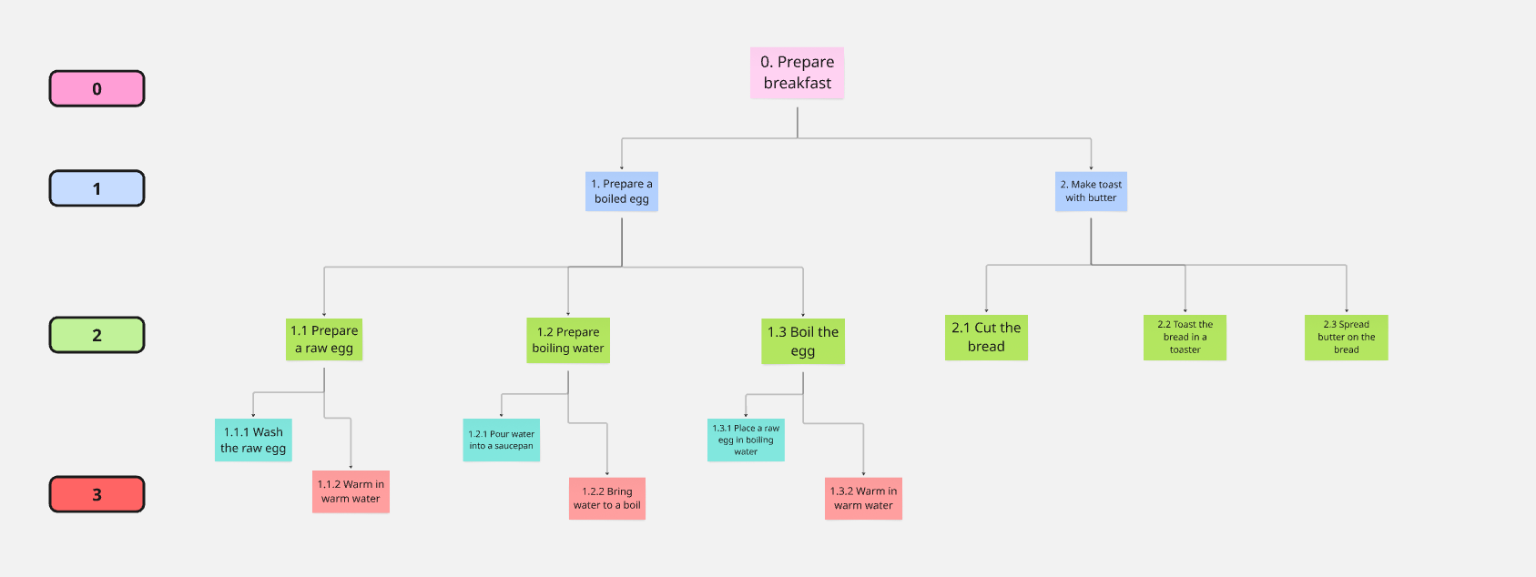

### Develop an object decomposition of breakfast based on the refined decomposition in the paragraph above:

**Purpose:**

The purpose of breakfast decomposition is to break down its components into more detailed criteria to simplify the selection of products. Planning the preparation and ensuring the diversity of nutrition

**Criteria:**

**Breakfast**:

Ensuring the diversity of dishes depending on the caloric content, fats, proteins, carbohydrates

**Hot dish**:

Ensuring the diversity of hot dishes depending on the caloric content, fats, proteins, carbohydrates and nutritional value

**Drink**:

Breakdown by caloric content, temperature of the drink.

