# Task:

**Text of the task:**  
 During the lockdown, many grocery stores and food service establishments have dramatically increased their online sales, and therefore the need for fast delivery of small batches of goods to individual customers has increased.

A group of students got together and decided to create a delivery service startup.

The idea is to quickly receive information about orders, the place and time of assembly, the delivery location, the desired delivery times and distribute the information to couriers who will receive orders at the assembly location and deliver the goods to the delivery location. We decided to deploy an online system where orders are collected and from where couriers quickly sort out orders for fulfillment. At the first stage, we decided to collect orders from stores and food service establishments by any available means and enter the system into the system in a single format, developing an operator, but creating a mobile application for couriers.

The courier should be able to view information about orders, select an order from the last location, book it, pick it up at the pick-up locations and deliver it to the client. The courier should promptly reflect the results of his actions in the system through a mobile application. The system should also have a dispatcher who monitors couriers and, if necessary, reassigns orders. Information about incoming orders should be sent to the accounting department (to another IT system) for settlements with suppliers of delivery orders.  
  
 Information about the delivery of the order should also be sent to the accounting department, where the payment of couriers will be calculated. The accrued payment should be transferred to the system and reflected in the courier's personal account. And an administrator's workplace is also planned, registering couriers and assigning access rights to everyone.  
  
**Actual tasks:**

1. Develop a decomposition of courier actions;

2. Determine the purpose and type of decomposition;

3. Specify the number of levels.

4. Develop an object decomposition of task actors.

5. Specify the purpose of the object decomposition.

6. Specify the number of levels.

### Decomposition of the courier's action:

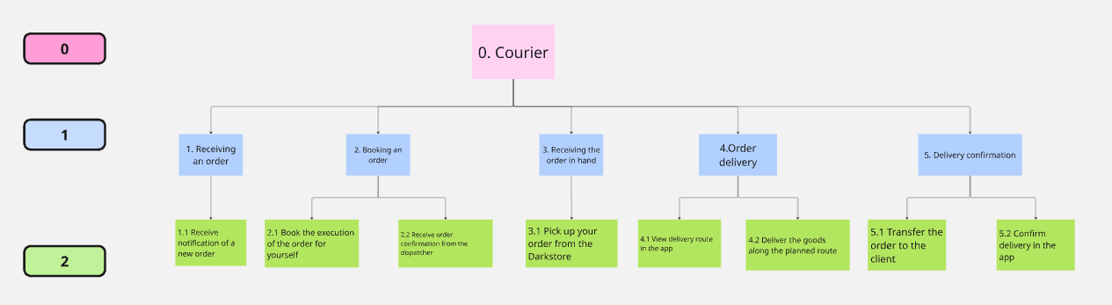

### 2-3. Purpose, type and number of levels:

**Objective**: Sequence of actions of couriers during the delivery process.

**Type**: Functional decomposition

**Levels**: 3 levels (0,1,2);

4. Object decomposition of persons:

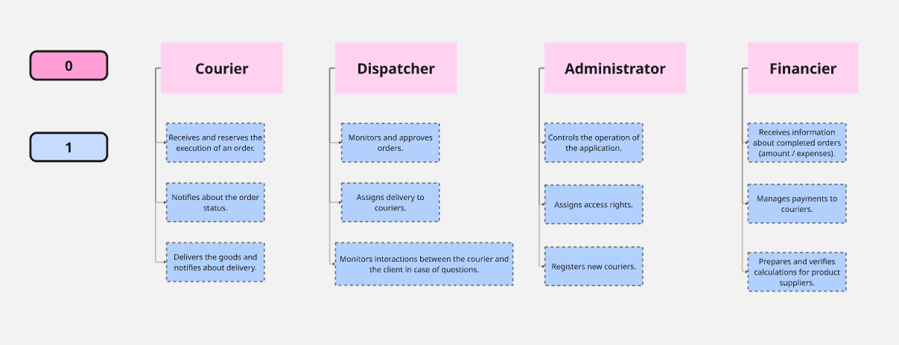

5-6. Goal, number of levels:

**Purpose**: Necessary for clear organization and structuring of the delivery system.

**Levels**: 2 levels (0.1).