NovaTel Telecom RAG — Base vs RAG Benchmark
Experiment E14 — structured SQL + unstructured FAISS/metadata retrieval, RRF fusion, local LLM generation. No knowledge graph, ontology or ColPali in this path.
Author: Person A (unstructured/RAG) | Date: 2026-10-14
Results file: data/experiments/benchmark_base_vs_rag/benchmark_results.json (run timestamp 2026-10-14T07:54:04.735524+00:00)
22 | 45.5% | 79.5% | 97.7%
Questions benchmarked | Base correctness | RAG correctness | RAG groundedness

1. Benchmark objective and experimental control
The objective is to isolate the contribution of retrieval. Both conditions use the SAME local model at the SAME temperature on the SAME question set; the only difference is whether the model is given retrieved NovaTel evidence. Any difference in the metrics is therefore attributable to retrieval and to how the model uses it — not to model choice, sampling, or question selection.
Variable | Base condition | RAG condition
Generation model | qwen2.5:7b-instruct | qwen2.5:7b-instruct
Quantization | Q4_K_M | Q4_K_M
Temperature / seed | 0 / fixed | 0 / fixed
Retrieval | none | structured SQL + unstructured FAISS/metadata -> RRF -> top-N context -> same model
Embedding model | n/a | all-MiniLM-L6-v2
Fusion | n/a | RRF (k=60)
Context given to model | none | top-6 evidence blocks, with provenance
Questions | 22 | 22

2. Evaluation method
Scoring rubric applied to every answer:
Dimension | Scale | Scored against
Correctness | 0 wrong / 1 partial / 2 fully correct | Reference evidence (known-relevant chunk or SQL record)
Relevance | 0 off-topic / 1 partial / 2 directly answers | The question
Groundedness (RAG only) | 0 unsupported / 1 partial / 2 fully supported | The RETRIEVED CONTEXT actually shown to the model
Hallucination | 0 none / 1 ≥1 unsupported claim | RAG: retrieved context. Base: reference evidence (no context exists)
Groundedness and hallucination are deliberately assessed ONLY against the context the model was shown, with the judge instructed not to consider factual correctness. A faithful summary of the wrong document therefore scores as grounded, and surfaces instead as a retrieval failure in the failure-type decomposition. This separation is what makes the failure attribution meaningful.
Benchmark composition (all queries reused from existing NovaTel eval sets, none written for this run):
Query group | n | Reference evidence used for scoring
Structured (SQL) | 8 | The actual SQLite row/count — deterministic
Unstructured — NovaTel synthetic docs | 8 | expected_document_ids from the retrieval benchmark
Unstructured — public TRAI PDFs | 6 | relevant_documents from the public PDF query set
Runtime retrieval classification observed across the run: {'hybrid': 10, 'unstructured': 12}.
What is NOT measured here:
- latency as a benchmark metric
- GPU/VRAM utilisation
- cost

3. Results
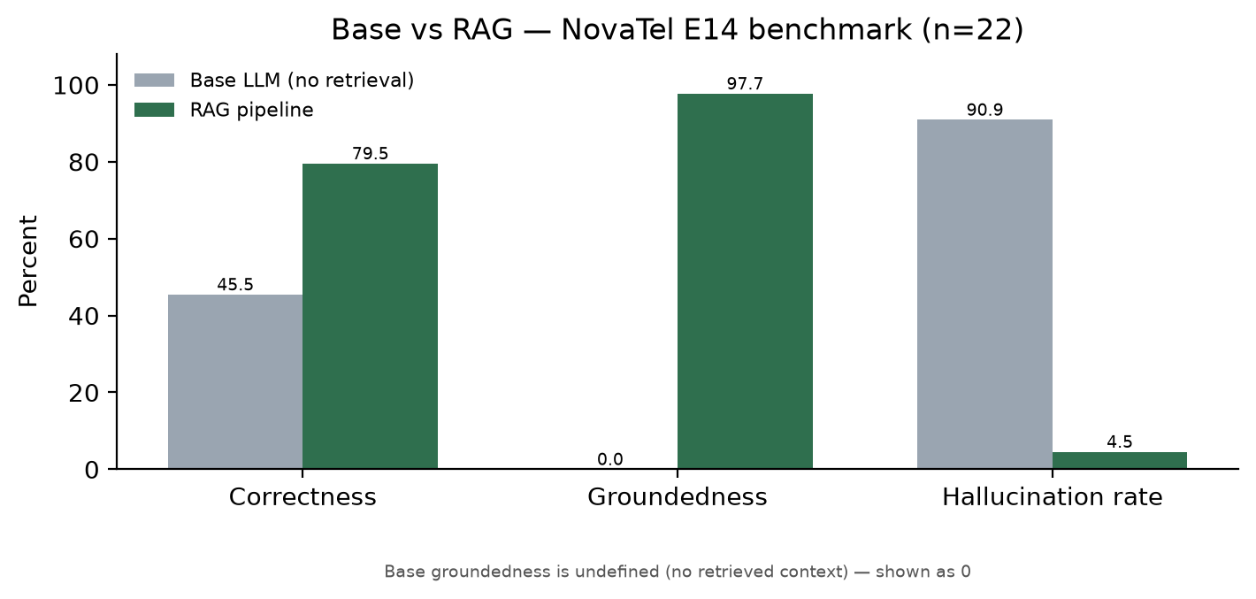
Headline metrics and deltas:
Metric | Base | RAG | Delta
Correctness | 45.5% | 79.5% | +34.1 pp
Relevance | 81.8% | 93.2% | +11.4 pp
Hallucination rate | 90.9% | 4.5% | -86.4 pp
Groundedness (RAG only) | n/a (no context) | 97.7% | n/a
Failure-type decomposition across all 22 queries: {'correct': 14, 'generation_failure': 8}. The reference evidence was successfully retrieved for 22/22 queries (100.0%) — measured deterministically against ground truth, not by a judge.
Category-level breakdown:
Query group | n | Base correctness | RAG correctness | Base halluc. | RAG halluc.
structured | 8 | 12.5% | 75.0% | 100.0% | 0.0%
unstructured_public | 6 | 66.7% | 66.7% | 83.3% | 0.0%
unstructured_synthetic | 8 | 62.5% | 93.8% | 87.5% | 12.5%
Failure types by category: {"structured": {"correct": 4, "generation_failure": 4}, "unstructured_public": {"generation_failure": 3, "correct": 3}, "unstructured_synthetic": {"correct": 7, "generation_failure": 1}}

3.1 Supporting retrieval precision (deterministic, no LLM)
Computed on this run's 14 document queries, from the evidence actually retrieved versus the pre-existing reference document ids: R@1 = 0.786, R@3 = 1.000, R@5 = 1.000, MRR@10 = 0.857.
For context only (different, larger, pre-existing query sets — NOT the same sample): synthetic 29-question benchmark Top-1/3/5 = 0.759/0.897/1.000 (MRR@10 not available (field absent in source file)); public 30-question benchmark R@1/3/5/10 = 0.467/0.767/0.900/1.000, MRR@10 = 0.645.

4. Query-level findings

Where RAG improved on the base model (13 queries)
These are the cases where retrieval supplied a fact or procedure the base model could not know. The clearest group is the customer-specific structured questions: the base model has no database access, so it either refuses or guesses, while the RAG answer reads the value from the SQL record and cites it.
- Q01 (unstructured_synthetic): correctness 1 → 2. I don't have access to my old registered phone number anymore. How can I update the number on my account?
- Q04 (unstructured_synthetic): correctness 1 → 2. Why is my latest postpaid bill higher than the monthly rental I expected to pay?
- Q13 (unstructured_synthetic): correctness 1 → 2. The OTP for signing into the My NovaTel app isn't arriving. How can I log in?
- Q17 (unstructured_synthetic): correctness 0 → 2. What documents do I need to provide if NovaTel asks me to complete KYC verification again?
- RW_004 (unstructured_public): correctness 1 → 2. How can I complain to my telecom service provider?
- RW_007 (unstructured_public): correctness 1 → 2. How can I stop receiving unwanted promotional calls and messages?
- S01 (structured): correctness 0 → 2. What is customer 1001's account status?
- S03 (structured): correctness 0 → 1. Show invoices for customer 1009
- S04 (structured): correctness 0 → 2. How many recharge_transactions have status FAILED?
- S06 (structured): correctness 0 → 1. Show all open tickets
- S07 (structured): correctness 0 → 2. How many payment_transactions are SUCCESS?
- S09 (structured): correctness 0 → 1. Show kyc_records with status Pending
- S12 (structured): correctness 0 → 1. Show fraud_cases with status Investigating

Where RAG regressed against the base model (1 queries)
These matter more than the wins, because they show retrieval actively hurting. In each case the retrieved context was faithfully used (high groundedness) but it steered the answer away from what the question actually asked — the broad public-regulation questions are the vulnerable group, where several similar TRAI documents compete and the top-ranked chunk is topically adjacent rather than correct.
- RW_010 (unstructured_public): correctness 2 → 0, groundedness 2, hallucination 0. Judge note: Partially correct but contradicts the reference.

Where RAG still overreached — generation failures (8 queries)
Every residual failure in this run is a generation failure, not a retrieval failure: the reference evidence was retrieved in 100% of cases, so the error is in how the model synthesised from evidence it already had. Typical shape: the answer is fully grounded in the retrieved text (it invents nothing) but answers a neighbouring question, or stops short of the specific fact asked for.
- Q08 (unstructured_synthetic): correctness 1, groundedness 2, hallucination 0 — correctness=1, retrieved_ok=True, groundedness=2, hallucination=0
- RW_001 (unstructured_public): correctness 1, groundedness 2, hallucination 0 — correctness=1, retrieved_ok=True, groundedness=2, hallucination=0
- RW_010 (unstructured_public): correctness 0, groundedness 2, hallucination 0 — correctness=0, retrieved_ok=True, groundedness=2, hallucination=0
- RW_023 (unstructured_public): correctness 1, groundedness 2, hallucination 0 — correctness=1, retrieved_ok=True, groundedness=2, hallucination=0
- S03 (structured): correctness 1, groundedness 2, hallucination 0 — correctness=1, retrieved_ok=True, groundedness=2, hallucination=0
- S06 (structured): correctness 1, groundedness 2, hallucination 0 — correctness=1, retrieved_ok=True, groundedness=2, hallucination=0
- S09 (structured): correctness 1, groundedness 2, hallucination 0 — correctness=1, retrieved_ok=True, groundedness=2, hallucination=0
- S12 (structured): correctness 1, groundedness 2, hallucination 0 — correctness=1, retrieved_ok=True, groundedness=2, hallucination=0

Both conditions correct (5 queries)
General telecom-knowledge questions the base model already answers well; retrieval neither helps nor hurts correctness here, but it does reduce unsupported claims.
Q20, Q25, Q28, RW_017, S15

5. Final assessment
Correctness. RAG scores 79.5% against the base model's 45.5%, a gain of +34.1 percentage points on 22 questions. The gain is concentrated in the structured group (12.5% → 75.0%), which is the expected result: those questions are unanswerable without database access.
Groundedness. RAG answers are 97.7% grounded in the context they were given. This says the generator is disciplined about staying inside its evidence; it does NOT say the evidence was the right evidence, which is why correctness is the lower number.
Hallucination. The rate falls from 90.9% to 4.5% (-86.4 pp). IMPORTANT ASYMMETRY: these two numbers rest on different bases. RAG hallucination is measured against the retrieved context; the base condition has no retrieved context, so its hallucination is measured against the reference evidence instead. The base figure therefore largely reflects the base model answering from parametric memory with content absent from the reference material. The direction of the result is sound and expected, but the two percentages are not strictly comparable and should not be quoted as a like-for-like delta.
Remaining issues. 8 of 22 queries remain incorrect, and all 8 are generation failures — retrieval surfaced the reference evidence every single time (100.0%). The work left is therefore in generation and ranking, not in recall: the top-ranked chunk is often topically adjacent rather than the best answer (this run's R@1 = 0.786 against R@3 = 1.000), and the model anchors on whatever sits at rank 1. Broad public-regulation questions are the weakest group (66.7% correctness, no better than base).
Conclusion. For NovaTel's own operational data — customer, invoice, recharge, ticket state — retrieval is decisive and the integrated pipeline is clearly the right architecture. For broad regulatory questions the base model is already competitive, and retrieval only pays off once ranking improves enough to put the correct document first rather than merely in the top three.

Scoring-method caveat (required reading)
Deterministic (no LLM involved): structured correctness (matched against the actual SQLite row/count, with question-echoed identifiers discarded as non-discriminative); correct abstention on the negative control; whether the reference evidence was retrieved; and the structured citation factcheck.
LLM-judged (local model qwen2.5:7b-instruct, temperature 0): document-side correctness and relevance (against the reference chunk), and groundedness and hallucination (against the retrieved context). These scores come from a local 7B-class judge, not a human or a frontier model, and MUST be human spot-checked before being quoted as findings. Judge JSON parse failures in this run: 0.
Sample size is 22 questions ({'structured': 8, 'unstructured_synthetic': 8, 'unstructured_public': 6}). This is a curated benchmark, not the full 74-question set, and per-category figures rest on 6–8 questions each.

