%MCIntegration 2-1

clear;

rand('seed',1);

N = 1000;

meanexp = zeros(1,N);

for i = (1:N)

meanexp(i) = mean(exp(rand(1,i)+1));

end

exp = exp(1)-1

exp10 = meanexp(10)

exp100 = meanexp(100)

exp1000 = meanexp(1000)

plot(1:N,meanexp);

>> MCIntrgration

exp =

1.7183

exp10 =

4.6426

exp100 =

4.4443

exp1000 =

4.6406

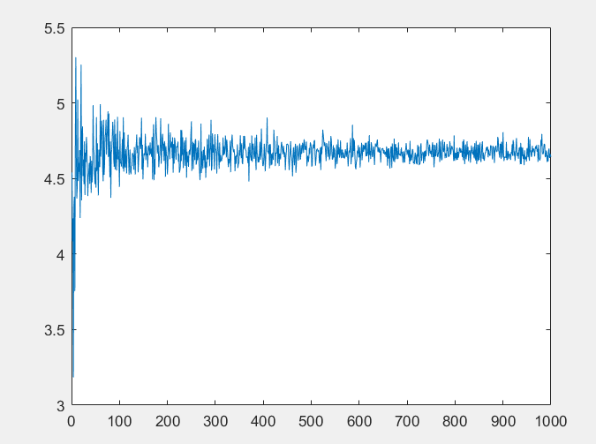

%MCIntegration_2

clear;

rand('seed',1);

N = 1000;

meanexp = zeros(1,N);

for i = (1:N)

meanexp(i) = mean(exp((rand(1,i)*2)))*2;

end

exp = exp(1)-1

exp10 = meanexp(10)

exp100 = meanexp(100)

exp1000 = meanexp(1000)

plot(1:N,meanexp);

>> MCIntrgration_2

exp =

1.7183

exp10 =

6.2090

exp100 =

5.7726

exp1000 =

6.2939

>>

