金融商品設計與評價

選擇權III

1. **(續)選擇權**

**四、各式各樣選擇權操作策略**

**（一）選擇權與標的物**

**1. 覆蓋性選擇權**

買入現貨，放空買權，形成覆蓋性賣權，似賣賣權；買入現

貨，放空賣權，形成覆蓋性賣權，似賣買權。

**2. 保護性**

買入現貨，買買權，形成保護性買權，似買賣權；買入現貨，買

賣權，形成保護性賣權，似買買權。

**（二）價差交易：同Class，一買一賣**

**1. 多頭、空頭（水平）**

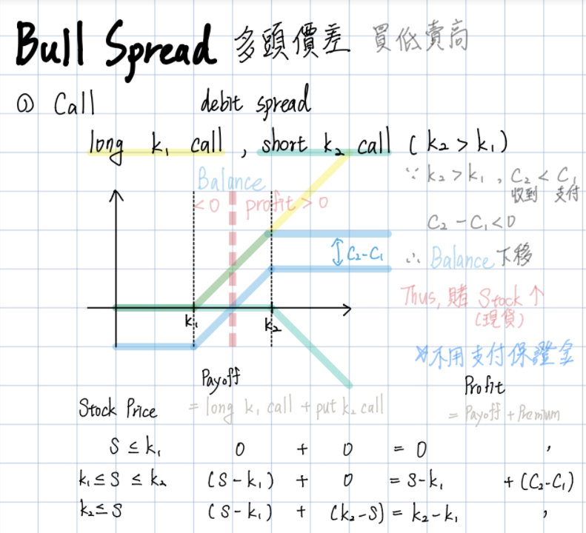 **(1) 多頭：買低賣高（履約價）**

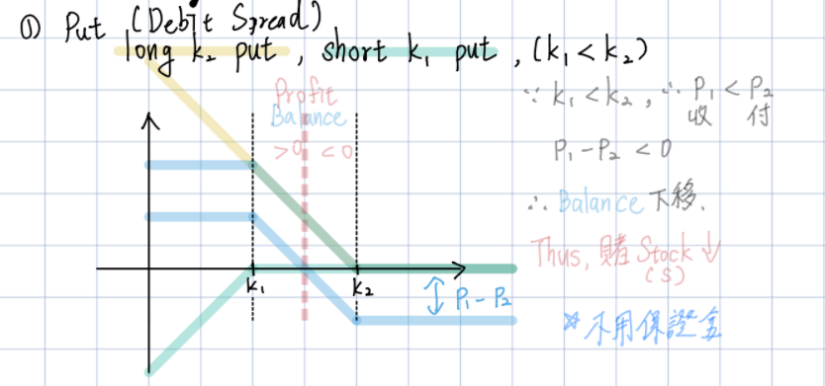**(2) 空頭：買高賣低**

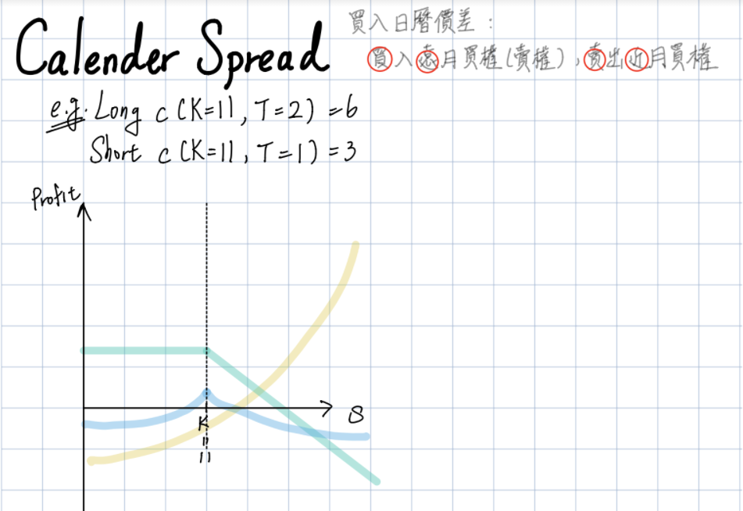**2. 日曆（垂直）：買遠賣近**

**3. 蝴蝶（垂直）：可拆解為Bull+Bear**

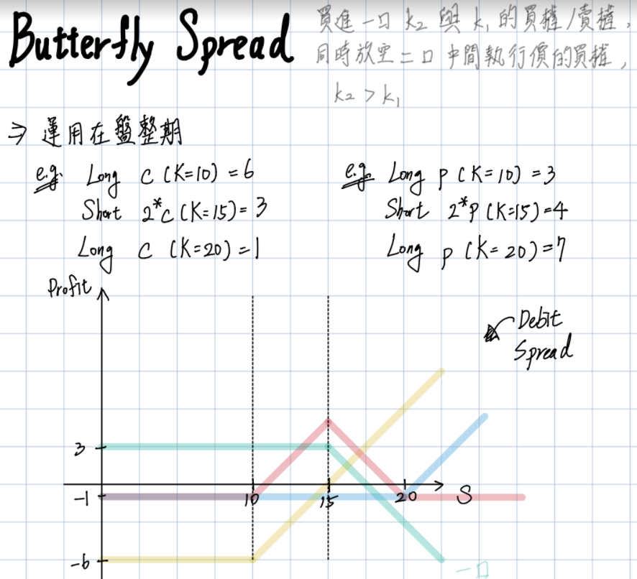

**五、選擇權價值間的關係**

**（一）買賣權平價關係**

買賣權兩者雖屬不同Class，價值卻有密切關係，當平價

關係不完美，則存在套利空間。

**（二）買權價值與履約價值**

若履約價越低，代表能用更低的價格去行使標的物長部位，因此履約價越低，買權價值越高。

**（三）賣權價值與履約價值**

若履約價越高，代表能用更高的價格去行使標的物短部位，因此履約價越高，賣權價值越高。

1. **問題**
2. **若選擇權為美式，要怎麼去使用BS Formula?**

%Protective Call

%input

clear;

p = 2;

X = 100;

S0 = 90:1:110;

%plot

plot(S0,S0-100,'--');

hold on; %wait

plot(S0,max(X-S0,0)-p,'.');

plot(S0,S0-100+max(X-S0,0)-p);

grid on;

title('protective put');

xlabel('S0');

ylabel('payoff');

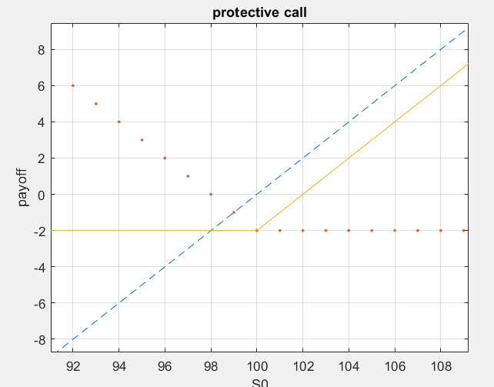

%Protective call

%input

clear;

c = 2;

X = 100;

S0 = 90:1:110;

%plot

plot(S0,100-S0,'--');

hold on; %wait

plot(S0,max(S0-X,0)-c,'.');

plot(S0,100-S0+max(S0-X,0)-c);

grid on;

title('Protective Put');

xlabel('S0');

ylabel('Profit');

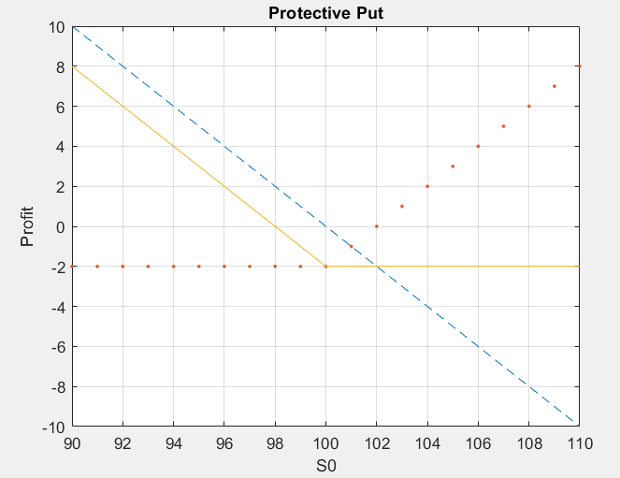

%CoveredCall

clear;

c = 2;

X = 105;

S0 = 92:1:112;

plot(S0,S0-100,'--');

hold on;

plot(S0,-(max(S0-X,0)-c),'.');

plot(S0,S0-100-(max(S0-X,0)-c));

grid on;

title('Covered Call');

xlabel('S0');

ylabel('profit');

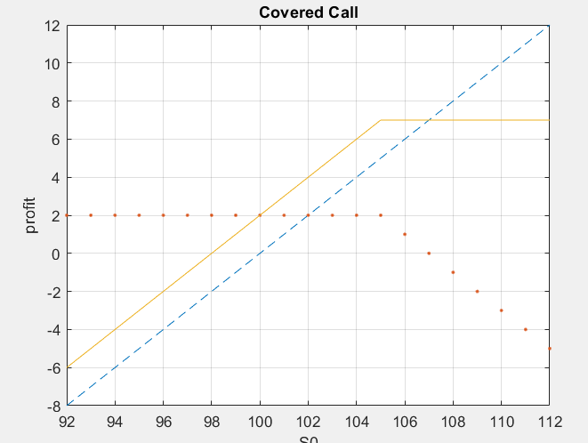

%CoveredPut

clear;

p = 2;

X = 100;

S0 = 92:1:112;

plot(S0,100-S0,'--');

hold on;

plot(S0,-(max(X-S0,0)-p),'.');

plot(S0,100-S0-(max(X-S0,0)-p));

grid on;

title('Covered Put');

xlabel('S0');

ylabel('Profit');

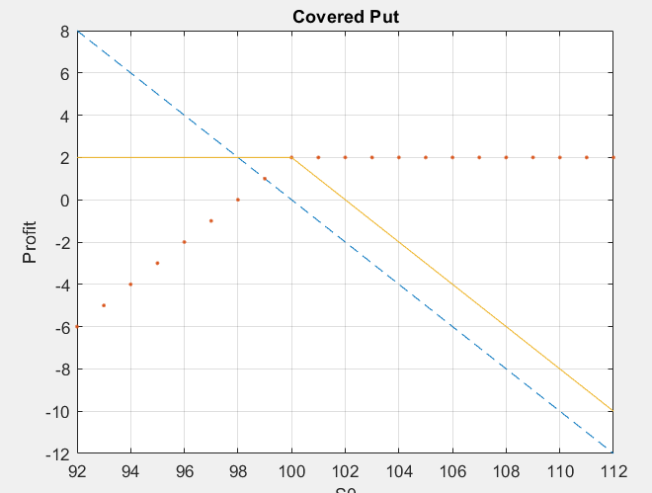

%Bull Spread(Put)

clear;

p1 = 1; %long

p2 = 3; %short

X1 = 100;

X2 = 105;

S0 = 95:1:110;

plot(S0,max(X1-S0,0)-p1,'--');

hold on;

plot(S0,-(max(X2-S0,0)-p2),'.');

plot(S0,max(X1-S0,0)-p1-(max(X2-S0,0)-p2));

grid on;

title('Bull Spread (Put)');

xlabel('S0');

ylabel('Profit');

plot(S0,zeros(1,16),'black');

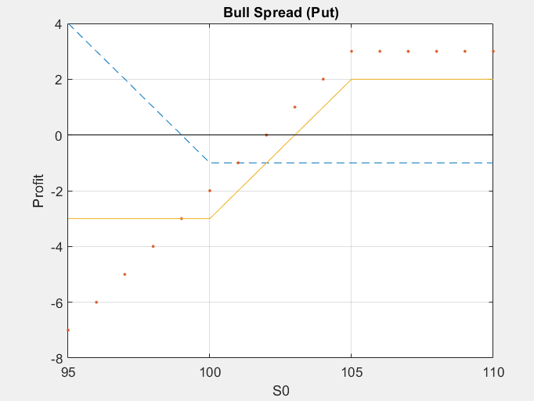

%Bull Spread(Call)

clear;

c1 = 3;

c2 = 1;

X1 = 100;

X2 = 105;

S0 = 95:1:110;

plot(S0,max(S0-X1,0)-c1,'--');

hold on;

plot(S0,-(max(S0-X2,0)-c2),'.');

plot(S0,max(S0-X1,0)-c1-(max(S0-X2,0)-c2));

grid on;

title('Bull Spread');

xlabel('S0');

ylabel('Profit');

plot(S0,zeros(1,16),'black');

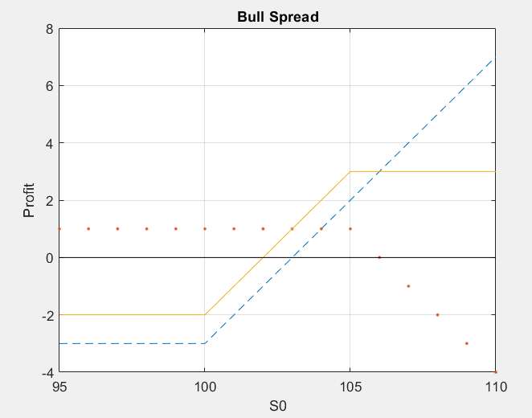

%Bear Spread(Put)

clear;

p1 = 1; %short

p2 = 3; %long

X1 = 100;

X2 = 105;

S0 = 95:1:110;

plot(S0,max(X2-S0,0)-p2,'--');

hold on;

plot(S0,-(max(X1-S0,0)-p1),'.');

plot(S0,max(X2-S0,0)-p1-(max(X1-S0,0)-p1));

grid on;

title('Bear Spread (Put)');

xlabel('S0');

ylabel('Profit');

plot(S0,zeros(1,16),'black');

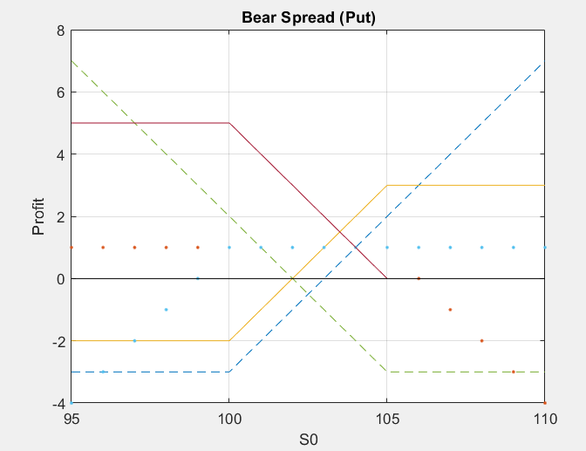

%Bear Spread(Call)

clear;

c1 = 3; %short

c2 = 1; %long

X1 = 100;

X2 = 105;

S0 = 95:1:110;

plot(S0,max(S0-X2,0)-c2,'--');

hold on;

plot(S0,-(max(S0-X1,0)-c1),'.');

plot(S0,max(S0-X2,0)-c2-(max(S0-X1,0)-c1));

grid on;

title('Bear Spread (Call)');

xlabel('S0');

ylabel('Profit');

plot(S0,zeros(1,16),'black');

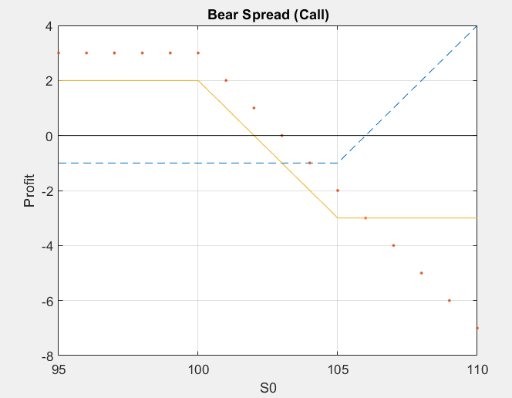

%Butterfly

clear;

c1 = 6;

c2 = 3;

c3 = 1;

X1 = 95; %long

X2 = 100; %short

X3 = 105; %long

S0 = 90:1:110;

plot(S0,max(S0-X1,0)-c1,'--');

hold on;

plot(S0,(max(S0-X3,0)-c3),'.');

plot(S0,-2*(max(S0-X2,0)-c2),'*');

plot(S0,max(S0-X1,0)-c1+(max(S0-X3,0)-c3)+-2*(max(S0-X2,0)-c2));

grid on;

title('Butterfly Spread');

xlabel('S0');

ylabel('Profit');

plot(S0,zeros(1,21),'black');

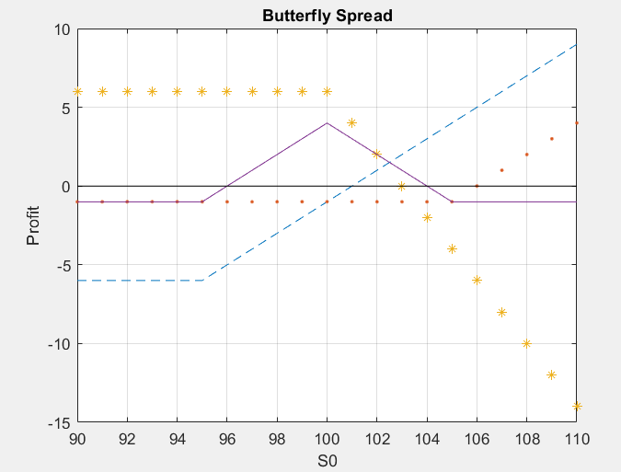

%CMBO

clear;

c = 1;

p = 6;

X = 105; %K:out-of the money call

X1 = 100; %K:at-the money put

S0 = 92:1:112;

%plot(S0,S0-100,'.');

plot(S0,S0-100-(max(S0-X,0)-c)-(max(X1-S0,0)-p));

hold on;

plot(S0,S0-100-(max(S0-X,0)-c),'*');

plot(S0,-(max(X1-S0,0)-p),'*');

plot(S0,S0-100,'.');

plot(S0,-(max(S0-X,0)-c)-(max(X1-S0,0)-p),'.')

grid on;

title('CMBO');

xlabel('S0');

ylabel('Profit');

legend({'CMBO','Covered Call (out)','Short Naked Put (at)','Long Stock','Short Strangle'},'Location','SouthEast');

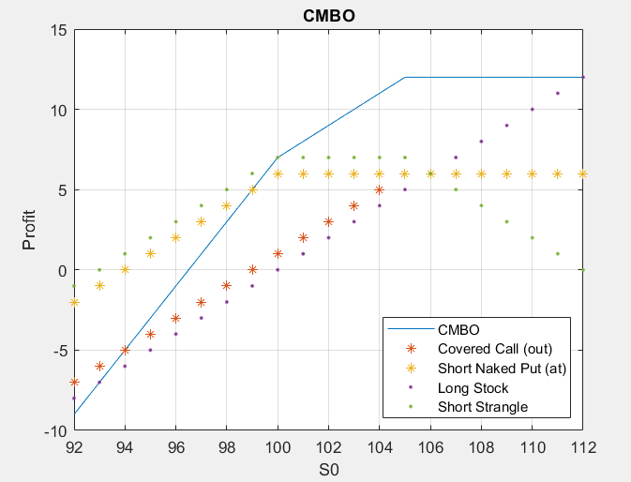

%Condor

clear;

p1 = 3; %long

p2 = 5; %short

c1 = 5; %short

c2 = 3; %long

X1 = 95;

X2 = 100;

X3 = 105;

X4 = 110;

S0 = 90:1:120;

plot(S0,max(X1-S0,0)-p1,'--');

hold on;

plot(S0,-(max(X2-S0,0)-p2),'.');

plot(S0,-(max(S0-X3,0)-c1),'*');

plot(S0,max(S0-X4,0)-c2,'.');

plot(S0,(max(X1-S0,0)-p1)-(max(X2-S0,0)-p2)-(max(S0-X3,0)-c1)+(max(S0-X4,0)-c2));

grid on;

title('Condor');

xlabel('S0');

ylabel('Profit');

plot(S0,zeros(1,31),'black');

