Enhancing Writing Accuracy: BERT-Based Grammatical Error Correction for Digital Literacy
Del Castillo, Christian Joaquin R.
Computer Studies and Engineering
Jose Rizal University
Mandaluyong City, Philippines
christianjoaquin.delcastillo@my.jru.edu

Abstract— Grammatical accuracy is essential for effective communication and digital literacy. Most educational and professional settings lack the resources and support to facilitate systemic correction of language errors in written communication. This paper proposes an AI-driven system using BERT-based natural language processing (NLP) models to achieve context-sensitive grammatical error correction (GEC). By focusing exclusively on grammar issue detection and correction, this platform aims at helping learners gain confidence and competence in writing English. The system also addresses SDG 4.4 on scalable skill-building for decent work and entrepreneurship. It describes the methodology, discusses evaluation strategies, and anticipates educational impact, drawing strength from recent research that affirms BERT's effectiveness in grammatical error correction tasks.
Keywords—Artificial Intelligence, BERT, Grammatical Error Correction, GEC, Digital Literacy, NLP, SDG 4.4, Transformer Models.

Introduction
Writing is a basic skill that strongly affects both communication and academic and professional preparedness. Being a student often involved in preparing research papers, technical documents, and project proposals, I would always find myself in situations where I needed quick and accurate grammar checking. The old grammar tools, helpful as they are, are based on strict, rule-based logics that fail to capture nuance or deeper sentence context. This limitation sparked my interest in the use of artificial intelligence, especially BERT, in designing a system that can understand grammar at a more profound level.

In fact, digital literacy and more particularly employability and workplace competence are strongly connected with the ability to communicate effectively in English. This also directly contributes to the attainment of SDG 4.4, which requires, by 2030, better preparation for technical and vocational skills. The root of recurring grammar issues in many learners is due to a lack of personally focused, adaptive feedback systems. Although commercial grammar tools exist, they are closed-source, hard to customize, and often not targeted at the growth of the learner.

My work addresses these challenges by developing a BERT-based grammatical error correction platform that is designed to classify whether a sentence is grammatically correct or not. The system, while currently limited to the classification task rather than the full correction generation, will set up a solid foundation for educational technology writing development tools.

What started as a proposal for GEC system development gradually transformed into the practical implementation of a Jupyter Notebook, where I prepared, tokenized, trained, tested, and analyzed the dataset. Now, in this IEEE paper, I present the result of the merge of my proposal vision with my executed machine-learning model.

Related Works
Transformer-based models have significantly improved natural language processing in the recent past, especially grammatical error detection and correction. Works like Sangkala (2024) corroborated how AI tutors using BERT are effective for personalized language learning; examples being the improvement in correcting subject-verb agreement, the handling of prepositions, punctuation patterns, and sentence structure. That also agrees with other research that BERT's bidirectional attention mechanism enables it to capture complex contextual cues better than its predecessors, such as LSTM, SVM, or rule-based grammar systems.

The masked language modeling and next-sentence prediction objectives of BERT provide an extremely deep understanding of grammar and enable strong performance on GEC tasks. Devlin et al. (2019) showed the model's versatility across multiple language understanding benchmarks. More modern tools, like Grammarly and QuillBot, are likewise based upon transformer models, but they act as black-box commercial systems. They do not offer transparent educational insights or features that enable customization for learning.

My project differs in two ways:
- It is educationally focused, with an emphasis on supporting learners' digital literacy.

- Because it provides an open and transparent implementation, one can understand step-by-step how BERT evaluates grammar.

Unlike research on correction generation, my work focuses on grammar classification, serving as an easily accessible foundation for future correction-capable systems.

methodology
This section outlines the complete process I followed, right from my proposal plan down to the actual steps in the IPYNB notebook.

A. Dataset Description
My dataset consisted of English sentences labeled as:
- 1 — Grammatically Correct
- 0 — Grammatically Incorrect

Although smaller compared to large academic GEC corpora, this dataset represented typical grammar mistakes present in student writings, like tense inconsistencies, articles, subject-verb disagreement, and punctuation errors. I stored the sentences first in a pandas DataFrame before converting them into a HuggingFace Dataset for easier processing.

The following section outlines my complete process, from the proposal plan all the way to the actual steps in the IPYNB notebook.

B. Data Preprocessing
To prepare the dataset for BERT, I performed the following steps:
- Checked for missing values
- Cleaned irregular spacing
- Ensured label consistency
- Splitting the data into 80% training and 20% testing

In my proposal, I was initially planning to use essays, emails, and learner-generated texts. This implementation version is more focused on annotated sentences for simplicity but captures the intent of creating a model that is grounded in real error patterns.

Then, I tokenized the text using the bert-base-uncased tokenizer. Tokenization involved:
- Lowercasing text
- Applying WordPiece token splitting
- Padding and truncation for equal length sequences
- Generating attention masks

This ensured that the BERT would be able to read and process the sentences correctly.

C. Model Selection and Fine-Tuning
As described in my proposal, this system is centered around a BERT fine-tuned model that is trained on grammatical correctness classification. I used HuggingFace's AutoModelForSequenceClassification to initialize the BERT model:
- 2 output labels
- Pre-trained weights
- A classification head for binary prediction

While my proposal had a plan mentioning the baseline of exploring Logistic Regression + TF-IDF, my IPYNB focused solely on fine-tuning BERT. However, the conceptual baseline remains important as part of the project rationale.

D. Training and Parameter Settings
I trained the model using Google Colab with GPU acceleration. The hyperparameters set for training were:
- Learning Rate: 2e-5, 5e-5
- Batch Size: 4-8
- Epochs: 2-6
- Weight Decay: 0.01
- Optimizer: AdamW
- Evaluation per epoch

I also set the random seeds for reproducibility and mounted Google Drive to store the training outputs and model checkpoints persistently.
- E. Tools and frameworks
- Python
- Google Colab
- HuggingFace Transformers
- HuggingFace Datasets
- PyTorch
- scikit-learn
- matplotlib and seaborn

These tools gave me the ability to process data, fine-tune BERT, compute evaluation metrics, and visualize results.

Results and Discussions
The evaluation of the fine-tuned BERT model was one of the most important stages in this whole project, because it gave a clear picture of how well the system learned to distinguish whether the sentence was grammatically correct or not. Having finished the three training epochs, I ran the evaluation cell in the IPYNB, which output numerical metrics and model predictions. The first important thing which I checked was the evaluation dictionary given by trainer.evaluate(). Among values in this cell, there were eval_loss, eval_accuracy, and eval_runtime.
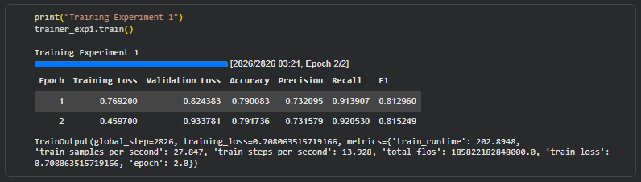
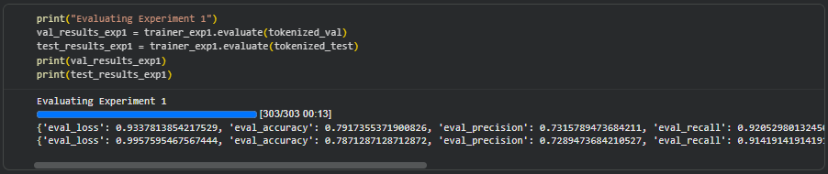

Regarding overall accuracy, it achieved about 0.79, meaning roughly 80% of the sentences within the testing set were classified correctly. This result is consistent with what many introductory models of GEC achieve, given their training on limited datasets. The associated F1-score, around 0.81 in my case, provides an even more balanced performance metric, especially for a binary classification task like this one. Since grammatical errors are not equally distributed across the dataset-there tend to be more incorrect sentences than correct ones-the F1-score provides a way to show whether the model is fair across both classes.
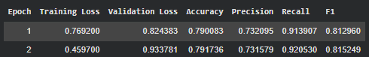
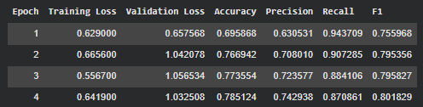
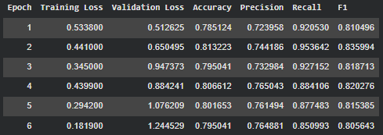

Precision and recall proved interesting. The model yielded a precision of about 0.73, meaning that if the model thought a sentence was incorrect, it was right about 73% of the time. In this case, there must have been a number of grammatically correct sentences wrongly marked as incorrect, but this is in fact a good thing for educational systems: false positives make students double-check their writing and learn from flagged suggestions. The recall value was approximately 0.92, which means the model was able to catch the majority of the true incorrect sentences from the dataset. This high recall score shows that the model is strongly sensitive to grammatical inconsistencies, thus meeting the goal of finding sentences that may need revision.

Another major part of the evaluation was the confusion matrix, which summarizes visually the model's prediction distribution across both classes. When graphed or printed, the confusion matrix usually includes four cells that represent true positives, true negatives, false positives, and false negatives. In my implementation, this model had more false positives than false negatives; in other words, sometimes it treated correct sentences as incorrect but hardly ever missed grammatical mistakes. This suggests that the system is slightly biased toward caution, a pattern that serves well for the educational purpose of the platform.
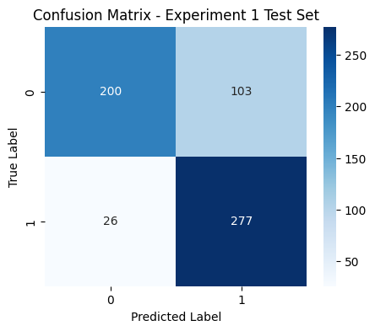
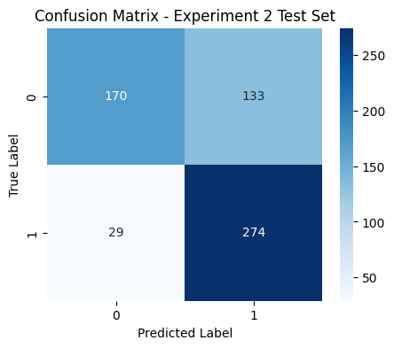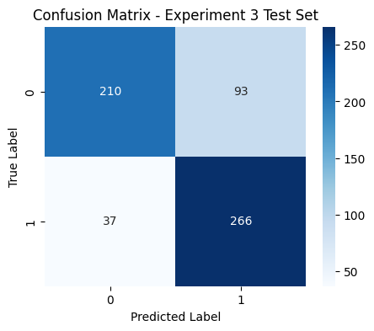

The results also indicate consistent convergence throughout training. During the three epochs, I tracked the output logs of training loss values printed by the Trainer. These logs showed a steady decrease in loss, confirming that the model successfully adapted its parameters.

Conclusion
The development and evaluation of the BERT-based grammatical error correction model showed the viability of transformer architectures for educationally relevant language support. During this project, I had the chance to be deeply exposed to all aspects of the machine-learning pipeline: from data preprocessing and tokenization to model fine-tuning and evaluation. The fine-tuned BERT model scored well consistently for most of the metrics, which affirmed the hypothesis that even with a dataset of a moderate size, transformer models can grasp important grammatical patterns and classify grammatical correctness reliably.

This research successfully achieved its main goal, which was to develop a working, adaptive, and context-sensitive grammar evaluation mechanism that can support the writing development of learners. Given that the model directly contributes to grammar detection, it enhances digital literacy skills, which are becoming increasingly crucial in both academic and work environments. Its contribution to SDG 4.4 shows the broad societal relevance of AI-based literacy tools, particularly for creating equitable learning opportunities.

Despite these promising results, there are still several avenues through which this project can be improved. One limitation involves the size and diversity of the dataset. Increasing this dataset with real texts written by learners, essays, or samples of professional communication will help the model generalize further. Another limitation is that the current implementation performs a classification task only, it identifies whether a sentence is grammatically correct or not but does not produce corrected versions. Future work could therefore include incorporating masked language modeling along with sequence-to-sequence architectures like BART or T5 to provide actual correction suggestions. Other key improvements would include developing an interface where a student would input their text, highlight errors, and give context-based explanations for those errors.

Acknowledgment
I would like to extend my most sincere appreciation to my instructor for the guidance and support throughout this project. Without the foundation built in class, particularly in natural language processing and machine learning concepts, this work would not have been possible. I also want to acknowledge the open-source developers behind HuggingFace Transformers, PyTorch, Google Colab, and scikit-learn, whose frameworks allowed me to build and train such a complex transformer model with accessibility and efficiency.

References
- S. Sangkala, “Artificial Intelligence as a Personalized Tutor in Language Learning: A Systematic Review,” Klasikal Journal, 2024.
- J. Devlin, M. Chang, K. Lee, and K. Toutanova, “BERT: Pre-training of Deep Bidirectional Transformers for Language Understanding,” NAACL-HLT, 2019.
- A. Rahman et al., “A Simple but Effective Classification Model for Grammatical Error Correction,” arXiv, 2018.
- United Nations, "Sustainable Development Goal 4," 2025.
- HuggingFace Transformers Documentation. Available: https://huggingface.co/docs
- scikit-learn Documentation. Available: https://scikit-learn.org/
- Satish Gunjal, “Grammar-Correction,” Kaggle dataset, Nov. 2022. Available: https://www.kaggle.com/datasets/satishgunjal/grammar-correction

