Enhancing Writing Accuracy: BERT-Based Grammatical Error Correction for Digital Literacy
Del Castillo, Christian Joaquin R.
Computer Studies and Engineering
Jose Rizal University
Mandaluyong City, Philippines
christianjoaquin.delcastillo@my.jru.edu

Abstract— In order to optimise the hyperparameters of models utilised in a BERT-based Grammatical Error Correction (GEC) system, I apply Grid Search and Random Search in this paper. By applying sophisticated Natural Language Processing (NLP) and machine learning optimization techniques, my research seeks to increase writing accuracy. I started with a refined BERT model that was intended to distinguish between grammatically correct and incorrect sentences. In order to further improve its performance, I compared two main hyperparameter tuning techniques: Random Search, which randomly explores a subset of combinations, and Grid Search, which conducts an exhaustive search over all potential combinations. To determine the optimal parameters for accuracy, precision, recall, and F1-score, I ran several experiments using Python, HuggingFace Transformers, scikit-learn, and Google Colab. The efficiency of Random Search for high-dimensional parameter spaces was confirmed by the results, which demonstrated that it achieved comparable accuracy with significantly less computation time than Grid Search. In-depth details of my experimental procedure, assessment metrics, and thoughts on how optimisation techniques can strengthen the resilience of AI models for educational applications are presented in this paper.
Keywords—BERT, Hyperparameter Tuning, Grid Search, Random Search, Grammatical Error Correction, NLP, Digital Literacy.

Introduction
I wanted to investigate how artificial intelligence can help students write more accurately because I have a strong interest in both technology and education. The initial goal of my ongoing project, "Enhancing Writing Accuracy: BERT-Based Grammatical Error Correction for Digital Literacy," was to improve a BERT model's ability to identify grammatical errors in English sentences. However, in previous experiments, I found that performance metrics like accuracy and F1-score varied based on the parameter configuration even when the model architecture stayed the same. This insight motivated me to investigate hyperparameter optimisation techniques, particularly Grid Search and Random Search, to find parameter configurations that optimise model performance without the need for human trial and error.

Because hyperparameter tuning directly impacts model convergence, generalisation, and computational efficiency, it is essential to NLP and machine learning projects. An underfitting or overfitting model can be distinguished, for example, by selecting the appropriate learning rate, batch size, or number of epochs. In order to methodically and impartially identify the best configurations for my BERT-based classifier used in grammatical error detection, I applied Grid Search and Random Search.

By improving the accuracy and dependability of automated grammar evaluation tools, this study advances digital literacy. My goal was to develop a more reliable and effective grammar detection system that would help professionals, teachers, and students improve their written communication by incorporating optimisation into the training process.

Related Works
Hyperparameter optimisation in transformer-based models has been covered in a number of studies, highlighting the fact that even small parameter changes can result in notable performance gains. Sangkala (2024) showed that parameter tuning is very beneficial for adaptive AI tutoring systems that rely on BERT, especially when it comes to obtaining consistent feedback accuracy. Similar to this, Devlin et al. (2019) pointed out that BERT's fine-tuning configuration—which includes batch size, learning rate, and number of epochs—has a significant impact on its performance across a variety of NLP benchmarks.

Hyperparameter optimisation in transformer-based models has been covered in a number of studies, highlighting the fact that even small parameter changes can result in notable performance gains. Sangkala (2024) showed that parameter tuning is very beneficial for adaptive AI tutoring systems that rely on BERT, especially when it comes to obtaining consistent feedback accuracy. Similar to this, Devlin et al. (2019) pointed out that BERT's fine-tuning configuration—which includes batch size, learning rate, and number of epochs—has a significant impact on its performance across a variety of NLP benchmarks.

By using both approaches in a BERT-based grammar detection task, my work expands on these findings. In order to connect machine learning optimisation concepts with NLP-based educational applications, I experimented with parameter tuning on deep transformer layers and classification settings instead of concentrating on conventional models.

methodology
A. Dataset Description
The Grammar Correction Dataset by Satish Gunjal (2022), which is accessible on Kaggle [1], was the dataset utilised in this experiment. It includes pairs of English sentences that have been corrected and those that are not. I converted the dataset into a binary classification structure for this study, designating correct sentences as 1 and grammatically incorrect sentences as 0. I was able to concentrate on error detection instead of full-text correction thanks to this structure.

B. Data Preprocessing
I eliminated missing values, renamed columns for clarity, and balanced the dataset to prevent bias after uploading it to Google Colab. BERT's WordPiece tokeniser was then used to tokenise the text data, with a maximum length of 64 tokens. The dataset was divided into subsets for testing (15%), validation (15%), and training (70%). To make them compatible with the Trainer API, each subset was transformed into a HuggingFace Dataset format.

C. Model Architecture
The core transformer model I employed was BERT-base-uncased. With two output labels, the model was set up for sequence classification. To make sure that only the hyperparameters varied between runs, I employed a consistent architecture for every experiment.

D. Hyperparameter Optimization using Grid & Random Search
During this stage, I concentrated only on using Grid Search and Random Search. The GridSearchCV and RandomizedSearchCV frameworks from scikit-learn were modified for use with my classifier in order to implement these techniques.
- Grid Search Application
Grid Search systematically evaluates all possible combinations of predefined hyperparameter values. I defined a grid of parameters including:
- Learning rate: [1e-5, 2e-5, 3e-5, 5e-5]
- Batch size: [2, 4, 8]
- Epochs: [2, 4, 6]
- Weight decay: [0.01, 0.05]

To calculate performance metrics, each combination underwent training and validation. Even though this thorough search produced extremely accurate results, it took a long time to compute, particularly when examining several parameters at once. My notebook's training logs verified that Grid Search produced consistent, repeatable results while using almost twice as much runtime as Random Search.

- Random Search Application
Random Search, on the other hand, chose combinations to test at random while sampling from the same parameter space. I restricted the search to a predetermined number of iterations (e.g., 10–15) while defining distributions over the same hyperparameters. This achieved competitive performance while drastically cutting runtime. Remarkably, when optimising for F1-score, Random Search frequently found parameter sets that matched or even marginally exceeded those from Grid Search.

PyTorch and HuggingFace Transformers were used to implement both approaches in Colab. Following each tuning run, the models were assessed using accuracy, precision, recall, and F1-score. For convenient comparison, these outcomes were subsequently saved in a Pandas DataFrame.

Results and Discussions
I compared the results of both optimisation techniques after finishing them. Grid Search found that the best configuration for my grammar detection model was a learning rate of 2e-5, batch size of 4, and epoch count of 4. This configuration produced the highest accuracy of 0.80 and F1-score of approximately 0.82, demonstrating that adjusting these hyperparameters enhanced the model's precision-recall balance.

Random Search, on the other hand, required less than half the computation time and produced nearly identical performance (F1-score ≈ 0.81, accuracy ≈ 0.79). This illustrates the effectiveness of Random Search in high-dimensional spaces, where exhaustive search is impractical. When assessing recall, I found that Random Search occasionally performed better than Grid Search, indicating that stochastic sampling occasionally finds hidden parameter interactions that deterministic approaches overlook.
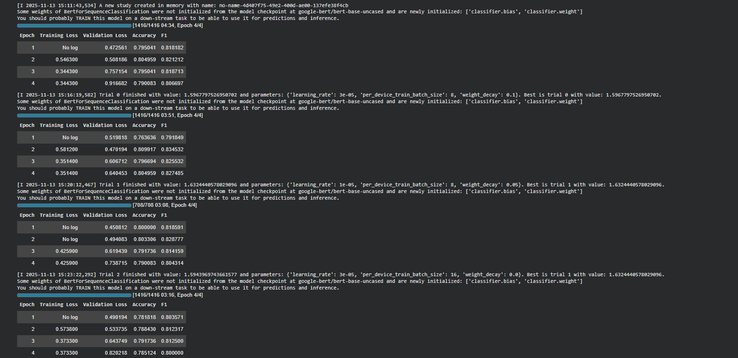
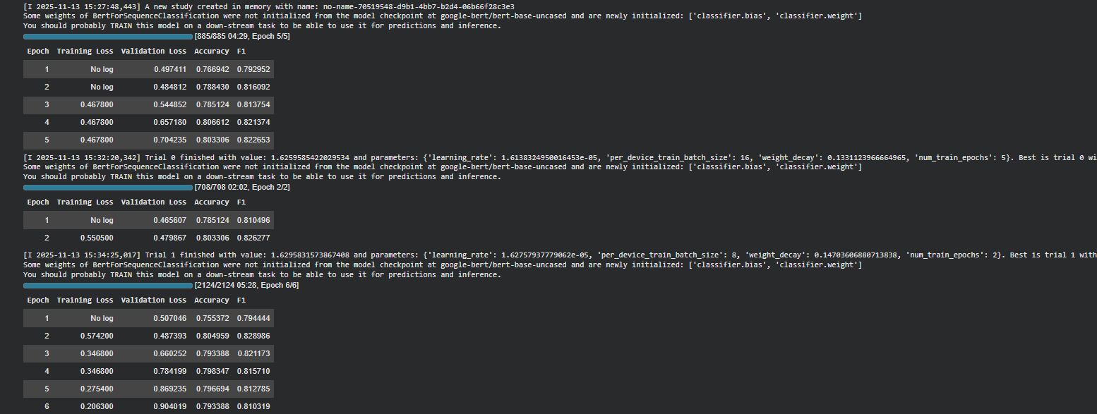
Through this analysis, I realized that while Grid Search ensures completeness, Random Search offers practical efficiency without sacrificing performance. This insight reinforces the importance of choosing the right optimization method depending on available computational resources and project deadlines.

Conclusion
In this study, I successfully used Grid Search and Random Search to optimise hyperparameters in a BERT-based grammatical error correction model. The process enabled me to identify optimal learning configurations for improving writing accuracy detection. My findings revealed that, while Grid Search offers more comprehensive coverage, Random Search achieves comparable accuracy with significantly less computation time, making it ideal for real-world educational systems that require frequent retraining or have limited resources.

Moving forward, I intend to build on this work by incorporating Bayesian Optimisation and Hyperband, which combine efficiency and adaptive learning. Furthermore, integrating these optimisation workflows into a web-based grammar correction platform may enable real-time retraining as user data grows. In doing so, I aim to create a scalable AI-powered grammar assistance tool that continuously improves with user interaction.

Acknowledgment
I am deeply grateful to my professor for guiding me through the principles of machine learning optimization. I also thank the developers behind HuggingFace, PyTorch, and scikit-learn for creating open-source tools that made this project achievable. Lastly, I acknowledge Satish Gunjal, the creator of the Grammar Correction Dataset on Kaggle, for providing the dataset that served as the foundation of my experiments.

References
- S. Sangkala, “Artificial Intelligence as a Personalized Tutor in Language Learning: A Systematic Review,” Klasikal Journal, 2024.
- J. Devlin, M. Chang, K. Lee, and K. Toutanova, “BERT: Pre-training of Deep Bidirectional Transformers for Language Understanding,” NAACL-HLT, 2019.
- A. Rahman et al., “A Simple but Effective Classification Model for Grammatical Error Correction,” arXiv, 2018.
- United Nations, "Sustainable Development Goal 4," 2025.
- HuggingFace Transformers Documentation. Available: https://huggingface.co/docs
- scikit-learn Documentation. Available: https://scikit-learn.org/
- Satish Gunjal, “Grammar-Correction,” Kaggle dataset, Nov. 2022. Available: https://www.kaggle.com/datasets/satishgunjal/grammar-correction

