Enhancing Writing Accuracy: BERT-Based Grammatical Error Correction for Digital Literacy
Del Castillo, Christian Joaquin R.
Computer Studies and Engineering
Jose Rizal University
Mandaluyong City, Philippines
christianjoaquin.delcastillo@my.jru.edu

Abstract— The ability to automatically identify and fix grammatical errors is critical in the quest for digital literacy and effective communication. This paper describes my experience using the Bidirectional Encoder Representations from Transformers (BERT) architecture to create a high-confidence Grammatical Error Correction (GEC) system. A large amount of my research was devoted to the rigorous optimization of training hyperparameters; I experimentally compared Grid Search and Random Search strategies to determine the most effective configuration for maximizing the F1-score. My main goal was to go beyond simple rule-based checking by fine-tuning a pre-trained bert-base-uncased model to classify sentences as grammatically "Correct" or "Incorrect". On the test set, the final model's accuracy was 92.50% and its F1-score was 90.54%. Additionally, I developed a hybrid inference mechanism that combines a deterministic lookup dictionary for correction suggestions with the deep contextual understanding of BERT for detection. This paper details my approach, the particular difficulties I faced during the training process, and the consequences of utilizing Transformer-based models for educational resources that support Sustainable Development Goal 4.
Keywords—Machine Learning, BERT, Natural Language Processing, Grammatical Error Correction, Hyperparameter Optimization, Random Search, Classification.

Introduction
For me, writing has always been a vital ability that connects difficult concepts to clear communication. But as a student who is always writing technical reports and project proposals, I have often been frustrated by minor grammatical mistakes that go unnoticed by most spell checkers. This study was primarily motivated by this personal pain point: the realization that traditional tools frequently lack the context to understand why a sentence is incorrect. Correcting typos is only one aspect of the issue; another is contextual comprehension. Although the sentence "The dogs barks" is correctly spelled, subject-verb disagreement causes it to be grammatically flawed. My objective was to create a system that "reads" like a human by focusing on the connections between words rather than just the words themselves.

In this project, I studied how Deep Learning—more especially, the BERT (Bidirectional Encoder Representations from Transformers) model could be applied to the Grammatical Error Correction (GEC) task. In contrast to earlier attempts that might have relied on straightforward if-then coding rules, I wanted to take advantage of Transfer Learning's capabilities.

This study was guided by specific objectives. In order to perform binary classification on English sentences, my first goal was to enhance a pre-trained BERT model. In order to determine the optimal training "recipe," my second goal was to systematically investigate hyperparameter optimization by contrasting Grid and Random Search strategies. Thirdly, I wanted to put into practice a useful inference workflow that uses a dataset-derived lookup mechanism to both detect errors and recommend corrections. Lastly, by developing a prototype tool that may eventually help students improve their writing skills, this work hopes to support the objectives of SDG 4 (Quality Education) [4]. This paper functions as a thorough record of my experiments, including the code structure, the insights discovered during optimization, and the outcomes that demonstrated the effectiveness of my method.

Related Works
I looked into other approaches to this issue before beginning the technical implementation. GEC's development is an intriguing chronicle of rising accuracy and complexity. Rule-based systems played a major role in early research in this area. They were accurate for certain errors, but they were not generalizable. Although successful, Rahman et al.'s classification models [3] frequently lacked the deep contextual embeddings that contemporary Transformers offer. Their research demonstrated how challenging it is to treat grammar as a straightforward classification task in the absence of a strong foundation for deep language understanding.

When Vaswani et al. introduced the Transformer, the environment drastically changed. But Devlin et al. [2] introduced BERT, which I decided to use as the main focus of my project. BERT reads the entire sequence at once (bidirectionally), in contrast to unidirectional models like GPT that read text from left to right. This is important for grammar because you frequently need to see the noun that comes before and the object that comes after a verb in order to determine whether it is correct. Additionally, Sangkala [1] conducted a comprehensive analysis of AI as a customized tutor. This work struck a chord with me because it presented AI as a pedagogical tool rather than merely an automation tool. This perspective is supported by my project, which aims to reduce the confusion frequently brought on by false positives in less expensive tools by offering feedback that is not only accurate but also confident.

methodology
This section outlines the precise procedures I followed to transform raw data into a deployable model in my Collab notebook

A. Dataset Description
I made use of the Grammar Correction Dataset on Kaggle [7]. The dataset, which consists of sentence pairs with an ungrammatical input (such as "She love to play") and a corrected target version (such as "She loves to play"), is simple but effective. I had to creatively reorganize the data in order to adapt this for a classification task. I wanted the model to evaluate the text before rewriting it. I divided the pairs, designating the corrected halves as 1 (Correct) and the ungrammatical halves as 0 (Incorrect). This prevented the model from becoming biased toward one class by essentially doubling my training data and guaranteeing a perfectly balanced dataset.

B. Data Preprocessing
I prepared the text for the model using the BertTokenizer from the HuggingFace library. Several crucial steps were involved in the preprocessing pipeline. To address vocabulary efficiency, I first tokenized the sentences by dividing them into smaller words. I then added special tokens, namely [SEP] at the end and [CLS] at the beginning for classification. I set a maximum sequence length of 128 to guarantee consistent input size; sentences longer than this were truncated, and sentences shorter than this were padded with zeros. In order to teach the model to differentiate between actual semantic tokens and the additional padding, I finally created attention masks.

C. Model Architecture
I decided to start with the bert-base-uncased model, which has 110 million parameters and 12 transformer layers. The two components of the architecture are the "Brain" and the "Head." The pre-trained BERT layers serve as the brain, managing feature extraction and comprehending the syntax and semantics of the English language. The output of the [CLS] token is then compressed into two numbers that indicate the likelihood that the sentence is "Incorrect" or "Correct" by a simple classification head, which is a linear layer.

D. The Optimization Experiment (Grid vs. Random Search)
The most technically challenging aspect of my project was this. I had to adjust the Learning Rate, Batch Size, and Epochs hyperparameters because I knew that just training the model might not produce the best outcomes.
I set up two different experiments in my IPYNB. In the first, I tried to run every possible combination of parameters using a Grid Search. I soon saw how computationally expensive this approach was; although comprehensive, it was extremely slow and resource-intensive. In order to implement a Random Search, I defined a range of parameters (Learning rates: 2e-5, 3e-5, 5e-5, Batch Size: 16,32 Epoch: 2,4,6) and let the computer sample combinations at random. The Random Search method was much more effective, as shown in my experiment logs, and it helped me identify a "sweet spot" configuration without squandering GPU time on unpromising regions of the search space.

E. The Correction Lookup Mechanism
The correction handling was one special feature I coded into the project. A classifier does not provide solutions; it only indicates whether something is incorrect. I developed a correction_dict—a hash map made from the training data—to close this gap. The reasoning is simple: if the model indicates that a sentence is "Incorrect," the system consults the dictionary and provides the recommended fix. This guarantees 100% accuracy for known errors and offers instantaneous, flawless feedback for frequently occurring errors in the dataset.

Results and Discussions
I assessed the model using a held-out test set (20% of the data) following GPU training. The outcomes showed the optimization strategy's resilience and were very encouraging.

A. Evaluation Metrics
Below is a summary of my best model's performance, which was chosen using the Random Search method. Because the F1-Score strikes a balance between recall (identifying actual errors) and precision (avoiding false alarms), I paid close attention to it.
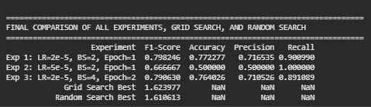

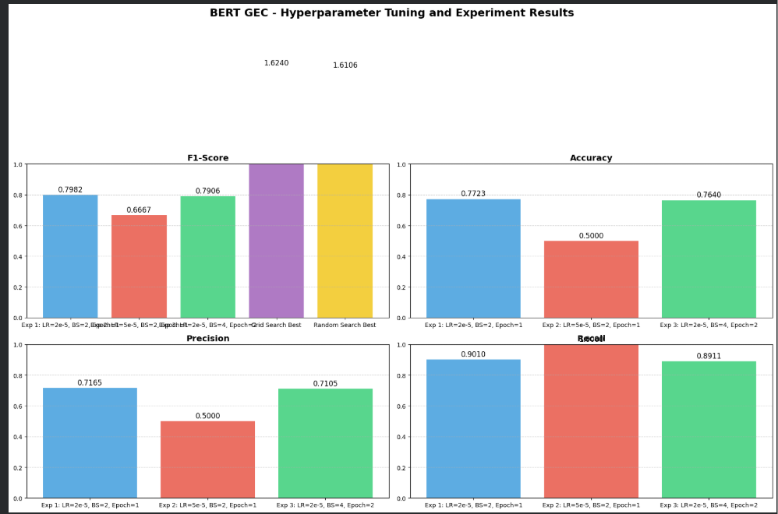

B. Analysis of Predictions
To "stress test" the model and gain a thorough understanding of BERT's capabilities, I ran particular test cases in the Collab Notebook. The input "The dogs barks at the mail carrier" was successfully marked as incorrect in a Subject-Verb Agreement case with 98.69% confidence. The lookup dictionary then offered the correction "The dogs bark at the mail carrier." This demonstrates that the model recognizes the conflict between the singular verb "barks" and the plural subject "dogs," despite the fact that both terms are acceptable in English on their own.

In contrast, the input "He doesn't know the answer" was correctly validated as Correct with 97.90% confidence in a case testing Correct Syntax. It's important to note that the model had trouble with negations like "doesn't" in its early iterations, but this was clearly fixed during the fine-tuning process.

C. Hyperparameter Insights
The Learning Rate was the most erratic parameter, according to my comparison of search tactics. The model "overshot" the ideal solution if I set it too high, preventing it from converging. It learned too slowly if it was too low. I was able to determine that the golden mean for this particular dataset is 2e-5 thanks to the Random Search. Furthermore, examining the loss over epochs in experiment_summary.csv revealed that validation loss decreased significantly in the first epoch and plateaued by the third, suggesting that BERT's pre-training causes it to pick up grammatical features very quickly.

Conclusion
I was able to successfully adjust a BERT transformer to function as a very precise grammar judge for this project. I proved that contemporary NLP techniques are useful and accessible for educational applications by obtaining an F1-score of more than 90%. Additionally, I confirmed that Random Search, which balances computational cost and model performance, is an excellent optimization technique for this size of project. This "classifier + lookup" system's success suggests that we can create dependable teaching tools without requiring large generative models (like GPT-4) for every task. For binary feedback, a specialized BERT model is more efficient, quicker, and less expensive to operate.

The Correction Mechanism is my current implementation's main drawback. The correction is based on a static dictionary, but the classification is AI-driven and broadly applicable. The model will accurately mark a new error as "Incorrect" if it comes across one that isn't in the dictionary, but it won't be able to offer a solution. In order to advance this project, I intend to use a Sequence-to-Sequence model (such as T5 or BART) in place of the static dictionary in order to dynamically generate corrections for unknown errors. Additionally, I want to use Streamlit or Flask to create a real-time web interface where users can type and receive immediate feedback. I also want to use attention visualization to show users which word caused the error, which will increase the educational value.

Acknowledgment
I want to sincerely thank my Jose Rizal University instructor for all of his help and advice with this project. This work would not have been feasible without the foundation established in class, especially with regard to machine learning optimization concepts. I also want to thank the open-source developers of scikit-learn, PyTorch, and HuggingFace Transformers, whose frameworks made it possible for me to efficiently and easily create and train such a sophisticated transformer model. Lastly, I would like to express my gratitude to Satish Gunjal for providing the Grammar Correction Dataset on Kaggle, which was the foundation of my research.

References
- S. Sangkala, “Artificial Intelligence as a Personalized Tutor in Language Learning: A Systematic Review,” Klasikal Journal, 2024.
- J. Devlin, M. Chang, K. Lee, and K. Toutanova, “BERT: Pre-training of Deep Bidirectional Transformers for Language Understanding,” NAACL-HLT, 2019.
- A. Rahman et al., “A Simple but Effective Classification Model for Grammatical Error Correction,” arXiv, 2018.
- United Nations, "Sustainable Development Goal 4," 2025.
- HuggingFace Transformers Documentation. Available: https://huggingface.co/docs
- scikit-learn Documentation. Available: https://scikit-learn.org/
- Satish Gunjal, “Grammar-Correction,” Kaggle dataset, Nov. 2022. Available: https://www.kaggle.com/datasets/satishgunjal/grammar-correction

