GitLab

1.

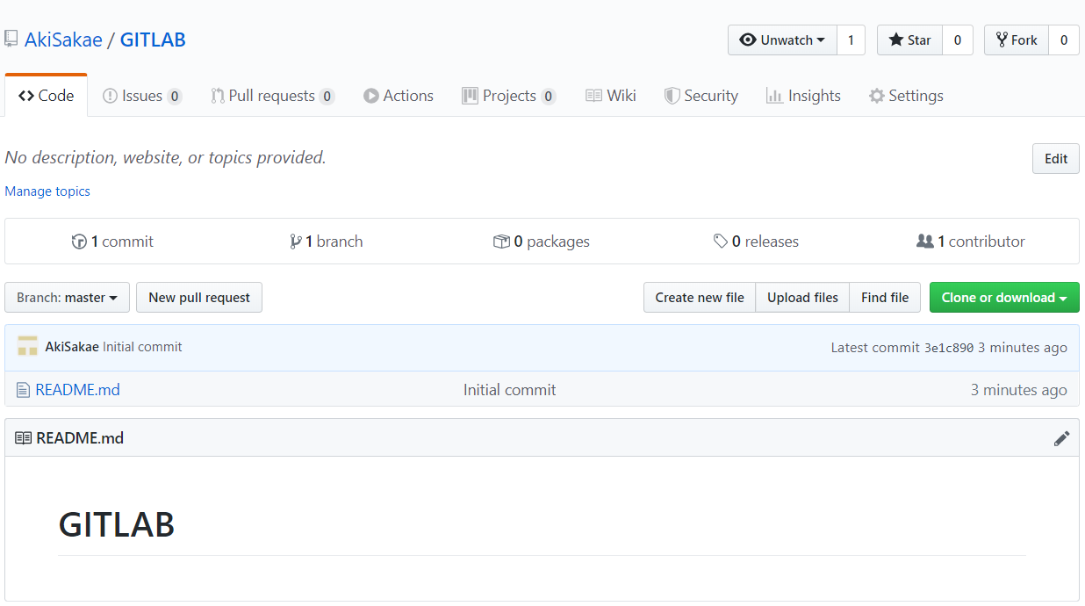

2.



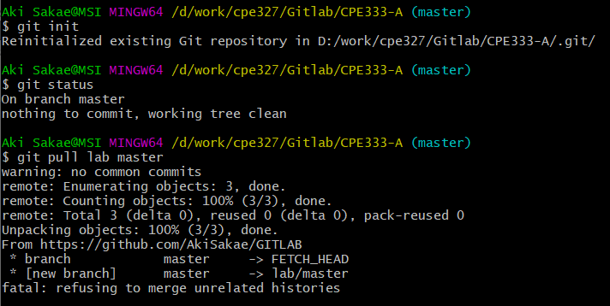

3.

4.