Table S1. The search strategy in each database.
Our search strategy was based on “Target condition” AND “Index test”. Each search term of “Target condition” or “Index test” was combined with “OR”. Database search was conducted on January 7, 2021.
MEDLINE via Ovid | Search terms
A serum anti-glomerular basement membrane antibody | Exp Anti-Glomerular Basement Membrane Disease/  (anti-GBM disease?).ab,ti.  (anti-GBM antibody disease?).ab,ti.  (crescentic glomerulonephritis type I).ab,ti.  (Goodpasture*).ab,ti.  (pulmonary-renal syndrome?).ab,ti.
Anti-glomerular basement membrane disease | (antiglomerular basement membrane antibod*).ab,ti.  (anti-GBM antibod*).ab,ti.  (collagen autoantibod*).ab,ti.  Exp Fluorescent Antibody Technique/  (FEIA).ab,ti.  (fluorescence enzyme immunoassay?).ab,ti.  (fluoroenzymeimmunoassay?).ab,ti.  (radioimmunoassay?).ab,ti.  Exp Enzyme-Linked Immunosorbent Assay/  (ELISA).ab,ti.  (enzyme-linked immunosorbent assay?).ab,ti.  (enzymoimmunoassay?).ab,ti.  (enzyme labeled immunoassay?).ab,ti.  (enzyme coupled immunoassay?).ab,ti.  (enzyme-linked immuno assay?).ab,ti.  Exp Blotting, Western/  (Western blot).ab,ti.  (Immunoblotting).ab,ti.  (dot blot assay?).ab,ti.  Exp Luminescent Measurements/  (CLEIA).ab,ti.  (chemiluminescen*).ab,ti.  (multiplex immunoassay?).ab,ti.
Embase via Embase.com
A serum anti-glomerular basement membrane antibody | "Goodpasture syndrome"/exp  "anti-GBM disease?":ab,ti  "anti-GBM antibody disease?":ab,ti  "crescentic glomerulonephritis type I":ab,ti  "Goodpasture*":ab,ti  "pulmonary-renal syndrome?":ab,ti
Anti-glomerular basement membrane disease | "antiglomerular basement membrane antibod*":ab,ti  "anti-GBM antibod*":ab,ti  "collagen autoantibod*":ab,ti  "fluorescent antibody technique"/exp  FEIA:ab,ti  "fluorescence enzyme immunoassay?":ab,ti  fluoroenzymeimmunoassay?:ab,ti  radioimmunoassay?:ab,ti  "enzyme linked immunosorbent assay"/exp  ELISA:ab,ti  "enzyme-linked immunosorbent assay?":ab,ti  "enzymoimmunoassay?":ab,ti  "enzyme labeled immunoassay?":ab,ti  "enzyme coupled immunoassay?":ab,ti  "enzyme-linked immuno assay?":ab,ti  "Western blotting"/exp  "Western blot":ab,ti  Immunoblotting:ab,ti  "dot blot assay?":ab,ti  Luminescence/exp  CLEIA:ab,ti  "chemiluminescen*":ab,ti  "multiplex immunoassay?":ab,ti
Central
A serum anti-glomerular basement membrane antibody | [Anti-Glomerular Basement Membrane Disease] explode all trees  (anti-GBM disease?):ti,ab,kw  (anti-GBM antibody disease?):ti,ab,kw  (Goodpasture syndrome?):ti,ab,kw  (Goodpasture*):ti,ab,kw
Anti-glomerular basement membrane disease | (antiglomerular basement membrane antibod*):ti,ab,kw  (anti-GBM antibod*):ti,ab,kw  (collagen autoantibod*):ti,ab,kw  [Fluorescent Antibody Technique] explode all trees  (FEIA):ti,ab,kw  (fluorescence enzyme immunoassay?):ti,ab,kw  (fluoroenzymeimmunoassay?):ti,ab,kw  (radioimmunoassay?):ti,ab,kw  [Enzyme-Linked Immunosorbent Assay] explode all trees  (ELISA):ti,ab,kw  (enzyme-linked immunosorbent assay?):ti,ab,kw  (enzymoimmunoassay?):ti,ab,kw  (enzyme labeled immunoassay?):ti,ab,kw  (enzyme coupled immunoassay?):ti,ab,kw  (enzyme-linked immuno assay?):ti,ab,tkw  [Blotting, Western] explode all trees  (Western blot):ti,ab,kw  (Immunoblotting):ti,ab,kw  (dot blot assay):ti,ab,kw  [Luminescent Measurements] explode all trees  (CLEIA):ti,ab,kw  (chemiluminescen*):ti,ab,kw  (multiplex immunoassay?):ti,ab,kw
ICTRP
 | “Anti-GBM disease” OR “Goodpasture”

Table S2. Risk of bias and applicability assessment using the modified Quality Assessment of Diagnostic Accuracy Studies tool.
Domain | Patient selection | Index test | Reference standard | Flow and timing
Risk of bias
Signaling questions | - Was a consecutive or random sample of patients enrolled?  - Was a case-control design avoided?  - Did the study avoid inappropriate exclusions?ª | - Were the index test results interpreted without knowledge of the results of the reference standard?^{b}  - If a threshold was used, was it pre-specified? | - Is the reference standard likely to correctly classify the target condition?^{c}  - Were the reference standard results interpreted without knowledge of the results of the index test?^{d}  - Were the criteria of a reference standard for the target condition pre-specified? | - Was there an appropriate interval between index test(s) and reference standard?^{e}  - Did all patients receive a reference standard?  - Did patients receive the same reference standard?  - Were all patients included in the analysis?^{f}
Explanations | a: Inappropriate exclusions were defined as excluding patients who could not have been performed a renal biopsy. | b: We judged the risk of bias based on whether it affected the diagnostic accuracy of the index test. | c: Typically, renal biopsy results of the anti-GBM disease are focal or diffuse segmental crescentic glomerulonephritis and the presence of linear fluorescence of IgG along the glomerular basement membrane. However, dependency only on pathology could lead to misdiagnosis because linear IgG staining in immunofluorescence stains could be seen in other diseases such as diabetic nephropathy and fibrillary glomerulonephritis. Clinical diagnosis including clinical presentation and renal biopsy with immunofluorescence stains can make a diagnosis of anti-GBM disease correctly.  d: We judged the risk of bias based on whether it affected the diagnostic accuracy of the index test. | e: Appropriate interval between the index test and reference standard was judged to be less than or equal to 1 year. We decided “1 year” antibodies could become undetectable within an average of 11 months after treatment for anti-GBM diseases (Lancet  . 1986 Jan 4;1(8471):5-8.).  f: We judged the risk of bias based on whether missing data in the studies affected the diagnostic accuracy of the index test.
Applicability
Signaling questions | Is there concern that the included patients do not match the review question? | Is there concern that the index test, its conduct, or interpretation differ from the review question? | Is there concern that the target condition as defined by the reference standard does not match the review question? | Not applicable

Figure S1. Assessment of risk of bias and applicability for each domain in the included studies.
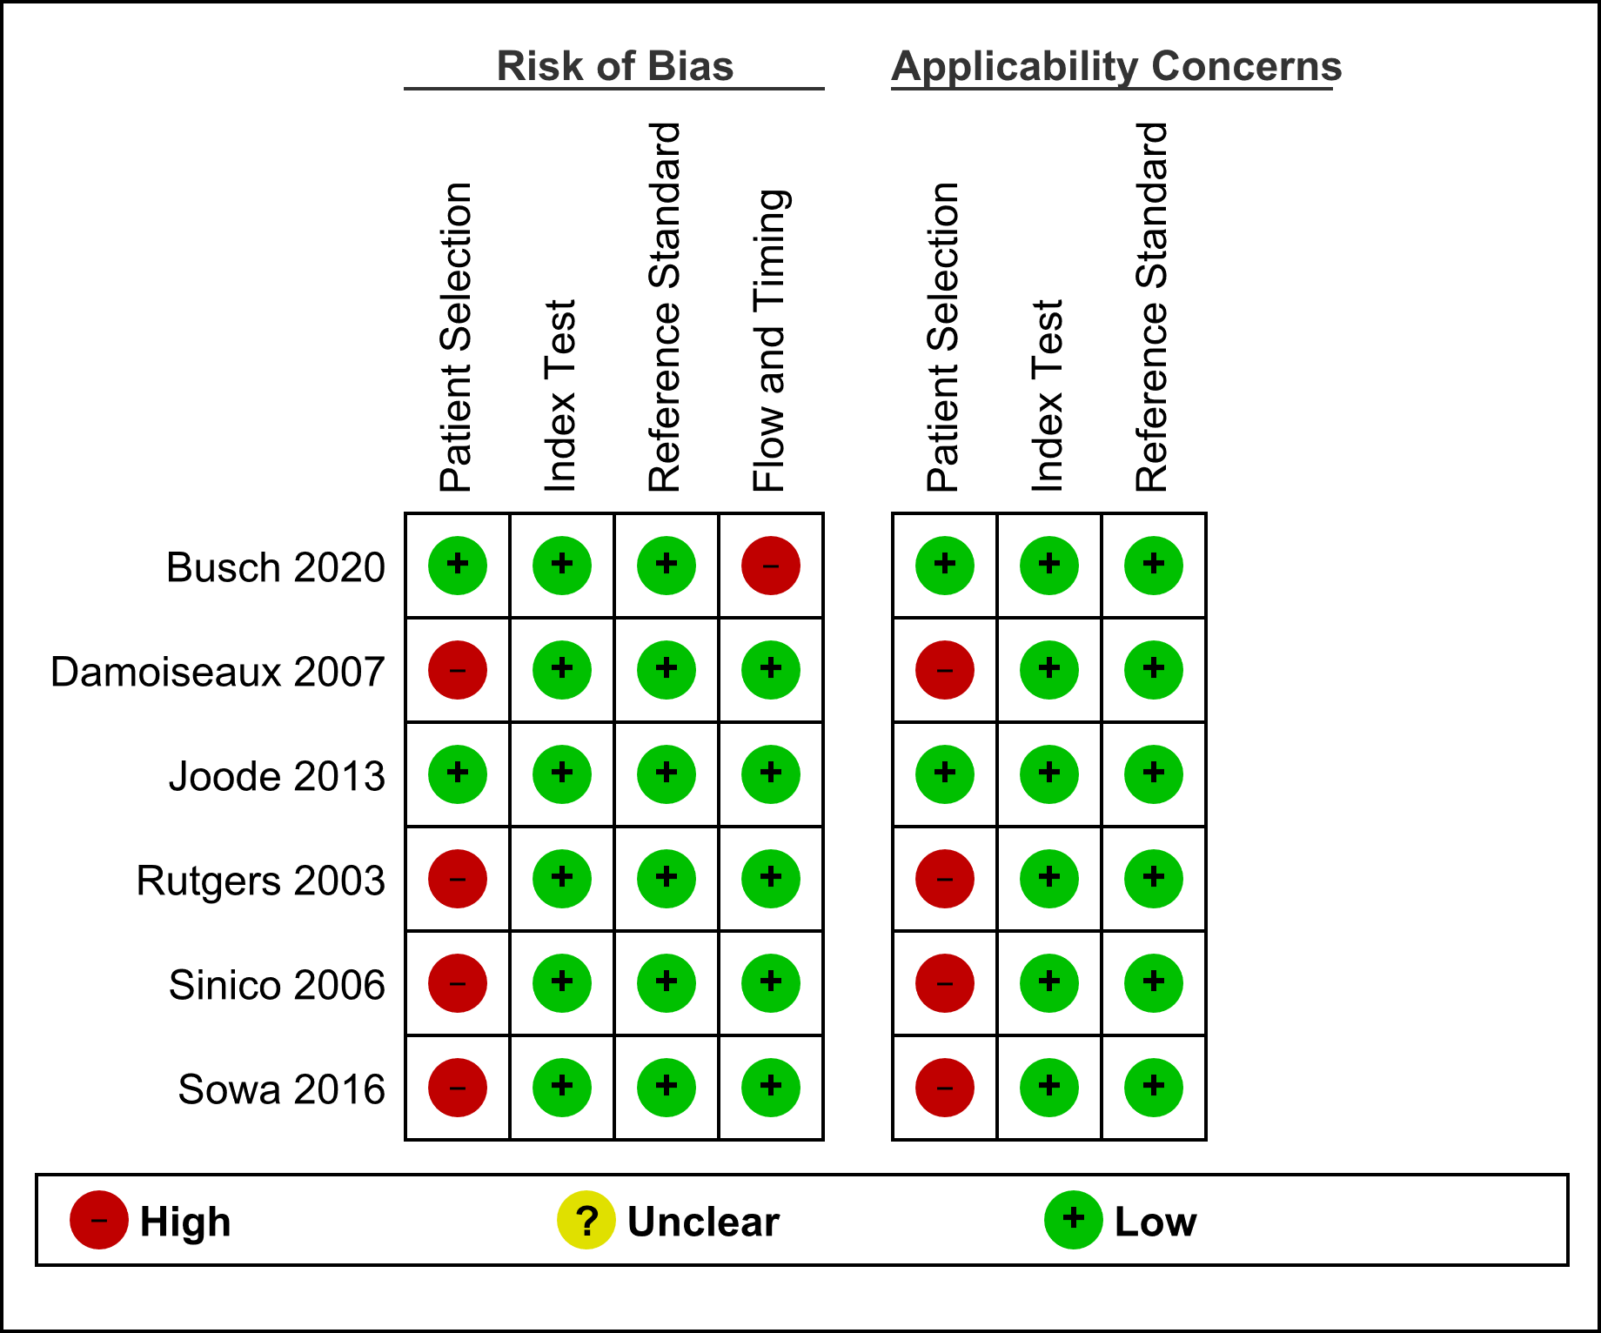
High risk of bias and high concerns for applicability in the patient selection domain was due to the case control design. Because number of excluded patients in the analysis was not clear in Busch et al, we judged it as high risk of bias in the flow and timing domain.

Figure S2. Univariate forest plots of sensitivity and specificity of serum anti-glomerular basement membrane antibodies.
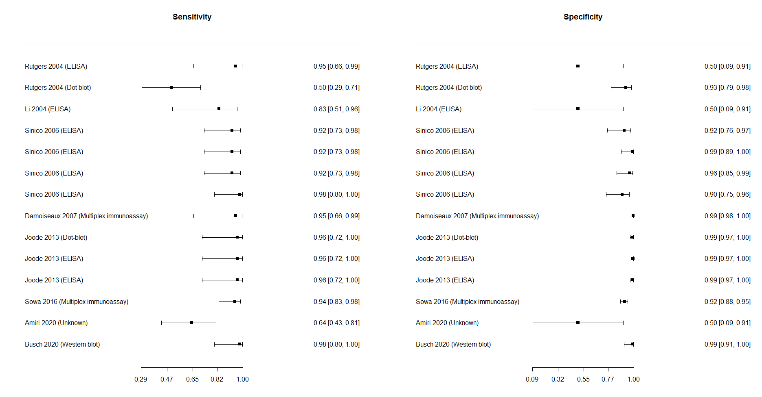

The sensitivity and specificity of serum anti-glomerular basement membrane antibodies were high, and heterogeneity was not large.

