Tia Yazzie

PSYC 81.09 Manning

Final Project README file

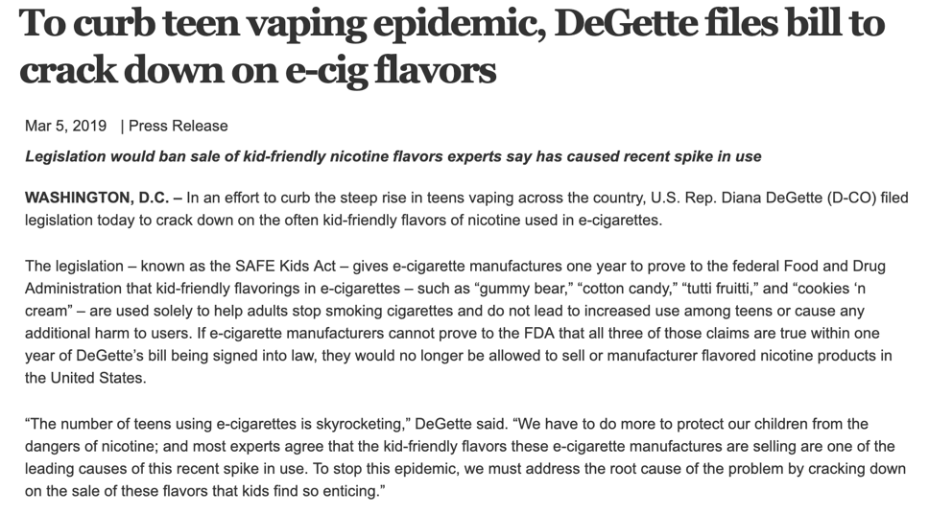

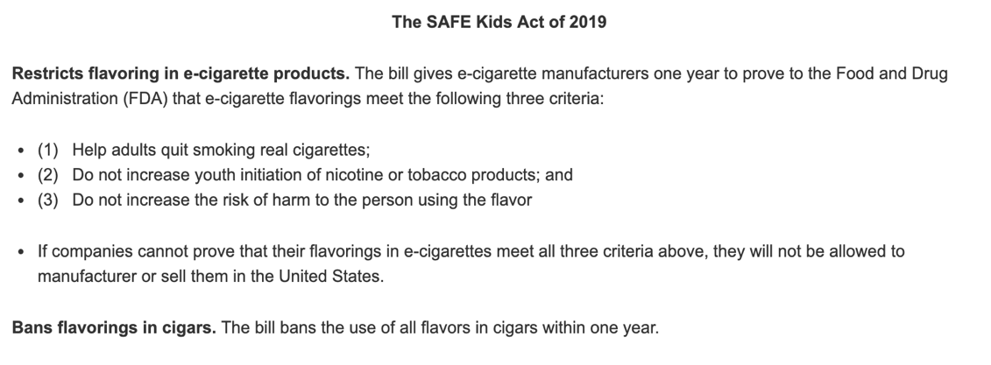

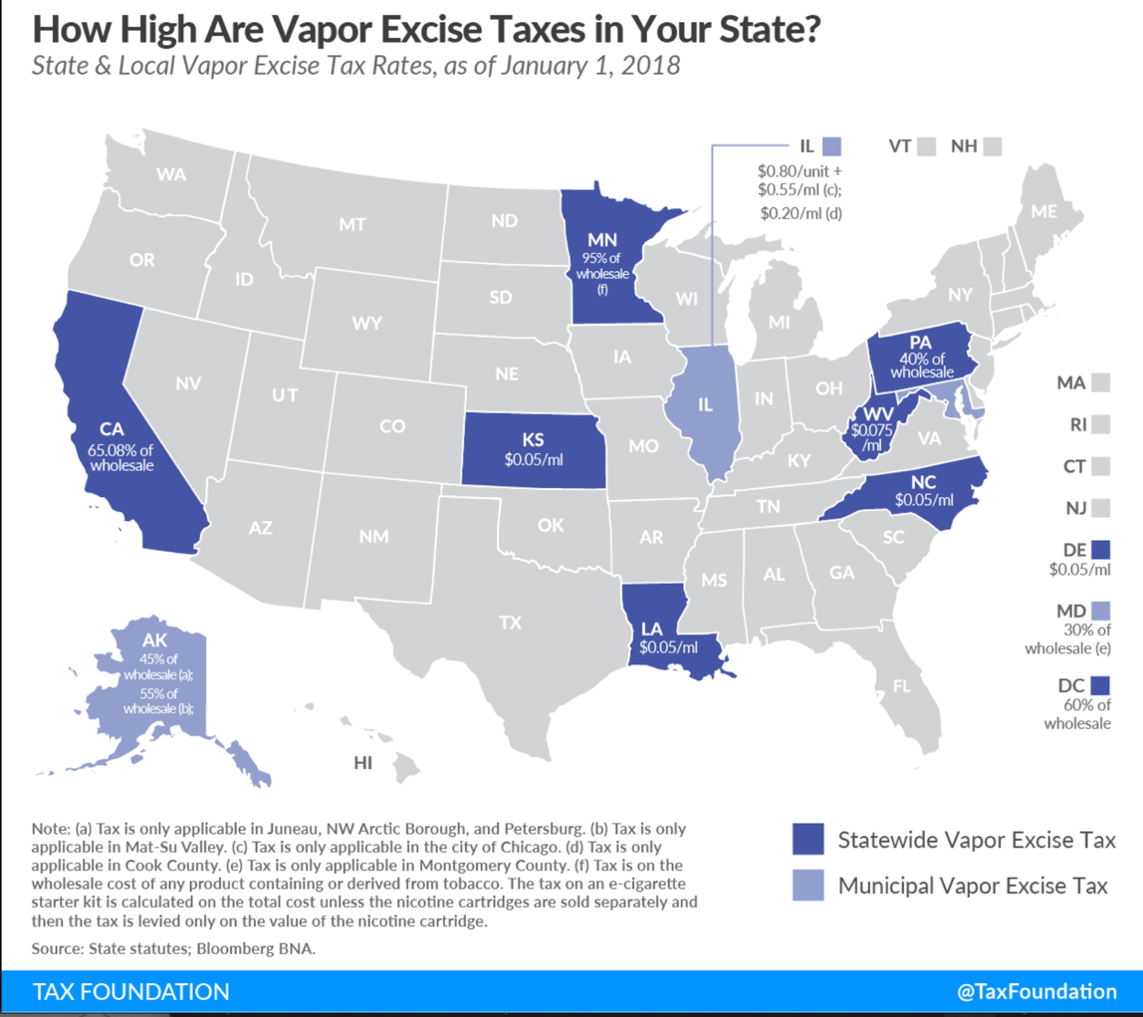

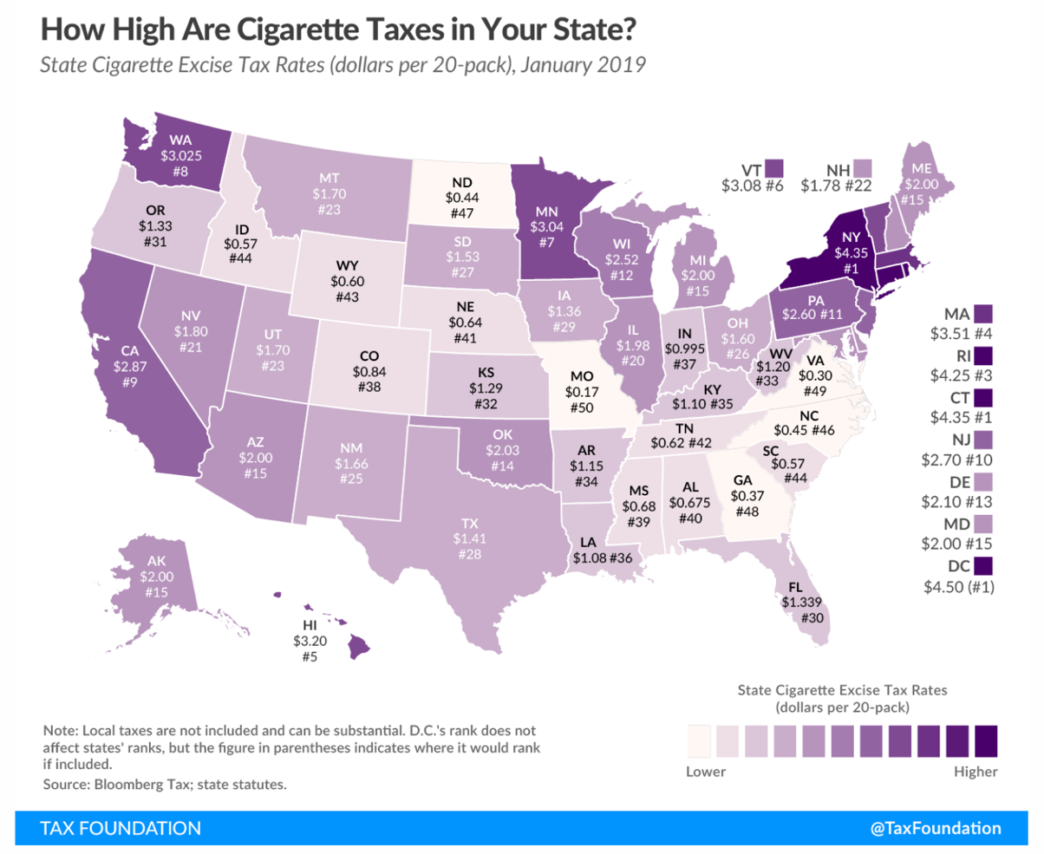

Recently this past March, Congresswoman Diana DeGette (D-CO) filed the SAFE Kids Act, also known as the “Stopping Appealing Flavors in E-Cigarettes for Kids Act,” which would crack down on the sale of “kid-friendly” flavors of nicotine used in e-cigarettes in stores nationwide. Enticing flavors such as Mango, Bubblegum, Cookies and Cream and others are being sold to youth across the country and becoming more accessible through local gas stations. Additionally, the enticing flavors allow the youth to become easily addicted to vaping or juuling, therefore, in order to reverse this epidemic, the FDA must impose additional restrictions on tobacco flavors used in e-cigarettes.

Additionally, states can impose their own special tax on commercial tobacco products, including e-cigarettes. Across the US, only 9 states have a state-wide vapor excise tax and 3 have municipal vapor excise tax. In comparison, all the states impose a cigarette tax according to the map above. Clearly, there is a discrepancy between cigarettes and e-cigarettes. With the use of e-cigarettes rising, the only clear way to tackle this public health issue to create and push legislation at the state and federal level to impose taxes on vapor tobaccos and even more so on flavored liquid nicotine used in e-cigarettes.

As an advocate for health issues and disparities among American Indian and Alaskan Indian populations and nations, the steady rise in e-cigarette usage among the youth is frightening because young adults and the older populations in our communities already have a high percentage of tobacco products use and if our youth become easily addicted to the usage of e-cigarettes, then the cycle continues just in a new form.