**Florian Guiho**



**Mathis Dupuy**

**Stegandroid**

**User guide**

Content

1. Purpose 3

2. Main screen 3

3. Settings screen 4

4. Encode screen 6

5. Decode screen 9

# Purpose

The main purpose of this document is to describe the way of how the application Stegandroid works. It will first give a general overview of the main screen of the application. In a second part, this document will present respectively how the settings screen, the encode screen and the decode screen works.

# Main screen

The Figure 1 below shows the main screen of the application. As the Figure 1 shows it, there are four buttons listed below:

* Encode
* Decode
* Settings
* About

These four buttons respectively give the access to the “encode” screen, the “decode” screen, the “settings” screen and the “about screen”.

The “encode” screen is used to hide data into a MP4 video. The “decode” screen is used to try to find hidden data into a video. The “settings” screen is used to set the preferences of the application, such as the algorithms to use with steganography or cryptography and the channel where to hide the data.

Thus, to access to a specific screen, it is necessary to simply click on the corresponding button.

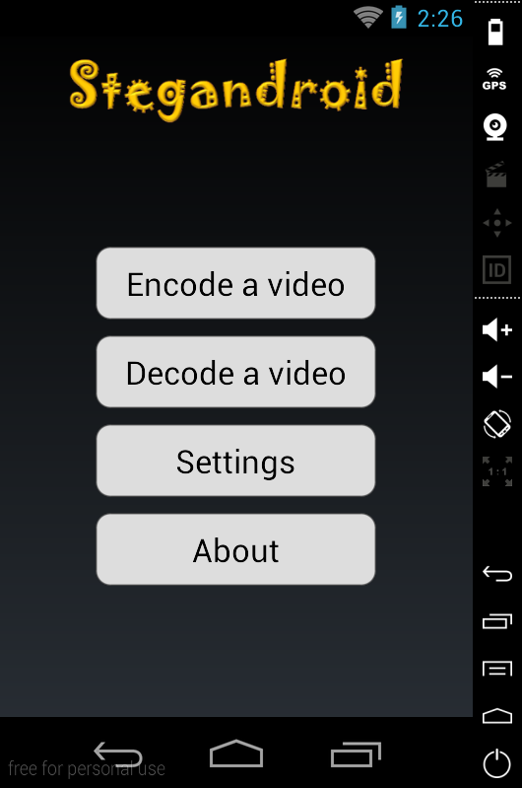

Figure 1: Main screen of the application

# Settings screen

As mentioned in the previous section the main goal of the settings screen is to set the preferences of the algorithm to use for hiding data or encrypting data. It is also used to specify which channels of the video will contain the hidden data. The Figure 2 below shows how the “Settings” screen is disposed.

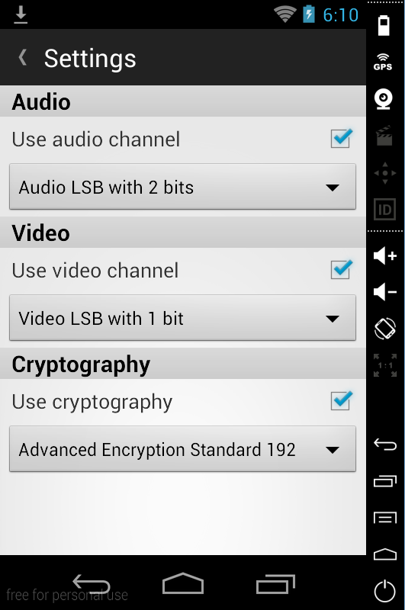

Figure 2: “Settings” screen of the application

As the Figure 2 shows it, the Settings screen is divided into two main sections which are the header and the main content.

The header simply contains a back arrow and the title of the current screen. The back arrow allows the user to go back to the main screen by a simple click on it.

The main content contains three main sections:

* An audio section
* A video section
* A cryptography section

Each section is separated with a grey header containing the name of the section. Each section contains a checkbox and a list of algorithms. The checkbox is used to specify if the user wants to use this feature. If the checkbox is not checked the list of algorithms is not visible. To select an algorithm, the user simply has to click on the list and then the application will shows the list of algorithms available for the specific feature as shown in the Figure 3.

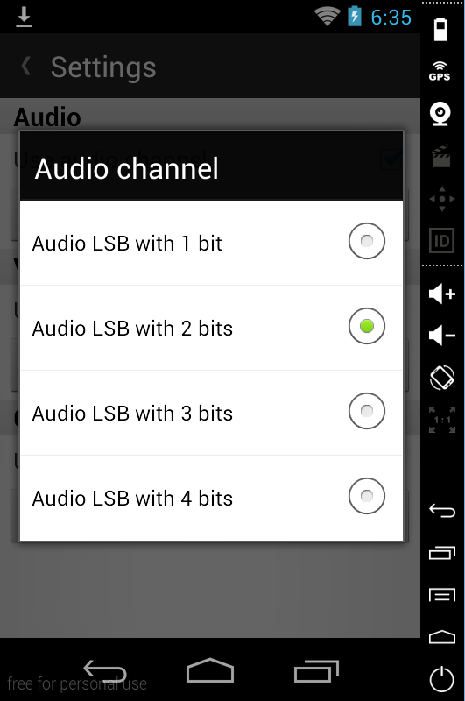

Figure 3: Algorithm choice for audio channel

For instance, if a user wants to hide data into the audio channel, but not into the video channel and wants to encrypt its data before hiding it, the user simply need to check the checkbox of the audio section and the checkbox of the cryptography section. Then, with the list of algorithms available, the user can specify which algorithm use for the specific feature.

# Encode screen

As mentioned in the section 2 of this document, the main purpose of the encode screen is to hide data into a MP4 video. The Figure 4 shows how the Encode screen is disposed.

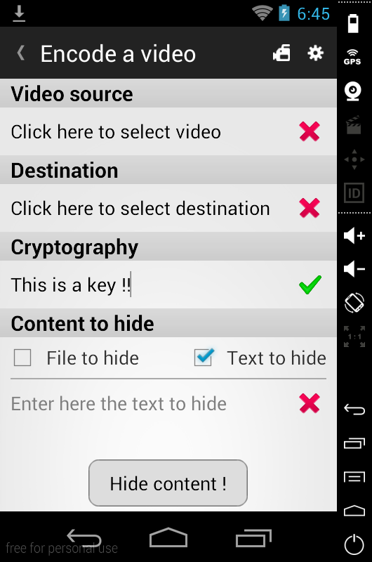

Figure 4: Encode screen

As the Figure 4 shows it, the Encode screen is divided into two main sections which are the header and the main content.

The header contains a back arrow, the title of the current screen, a camera icon and a setting icon. The back arrow allows the user to go back to the main screen by a simple click on it. The camera icon allows the user to access to the camera of the smartphone to record a video which can then contain the data to hide. The setting icon allows the user to access to the settings screen of the application, explained in the previous section of this document.

The main content contains several sections:

* A video source section
* A destination section
* A cryptography section
* A content to hide section

Each section is separated with a grey header containing the name of the section. The video source section allows the user to select the location of the video that will contain the data to hide. A simple click on this section will open the gallery or the file manager of the smartphone to select the video as shown in the Figure 5.

|  |  |
| --- | --- |
|  |  |
| Figure 5: Select video source | Figure 6: Select directory where to save  new video |

The destination section allows the user to select the directory where the new generated video - which will contain the hidden data - will be saved. A simple click on it will open a directory explorer as shown in the Figure 6. If no destination directory is selected when choosing the video source, the directory of the selected video will be used as the destination directory.

The cryptography section allows the user to specify the key to encrypt the data before hiding, with the previously selected algorithm in the Settings screen. If the user does not want to encrypt its data before hiding, this section is not visible.

The content to hide section allows the user to specify the content to hide in the video. The content can be a text or a file. If the user wants to hide a text, the user simply need to check the checkbox at the left of the “Text to hide” label and then fill the edit text below. Otherwise, if the user wants to hide a file, the user simply needs to check the checkbox at the left of the “File to hide” label. In this case, a button very similar to the video source section and the destination section will appear and will allow the user to select the file to hide.

Finally, at the bottom of the Encode screen, there is a button “Hide content” which will launch the process of hiding data into the selected video. This operation can have two results:

* Success
* Error

In the case of success the user is notify that a new video was created into the destination directory as shown in the Figure 7. Otherwise, one or more several error messages appear on the screen and indicate the errors that occurred before or during the process of hiding data as shown in the Figure 8.

|  |  |
| --- | --- |
|  |  |
| Figure 7: Success of the hiding process | Figure 8: Error during the hiding process |

Each section listed above have an icon on the right of the screen. This icon indicates if data selected or entered are valid or not.

**Notes:**

It is important to select a channel where data can be hidden. Otherwise the user will be notified with the following error message: “Not enough space in video to hide data with selected channel(s). You can hide a maximum of 0 bytes. Have you selected a channel in the settings”.

The key length of the cryptography algorithm must match the specifications of the selected algorithm. For instance, the AES 128 bits must have a key length of 16 bytes and the AES 192 bits must have a key length of 24 bytes..

The name of the MP4 output file is “steg_” following by the current date and time when the new video is created. For instance it could be “steg_20141221_234242.mp4”.

# Decode screen

As mentioned in the section 2 of this document, the main purpose of the decode screen is to try to find data that were hidden into a selected MP4 video. The Figure 9 shows how the decode screen is disposed.

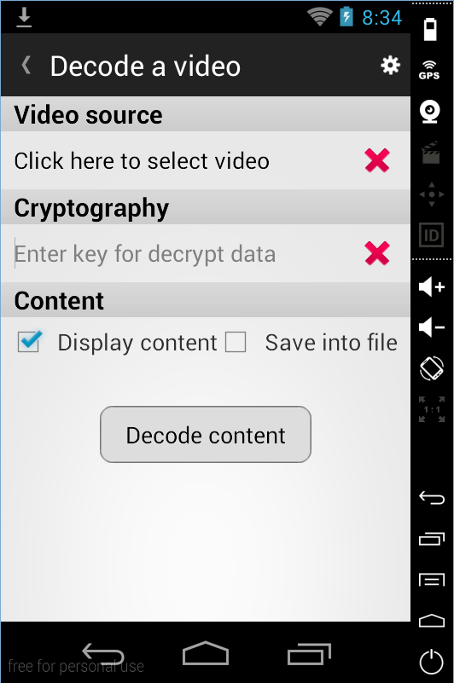

Figure 9: Encode screen

As the Figure 9 shows it, the Decode screen is divided into two main sections which are the header and the main content.

The header contains a back arrow, the title of the current screen, and a setting icon. The back arrow allows the user to go back to the main screen by a simple click on it. The setting icon allows the user to access to the settings screen of the application, explained in the previous section of this document.

The main content contains several sections:

* A video source section
* A cryptography section
* A content section

Each section is separated with a grey header containing the name of the section. The video source section allows the user to select the location of the video where the application will try to find hidden data. A simple click on this section will open the gallery or the file manager of the smartphone to select the video as shown in the Figure 5.

The cryptography section allows the user to specify the key to decrypt the data that were found into the selected MP4 video, with the previously selected algorithm in the Settings screen. If the user does not want to encrypt its data before hiding, this section is not visible.

The content section allows the user to select if the content found should be simply displayed on the screen or save into a file. In the case of the content should be saved into a file, a new button appears allowing the user to select the destination directory where the file will be saved as shown in the Figure 10.

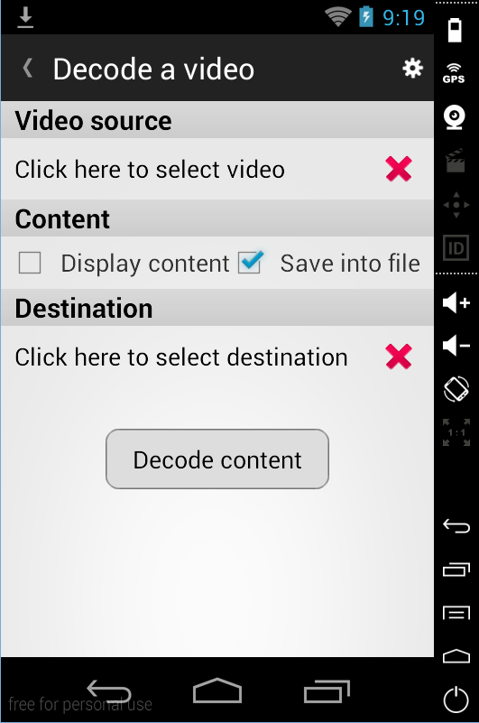

Figure 9: Encode screen with save file

Each section listed above have an icon on the right of the screen. This icon indicates if data selected or entered are valid or not.

**Notes:**

The key length of the cryptography algorithm must match the specifications of the selected algorithm. For instance, the AES 128 bits must have a key length of 16 bytes and the AES 192 bits must have a key length of 24 bytes.

The name of the output file containing the hidden data is “steg_decoded_” following by the current date and time when the new file is created. It is a text file. For instance it could be: “steg_decoded_20141221_234242.txt”.