**Florian Guiho**



**Mathis Dupuy**

**Stegandroid**

**Log Book**

Content

1. What is the project *Stegandroid* 3

2. What are the possible actions for the user 3

3. Technologies 4

4. Planning for the project 5

5. What has been achieved with the user interface 6

5.1 Main action 6

5.2 Setting action 6

5.3 Encode action 8

5.4 Decode action 9

5.5 Social network action 10

5.6 About action 10

6. Conclusion 11

# What is the project *Stegandroid*

Steganography is the art of hiding data into a media container. The media container can be a text file, a PDF document, an image or a video. More the container is small more it is hard to hide a lot of data and with efficiency. As a consequence, video offers interesting properties because these files are often very large.

The main purpose of the project *Stegandroid* is to perform steganography on video file on a mobile device. This document aims to describe some key points about the project. This document will be updated regularly as long as the development of the project will continue.

# What are the possible actions for the user

With *Stegandroid*, the user can perform several actions listed below:

* Select the action to perform. This action is known as the **main action**. With this action the user can select the following actions detailed later:
  + Setting action
  + Encode action
  + Decode action
  + Social network action
  + About action
* Set preferences for embedding and decode data. This action is known as the **setting action.** This action contains the following features:
  + Select the channels where steganography will be applied :
    - The video channel with the h264 part of the MP4
    - The audio channel with the AAC part of the MP4
    - The metadata channel where various information are stored about the media. It can be the name of the artist or whatever.
  + Select a cryptography algorithm to encrypt data before embedding data into the media container
* Embed data into a video container. This action is known as the **encode action**. This action contains the following features:
  + Select a video container where data will be embedded
  + Select a destination directory where to save the new video with embedded data
  + Select the type of the content to hide. It can be a simple text written by the user or a file.
  + If the content to hide is a file, the user can then select the file to hide
  + Enter a personal key which will be used to encrypt the data with the cryptography algorithm selected in the setting action
  + Access to the setting action in order to change the user’s preference
  + Access to the camera in order to record a video which can be potentially used to embed data
* Decode data into a video container. This action is known as the **decode action**. This action contains the following features:
  + Select the video which is supposed to contain the embedded data
  + Enter the personal key to decrypt the data with the cryptography algorithm selected in the setting action
  + Access to the setting action in order to change the user’s preference
* Upload and download video on social networks. This action is known as the **social network** action. This action contains the following features:
  + Connect with the login and the password
  + Upload a video on a social network
  + Download a video from a social network
* Consult the information relative to the project (e.g.: context of the project, creators, etc…). This action is known as about action.

**Note:** The actions listed above can be subject to modifications.

# Technologies

In order to complete the project, the following technologies have been retained:

* Android with Java
* Genymotion emulator to emulate the Android device
* Usage of MP4 containers
* Usage of the ‘*Java Advanced Audio Decoder*’ (JAAD) library to extract the audio from a MP4 container
* Usage of the IsoParser library to extract the video from a MP4 container, but also to create a MP4 container from the audio, video and metadata signals.

**Note:** The technologies listed above can be subject to modifications

# Planning for the project

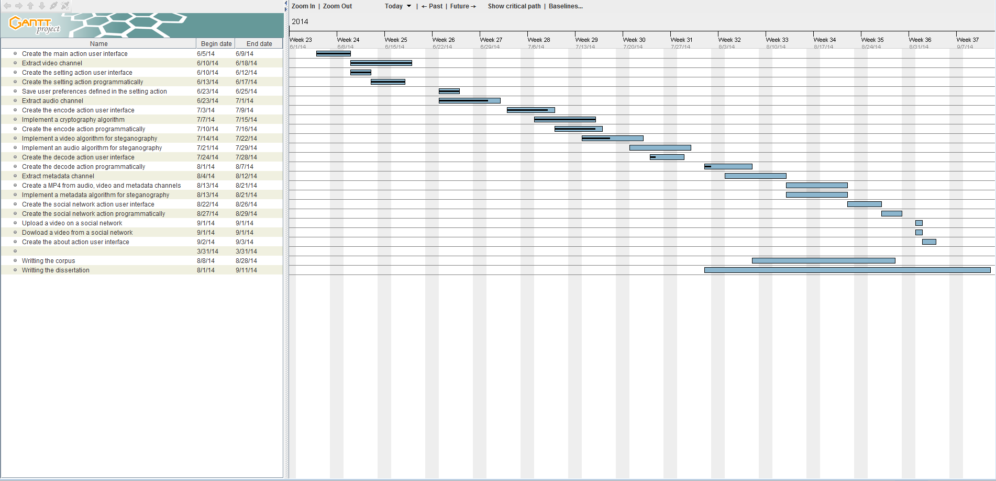

# What has been achieved with the user interface

## 5.1 Main action

As mentioned in the section 2 of this document, the main action allow the user to have access to the several actions. The main action was the first development of the project. Its development is now complete. The following images show screenshots of the main action:

|  |  |
| --- | --- |
| Figure 2:  Screenshot of the main action | Figure 3:  Screenshot of the main action with details |
|  |  |

The figure shows with numbers the access to the following actions:

* 1 = Access to the encode action
* 2 = Access to the decode action
* 3 = Access to the setting action
* 4 = Access to the about action

**Note:**  In this screenshot there is no button allowing the access to the social network action. This is due to the fact that the social network action will be the last action developed

## 5.2 Setting action

As mentioned in the section 2 of this document, the setting action allows the user to set the preferences for embedding and decoding data into a video a container. The following image shows a screenshot of the setting action:

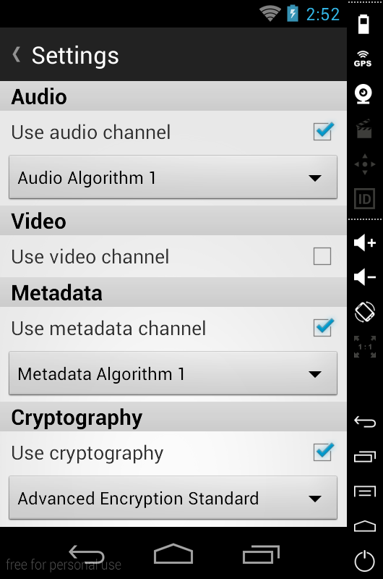

Figure 4:

Screenshot of the setting action

As the figure 4 shows it, the setting action is divided into several sections listed here:

* A header with the title of the action and an arrow on the left allowing the user to go back on the main action
* An audio section
* A video section
* A metadata section
* A cryptography section

Each section mentioned above is composed of a checkbox which allows the usage of the function such as the usage of the audio channel, the metadata channel, and the usage of cryptography as showed in the figure 4. Furthermore, if the checkbox is ticked, a spinner allowing the choice of the algorithm to apply appears. If the checkbox is unticked, the spinner is not visible.

The development of the setting action is now completed according to the actions listed in the section 2 of this document.

## 5.3 Encode action

As mentioned in the section 2 of this document, the encode action allows the user to embed data into a selected video. The following images show screenshots of the encode action:

|  |  |
| --- | --- |
| Figure 5:  Screenshot of the encode action with text to hide | Figure 6:  Screenshot of the encode action with file to hide |

As the figures 5 and 6 show it, the encode action is divided into several sections listed below:

* A header with the title of the action and an arrow on the left allowing the user to go back on the main action. On the right of the header, there is also a setting icon allowing the user to access to the setting action.
* A video source section which allows the user to select the source video
* A destination section which allows the user to select the destination directory where the new video with embedded content will be saved
* A content to hide which allows the user to select the content type to hide. If the ‘File to hide’ option is ticked, then the user is invited to select the file to hide. If the ‘Text to hide’ option is ticked, then the user is invited to manually enter a text to hide.

Finally there is a button which launches the process of embedding data.

The development of the user interface for the encode action with is not completed. It misses a button in the header allowing the user to access to the camera in order to record a video. It also missed a password field where the user can enter a key for a cryptography algorithm previously selected in the setting action.

## 5.4 Decode action

As mentioned in the section 2 of this document, the decode action allows the user to decode data which has been encoded in a video container. The following image show a screenshot of the decode action:

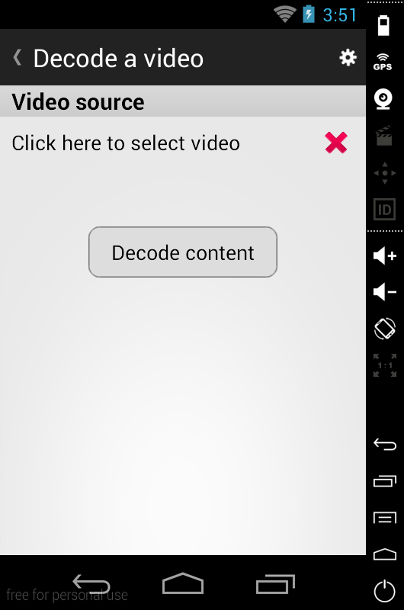

Figure 7:

Screenshot of the decode action

As the figures 7 shows it, the decode action is divided into several sections listed below:

* A header with the title of the action and an arrow on the left allowing the user to go back on the main action. On the right of the header, there is also a setting icon allowing the user to access to the setting action.
* A video source section which allows the user to select the source video

Finally there is a button which launches the process of decoding data.

The development of the user interface for the decode action is not completed yet. It misses components such as a password field where the user can enter a key for a cryptography algorithm previously selected in the setting action.

## 5.5 Social network action

As mentioned earlier in this document, the social network action has not been implemented yet. This action will be developed at the end of the project.

## 5.6 About action

As mentioned in the section 2 of this document, the about action purpose is to provide various information to the user about the project. The following image shows a screenshot of the action:

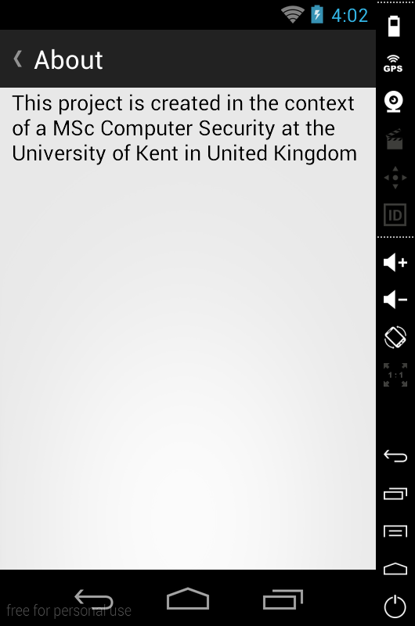

Figure 8:

Screenshot of the about action

As the screenshot above shows it, there is only a text at the current time. However, this is not the most important part of the project. As a consequence, the about action will be finished at the end of the project.

# Conclusion

This document presented some details about the *Stegandroid* project. However, as mentioned earlier, this document is not a final version. It will be updated as long as the project development will continue.