
DEPARTMENT OF COMPUTER SCIENCE AND ENGINEERING

Course: CSE489
Name: Md Akib
ID: 21201081
Email: md.akib@g.bracu.ac.bd

Project Title:
Fitness Platform & App — Flutter Mobile Application

Project Features:
By the end of this course, the following features have been fully implemented:
- User Authentication (Login & Sign Up)
- User Profile & Health Dashboard
- Workout Tracking
- Nutrition & Diet Tracking
- Trainer Marketplace

1. Project Overview

This project is a Flutter-based mobile fitness platform designed to upgrade and modernize an existing fitness ecosystem. The application provides users with a comprehensive health and fitness management solution in a single mobile app.

The platform enables users to track workouts, monitor health metrics, receive AI-driven personalized training plans, manage their daily nutrition and diet, and interact with professional trainers through a built-in marketplace.
Attribute | Value
Technology | Flutter (Dart) — Cross-platform mobile framework
Architecture | Provider + MVC pattern (Models, Providers, Screens)
Target OS | Android & iOS
State Mgmt | Provider (ChangeNotifier)
Local Storage | shared_preferences (auth persistence)
Charts | fl_chart library (bar chart, custom painter)

2. System Architecture

The application follows a Provider + MVC-like architecture. The three layers are strictly separated to ensure maintainability and testability:

Layer | Responsibility
Models | Pure data classes (no logic). Define the shape of data: UserModel, Exercise, WorkoutSession, Meal, FoodItem, Trainer.
Providers | Business logic and state management using ChangeNotifier. AuthProvider, WorkoutProvider, NutritionProvider, TrainerProvider.
Screens | UI-only widgets. Read state from providers via context.watch<>(). Never contain business logic directly.
Utils | Shared constants: AppTheme, AppColors — single source of truth for all visual styling.

Navigation Flow:
The navigation schema (from the provided schema diagram) is:
- Login Screen → (Sign In) → Health Dashboard
- Health Dashboard → (Navigate) → Workout Tracking
- Health Dashboard → (Navigate) → Nutrition Tracking
- Health Dashboard → (Navigate) → Trainers & Coaching
- Health Dashboard → (Navigate) → Profile Settings
All sub-screens have a Back action returning to the Health Dashboard.
Project File Structure:
lib/
main.dart # App entry, MultiProvider setup
models/
user_model.dart # User data class (BMI, initials helpers)
workout_model.dart # Exercise, WorkoutSession, mock data
nutrition_model.dart # FoodItem, Meal, DailyNutrition, FoodDatabase
trainer_model.dart # Trainer, TrainerData, filter categories
providers/
auth_provider.dart # Login / Signup / Logout logic
workout_provider.dart # Active session, rest timer, completion
nutrition_provider.dart # Daily food log, macro totals, search
trainer_provider.dart # Trainer search, filter, booking
screens/
login_screen.dart # Screen 1: Login
signup_screen.dart # Screen 1b: Registration
dashboard_screen.dart # Screen 2: Health Dashboard
workout_screen.dart # Screen 3: Workout Tracking
nutrition_screen.dart # Screen 4: Nutrition & Diet
trainer_screen.dart # Screen 5: Trainer Marketplace
utils/
app_theme.dart # Global colors, theme data

3. Feature Descriptions

3.1 User Authentication (Login & Sign Up)
The authentication system is managed entirely by AuthProvider. It uses a mock user database (simulating a real backend API) and exposes three public methods: login(), signUp(), and logout().

Key implementation details:
- Form validation — Flutter's GlobalKey<FormState> runs all field validators in one call
- Async state machine — AuthStatus enum (idle, loading, success, error) drives UI spinner and error banner
- Navigation guard — Navigator.pushReplacement() after login prevents returning to Login via Back
- Auto-login after signup — pushAndRemoveUntil() clears the entire navigation stack
- Password visibility toggle — obscureText state controlled per-field

Key Code — AuthProvider login():
Future<bool> login(String email, String password) async {
_status = AuthStatus.loading;
notifyListeners(); // triggers UI spinner

await Future.delayed(Duration(milliseconds: 1200)); // simulate API

final match = _registeredUsers.firstWhere(
(u) => u["email"] == email && u["password"] == password,
orElse: () => {},
);

if (match.isEmpty) {
_status = AuthStatus.error;
_errorMessage = "Invalid email or password.";
notifyListeners();
return false;
}

_currentUser = UserModel(...); // populate user model
_isLoggedIn = true;
_status = AuthStatus.success;
notifyListeners();
return true;
}

3.2 User Profile & Health Dashboard
The Health Dashboard is the central hub of the application. It is accessed immediately after login and provides an at-a-glance summary of the user's health and fitness status.

Dashboard components:
- Header — Personalized greeting with user initials avatar
- Metric Cards — Steps (8,240), Calories (1,820 kcal), Heart Rate (72 bpm)
- Weekly Activity Bar Chart — 7-day active minutes visualization using fl_chart BarChart
- Today's Plan Card — Shows AI-suggested workout with duration and exercise count
- AI Recommendation Card — Gradient card with personalized training tip
- Daily Goal Progress — Linear progress bar showing 72% completion
- Bottom Navigation Bar — 5 tabs: Home, Workout, Nutrition, Trainers, Profile

Key Code — Weekly Activity Bar Chart:
// Weekly activity data (Mon-Sun), values = active minutes
final weekData = [40.0, 65.0, 50.0, 80.0, 55.0, 90.0, 70.0];

BarChart(BarChartData(
maxY: 100,
gridData: FlGridData(show: false),
barGroups: List.generate(7, (i) {
return BarChartGroupData(x: i, barRods: [
BarChartRodData(
toY: weekData[i],
color: i == 5 ? AppColors.primary // highlight best day
: AppColors.primary.withOpacity(0.25),
width: 28,
borderRadius: BorderRadius.circular(6),
),
]);
}),
))

3.3 Workout Tracking
The Workout Tracking screen (Screen 3 from wireframe) provides a complete active session management system with exercise completion tracking and a live rest timer.

Workout Tracking components:
- Active Session Tab — Start Session button, session header with gradient, exercise checklist
- Exercise Cards — Name, sets × reps × weight, animated completion circle, Done/Next badge
- Rest Timer — 45-second countdown using Timer.periodic(), Skip button
- Progress Bar — Real-time progress ratio (completed / total exercises)
- History Tab — List of past workout sessions with category icon and date
- Swipe actions — Exercises can be completed by tapping the circle checkbox

Key Code — Rest Timer (WorkoutProvider):
// Starts a countdown timer for the rest period after an exercise
void _startRestTimer(int seconds) {
_restTimer?.cancel(); // cancel any existing timer first
_restSeconds = seconds;
_isResting = true;
notifyListeners();

_restTimer = Timer.periodic(const Duration(seconds: 1), (timer) {
if (_restSeconds > 0) {
_restSeconds--;
notifyListeners(); // updates countdown UI every second
} else {
_isResting = false;
timer.cancel(); // prevent memory leak
notifyListeners();
}
});
}

@override
void dispose() {
_restTimer?.cancel(); // IMPORTANT: clean up on widget dispose
super.dispose();
}

3.4 Nutrition & Diet Tracking
The Nutrition screen (Screen 4) provides a complete daily diet tracking system with macro breakdown, meal management, and a searchable food database.

Nutrition Tracking components:
- Calorie Summary Card — Shows consumed vs goal (1,820 / 2,400 kcal), remaining kcal badge
- Donut Chart — Custom CustomPainter drawing 3 arcs: Carbs (blue), Protein (green), Fat (orange)
- Macro Cards — Carbs / Protein / Fat each with value, goal, and mini progress bar
- Meal Cards — Breakfast, Lunch, Dinner, Snacks — expandable, show all food items
- Swipe to Delete — Dismissible widget allows swiping food items left to remove
- Add Food Sheet — Searchable food database (15 items), real-time filtering, tap to add
- Meal Selector — Bottom sheet to select which meal to log into

Key Code — Donut Chart (CustomPainter):
// Draws 3 arcs representing Carbs, Protein, Fat ratios
class _DonutPainter extends CustomPainter {
@override
void paint(Canvas canvas, Size size) {
final center = Offset(size.width / 2, size.height / 2);
final radius = size.width / 2 - 12;
double startAngle = -pi / 2; // start from top

void drawArc(double ratio, Color color) {
if (ratio <= 0) return;
final sweepAngle = ratio * 2 * pi - 0.05; // small gap
canvas.drawArc(
Rect.fromCircle(center: center, radius: radius),
startAngle + 0.025,
sweepAngle,
false,
Paint()
..color = color
..style = PaintingStyle.stroke
..strokeWidth = 22
..strokeCap = StrokeCap.round,
);
startAngle += ratio * 2 * pi;
}

drawArc(carbsRatio, AppColors.chartBlue);
drawArc(proteinRatio, AppColors.chartGreen);
drawArc(fatRatio, AppColors.chartOrange);
}
}

3.5 Trainer Marketplace
The Trainer Marketplace (Screen 5) provides a searchable, filterable directory of certified fitness trainers. Users can browse profiles, filter by specialty, and book sessions.

Trainer Marketplace components:
- Search Bar — Live text filtering across trainer name, specialty, and tags
- Category Chips — All · Strength · Cardio · HIIT · Nutrition · Yoga (animated active state)
- Trainer Cards — Avatar with initials, name, specialty, star rating, price pill, Book button
- Top-Rated Badge — ⭐ overlay on trainer avatar for top-rated trainers
- Book Button — State managed by TrainerProvider; turns green "✓ Booked" and persists
- Trainer Detail Sheet — Full profile with bio, stats (rating/reviews/experience), specialty tags
- Empty State — Friendly "No trainers found" UI when search yields no results

Key Code — Category Filter + Search (TrainerProvider):
// Returns filtered trainers based on active category and search query.
// Search query takes priority over category filter when both are active.
List<Trainer> get filteredTrainers {
if (_searchQuery.trim().isNotEmpty) {
return TrainerData.search(_searchQuery); // search overrides category
}
return TrainerData.byCategory(_selectedCategory);
}

// Sets the active category chip and clears any search query.
void selectCategory(String category) {
_selectedCategory = category;
_searchQuery = ""; // clear search when switching categories
notifyListeners();
}

4. Screenshots

The following screenshots illustrate the key screens of the application, matching the wireframes provided in the project specification.

Screen 1 — Login Screen — Email/password fields, Log in button, Google & Apple sign-in options, Sign up link
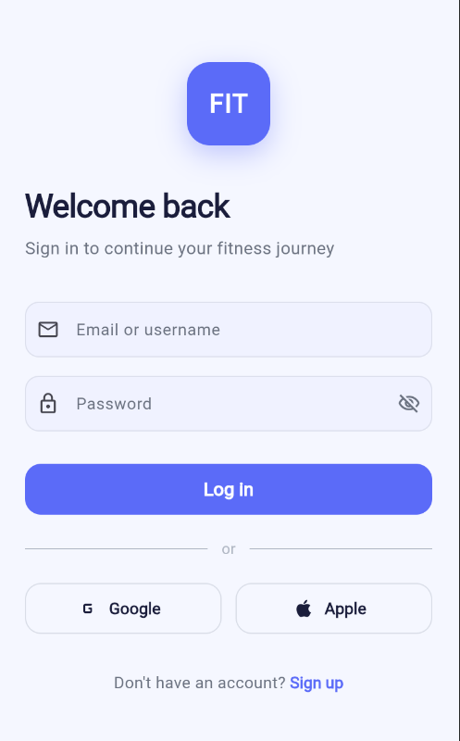
Screen 1b — Sign Up Screen — Full name, email, password, confirm password fields, Terms checkbox, Create Account button
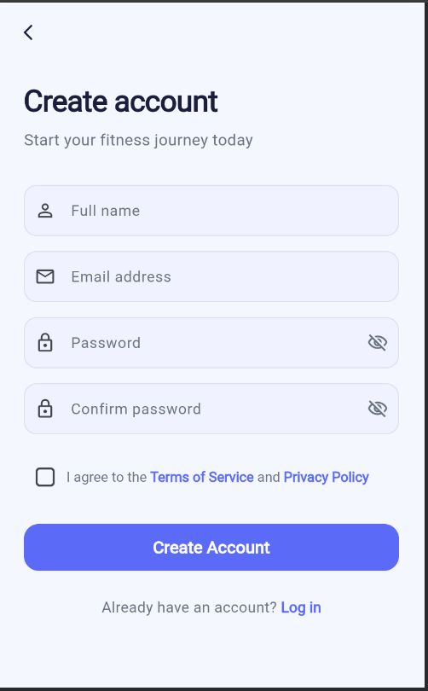
Screen 2 — Health Dashboard — Steps/Calories/Heart rate cards, weekly bar chart, Today's Plan card, AI recommendation, daily goal progress bar
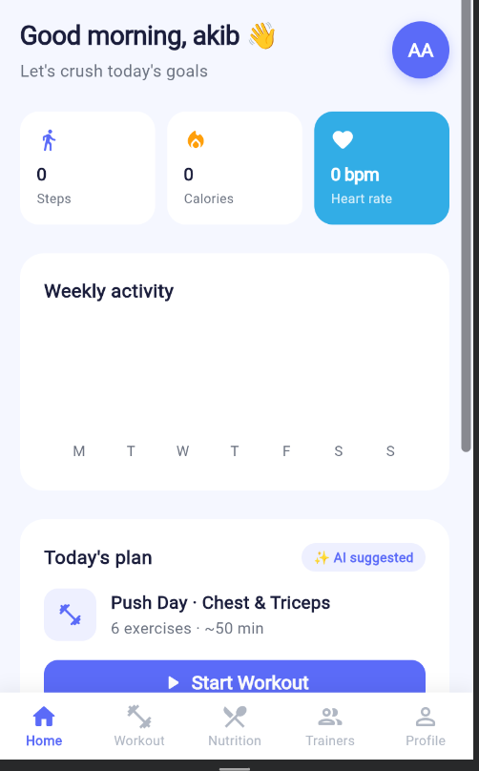
Screen 3 — Workout Tracking — Session header with Start button, exercise checklist, rest timer countdown, progress bar, History tab
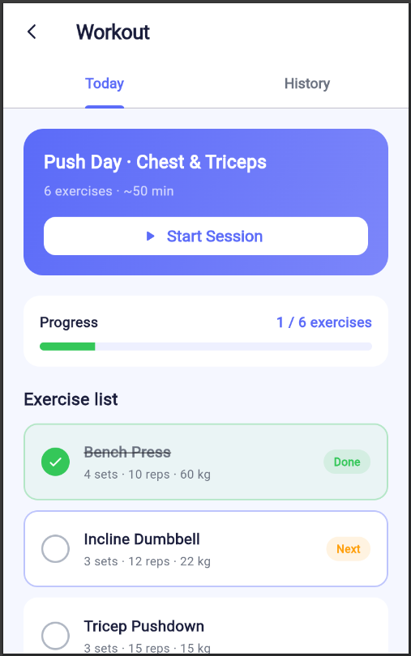
Screen 4 — Nutrition & Diet — Donut macro chart, Carbs/Protein/Fat cards, expandable meal cards, Add Food search sheet
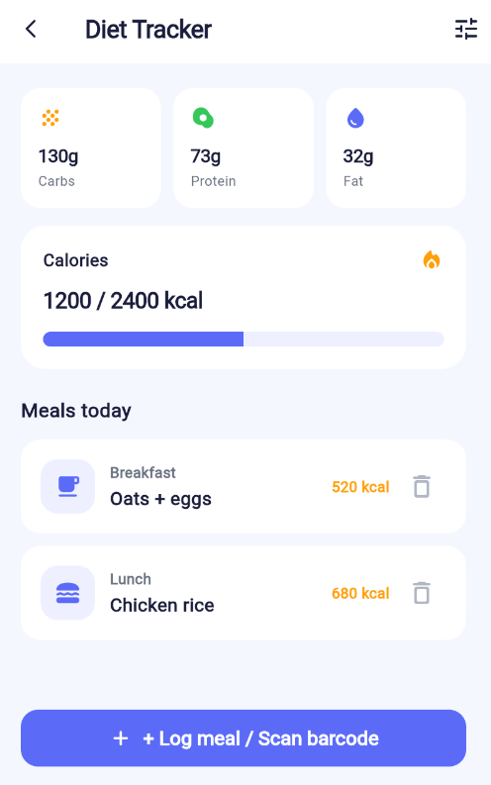
Screen 5 — Trainer Marketplace — Search bar, category filter chips, trainer cards with rating and price, Trainer detail bottom sheet
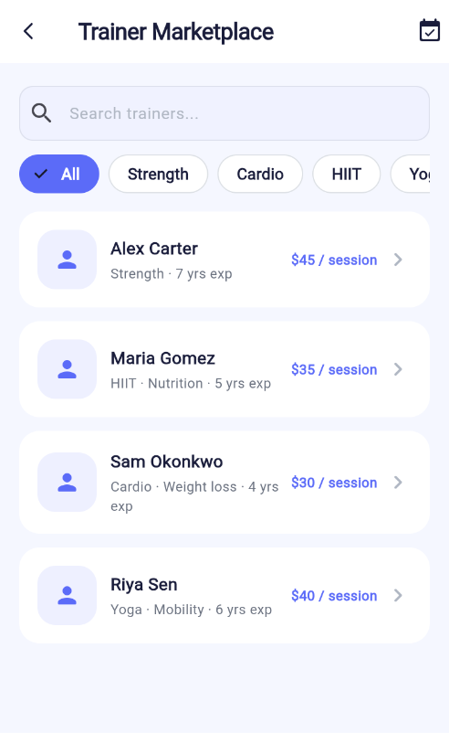

5. Online Resources Used

a) References:
- Flutter Official Documentation — https://docs.flutter.dev
- Dart Language Tour — https://dart.dev/guides/language/language-tour
- Provider Package (pub.dev) — https://pub.dev/packages/provider
- fl_chart Package — https://pub.dev/packages/fl_chart
- Material Design 3 Guidelines — https://m3.material.io
- Flutter Widget Catalog — https://docs.flutter.dev/reference/widgets

b) Stack Overflow / GitHub links:
- Custom Painter in Flutter — https://stackoverflow.com/questions/tagged/flutter+custompaint
- Flutter Provider State Management — https://stackoverflow.com/questions/tagged/flutter+provider
- Dismissible Widget (swipe to delete) — https://api.flutter.dev/flutter/widgets/Dismissible-class.html
- ModalBottomSheet usage — https://api.flutter.dev/flutter/material/showModalBottomSheet.html
- Flutter Timer.periodic — https://api.dart.dev/stable/dart-async/Timer/Timer.periodic.html
- fl_chart BarChart examples — https://github.com/imaNNeo/fl_chart/tree/main/example

6. Future Enhancements

The following enhancements can be added to the current system to further improve functionality, scalability, and user experience:

- Real Backend API Integration — Replace mock data with a REST API (Node.js / Django / Firebase) for persistent user data, real-time syncing, and multi-device support.
- Local Database (SQLite / Hive) — Persist workout history, meal logs, and user preferences locally using the sqlite or hive package for offline-first support.
- Profile Settings Screen — Allow users to update weight, height, goal, notification preferences, and account details (Screen 6 from schema diagram).
- Barcode Scanner for Food Logging — Integrate the mobile_scanner package to scan food product barcodes and auto-populate nutritional data from an external food API.
- Real AI/ML Recommendations — Connect to an ML model or LLM API to generate truly personalized workout and nutrition plans based on the user's history and biometrics.
- In-App Trainer Chat — Add real-time messaging between users and booked trainers using Firebase Realtime Database or WebSockets.
- Push Notifications — Remind users of scheduled workouts, meal logging, rest day reminders, and trainer session appointments using flutter_local_notifications or FCM.
- Payment Integration — Implement Stripe or SSL Commerz payment gateway for booking paid trainer sessions within the Trainer Marketplace.
- Dark Mode Support — Add a dark theme variant using Flutter's ThemeMode.dark with the existing AppColors constants for a seamless toggle.
- Wearable Device Integration — Sync real step count, heart rate, and calorie burn data from smartwatches or fitness bands using the health package.

