

**A**

**Report On**

**“MOVIE TICKET BOOKING SYSTEM”**

**Submitted to**

**KIT’S College of Engineering (Autonomous), Kolhapur**

**Submitted By: -**

Sarvesh Gawade (A01)

Irfan Mestri (A04)

Akib Maner (A05)

Sanmil Gaonkar (A11)

**Submitted To: -**

**Mrs. R. B. Pandhare Mam**

**Department of Computer Science & Engineering**

**KIT’S College Of Engineering, Kolhapur.**

**The year 2021-2022**

**KIT’S College of Engineering (Autonomous), Kolhapur**

Department of Computer Science

### MINI PROJECT WORK

This is to certify that the project entitled

**“MOVIE TICKET BOOKING SYSTEM”**

is the bonafide record of mini-project work done by

Sarvesh Gawade (A01)

Irfan Mestri (A04)

Akib Maner (A05)

Sanmil Gaonkar (A11)



Project Guide Head of the Department

**Mrs. R.B. Pandhare DR. M. S. Kalas**

Submitted for the Mini Project Examination held on

- -

Internal Examiner External Examiner

## DECLARATION

## I certify that

## The work contained in this report is original and has been done by us under the guidance of my supervisor

## The work has not been submitted to any other institute for any degree or diploma.

## I have followed the guidelines provided by the institute in preparing the report.

## I have confirmed the norms and guidelines given in the Ethical Code of Conduct of the Institute

## Whenever I have used materials (data, theoretical analysis, figures, and text) from other sources, I have given due credit to them by citing them in the text of the report and giving their details in the references. further, I have taken permission from the copyright owners of the sources, whenever necessary.

Signature of the Students:

Sarvesh Gawade (A01) Irfan Mestri (A04) Akib Maner (A05) Sanmil Gaonkar(A11)

## ACKNOWLEDGMENT

We would like to express our deep gratitude to Mrs. R.B. Pandhare & H.O.D, Ms. M. S. Kalas, for their constant encouragement and belief in us. Their guidance and attention thought the community services work has been of immense help to us. We express our sincere thanks to all the teaching and non-teaching staff and all those who have directly and indirectly helped in conducting these activities successfully.

## ABSTRACT

The project objective is to book cinema tickets. This application will reserve the tickets. This ticket reservation system provides a website for a cinema hall where any user can access it. The user is required to log in to the system and needs basic knowledge of payments for booking the tickets.

Tickets can be collected at the counter and watching movies with family and friends in the theatre is one of the best mediums of entertainment after having a hectic schedule. But all this excitement vanishes after standing in hours in long queues to get tickets booked. The website provides complete information regarding currently running movies with details of show timings and available seats.

 Ticket reservations are done using various payment methods. Our ticket reservation system is one of the best opportunities for those who cannot afford enough time to get their tickets reserved while standing in long queues. Now people can book tickets at any time of day or night.

**Table of Contents**

**Chapter 1 .........................................................................................................................1**

Introduction ............................................................................................................................1

1.1 Problem Statement.....................................................................................................1

1.2 Points to be covered...................................................................................................1

1.3 Scope .........................................................................................................................2

**Chapter 2 ..........................................................................................................................3**

Project Management ...............................................................................................................3

2.1 Methodology ...............................................................................................................3

2.2 Project Plan .................................................................................................................4

2.3Project Management Life Cycle ..................................................................................4

**Chapter 3 .......................................................................................................................5**

System Analysis .....................................................................................................................5

3.1 Background Study ........................................................................................................5

3.2 Software system attributes ...........................................................................................5

3.2.1 Reliability ...............................................................................................................5

3.2.2 Availability ............................................................................................................5

3.3.3 Security ..................................................................................................................5

3.3 Scope of working .........................................................................................................6

**Chapter 4 ........................................................................................................................7**

System Design ........................................................................................................................7

4.1 Data Flow Diagram……………………………………..............................................8

4.2 Customer Use Case………………………………………………………………….9

4.3 User Interface .............................................................................................................

**Chapter 5 ..........................................................................................................................11**

System Testing ....................................................................................................................11

5.1 Integration Testing ...................................................................................................11

5.2 Unit Testing ..............................................................................................................11

5.3 System Testing .........................................................................................................11

5.4 Test Chart…………………………………………………………………………..11

**Chapter 6 ..........................................................................................................................12**

Conclusion ..............................................................................................................................12

6.1 Conclusions ..................................................................................................................12

6.2 Limitations of the system .............................................................................................12

**Chapter 1**

**Introduction**

Software-oriented booking systems bring tour and activity business owners into the 21st century. And when you pair the technology with old-school customer service, your business gets an exciting edge for selling services. “ What If you can check whether a ticket for a certain movie is available in your nearest possible theatre through your device ?” or “what if instead of having queued for the tickets you book as many as you can at home in a few clicks ? ” or “there is no problem asking for the change for money while booking the tickets !”. So now it is possible to do so, with our software.

**1.1 Problem Statement**

The traditional way of booking the ticket for the movie is the customer needs to go to the specific theatre where the desired movie was playing and need to stand in queue and buy the ticket for the movie this will become more difficult for a person to overcome this problem the project gives a real-life understanding of online movie ticket booking system and activities performed by various roles in the supply chain. Here we provide automation for movie ticket booking. The movie ticket booking system project captures activities performed by different roles in real-life ticket booking which provides enhanced techniques for maintaining the required information up to date, which results in efficiency. The project gives a real-life understanding of the movie ticket booking system and activities performed by various roles in the supply chain.

**1.2 Points to be covered**

1. Movie to be watched
2. Displaying total seats reserved and remaining seats
3. No. of seats to be booked.
4. Class of seats.
5. Confirmation of tickets booked.

**1.3 Scope**

This software system will be a Movie Ticket Booking System. This system will be designed to maximize the ease the customers to book tickets, which would otherwise have to be booked by standing in long queues at the theaters.

More specifically, this system is designed to allow a customer to book his tickets at any time of the day. The system also contains a relational database containing a list of Movies, Timings, Seats, Prices, and Bookings.

**Chapter 2**

**Project Management**

**2.1 Methodology**

We have used the Iterative and Incremental Development model (IID) for our project development. This development approach is also referred to as the Iterative Waterfall Development approach. Iterative and Incremental Development is a software development process developed in response to the more traditional waterfall model. This model is designed to take care of such a big project. The large and complicated projects chiefly demand better development and testing procedure. The waterfall model is well known for its repeated testing process. Hence we choose the waterfall model for developing my software.

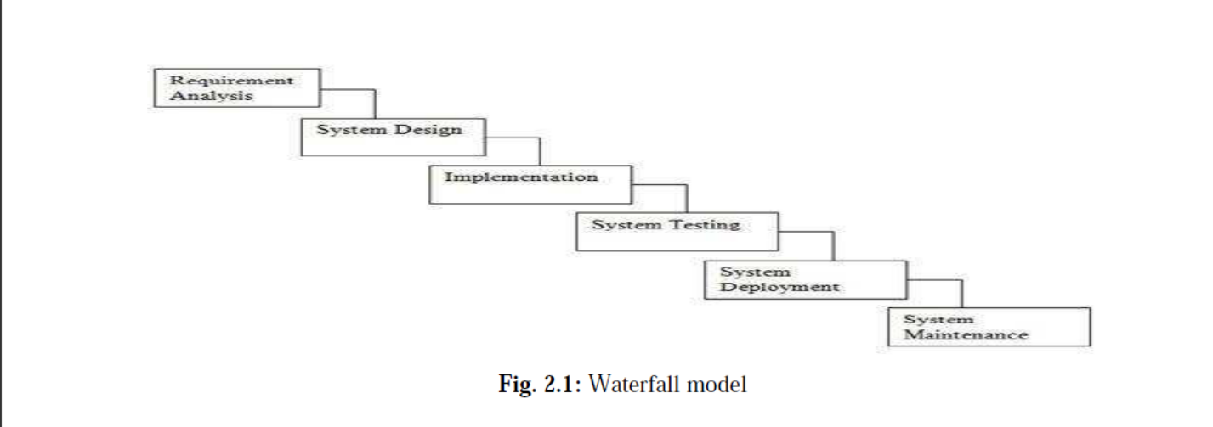

Some advantages of the waterfall model:

o Simple and easy to understand and use.

o, Easy to manage due to the rigidity of the model.

o Phases are processed and completed one at a time

o Works well for smaller projects where requirements are very well understood.

**2.2 Project Plan:**

Once we examine that the project is feasible, we undertake project planning. The table below describes

how we planned my project.

**2.1.2 Project Management Life Cycle**

The Project Management Life Cycle has four phases. Each project life cycle phase is described along

with the tasks need to be complete it

The four phases are

1. Initiation

2. Planning

3. Execution

4. Closure.

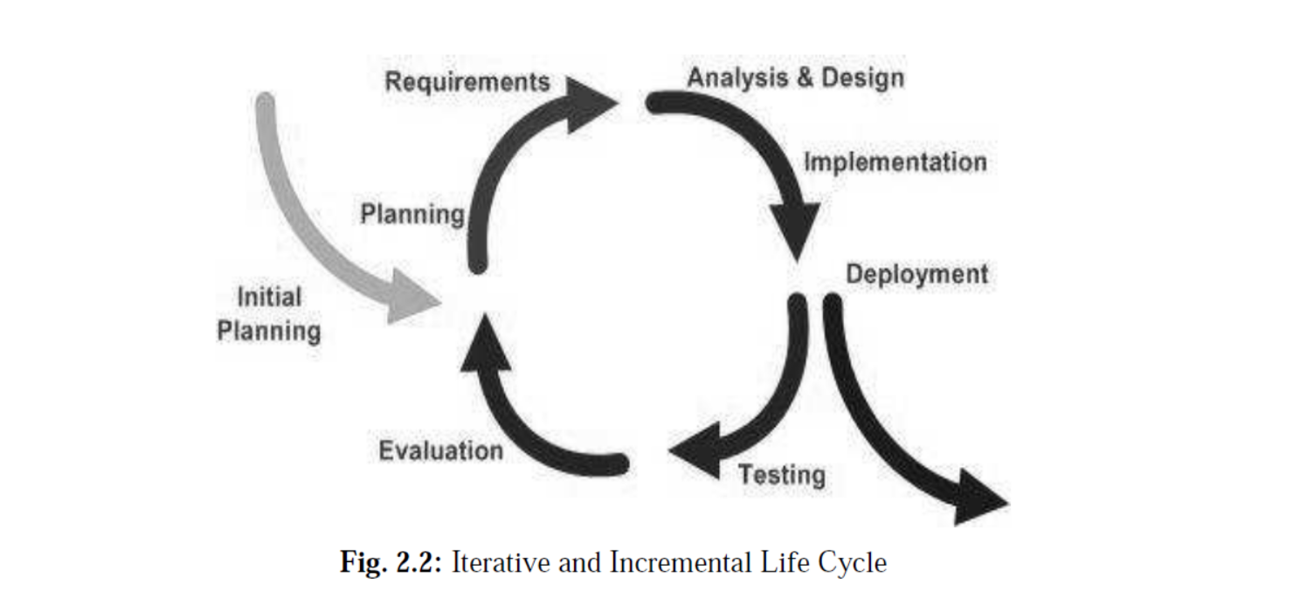

**Chapter 3**

**System Analysis**

**3.1 Background Study**

System Analysis is a separation of a substance into parts for study and their implementation and detailed examination. Before designing any system the nature of the business and the way it currently operates must be clearly understood. The detailed examination provides the specific data required during design to ensure that all the client's requirements are fulfilled. The investigation or the study conducted during the analysis phase is largely based on the feasibility study. Rather it would not be wrong to say that the analysis and feasibility phases overlap. The high-level analysis begins during the feasibility study. Though analysis is represented as one phase of the system development life cycle (SDLC), this is not true. The analysis begins with system initialization and continues until its maintenance. Even after successful implementation of the system, the analysis may play its role in the periodic maintenance and up-gradation of the system. One of the main causes of project failures is inadequate understanding, and one of the main causes of inadequate understanding of the requirements is the poor planning of system analysis.

**3.2 Software system attributes**

**3.2.1 Reliability**: This application is a reliable product that produces fast & verified output of all its process.

**3.2.2 Availability:** This application will be available to use and help them to carry out their operations conveniently.

**3.2.3 Security:** This application will be designed in a maintainable manner. It will be easy to incorporate new requirements in the individual modules.

**3.3 Scope of working:**

The proposed software product is the Movie ticket booking system. More specifically, this system is designed to allow a customer to book his tickets at any time of the day. The system also contains a relational database containing a list of Movies, Timings, Seats, Prices, and Bookings... The current system in use is an offline-based movie ticket booking system. It is very time-consuming. The system intends to reduce the time gap and provide ease of movie ticket booking to customers. Requirement statements in these documents are both functional and non-functional.

**Chapter 4**

**System Design**

**4.1 Data Flow Diagram of Movie Ticket Booking System**

The context diagram is the most abstract data flow representation of a system. It represents the entire system as a single bubble. The various external entities with which the system interacts and the data flow occurring between the system and the external entities are also represented. The name context diagram is well justified because it represents the context in which the system is to exist i.e. the external entities (users) that would interact with the system and specific data items they would be receiving from the system.

**4.2 Customer Use Case :**

**[A]** Customer initiates a login to the website/system by his/her name.

**[B]** The Customer accesses the Movie Ticket Booking System and selects the movie from the given list

**[C]** The Customer searches and selects for a movie timing

**[D]** The Customer chooses to book the movie by logging in with his/her name and contact no.

**[E]** The Customer enters the no. of tickets and class (classic and prime) for booking. He will get the message if the seats are full.

**[F]** The Customer enters the payment details.

**[G]** Customer gets ticket finalization message if the payment is successful.

**4.3 User Interface**

**4.3.1 Home Page**

**Actor-1:** any user

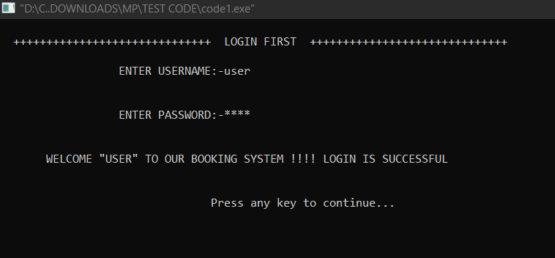

**4.3.2 Admin login page**

**Actor:** Admin users

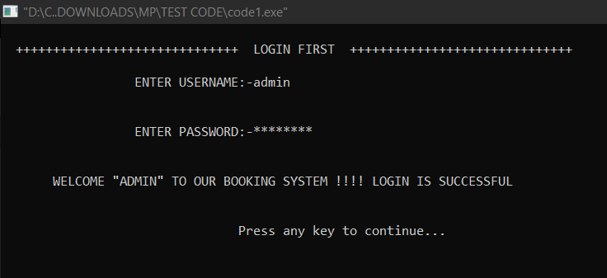

**Flow:**

1. Only Admin users can browsers this page.

2. Admin users can search all the old transactions of booking

**4.3.3 Transaction History page**

**Actor:** Admin users

**Output:** Transaction History.

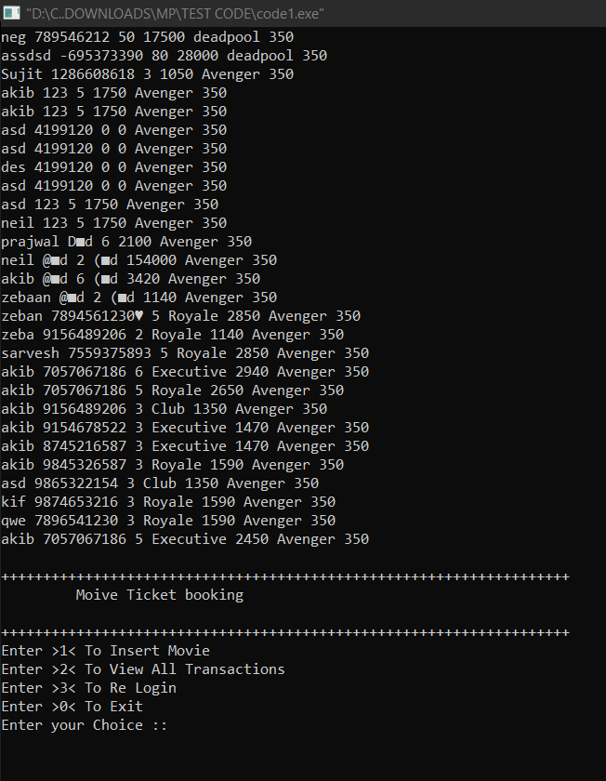**Flow:**1. Admin users can browse this page.

2. Admin users can view all appointment history.

**Chapter 5**

**System Testing**

**5.1 Integration Testing**

Integration testing is done before, during, and after the integration of a new module into the main software package. This involves testing each code module. One piece of software can contain several modules which are often created by several different programmers. It is crucial to test each module's effect on the entire program model. After integration testing, the project works successfully.

**5.2 Unit Testing**

Unit testing is performed on each module or block of code during development. Unit testing is normally done by the programmer who writes the code.

**5.3 System Testing**

System testing is done by a professional testing agent on the completed software product before it is introduced to the market.

**5.4 Test Chart**

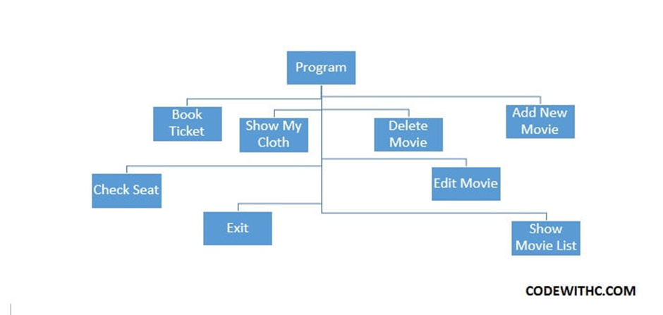

**Chapter 6**

**Conclusion**

**6.1 Conclusions**

1. This project has been developed successfully and the performance of the system has been found satisfactory.

2. Use of this interface helps customers in having immediate information about running movies and reserve their seats without wasting their precious time.

3. User-friendly Interface also for the admin to add and delete movie information

**6.2 Limitations of the system**

o Online payment is not available in this version.

o Data delete & edit system is not available for all sections.

o User account not verified by Mobile SMS not available in this system.