ROAD ACCIDENT REPORT SQL QUERIES

CY Casualties
Select sum(Number_of_Casualties) as CY_casualties
from road_accident where year(Accident_Date)='2022'
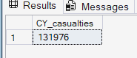
CY_Accidents
Select count(Distinct Accident_Index) as CY_Accidents
from road_accident where year(Accident_Date)='2022'
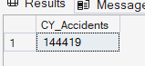
CY_Fatal_Casualties
Select sum(Number_of_Casualties) as CY_Fetal_Casulties
from road_accident where year(Accident_Date)='2022'
and Accident_Severity='Fatal'
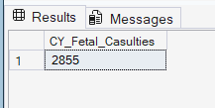
CY_Seriuos_Casualties
Select sum(Number_of_Casualties) as CY_Serious_Casulties
from road_accident where year(Accident_Date)='2022'
and Accident_Severity='Serious'
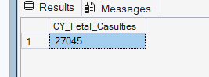
CY_Slight_Casualties
Select sum(Number_of_Casualties) as CY_Slight_Casulties
from road_accident where year(Accident_Date)='2022'
and Accident_Severity='Slight'
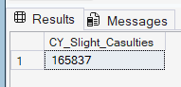
T_Fatal_Casulties
Select sum(number_of_casualties) as T_Fatal_Casulties
from road_accident where Accident_Severity='Fatal'
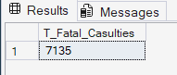
T_Serious_Casulties
Select sum(number_of_casualties) as T_Serious_Casulties
from road_accident where Accident_Severity='Serious'
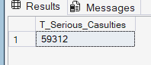
T_Slight_Casulties
Select sum(number_of_casualties) as T_Slight_Casulties
from road_accident where Accident_Severity='Slight'
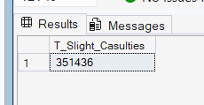
PCT fatal
Select CAST((CAST(sum(number_of_casualties) as decimal(10,2))/
(select CAST(sum(number_of_casualties) as decimal(10,2))
from road_accident))*100 as decimal(10,2)) as PCT
from road_accident where Accident_Severity='Fatal'
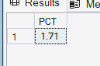
PCT Serious
Select CAST((CAST(sum(number_of_casualties) as decimal(10,2))/
(select CAST(sum(number_of_casualties) as decimal(10,2))
from road_accident))*100 as decimal(10,2)) as PCT
from road_accident where Accident_Severity='Serious'
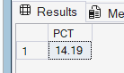
PCT Slight
Select CAST((CAST(sum(number_of_casualties) as decimal(10,2))/
(select CAST(sum(number_of_casualties) as decimal(10,2))
from road_accident))*100 as decimal(10,2)) as PCT
from road_accident where Accident_Severity='Slight'
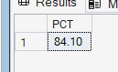
Vehicle_group and CY_casualties
select
case
When vehicle_type in ('Car','Taxi/Private hire car') then 'Car'
When vehicle_type in ('Bus or coach (17 or more pass seats','Minibus (8 - 16 passenger seats)') then 'Bus'
When vehicle_type in ('Motorcycle over 125cc and up to 500cc','Motorcycle over 500cc','Motorcycle 125cc and under','Motorcycle 50cc and under','Pedal cycle') then 'Bike'
When vehicle_type in ('Agricultural vehicle') then 'Agricultural'
When vehicle_type in ('Van / Goods 3.5 tonnes mgw or under','Goods 7.5 tonnes mgw and over','Goods over 3.5t. and under 7.5t') then 'Van'
ELSE 'Others'
END as Vehicle_group, sum(number_of_casualties) as CY_casualties
from road_accident where year(accident_date)= '2022'
group by
case
When vehicle_type in ('Car','Taxi/Private hire car') then 'Car'
When vehicle_type in ('Bus or coach (17 or more pass seats','Minibus (8 - 16 passenger seats)') then 'Bus'
When vehicle_type in ('Motorcycle over 125cc and up to 500cc','Motorcycle over 500cc','Motorcycle 125cc and under','Motorcycle 50cc and under','Pedal cycle') then 'Bike'
When vehicle_type in ('Agricultural vehicle') then 'Agricultural'
When vehicle_type in ('Van / Goods 3.5 tonnes mgw or under','Goods 7.5 tonnes mgw and over','Goods over 3.5t. and under 7.5t') then 'Van'
ELSE 'Others'
End
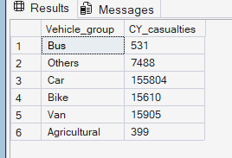

Vehicle_group and T_casualties
select
case
When vehicle_type in ('Car','Taxi/Private hire car') then 'Car'
When vehicle_type in ('Bus or coach (17 or more pass seats','Minibus (8 - 16 passenger seats)') then 'Bus'
When vehicle_type in ('Motorcycle over 125cc and up to 500cc','Motorcycle over 500cc','Motorcycle 125cc and under','Motorcycle 50cc and under','Pedal cycle') then 'Bike'
When vehicle_type in ('Agricultural vehicle') then 'Agricultural'
When vehicle_type in ('Van / Goods 3.5 tonnes mgw or under','Goods 7.5 tonnes mgw and over','Goods over 3.5t. and under 7.5t') then 'Van'
ELSE 'Others'
END as Vehicle_group, sum(number_of_casualties) as CY_casualties
from road_accident
group by
case
When vehicle_type in ('Car','Taxi/Private hire car') then 'Car'
When vehicle_type in ('Bus or coach (17 or more pass seats','Minibus (8 - 16 passenger seats)') then 'Bus'
When vehicle_type in ('Motorcycle over 125cc and up to 500cc','Motorcycle over 500cc','Motorcycle 125cc and under','Motorcycle 50cc and under','Pedal cycle') then 'Bike'
When vehicle_type in ('Agricultural vehicle') then 'Agricultural'
When vehicle_type in ('Van / Goods 3.5 tonnes mgw or under','Goods 7.5 tonnes mgw and over','Goods over 3.5t. and under 7.5t') then 'Van'
ELSE 'Others'
End
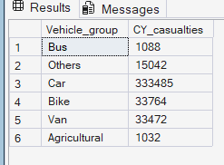
CY_casualties monthly trend
select DATENAME(MONTH,accident_date), sum(number_of_casualties)
from road_accident where year(accident_date)='2022'
group by DATENAME(MONTH,accident_date)
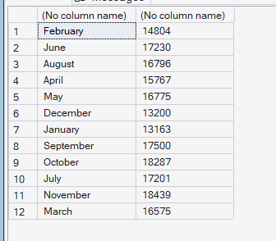
Casualties by road type
select road_type, sum(number_of_casualties) as CY_casualties
from road_accident where year(accident_date)='2022'
group by road_type
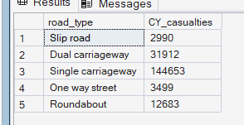
Casualties by urban/rural
select urban_or_rural_area, cast(cast(sum(number_of_casualties) as
decimal(10,2)) *100/(select cast(sum(number_of_casualties) as
decimal(10,2)) from road_accident where year(accident_date)='2022')
as decimal(10,2)) as PCT from road_accident where year(accident_date)='2022'
group by urban_or_rural_area
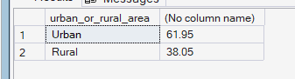
Casualty by location
select urban_or_rural_area, sum(number_of_casualties) as 'Total casualties',
cast(cast(sum(number_of_casualties) as
decimal(10,2)) *100/(select cast(sum(number_of_casualties) as
decimal(10,2)) from road_accident)
as decimal(10,2)) as PCT from road_accident
group by urban_or_rural_area
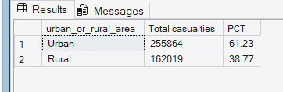
Casualties by light condition
select
case
when light_conditions in ('Darkness - no lighting','Darkness - lights lit','Darkness - lighting unknown','Darkness - lights unlit') then 'Night'
else 'Day'
end as light_condition_grouped,
cast(cast(sum(number_of_casualties) as
decimal(10,2)) *100/(select cast(sum(number_of_casualties) as
decimal(10,2)) from road_accident where year(accident_date)='2022')
as decimal(10,2)) as PCT from road_accident
where year(accident_date)='2022' group by
case
when light_conditions in ('Darkness - no lighting','Darkness - lights lit','Darkness - lighting unknown','Darkness - lights unlit') then 'Night'
else 'Day'
end
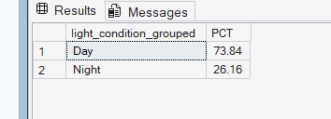
Top 10 locations by total casualties
select top 10 local_authority, sum(Number_of_casualties) as
Total_casualties from road_accident group by local_authority
order by Total_casualties DESC
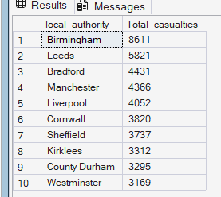
Casualties by road condition
select
case
when road_surface_conditions in ('Dry') then 'Dry'
when road_surface_conditions in ('Wet or damp','Flood over 3cm. deep') then 'Wet'
else 'snow'
end as 'road_surface_condition', sum(number_of_casualties) CY_casualties
from road_accident where year(accident_date)='2022'
group by
case
when road_surface_conditions in ('Dry') then 'Dry'
when road_surface_conditions in ('Wet or damp','Flood over 3cm. deep') then 'Wet'
else 'snow'
end
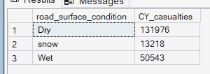
Casualties by weather condition
select
case
when weather_conditions in ('Fine no high winds','Fine + high winds') then 'Fine'
when weather_conditions in ('Raining no high winds','Raining + high winds') then 'Rain'
when weather_conditions in ('Snowing no high winds','Snowing + high winds') then 'Snow'
else 'Others'
end as 'road_surface_condition', sum(number_of_casualties) CY_casualties
from road_accident where year(accident_date)='2022'
group by
case
when weather_conditions in ('Fine no high winds','Fine + high winds') then 'Fine'
when weather_conditions in ('Raining no high winds','Raining + high winds') then 'Rain'
when weather_conditions in ('Snowing no high winds','Snowing + high winds') then 'Snow'
else 'Others'
end
