**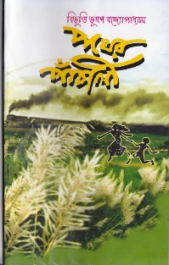  
1.   
Book Name:** Pather Panchali  
  
**Publish Year:** 1929  
  
**Short Description:** Pather Panchali deals with the life of the Roy family, consisting of Harihar, Sarbajaya, Apu and Durga, both in their ancestral village Nishchindipur in rural Bengal and later when they move to Varanasi in search of a better life, as well as the anguish and loss they face during their travels.  
  
**Genre:** Drama  
  
**Author Name:** Bibhutibhushan Bandyopadhyay   
  
**Author Short Biography:** Bibhutibhushan Bandyopadhyay was an Indian Bangali author and one of the leading writers of modern Bangla literature. His best known work is the autobiographical novel, [Pather Panchali: Song of the Road](https://www.goodreads.com/book/show/617097.Pather_Panchali__Song_of_the_Road" \o "Pather Panchali: Song of the Road) which was later adapted (along with Aparajito, the sequel) into the Apu Trilogy films, directed by [Satyajit Ray](https://www.goodreads.com/author/show/6590819.Satyajit_Ray" \o "Satyajit Ray).  
The 1951 Rabindra Puraskar, the most prestigious literary award in the West Bengal state of India, was posthumously awarded to Bibhutibhushan for his novel, Isamati.

**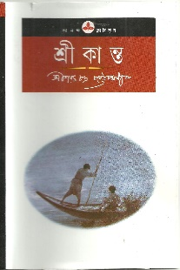  
2.  
Book Name:** Srikanta **Publish Year:** 1917  
 **Short Description:** Srikanta, the narrator of Saratchandra’s epic novel, is an aimless drifter, a passive spectator to his own life, a weak and impressionable soul who cannot survive without the support of an individual stronger than himself. As a child he idealizes the chaste and selfless Annada Didi. Arriving in Burma as a young man looking for new experiences, Srikanta meets the rebellious Abhaya who rejects her violent, bigamous husband to live openly with her lover. Srikanta then experiments with becoming a sanyasi, is bewitched for a while by the Vaishnavi, Kamal Lata, and wanders on till his directionless existence finally finds a focus—when he resigns himself to life with the notorious but stunning Pyari Baiji, breaking free of the social values he grew up with. Through his dynamic and arresting characters, Saratchandra brings alive nineteenth-century Bengal, rife with prejudices and ready for change.  
 **Genre:** Fiction **Author Name:** Sarat Chandra Chattopadhyay **Author Short Biography:** was a legendary Bengali novelist from India. He was one of the most popular Bengali novelists of the early 20th century. His childhood and youth were spent in dire poverty. Saratchandra received very little formal education but inherited something valuable from his father—his imagination and love of literature.  
Some of his best known novels are [Devdas](https://www.goodreads.com/book/show/258497.Devdas) (1917), [Nishkriti](https://www.goodreads.com/book/show/17342813.Nishkriti" \o "Nishkriti) (1917), [Srikanta](https://www.goodreads.com/book/show/1417962.Srikanta" \o "Srikanta) in four parts (1917, 1918, 1927 and 1933), [Griha Daha](https://www.goodreads.com/search/search?q=Griha%20Daha" \o "Griha Daha) (1920), [Sesh Prasna](https://www.goodreads.com/search/search?q=Sesh%20Prasna" \o "Sesh Prasna) (1929) and [Sesher Parichay](https://www.goodreads.com/search/search?q=Sesher%20Parichay" \o "Sesher Parichay) published posthumously (1939).

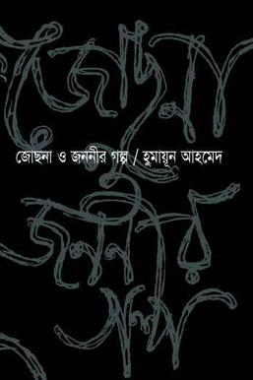  
**3.**  
**Book Name:** Josna O Jononir Golpo  
  
**Publish Year:** 2004

**Short Description:** In this book, by means of an engrossing fictional story which skilfully incorporates various historical figures and many true incidents as well as the author's own personal experiences, fortified with excerpts from newspapers and other documents, Humayun Ahmed manages to produce a remarkably vivid and well balanced picture of the political events and bloody civil war which led to the emergence of Bangladesh as an independent state in 1971.

**Genre:** Fiction

**Author Name:** Humayun Ahmed

**Author Short Biography:** Humayun Ahmed (13 November 1948 – 19 July 2012) was a Bangladeshi author, dramatist, screenwriter, playwright and filmmaker. He was the most famous and popular author, dramatist and filmmaker ever to grace the cultural world of Bangladesh since its independence in 1971. Dawn referred to him as the cultural legend of Bangladesh. Humayun started his journey to reach fame with the publication of his novel Nondito Noroke (In Blissful Hell) in 1972, which remains one of his most famous works. He wrote over 250 fiction and non-fiction books, all of which were bestsellers in Bangladesh.

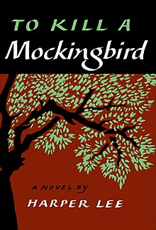  
**4.  
Book Name:** To kill a Mockingbird

**Publish Year:** 1960

**Short Description**: he novel examines racism in the American South through the innocent wide eyes of a clever young girl named Jean Louise (“Scout”) Finch. Its iconic characters, most notably the sympathetic and just lawyer and father Atticus Finch, served as role models and changed perspectives in the United States at a time when tensions regarding race were high. *To Kill a Mockingbird* earned the Pulitzer Prize for fiction in 1961 and was made into an Academy Award-winning film in 1962, giving the story and its characters further life and influence over the American social sphere.

**Genre:** Southern Gothic fiction

**Author Name:** Harper Lee

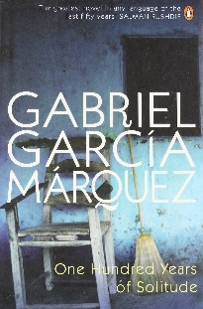**Author Short Biography:** Nelle Harper Lee (April 28, 1926 – February 19, 2016) was an American [novelist](https://en.wikipedia.org/wiki/Novelist) best known for her 1960 novel [*To Kill a Mockingbird*](https://en.wikipedia.org/wiki/To_Kill_a_Mockingbird). It won the 1961 [Pulitzer Prize](https://en.wikipedia.org/wiki/Pulitzer_Prize) and has become a classic of modern [American literature](https://en.wikipedia.org/wiki/American_literature). Lee has received numerous accolades and honorary degrees, including the [Presidential Medal of Freedom](https://en.wikipedia.org/wiki/Presidential_Medal_of_Freedom) in 2007 which was awarded for her contribution to literature.  
  
**5.**  
**Book Name:** One Hundred Years of Solitude

**Publish Year:** 1967

**Short Description:** The novel tells the story of seven generations of the Buendía family and follows the establishment of their town Macondo until its destruction along with the last of the family’s descendents. In fantastical form, the novel explores the genre of magic realism by emphasizing the extraordinary nature of commonplace things while mystical things are shown to be common. Márquez highlights the prevalence and power of myth and folktale in relating history and Latin American culture. 

**Genre:** Magical Realism

**Author Name:** [Gabriel García Márquez](https://www.britannica.com/biography/Gabriel-Garcia-Marquez)

**Author Short Biography:** Gabriel García Márquez (6 March 1927 – 17 April 2014) was a [Colombian](https://en.wikipedia.org/wiki/Colombian_people) novelist, short-story writer, screenwriter, and journalist, known affectionately as Gabo or Gabito throughout Latin America. Considered one of the most significant authors of the 20th century, particularly in the [Spanish language](https://en.wikipedia.org/wiki/Hispanic_literature), he was awarded the 1972 [Neustadt International Prize for Literature](https://en.wikipedia.org/wiki/Neustadt_International_Prize_for_Literature" \o ") and the [1982 Nobel Prize in Literature](https://en.wikipedia.org/wiki/1982_Nobel_Prize_in_Literature).

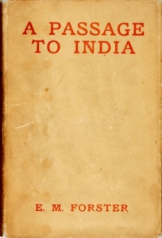 **6.  
Book Name:** A Passage to India

**Publish Year:** 1924

**Short Description:** The book follows a Muslim Indian doctor named Aziz and his relationships with an English professor, Cyril Fielding, and a visiting English schoolteacher named Adela Quested. When Adela believes that Aziz has assaulted her while on a trip to the Marabar caves near the fictional city of Chandrapore, where the story is set, tensions between the Indian community and the colonial British community rise. The possibility of friendship and connection between English and Indian people, despite their cultural differences and imperial tensions, is explored in the conflict. The novel’s colorful descriptions of nature, the landscape of India, and the figurative power that they are given within the text solidifies it as a great work of fiction.  
 **Genre:** Fiction

**Author Name:** E. M. Foster

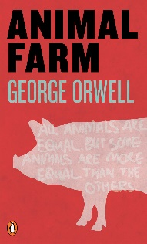**Author Short Biography:** Edward Morgan Forster (1 January 1879 – 7 June 1970) was an English fiction writer, essayist and [librettist](https://en.wikipedia.org/wiki/Librettist). Many of his novels examine class difference and hypocrisy, including [*A Room with a View*](https://en.wikipedia.org/wiki/A_Room_with_a_View) (1908), [*Howards End*](https://en.wikipedia.org/wiki/Howards_End) (1910) and [*A Passage to India*](https://en.wikipedia.org/wiki/A_Passage_to_India) (1924). The last brought him his greatest success. He was nominated for the [Nobel Prize in Literature](https://en.wikipedia.org/wiki/Nobel_Prize_in_Literature) in 16 separate years.  
  
**7.**  
**Book Name:** Animal Farm

**Publish Year:** 1945

**Short Description:** All animals are equal, but some animals are more equal than others.”  
A farm is taken over by its overworked, mistreated animals. With flaming idealism and stirring slogans, they set out to create a paradise of progress, justice, and equality. Thus the stage is set for one of the most telling satiric fables ever penned-a razor-edged fairy tale for grown-ups that records the evolution from revolution against tyranny to a totalitarianism just as terrible.

**Genre:** Allegory, Political Satire

**Author Name:** George Orwell

**Author Short Biography:** Eric Arthur Blair (25 June 1903 – 21 January 1950),  known by his [pen name](https://en.wikipedia.org/wiki/Pen_name) George Orwell, was an English [novelist](https://en.wikipedia.org/wiki/Novelist), [essayist](https://en.wikipedia.org/wiki/Essayist), [journalist](https://en.wikipedia.org/wiki/Journalist) and [critic](https://en.wikipedia.org/wiki/Critic). His work is characterised by lucid prose, biting [social criticism](https://en.wikipedia.org/wiki/Social_criticism), opposition to [totalitarianism](https://en.wikipedia.org/wiki/Totalitarianism), and outspoken support of [democratic socialism](https://en.wikipedia.org/wiki/Democratic_socialism). As a writer, Orwell produced [literary criticism](https://en.wikipedia.org/wiki/Literary_criticism) and [poetry](https://en.wikipedia.org/wiki/Poetry), [fiction](https://en.wikipedia.org/wiki/Fiction) and [polemical](https://en.wikipedia.org/wiki/Polemic) journalism. He is known for the [allegorical](https://en.wikipedia.org/wiki/Allegory) novella [*Animal Farm*](https://en.wikipedia.org/wiki/Animal_Farm) (1945) and the [dystopian](https://en.wikipedia.org/wiki/Utopian_and_dystopian_fiction) novel [*Nineteen Eighty-Four*](https://en.wikipedia.org/wiki/Nineteen_Eighty-Four) (1949). His non-fiction works, including [*The Road to Wigan Pier*](https://en.wikipedia.org/wiki/The_Road_to_Wigan_Pier) (1937), documenting his experience of working-class life in the north of England, and [*Homage to Catalonia*](https://en.wikipedia.org/wiki/Homage_to_Catalonia) (1938), an account of his experiences soldiering for the [Republican](https://en.wikipedia.org/wiki/Republican_faction_(Spanish_Civil_War)) faction of the [Spanish Civil War](https://en.wikipedia.org/wiki/Spanish_Civil_War) (1936–1939), are as critically respected as his [essays](https://en.wikipedia.org/wiki/George_Orwell_bibliography) on [politics](https://en.wikipedia.org/wiki/Politics) and [literature](https://en.wikipedia.org/wiki/Literature), [language](https://en.wikipedia.org/wiki/Language) and [culture](https://en.wikipedia.org/wiki/Culture). In 2008, [*The Times*](https://en.wikipedia.org/wiki/The_Times) ranked George Orwell second among "The 50 greatest British writers since 1945".  
  
**8.**

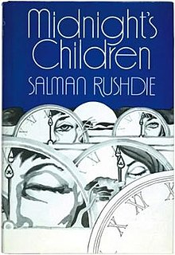**Book Name:** Midnight’s Children

**Publish Year:** 1981  
 **Short Description:** Saleem Sinai was born at midnight, the midnight of India's independence, and found himself mysteriously "handcuffed to history" by the coincidence. He is one of 1,001 children born at the midnight hour, each of them endowed with an extraordinary talent and whose privilege and curse it is to be both master and victims of their times. Through Saleem's gifts-inner ear and wildly sensitive sense of smell-we are drawn into a fascinating family saga set against the vast, colorful background of the India of the 20th century.

**Genre:**  Magical Realism, Historical Fiction.

**Author Name:** Salman Rushdie

**Author Short Biography:** Sir AhmedSalman Rushdie (born 19 June 1947) is an Indian-born British American novelist and essayist. His work, combining [magical realism](https://en.wikipedia.org/wiki/Magical_realism) with [historical fiction](https://en.wikipedia.org/wiki/Historical_novel), is primarily concerned with the many connections, disruptions, and migrations between [Eastern](https://en.wikipedia.org/wiki/Eastern_world) and [Western civilizations](https://en.wikipedia.org/wiki/Western_civilization), with much of his fiction being set on the [Indian subcontinent](https://en.wikipedia.org/wiki/Indian_subcontinent).

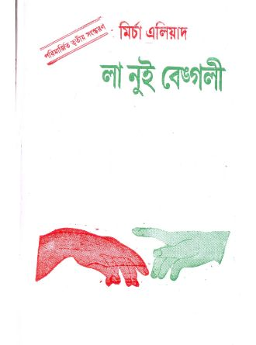**9.  
Book Name:** La Nuit Bengali (Bengal Nights)

**Publish Year:** 1933

**Short Description:** The Book "La Nuit Bengali" explains the passion of a love story. Its simplicity allows anyone to understand the love between two people and two cultures. Eliade highlights two cultures and religions but shows no biased emotions that favor either culture or religion. He shares the idea of a religion that only shows how to love others and the world. In contrast to the concept of love as we think of it today, Eliade brings out the simplicity of a love story, yet the complicated idea of a love with no boundaries.

**Genre:** Fictional Autobiography

**Author Name:** Mircea Eliade

**Author Short Biography:** Mircea Eliade(February 24, 1907 – April 22, 1986) was a [Romanian](https://en.wikipedia.org/wiki/Romanians) [historian of religion](https://en.wikipedia.org/wiki/History_of_religion), fiction writer, philosopher, and professor at the [University of Chicago](https://en.wikipedia.org/wiki/University_of_Chicago). He was a leading interpreter of religious experience, who established [paradigms](https://en.wikipedia.org/wiki/Paradigm) in religious studies that persist to this day. One of his most instrumental contributions to religious studies was his theory of [*eternal return*](https://en.wikipedia.org/wiki/Eternal_Return_(Eliade)), which holds that myths and rituals do not simply commemorate hierophanies, but, at least to the minds of the religious, actually participate in them. His literary works belong to the [fantastic](https://en.wikipedia.org/wiki/Fantastic) and [autobiographical](https://en.wikipedia.org/wiki/Autobiographical_novel) genres. The best known are the novels *[Maitreyi](https://en.wikipedia.org/wiki/Bengal_Nights_(novel)" \o "Bengal Nights (novel))* ('La Nuit Bengali' or 'Bengal Nights'), *[Noaptea de Sânziene](https://en.wikipedia.org/wiki/Noaptea_de_S%C3%A2nziene" \o "Old Style and New Style dates)* ('The Forbidden Forest'), *Isabel și apele diavolului* ('Isabel and the Devil's Waters'), and *[Romanul Adolescentului Miop](https://en.wikipedia.org/wiki/Romanul_Adolescentului_Miop" \o "Romanul Adolescentului Miop)* ('Novel of the Nearsighted Adolescent').  
  
**10.**

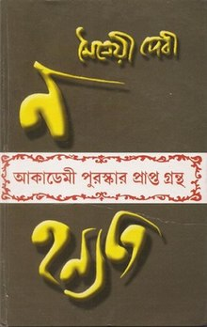**Book Name:** Na Hanyate(It Does Not Die**)**

**Publish Year:** 1974

**Short Description:** Precocious, a poet, a philosopher's daughter, Maitreyi Devi was sixteen years old in 1930 when Mircea Eliade came to Calcutta to study with her father. More than forty years passed before Devi read *Bengal Nights*, the novel Eliade had fashioned out of their encounter, only to find small details and phrases, even her given name, bringing back episodes and feelings she had spent decades trying to forget. *It Does Not Die* is Devi's response. In part a counter to Eliade's fantasies, the book is also a moving account of a first love fraught with cultural tensions, of false starts and lasting regrets.On its own, *It Does Not Die* is a fascinating story of cultural conflict and thwarted love.

**Genre:** Romance, Autobiographical

**Author Name:** Maitreyi Devi

**Author Short Biography:** Maitreyi Devi (1 September 1914 – 29 January 1989) was an [Indian](https://en.wikipedia.org/wiki/India) poet and novelist. She was the daughter of philosopher [Surendranath Dasgupta](https://en.wikipedia.org/wiki/Surendranath_Dasgupta" \o ") and protégée of poet [Rabindranath Tagore](https://en.wikipedia.org/wiki/Rabindranath_Tagore). She studied in St. John's Diocesan Girls' Higher Secondary School, [Calcutta](https://en.wikipedia.org/wiki/Kolkata) (now Kolkata) and graduated from the [Jogamaya Devi College](https://en.wikipedia.org/wiki/Jogamaya_Devi_College" \o "Jogamaya Devi College), an affiliated undergraduate women's college of the historic [University of Calcutta](https://en.wikipedia.org/wiki/University_of_Calcutta), in [Kolkata](https://en.wikipedia.org/wiki/Kolkata). She published her first book of poetry at age 16, with a preface by Tagore. She is best known for her [Sahitya Akademi Award](https://en.wikipedia.org/wiki/Sahitya_Akademi_Award" \o "Sahitya Akademi Award)-winning novel, [*Na Hanyate*](https://en.wikipedia.org/wiki/Na_Hanyate) (It Does Not Die).