
COMSATS University Islamabad
Wah Campus
PROJECT PROPOSAL
Artificial Intelligence

Project Title
NOVA AI — Neural Orchestrated Voice Assistant
A Voice-Controlled Intelligent Personal Assistant with NLP-Based Intent Recognition, Real-Time OS Automation, and Vision-Based Gesture Control

Submitted by
Muhammad Akif Naveed
FA24-BSE-129
Supervised by
Ms. Maira Afzal
Department of Computer Science

1. Executive Summary
NOVA AI (Neural Orchestrated Voice Assistant) is a Python-based, voice-activated intelligent personal assistant designed for Windows. It integrates natural language processing for intent classification, a large language model via the Groq API for conversational intelligence, real-time web service integrations, comprehensive operating system automation, and a persistent vision-based hand gesture control engine.
The assistant operates on a dual-pipeline architecture: a continuous background layer that keeps the gesture recognition engine and wake-word listener active at all times, and a primary processing pipeline that activates fully upon detection of the wake phrase "Hey NOVA." This design ensures minimal resource overhead during idle states while enabling immediate and fully capable responses on activation.
NOVA is built as a modular, backend-heavy system comprising 25 functional modules spanning voice interaction, knowledge retrieval, OS control, scheduling, memory management, and real-time communication. The interface is a minimalist HUD-style dark overlay, reflecting a philosophy of maximum functionality with minimal visual intrusion. All tools and APIs used are freely available, making the system fully reproducible without licensing costs.

2. Core Design Philosophy
NOVA is designed around three governing principles:
- Voice-first, always-on: The system maintains a persistent background state through a dedicated wake-word listener and gesture recognition thread. Full capabilities activate instantly on demand, with no manual launch required.
- Backend-heavy, UI-minimal: Processing intelligence is concentrated in the pipeline modules. The HUD overlay surfaces only essential status information, avoiding the overhead and distraction of a full application window.
- Modular and extensible: Each of the 25 modules is independently registered in a central configuration file. Features can be enabled or disabled, and new integrations can be added without modifying core system code.

3. System Architecture
The architecture separates the system into two parallel execution layers. The always-running background layer hosts the gesture recognition engine and wake-word listener as dedicated daemon threads. Upon activation, the primary pipeline routes voice input through the speech-to-text module, into the NLP intent engine for local classification, and onward to either the Groq LLM or the local module router depending on query complexity. All outputs are delivered through the TTS engine and reflected on the HUD display.

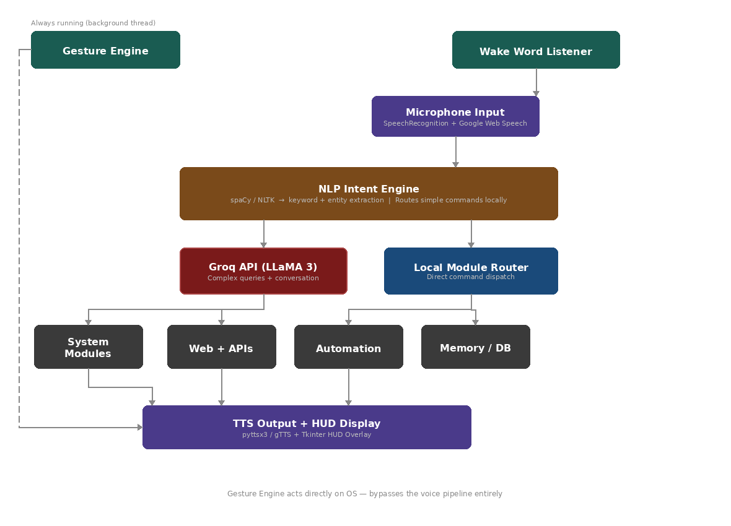
Figure 1: NOVA AI System Architecture

4. Module-by-Module Breakdown

4.1 Wake Word Detection (Module 1)
NOVA operates in a perpetual low-power listening state. The wake-word engine runs on a background thread using pvporcupine (offline, free tier) or an energy-threshold keyword scan via SpeechRecognition. Upon detecting "Hey NOVA," a threading.Event signal activates the full voice pipeline without blocking the main application.

4.2 Speech-to-Text (Module 2)
Following wake-word activation, microphone audio is captured, silence-trimmed, and sent to the Google Web Speech API via the SpeechRecognition library. An offline fallback using OpenAI Whisper (running locally) is available for privacy-sensitive contexts. Key parameters including energy_threshold and pause_threshold are configurable for ambient noise conditions.

4.3 NLP Intent Engine (Module 3)
The intent engine constitutes the first processing layer. It uses spaCy for fast named-entity recognition (extracting cities, times, application names, and contacts) and NLTK for tokenization and stopword removal. A rule-based classification system routes common commands — such as application launches or time queries — to local handlers in milliseconds, reserving Groq API calls for complex or ambiguous inputs. Defined intent categories include: System, Web, Information, Automation, Memory, Creative, and Conversation.

4.4 Groq LLM Brain (Module 4)
For queries exceeding the rule-based classifier's confidence threshold, input is forwarded to the Groq API (LLaMA 3 70B, free tier). The request includes a stateful message history array, a system prompt defining NOVA's persona and contextual awareness, and relevant memories retrieved from the SQLite database. This module handles email drafting, complex Q&A, code explanation, and open-ended conversation.

4.5 Real-Time Web Integrations (Modules 5–7)
Three modules provide external data retrieval:
- Weather Information (Module 5): Queries the OpenWeatherMap API using the city entity extracted by the NLP engine. Provides temperature, humidity, and conditions. Default city is stored in the configuration file.
- Space and Science News (Module 6): Fetches NASA's Astronomy Picture of the Day (APOD) via the NASA Open API, delivering the title, explanation, and a science summary through the TTS engine.
- Wikipedia Knowledge Base (Module 7): Returns three-sentence summaries from Wikipedia for "tell me about X" queries, with disambiguation handling for multi-result searches.

4.6 Automation and OS Control (Modules 8–12, 16–18)
NOVA provides comprehensive automation across applications and OS functions:
- Web Automation (Module 8): Opens pre-configured URLs and performs browser interactions including clicking, scrolling, commenting, and searching, via selenium and webbrowser. Site mappings are maintained in a sites.json configuration file.
- Application Launcher (Module 9): Launches any installed Windows application using subprocess and os. Fuzzy string matching via fuzzywuzzy accommodates natural phrasing variations. Application paths are maintained in apps.json.
- Email Compose and Send (Module 10): Orchestrates a full voice-driven email workflow — the user describes intent, Groq drafts the message, NOVA reads it back for confirmation, and it is sent via Gmail SMTP using smtplib. Credentials are stored securely in a .env file.
- WhatsApp Messaging (Module 11): Sends messages via PyWhatKit by opening WhatsApp Web, navigating to the target contact, and submitting the message. Contact phone numbers are stored in contacts.json.
- Music and Media Control (Module 12): Plays YouTube content or local files via VLC, with playback control using pyautogui keyboard shortcuts.
- System Controls (Module 16): Manages volume (pycaw), brightness (screen-brightness-control), power states (os), and reports battery and CPU metrics (psutil).
- Screenshot and Screen Automation (Module 17): Captures screenshots with timestamped filenames, performs screen clicks, and types text at the cursor position using pyautogui and Pillow.
- Clipboard Manager (Module 18): Reads and writes clipboard content by voice via pyperclip.

4.7 Knowledge, Notes, and Scheduling (Modules 13–15, 19–20)
- Notes and Reminders (Module 13): Stores notes and time-based reminders in SQLite. A background thread checks the reminders table every minute and triggers a TTS alert at the scheduled time. Natural language date expressions are parsed using dateparser.
- Calendar and Task Scheduling (Module 14): Manages calendar events and a personal task list in SQLite. The HUD displays upcoming events on startup.
- Date, Time, and Calculations (Module 15): Answers temporal queries and evaluates arithmetic expressions using Python's built-in datetime and eval() with safety sandboxing.
- Language Translation (Module 19): Translates text between languages using deep-translator, requiring no API key for standard usage.
- Memory System (Module 20): Persists user facts, preferences, and contact information in SQLite. After each Groq session, key facts are extracted and stored. The ten most contextually relevant memories are injected into the Groq system prompt at the start of each conversation.

4.8 Hand Gesture Control (Module 22)
The gesture control engine is an always-on, vision-based input system running as a dedicated daemon thread, entirely independent of the voice pipeline. It uses OpenCV for camera capture and frame processing, and MediaPipe Hands for 21-landmark skeletal tracking.
Volume control is continuous: the Euclidean distance between the thumb tip (landmark 4) and index finger tip (landmark 8) is mapped linearly to system volume via pycaw. Discrete gestures are debounced over a 0.4-second hold period to prevent accidental triggers. The engine operates at 15–20 FPS, maintaining a minimal CPU footprint.

Gesture | Detection Logic | OS Action
Open Palm (5 fingers extended) | All fingertips above knuckles | Play / Resume Media
Closed Fist (0 fingers) | All fingers fully curled | Pause Media
Index Finger Up | Only index finger extended | Volume Up (+5%)
Index + Middle Fingers Up | Two fingers extended | Scroll Up
Three Fingers Up | Three fingers extended | Scroll Down
Pinch (thumb + index close) | Distance between tips < 30px | Zoom In
OK Sign (circle formed) | Thumb + index touching, others up | Next Browser Tab
Swipe Left | Wrist x-delta exceeds threshold | Previous Track
Swipe Right | Wrist x-delta exceeds threshold | Next Track

Table 1: Gesture-to-Action Mapping

4.9 HUD Interface (Module 23)
The HUD is a frameless, always-on-top, semi-transparent dark overlay built with Tkinter, docked to the right side of the screen. It displays: an animated audio waveform (matplotlib FuncAnimation) that pulses during listening and speaking states; a four-state status indicator; the last five command-response exchanges; an optional gesture camera feed; a reminders ticker; and a live clock. Clicking the waveform manually activates NOVA as an alternative to the wake word. The color scheme uses #0D0D0D background with #00D4FF cyan accents and a monospace typeface for a pure HUD aesthetic.

4.10 Personality, Activity Log, and Config Manager (Modules 21, 24, 25)
- Personality and Jokes (Module 21): pyjokes provides offline humor; Groq handles open-ended banter and motivational content. The startup greeting is time-aware, summarizing pending reminders and events.
- Activity Log (Module 24): Every command processed by NOVA is logged with a timestamp to SQLite. Logs older than 30 days are automatically purged. Users can query recent activity by voice.
- Plugin and Config Manager (Module 25): All modules are registered in config.json. NOVA supports hot-reloading of configuration at runtime, enabling modifications to app shortcuts, site mappings, and feature flags without restarting the system.

5. Master Module Reference

# | Module | Function | Key Technology | Processing | Storage
1 | Wake Word Detection | Activates NOVA on "Hey NOVA" | pvporcupine / SpeechRecognition | — | —
2 | Speech-to-Text (STT) | Converts voice to text | SpeechRecognition + Google Web Speech | — | —
3 | NLP Intent Engine | Classifies command, extracts entities | spaCy + NLTK | NLP | —
4 | Groq LLM Brain | Complex queries and conversation | Groq API (LLaMA 3 70B) | Groq | Conversation log
5 | Weather Information | Real-time weather by city | OpenWeatherMap API | NLP | —
6 | Space & Science News | NASA APOD and science updates | NASA Open API | NLP | —
7 | Wikipedia Knowledge Base | Concise knowledge summaries | wikipedia (Python) | NLP | —
8 | Web Automation & Browser | Open sites, interact with pages | selenium + webbrowser | NLP | sites.json
9 | Application Launcher | Open any Windows application by voice | os + subprocess + fuzzywuzzy | NLP | apps.json
10 | Email Compose & Send | Draft and send emails by voice | smtplib + Groq API | Groq + NLP | .env
11 | WhatsApp Messaging | Send WhatsApp messages by voice | PyWhatKit | NLP | contacts.json
12 | Music & Media Control | Play YouTube or local music | PyWhatKit + VLC | NLP | —
13 | Notes & Reminders | Save notes, set timed alerts | sqlite3 + dateparser | NLP | memory.db
14 | Calendar & Task Scheduling | Events and to-do list management | sqlite3 + dateparser | NLP | memory.db
15 | Date, Time & Calculations | Time, date queries and arithmetic | datetime + eval() | NLP | —
16 | System Controls | Volume, brightness, shutdown, battery | pycaw + psutil + os | NLP | —
17 | Screenshot & Screen Tools | Screenshot, click, type automation | pyautogui + Pillow | NLP | Desktop
18 | Clipboard Manager | Read and write clipboard content | pyperclip | NLP | —
19 | Language Translation | Translate text to any language | deep-translator | NLP | —
20 | Memory System | Persistent user facts and preferences | sqlite3 | Groq | memory.db
21 | Personality & Small Talk | Jokes, banter, startup greetings | pyjokes + Groq API | Groq | —
22 | Hand Gesture Control | Always-on OS control via gestures | OpenCV + MediaPipe + pycaw | CV logic | —
23 | HUD Interface | Minimal dark always-on-top overlay | Tkinter + matplotlib | — | —
24 | Activity Log & History | Full command log with timestamps | sqlite3 | — | activity_log.db
25 | Plugin & Config Manager | Enable/disable modules, hot-reload | json config | — | config.json

Table 2: Complete Module Reference

6. Complete Technology Stack
All tools, libraries, and APIs used in NOVA are freely available under open-source or free-tier licensing. No paid subscriptions are required.

Category | Tool / Library
Language | Python 3.11 (Windows)
Wake Word | pvporcupine (free tier) / energy threshold
Speech-to-Text | SpeechRecognition + Google Web Speech API
Offline STT Fallback | Whisper (openai-whisper, local)
NLP Layer | spaCy + NLTK + dateparser
LLM Brain | Groq API (LLaMA 3 70B)
Text-to-Speech | pyttsx3 (offline primary) + gTTS (online)
Gesture Vision | OpenCV + MediaPipe
Weather | OpenWeatherMap API
News | NASA Open API
Knowledge Base | wikipedia (Python library)
Web Automation | selenium + webbrowser
Messaging | PyWhatKit
System Audio | pycaw (Windows Audio API)
System Metrics | psutil
Brightness Control | screen-brightness-control
Screen Automation | pyautogui
Clipboard | pyperclip
Translation | deep-translator
Email | smtplib + email (built-in)
Fuzzy Matching | fuzzywuzzy / rapidfuzz
Date Parsing | dateparser
Jokes | pyjokes
Memory / Database | sqlite3 (built-in Python)
HUD Interface | Tkinter + matplotlib
Configuration | json (built-in)
Environment Secrets | python-dotenv
Threading | threading (built-in)

Table 3: Technology Stack

7. System Scope and Boundaries

7.1 In Scope
The following are within the defined boundaries of this project:
- All 25 modules described in this proposal
- Windows 10/11 operating system only
- Python 3.11 implementation using the tools listed in Section 6
- English voice input with multi-language translation output
- Local execution — no cloud hosting, no mobile application, no server infrastructure
- All APIs and libraries operating under free or open-source terms

7.2 Out of Scope (Future Versions)
The following capabilities are explicitly deferred to future development phases:
- Face recognition-based user identification or tone adjustment
- Custom wake-word training and enrollment
- Linux and macOS platform support
- Real-time video call integration
- Mobile application companion

8. Conclusion
NOVA AI represents a technically substantive implementation of a modern intelligent personal assistant, built entirely on freely available tools within a Python ecosystem. Its 25-module architecture demonstrates practical integration of natural language processing, large language model APIs, computer vision, OS automation, and persistent memory — skills directly aligned with the objectives of the Artificial Intelligence course.
The modular design ensures that each component can be developed, tested, and evaluated independently, while the unified configuration system demonstrates a mature approach to software architecture. The project scope is well-defined, the technology stack is finalized, and all required tools are confirmed to be accessible at no cost.
NOVA is ready to proceed to the implementation phase.

