**Face Recognition System for Authentication**

**Project Developer:** Akif Artun

**Project Github Links:** https://github.com/Akifartun/Artificial-Intelligence

**Table of Contents**

1. Introduction 2

1.1 Purpose of the Project 2

1.2 Project Plan 2

2. Scope of the Project 2

2.1 Data Collection and Preprocessing 2

2.1.1 Data Collection Process 2

2.1.2 Splitting the Data Set 3

2.2 Model Selection and Training 3

2.2.1 YOLOv8: 3

2.2.2 Model Selection: 3

2.2.3 Training: 3

2.3 Evalution and Fine-tuning 4

2.3.1 Evaluation Metrics: 4

2.3.2 Fine-tuning: 4

2.4 Integration and Testing 5

2.4.1 Integration: 5

2.4.2 Testing: 5

3. Innovation of the Project 7

1. Introduction

1.1 **Purpose of the Project**

The goal of this project is to develop a robust face recognition system for authentication purposes using YOLOv8. Given the advancements in YOLO (You Only Look Once) models for object detection and the need for accurate real-time face recognition, YOLOv8 is selected for its superior performance and speed. The system is trained to recognize six team members using a dataset of 1325 images.

1.2 Project Plan

The Gantt Chart for better execution of the project is shown in Figure 1.

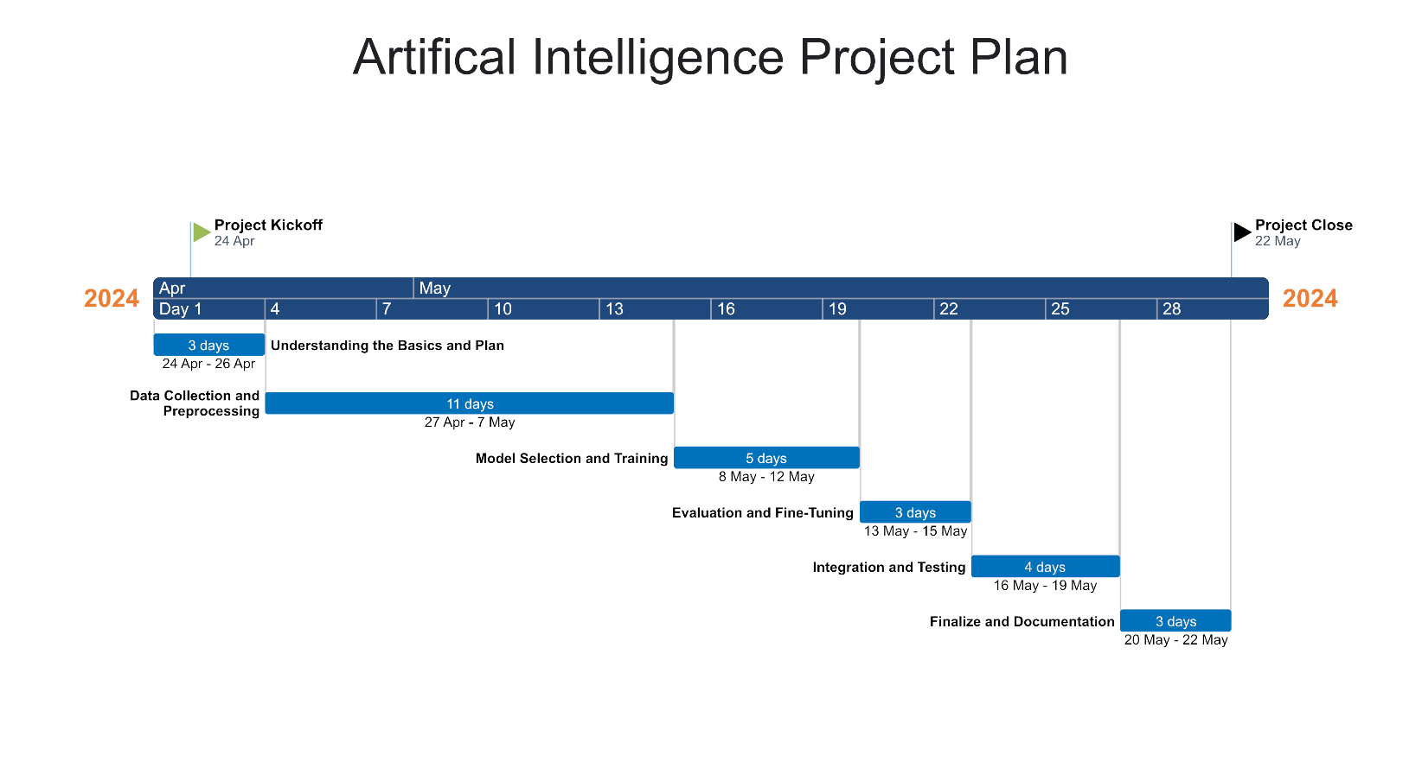

Figure 1

2. Scope of the Project

2.1 Data Collection and Preprocessing

2.1.1 Data Collection Process: A total of 1325 photographs were collected for the project, taken from the faces of 6 different teammates. These pictures provide a wide variety for the model to learn various facial features and to recognise different people.

|  |  |  |  |  |  |  |  |
| --- | --- | --- | --- | --- | --- | --- | --- |
|  | Akif | Alp | Ata | Emre | Kübra | Şevval | Total |
| Train | 210 *(%80)* | 158 *(%80)* | 179 *(%80)* | 183 *(%80)* | 194 *(%80)* | 136 *(%80)* | 1060 *(%80)* |
| Valid | 52 *(%20)* | 39 *(%20)* | 45 *(%20)* | 46 *(%20)* | 49 *(%20)* | 34 *(%20)* | 265 *(%20)* |
| Total | 262 *(%100)* | 197 *(%100)* | 224 *(%100)* | 229 *(%100)* | 243 *(%100)* | 170 *(%100)* | 1325 *(%100)* |

Table 1

2.1.2 Splitting the Data Set**:** The collected data is divided into 80% (1060 images) training data and 20% (265 images) test data for training and evaluation of the model. This separation provides a sufficient test set to evaluate the accuracy of the model.

2.2 Model Selection and Training

2.2.1 YOLOv8: YOLOv8 was chosen due to its balance of speed and accuracy, making it suitable for real-time face recognition. Its architecture allows for efficient detection with lower latency, which is crucial for authentication systems.

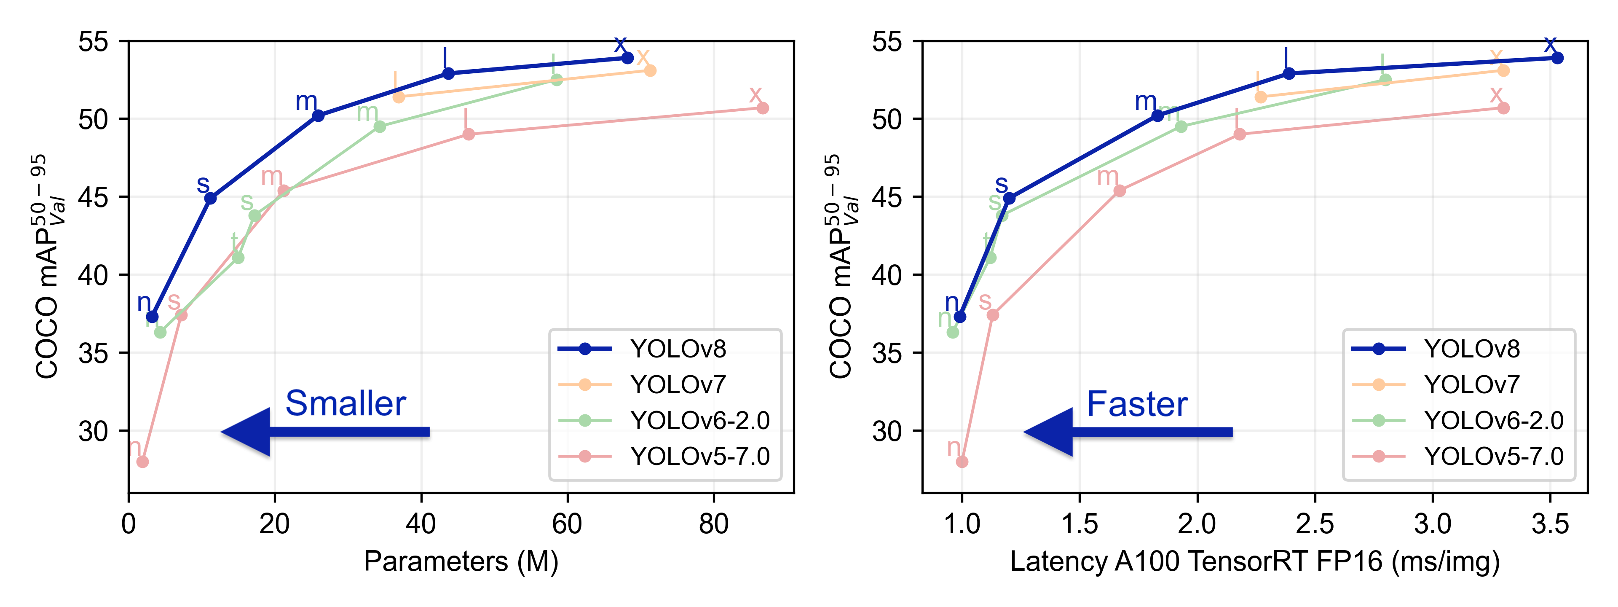

Figure 2

2.2.2 Model Selection: The YOLOv8m model was chosen due to its optimal balance between speed and accuracy, making it ideal for real-time face recognition tasks. YOLOv8m provides higher accuracy than the smaller YOLOv8s model while maintaining reasonable inference speed, crucial for quick and reliable face authentication.

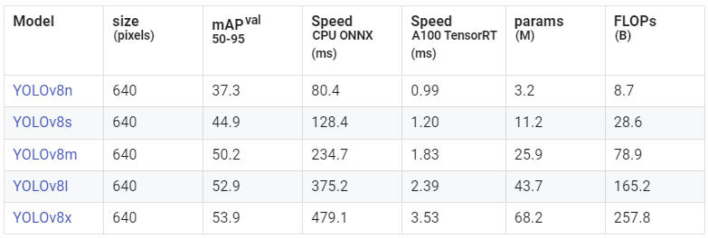

Figure 3

2.2.3 Training: The model was trained using a GPU for accelerated processing. Key parameters included a batch size of **32**, an initial learning rate of **0.001**, and **200** epochs. During training, early stopping was implemented to prevent overfitting, and checkpoints were saved for the best-performing models.

2.3 Evalution and Fine-tuning

2.3.1 Evaluation Metrics: The model's performance was evaluated using precision, recall, and F1-score to measure its accuracy in identifying the six team members. Confusion matrices were also generated to analyze misclassifications.

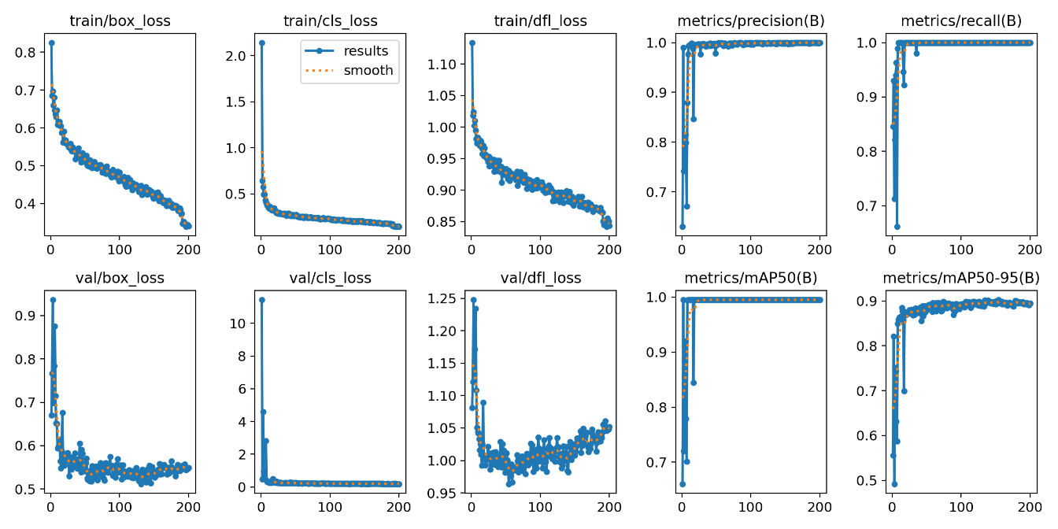

Figure 4

2.3.2 Fine-tuning: During the fine-tuning phase, one of the key steps taken was balancing the number of images per person in the validation dataset. Initially, there was an imbalance in the number of images representing each individual, which could lead to biased performance and inaccurate evaluation metrics. By balancing the validation dataset and optimizing these parameters, we achieved a more reliable and robust face recognition system.

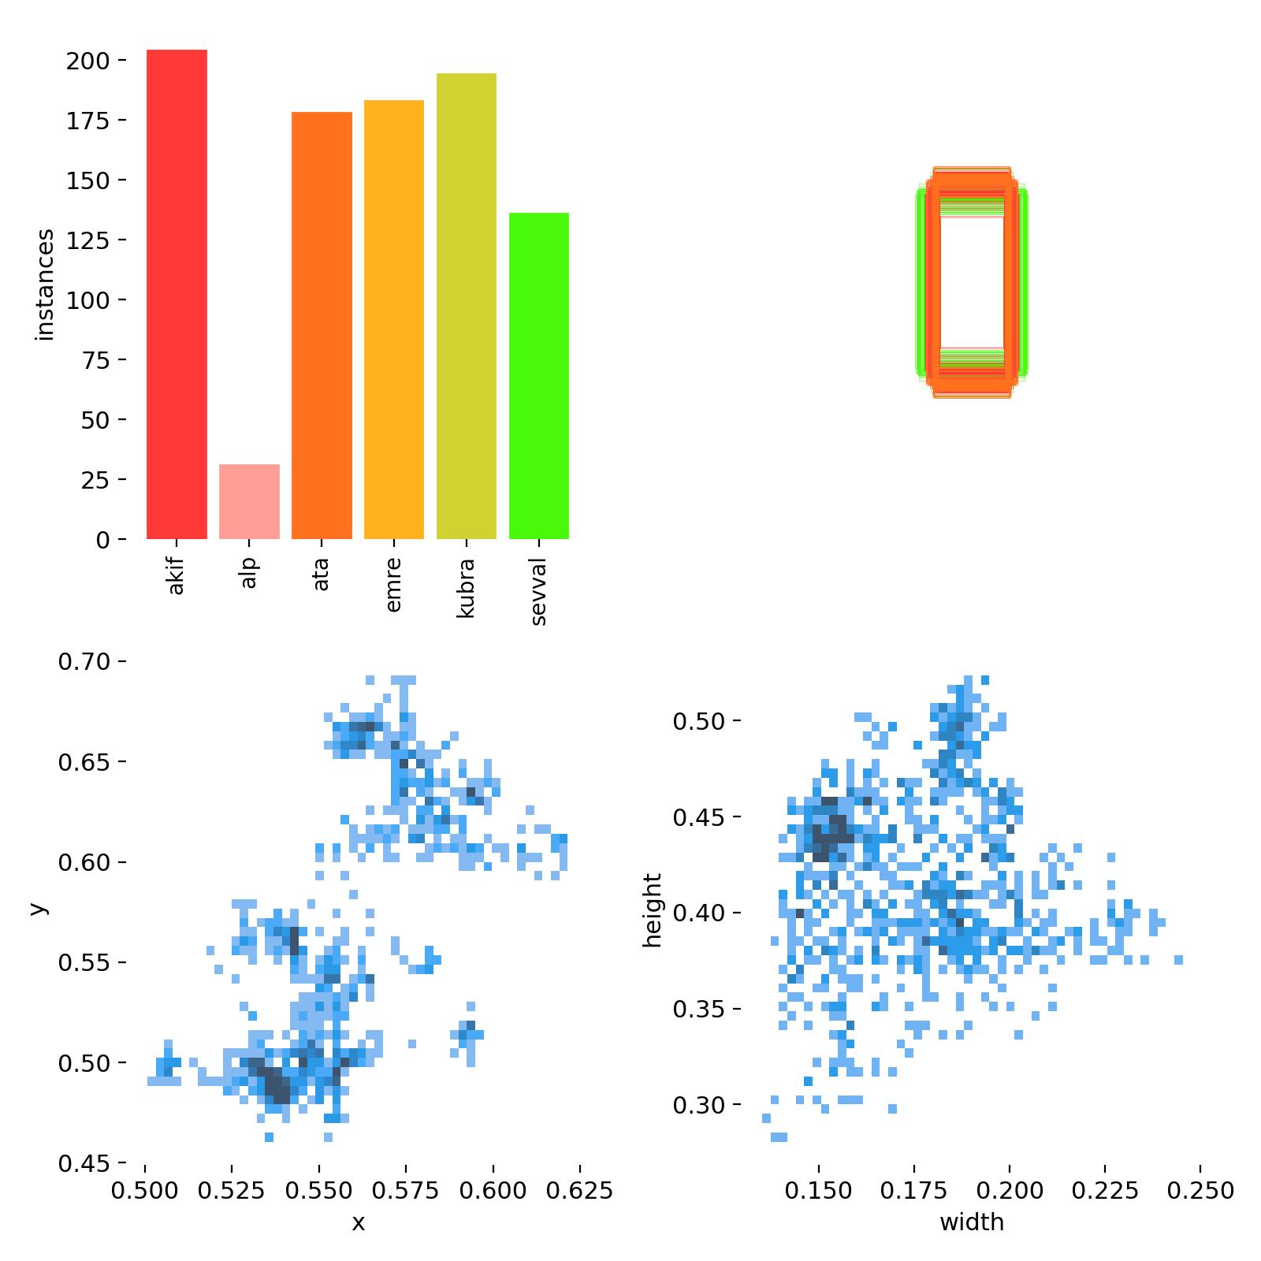 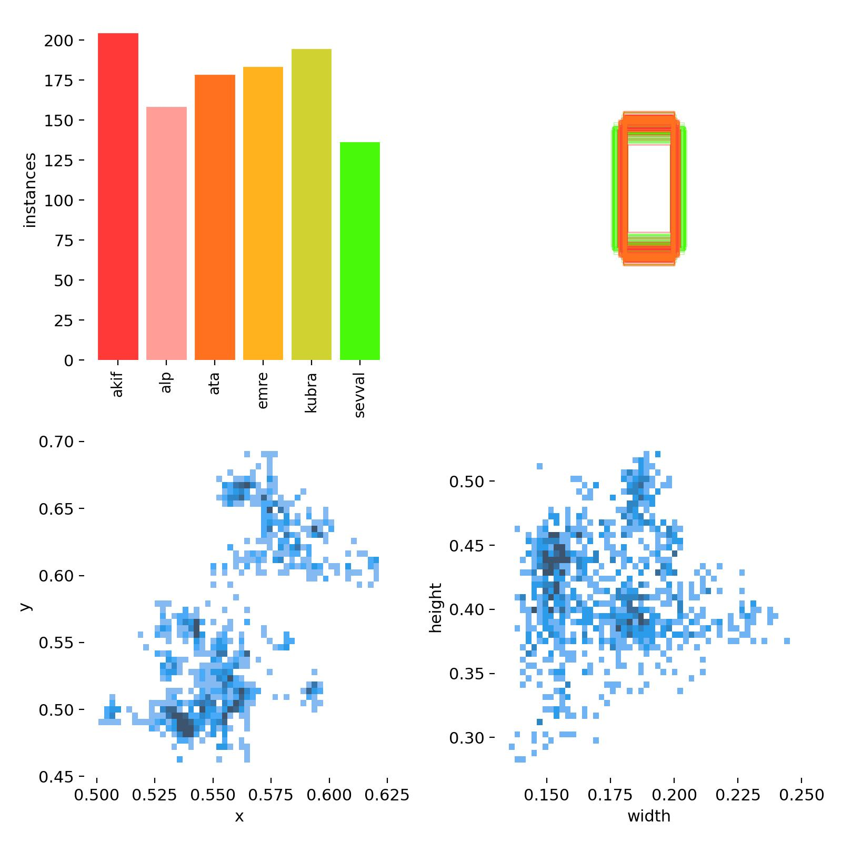

Figure 5. Unbalanced Dataset Figure 6. Balanced Dataset

2.4 Integration and Testing

2.4.1 Integration: For this project, although a full application was not developed, the trained YOLOv8m model was prepared for potential integration into various systems. The model was saved in a format compatible with popular deep learning frameworks, such as PyTorch, enabling easy loading and inference in future applications.

2.4.2 Testing: The testing phase involved a comprehensive evaluation of the model using the testing dataset, focusing on assessing improvements made through fine-tuning. The model's performance was evaluated using metrics such as precision, recall, and F1-score. To visualize the impact of fine-tuning, performance graphs comparing the model's accuracy before and after fine-tuning were generated. These graphs clearly demonstrate the enhancements achieved, with noticeable improvements in key metrics.

For the graphs shown below, pink represents the balanced dataset and grey represents the unbalanced dataset.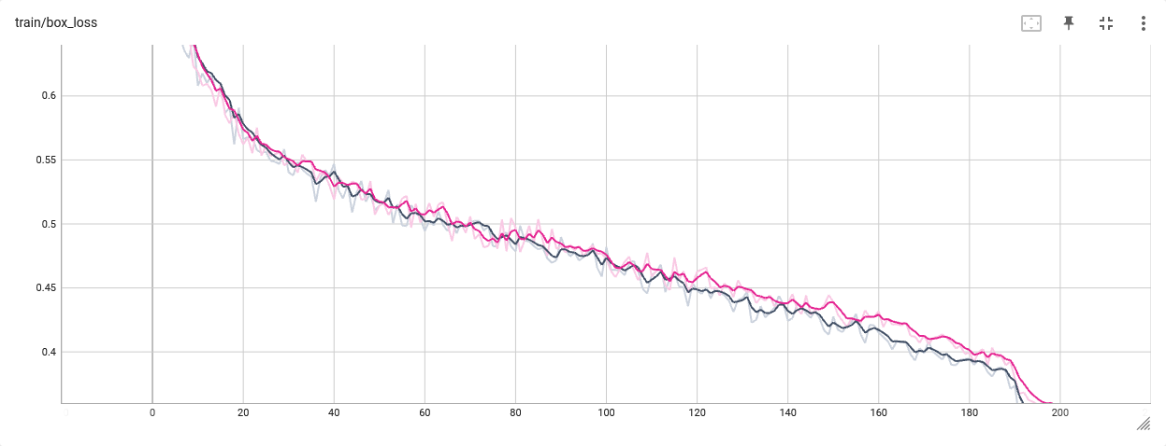

Figure 7. train/box_loss

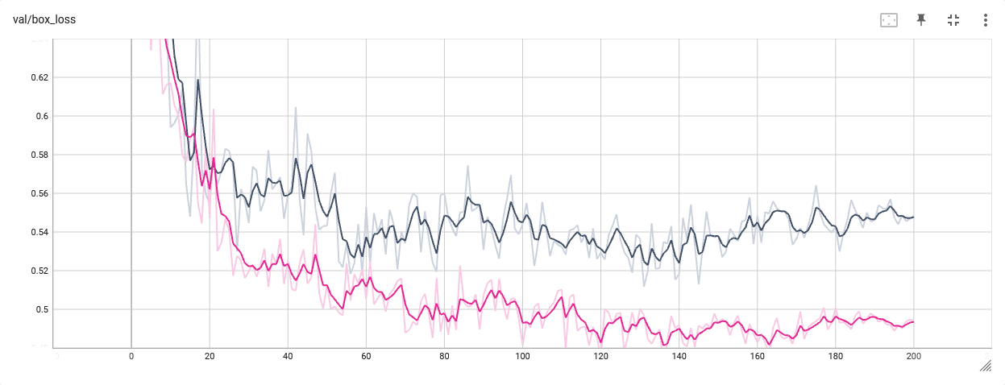

Figure 8. val/box_loss

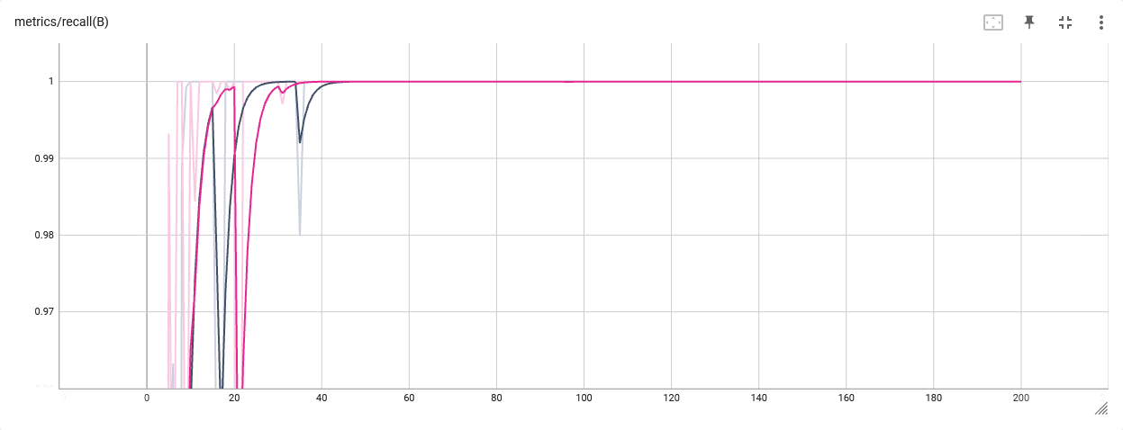

Figure 9. Recall

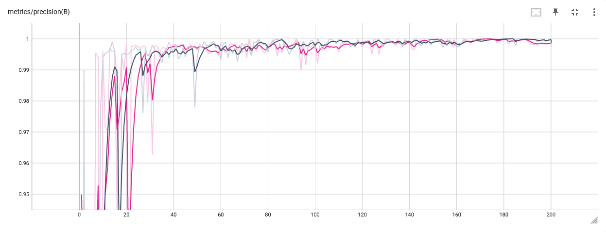

Figure 10. Precision

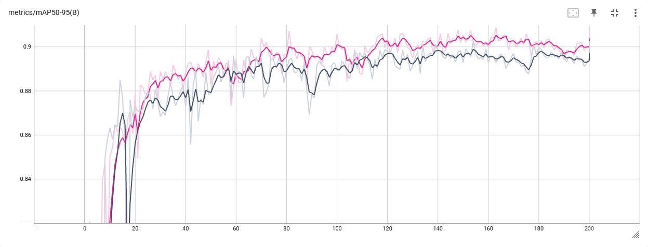

Figure 11. mAP50-95

3. Innovation of the Project

The main novelty of this project lies in the unique dataset we have collected. Traditionally, the datasets used in the development of face recognition systems are usually obtained from public or publicly available sources. However, in this project, in order to achieve a stronger result in terms of reliability and accuracy, a dataset consisting of photographs of our teammates taken under real-world conditions was collected. This unique dataset was used for the training and testing of the face recognition algorithm. This data set, which includes the photos of our teammates, enabled the system to better adapt to real-world use and produce more reliable results. This approach emphasises the importance of previously unobtained, unique data sets to improve the accuracy and reliability of our system.