Prototype of Food Hardness Measurement App Using Swept-Sine Technique

Akihide Yoshida, Akira Ohta, Akihito Kobayashi

AI System Department, Nihon Kougakuin Hachioji College

Hachioji-city, Japan

[g023c1133@g.neec.ac.jp](mailto:g023c1133@g.neec.ac.jp)

*Abstract*— The Swept-Sine technique using a smartphone makes available so that consumers can check food quality by themselves. Sweep sounds apply to gelatine samples with various hardness from the smartphone speaker, and response sounds are captured with a microphone of the identical smartphone. Impulse response is calculated by convolution integral between the sweep sounds and response sounds. Between frequency distribution of the impulse response and the hardness of the samples are investigated. Measurement using k-fold cross-validation methods and support vector machine shows an average accuracy of 0.958 in hardness classification. As a result of 72-time measurement, principal component analysis showed clear separations among hardness groups.

***Keywords—Swept-Sine method, Food hardness, Impulse response, Frequency response, Smartphone***

# Introduction

Food quality assessment is important for consumers to keep their health and to feel satisfaction. There are two kinds of inspection in the assessment; destructive and non-destructive. Destructive inspection, such as a Texturometer, causes some damage to foods. On the other hand, non-destructive inspection, such as near-infrared spectroscopy or chromatography, does less or no damage to foods. It is, however, too troublesome for consumers to be applied easily.

In 2000, A. Farina proposed the Swept-Sine technique. He measured the impulse response using acoustic waves with a frequency from 1 Hz to 20 kHz [1]. His experiment showed a high degree of signal / noise (S/N) ratio. A. Kobayashi, T. Nebashi, and A. Ohta has reported an acoustic technique improved his Swept-Sine technique and determined the ripeness of avocados [2]. Their improved technique using a headset still remains poor reproducibility due to the limitation of the number of samples.

The aim of this study is to ensure that this technique achieves the sufficiently high reproducibility. We select samples with various amounts of gelatin content and measure them repeatedly in order to extend it to various foods other than fruits. A smartphone substitutes for the headset, so that customers may easily check food quality by themselves.

# Thoery

Figure 1 shows the experimental flow of the Swept-Sine technique. In this study, the speaker at the bottom right of a smartphone generates a sweep sound, whose frequency rises exponentially, and exposes the sound to a sample. The microphone at the bottom center of the smartphone received the sound traveling through the sample.

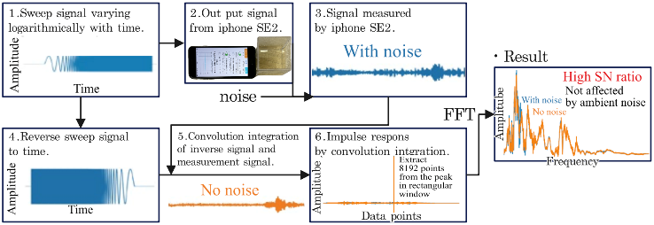

1. Flow diagram of the algorithm in this experiment

The sweep sound is expressed by Eq. (1).

$x\left(t\right)=\sin\left\{2π{f_{start}}^{T}\left(\frac{{\left(\frac{f_{end}}{f_{start}}\right)}^{t/T}-1}{log\left(\frac{f_{end}}{f_{start}}\right)}\right)\right\}$, (1)

where *f*start and *f*end are frequencies at both ends. *T* and *t* are duration and time.

Equation (2) represents an inverse filter:

$y\left(t\right)=x\left(T-t\right)∙\left\{{{\left(\frac{f_{end}}{f_{start}}\right)}^{t/T}}/T\right\}$, (2)

where the former $x\left(T-t\right)$ indicates a time-reversed signal of the sweep sound, and the latter $\left\{{{\left(\frac{f_{end}}{f_{start}}\right)}^{t/T}}/T\right\}$ is to compensate for frequencies exponentially changing with time. Such a compensation is necessary because the exponential change in frequency of the sweep sound produces an impulse response that is biased towards the relatively low frequencies. The response sound from the sample was processed with this filter. It achieved a high degree of S/N ratio.

Farina's technique tends to introduce nonlinear distortion before the main peak. The impulse response before the peak can, therefore, be ignored. In this study, sampling started at the main peak, and frequency response was calculated from the following 8,192 data with the Fast Fourier Transformation (FFT). All processing, from sweep sound generation to FFT calculations, is carried out by a smartphone app written in the Swift language. The captured sound contains errors due to ambient noise and sample variations, but this technique is able to extract the frequency response of the sample itself.

# Experiment

In this experiment, we set a sampling rate of 48 kHz, *f*start of 1 Hz, *f*end of 20 kHz, and T of 5 s for sweep sound. An Apple iPhone SE2 is used as the measurement device.

As shown in Fig. 2, the measurement sample is adhered to the smartphone with a 1-mm-thich gel tape. Samples are made by dissolving 3.25, 5.0, 7.5, and 10.0 g of gelatin powder (“Cock Gelatine,” Morinaga Seika) in 50 ml of water, respectively. To confirm the reproducibility of the response frequency, the hardness of the sample was measured 18 times for each sample.

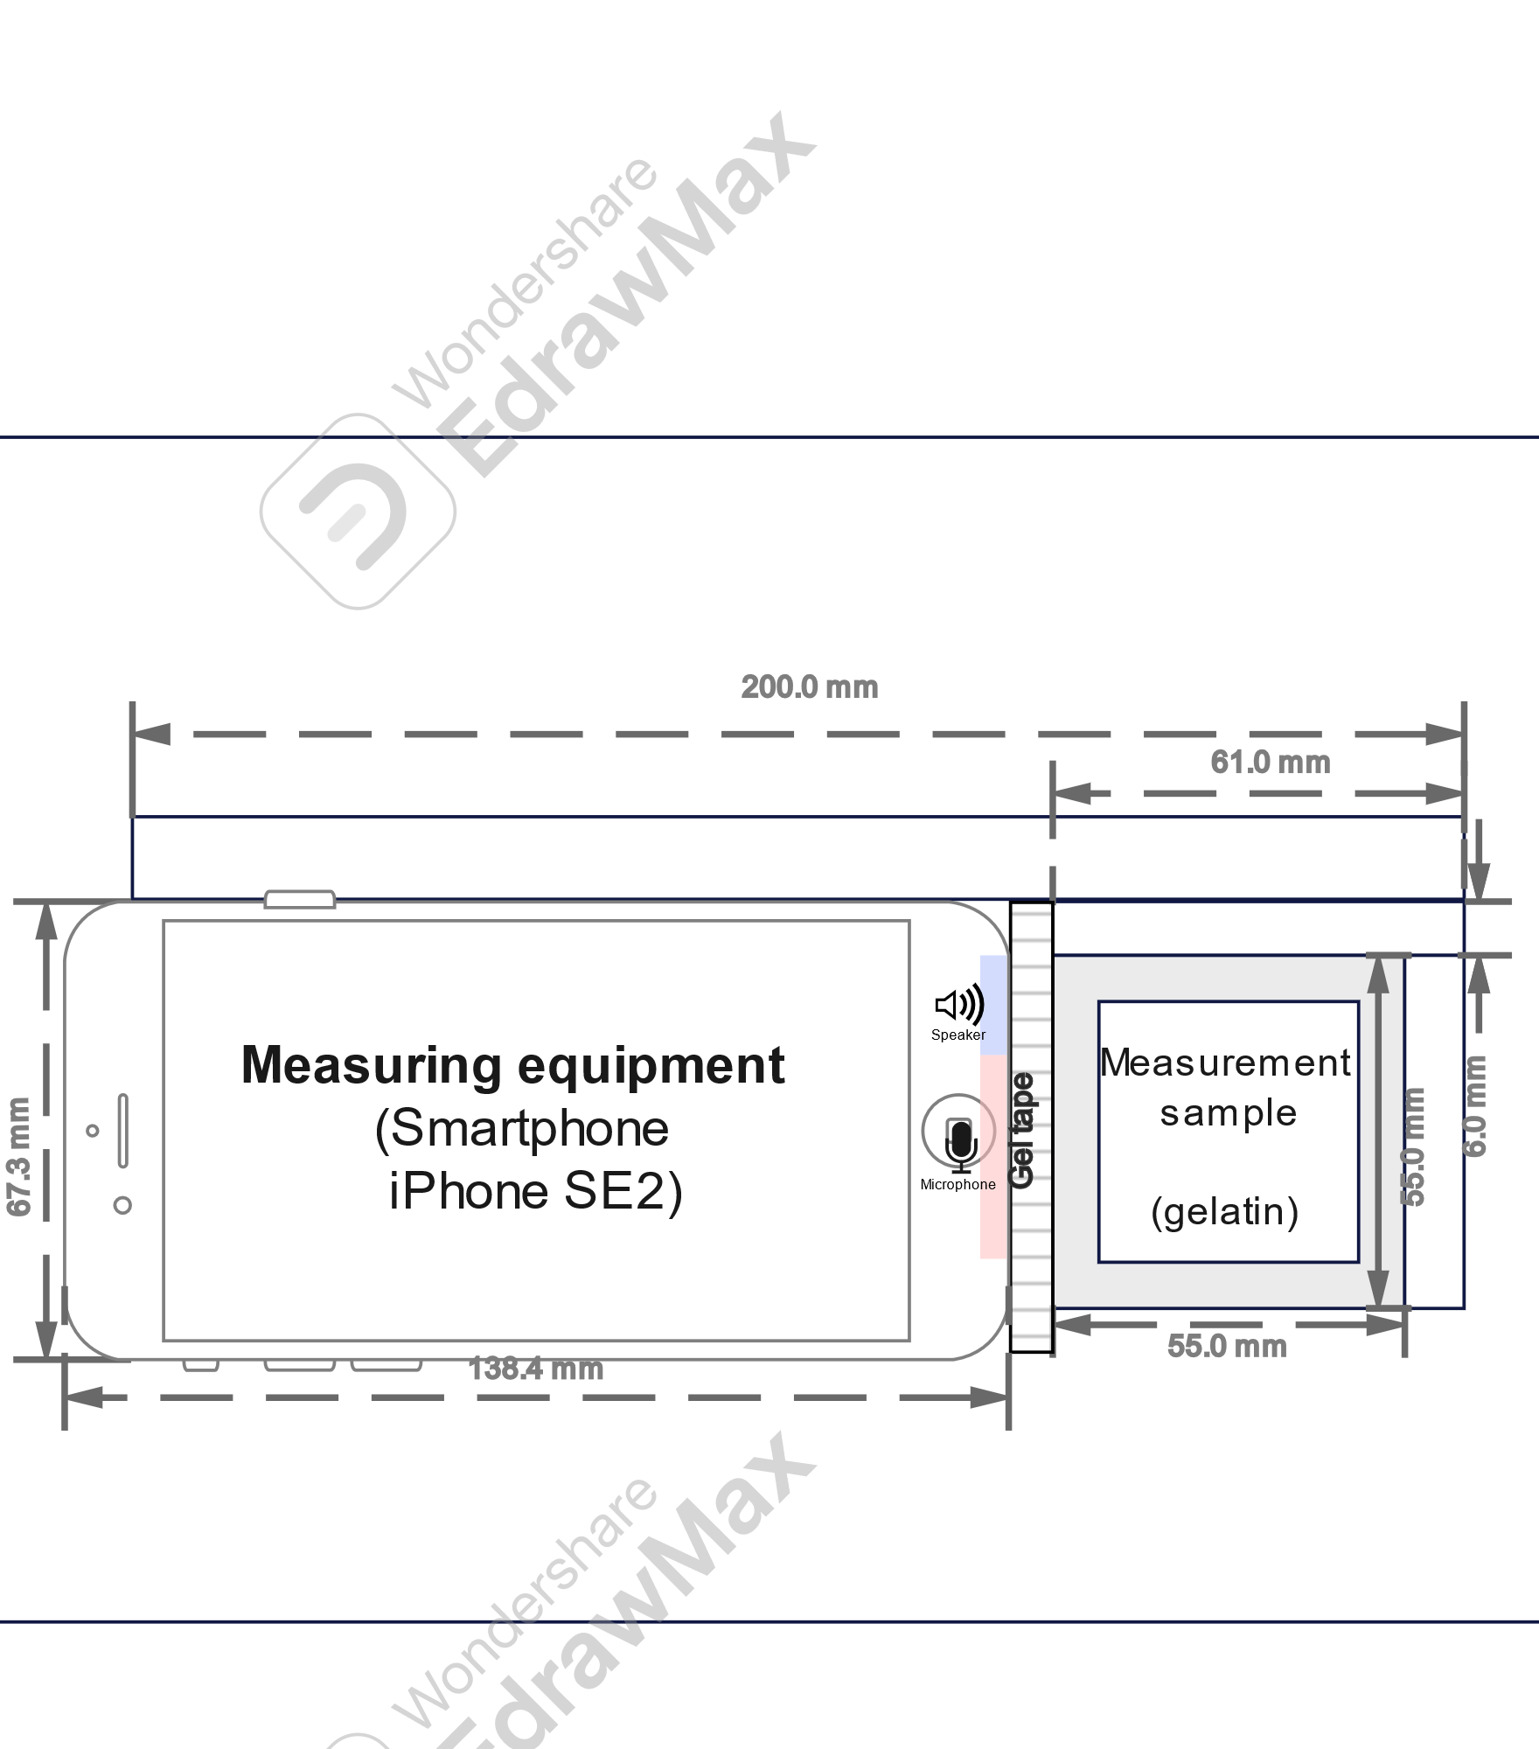

1. Apparatus for securing smartphone and gelatin samples.

The frequency response measured in a range from 1 to 5 kHz is classified using Principal Component Analysis (PCA). Setting frequency response as an explanatory variable and gelatin content as a response variable, Support Vector Machine (SVM) with Radial Basis Function kernel is applied using k-fold cross-validation with 9-Fold to verify classification accuracy.

# Results and discussion

## Frequency characteristics of each gelatin sample

Figure 3 shows the frequency characteristics of the 4 groups of different gelatin content. The frequency response of 10.0, 7.5, and 5.0-g groups showed peaks in a range from 1 to 3 kHz and fell at 2 kHz, whereas that of the 3.25-g group only had lower amplitude in that range. The frequency response of the box without gelatine is similar to that of the gelatin samples in the range from 1.5 to 3 kHz, but that doesn’t show for the smartphone without the box. Therefore, the range from 1.6 to 3 kHz is considered to be the frequency characteristic of acrylic boxes.

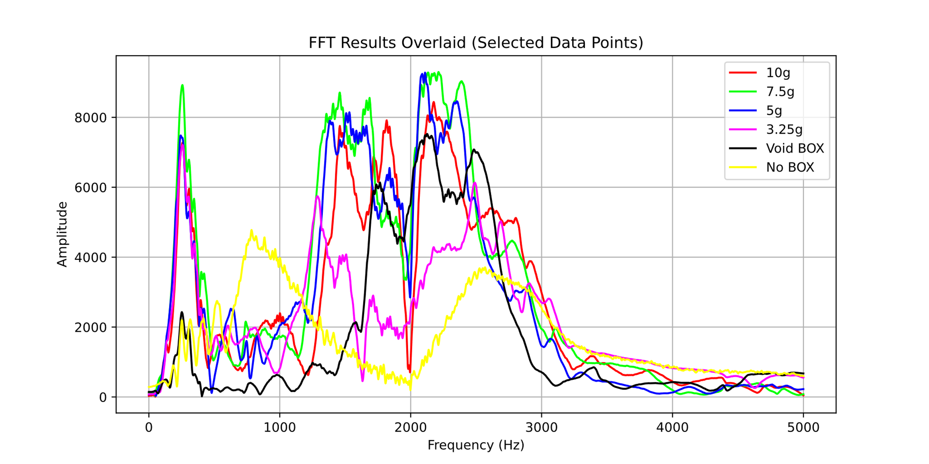

1. Acoustic Frequency Characteristics of Gelatin Samples.

## Principal component analysis of Measurement Data and Classification Accuracy

Figure 4 shows the results of the PCA performed on each of the 72-item data in three dimensions that represent the first, second, and third principal components.

The contributions of the second and third principal components were both low; 0.17 for the second and 0.12 for the third, respectively. The principal component scores for each principal component dot fully capture the differences among the gelatin amounts, as there are two types of data with scores close to 0. However, the scores for 3.25, 5.0, 7.5, and 10 g are clustered at relatively close coordinates. As the gelatin content decreases, the principal component scores become more stable and cluster more tightly around certain coordinates. In the first principal component, the negative correlation increased with increasing gelatin content. In the second principal component, a positive correlation was observed except for 7.5 g and 5 g. In the third principal component, negative correlations were observed except for 10 g and 7.5 g. These show that the amount of gelatin affects greatly on the frequency response than the error. The average correct classification by k-fold cross-validation and SVM with frequency response up to 5 kHz as the explanatory variable and gelatin content as the objective variable was about 0.958. This indicates that a simple model such as SVM can easily classify the frequency characteristics of gelatin content.

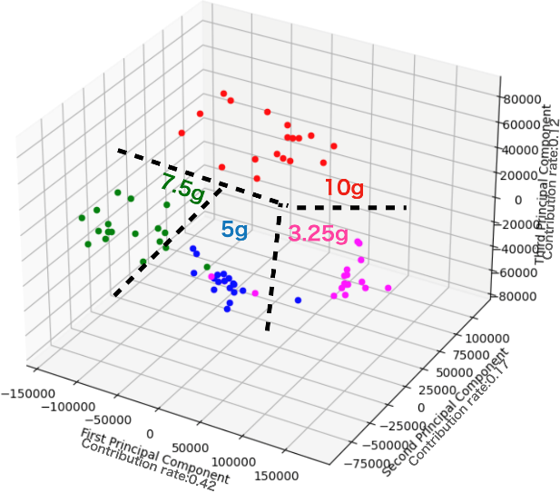

1. Principal Component Analysis of Acoustic Frequency Characteristics of Gelatin Samples.

# Conclusion

Our concept, the Swept-Sine technique with a smartphone, was demonstrated. The difference in gelatine content was visually confirmed by the PCA method. The classification using k-fold cross-validation and SVM achieves sufficiently high accuracy, even when the samples were encased in rigid case such as an acrylic box. This demonstrated the possibility of checking the quality of food, even when it is packaged in laminate or other materials, without damaging the food or its packaging. This method will be used to evaluate the quality of edible meats and fruits at grocery stores and supermarkets.

##### References

1. A. Farima, “Simultaneous measurement of impulse response and distortion with a swept-sine technique,” *Proc. of 108AES*, 5093 (D-4), (2000)
2. A. Kobayashi, T. Nebashi, and A. Ohta,“Relationship between Food Hardness and Frequency Response Using Swept-Sine Technique,” *Proc. of IEEE 12th GCCE*, p.242, (2023).