**Erika Bailon – Homework #2 CSCI 3287**

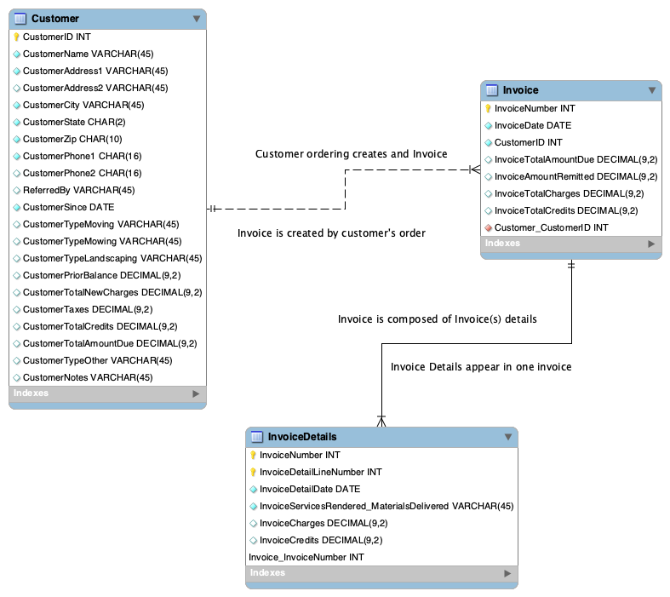

-- MySQL Script generated by MySQL Workbench

-- Sat Sep 28 14:15:37 2019

-- Model: New Model Version: 1.0

-- MySQL Workbench Forward Engineering

SET @OLD_UNIQUE_CHECKS=@@UNIQUE_CHECKS, UNIQUE_CHECKS=0;

SET @OLD_FOREIGN_KEY_CHECKS=@@FOREIGN_KEY_CHECKS, FOREIGN_KEY_CHECKS=0;

SET @OLD_SQL_MODE=@@SQL_MODE, SQL_MODE='ONLY_FULL_GROUP_BY,STRICT_TRANS_TABLES,NO_ZERO_IN_DATE,NO_ZERO_DATE,ERROR_FOR_DIVISION_BY_ZERO,NO_ENGINE_SUBSTITUTION';

-- -----------------------------------------------------

-- Schema mydb

-- -----------------------------------------------------

-- -----------------------------------------------------

-- Schema mydb

-- -----------------------------------------------------

CREATE SCHEMA IF NOT EXISTS `mydb` DEFAULT CHARACTER SET utf8 ;

USE `mydb` ;

-- -----------------------------------------------------

-- Table `mydb`.`Customer`

-- -----------------------------------------------------

DROP TABLE IF EXISTS `mydb`.`Customer` ;

CREATE TABLE IF NOT EXISTS `mydb`.`Customer` (

`CustomerID` INT NOT NULL AUTO_INCREMENT,

`CustomerName` VARCHAR(45) NOT NULL,

`CustomerAddress1` VARCHAR(45) NOT NULL,

`CustomerAddress2` VARCHAR(45) NULL,

`CustomerCity` VARCHAR(45) NOT NULL,

`CustomerState` CHAR(2) NOT NULL,

`CustomerZip` CHAR(10) NOT NULL,

`CustomerPhone1` CHAR(16) NOT NULL,

`CustomerPhone2` CHAR(16) NULL,

`ReferredBy` VARCHAR(45) NULL,

`CustomerSince` DATE NOT NULL,

`CustomerTypeMoving` VARCHAR(45) NULL,

`CustomerTypeMowing` VARCHAR(45) NULL,

`CustomerTypeLandscaping` VARCHAR(45) NULL,

`CustomerPriorBalance` DECIMAL(9,2) NULL,

`CustomerTotalNewCharges` DECIMAL(9,2) NULL,

`CustomerTaxes` DECIMAL(9,2) NULL,

`CustomerTotalCredits` DECIMAL(9,2) NULL,

`CustomerTotalAmountDue` DECIMAL(9,2) NULL,

`CustomerTypeOther` VARCHAR(45) NULL,

`CustomerNotes` VARCHAR(45) NULL,

PRIMARY KEY (`CustomerID`))

ENGINE = InnoDB;

-- -----------------------------------------------------

-- Table `mydb`.`Invoice`

-- -----------------------------------------------------

DROP TABLE IF EXISTS `mydb`.`Invoice` ;

CREATE TABLE IF NOT EXISTS `mydb`.`Invoice` (

`InvoiceNumber` INT NOT NULL AUTO_INCREMENT,

`InvoiceDate` DATE NOT NULL,

`CustomerID` INT NOT NULL,

`InvoiceTotalAmountDue` DECIMAL(9,2) NULL,

`InvoiceAmountRemitted` DECIMAL(9,2) NULL,

`InvoiceTotalCharges` DECIMAL(9,2) NULL,

`InvoiceTotalCredits` DECIMAL(9,2) NULL,

`Customer_CustomerID` INT NOT NULL,

PRIMARY KEY (`InvoiceNumber`),

CONSTRAINT `fk_Incoice_Customer`

FOREIGN KEY (`Customer_CustomerID`)

REFERENCES `mydb`.`Customer` (`CustomerID`)

ON DELETE NO ACTION

ON UPDATE NO ACTION)

ENGINE = InnoDB;

CREATE INDEX `fk_Incoice_Customer_idx` ON `mydb`.`Invoice` (`Customer_CustomerID` ASC) VISIBLE;

-- -----------------------------------------------------

-- Table `mydb`.`InvoiceDetails`

-- -----------------------------------------------------

DROP TABLE IF EXISTS `mydb`.`InvoiceDetails` ;

CREATE TABLE IF NOT EXISTS `mydb`.`InvoiceDetails` (

`InvoiceNumber` INT NOT NULL,

`InvoiceDetailLineNumber` INT NOT NULL,

`InvoiceDetailDate` DATE NOT NULL,

`InvoiceServicesRendered_MaterialsDelivered` VARCHAR(45) NOT NULL,

`InvoiceCharges` DECIMAL(9,2) NULL,

`InvoiceCredits` DECIMAL(9,2) NULL,

`Invoice_InvoiceNumber` INT NOT NULL,

PRIMARY KEY (`InvoiceNumber`, `InvoiceDetailLineNumber`, `Invoice_InvoiceNumber`),

CONSTRAINT `fk_InvoiceDetails_Invoice1`

FOREIGN KEY (`Invoice_InvoiceNumber`)

REFERENCES `mydb`.`Invoice` (`InvoiceNumber`)

ON DELETE NO ACTION

ON UPDATE NO ACTION)

ENGINE = InnoDB;

CREATE INDEX `fk_InvoiceDetails_Invoice1_idx` ON `mydb`.`InvoiceDetails` (`Invoice_InvoiceNumber` ASC) VISIBLE;

SET SQL_MODE=@OLD_SQL_MODE;

SET FOREIGN_KEY_CHECKS=@OLD_FOREIGN_KEY_CHECKS;

SET UNIQUE_CHECKS=@OLD_UNIQUE_CHECKS;

**List of Assumptions**

* I assumed we might have international customers so then some might have LADA on the phone numbers, hence the length of the phone CHAR
* For some reason the key in the ‘InvoiceDetails’ table doesn’t show up I don’t know why or what settings are wrong. I remember Paradise saying something about not showing on his tables sometimes either.