**Erika Bailon**

**CSCI 3287**

**Homework 3 – SQL**

SELECT city FROM offices;

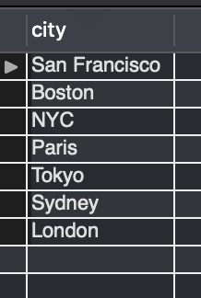

FIRST - SELECT officeCode, city FROM offices;

Then - SELECT EmployeeNumber, LastName, FirstName, Extension

FROM employees

WHERE officeCode = '4';

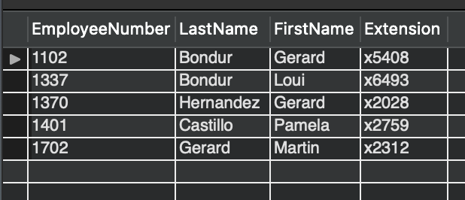

SELECT ProductCode, ProductName, ProductVendor, quantityInStock, ProductLine

FROM Products

WHERE quantityInStock BETWEEN 100 AND 1000;

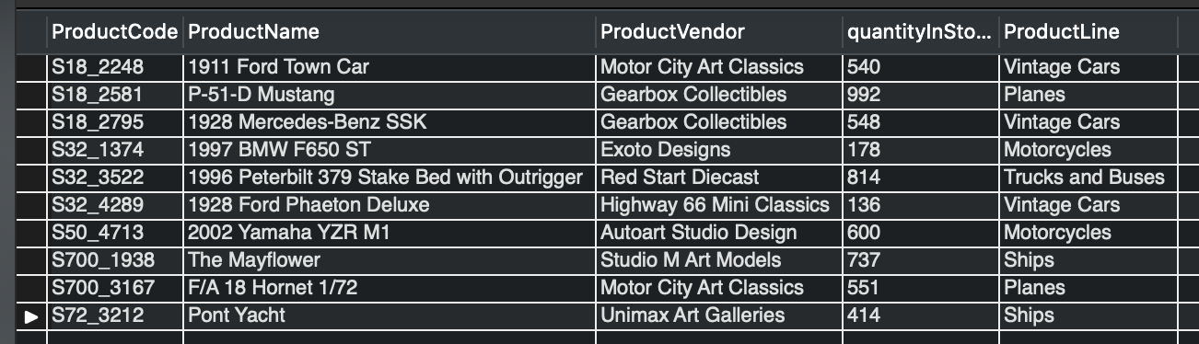

1. SELECT ProductCode, ProductName, ProductVendor, BuyPrice, MSRP

FROM Products

WHERE MSRP = (SELECT MIN(MSRP) FROM Products);

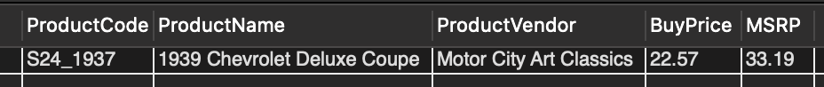

1. SELECT ProductName, (MSRP-BuyPrice) AS Profit

FROM Products WHERE (MSRP-BuyPrice) = (SELECT MAX(MSRP-BuyPrice) FROM Products);

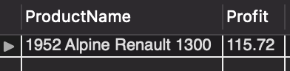

1. SELECT country, COUNT(customerName) as 'Customers'

FROM customers

GROUP BY country

HAVING COUNT(customerName) > 10

ORDER BY COUNT(customerName) asc;

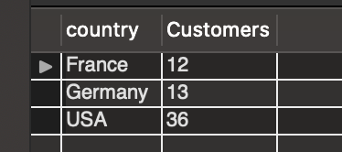

1. SELECT Products.ProductCode, Products.ProductName, OrderDetails.quantityOrdered as OrderCount

FROM OrderDetails

INNER JOIN Products ON OrderDetails.ProductCode=Products.ProductCode

WHERE quantityOrdered = (SELECT MAX(quantityOrdered)FROM OrderDetails);

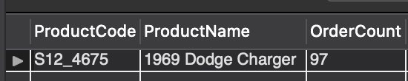

1. First to find the employee number of the supervisors –

SELECT employeeNumber, firstName FROM employees WHERE firstName = 'Diane' OR firstName = 'William';

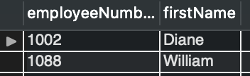

THEN ….

SELECT EmployeeNumber, CONCAT(FirstName, ' ' , LastName) as Name

FROM employees

WHERE reportsTo = '1002' OR reportsTo = '1088';

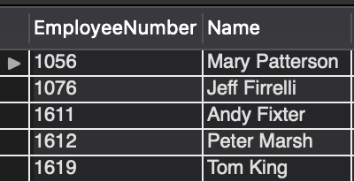

1. SELECT EmployeeNumber, LastName, FirstName

FROM employees

WHERE reportsTo IS NULL;



1. SELECT productNAme

FROM products

WHERE productLine = 'Classic Cars' AND productName LIKE '197%';

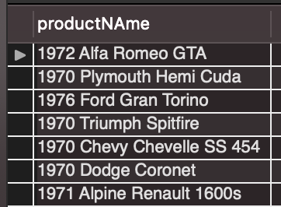

1. SELECT MONTHNAME(orderDate) AS Month, COUNT(orderNumber) AS Total

FROM orders

WHERE EXTRACT(year from orderdate)= '2005'

GROUP BY Month ORDER BY Total DESC Limit 1;



1. SELECT employees.firstName, employees.lastName

FROM Employees

LEFT OUTER JOIN Customers ON Customers.salesRepEmployeeNumber=employees.employeeNumber

WHERE employees.jobTitle = 'Sales Rep' AND Customers.salesRepEmployeeNumber IS NULL;

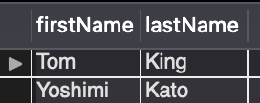

1. SELECT Customers.customerName

FROM Customers

LEFT OUTER JOIN Orders ON Orders.customerNumber=Customers.customerNumber

WHERE Customers.country='Germany' AND orders.customerNumber IS NULL;

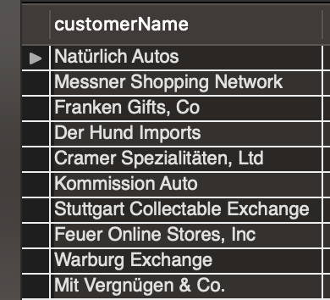

1. SELECT CustomerName,sum(quantityOrdered)

FROM Customers c

JOIN Orders o on c.customerNumber = o.customerNumber

JOIN OrderDetails od on o.orderNumber = od.orderNumber

GROUP BY o.customerNumber

HAVING sum(quantityOrdered)>1700;

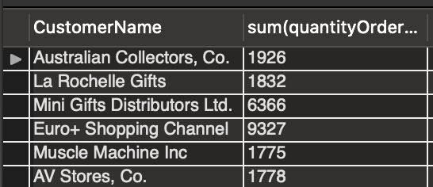

1. CREATE TABLE TopCustomers (CustomerNumber Integer NOT NULL, ContactDate Date NOT NULL,

OrderTotal Decimal(9,2) NOT NULL,

CONSTRAINT CustomerNumber_PK PRIMARY KEY (CustomerNumber));

1. INSERT INTO TopCustomers (CustomerNumber, ContactDate, OrderTotal)

SELECT c.CustomerNumber,CURDATE(), sum(priceEach*quantityOrdered)

FROM Customers c

JOIN Orders o on c.customerNumber = o.customerNumber

JOIN OrderDetails od on o.orderNumber = od.orderNumber

GROUP BY o.customerNumber

HAVING sum(priceEach*quantityOrdered) > 140000;



1. SELECT * from topcustomers ORDER BY OrderTotal desc;

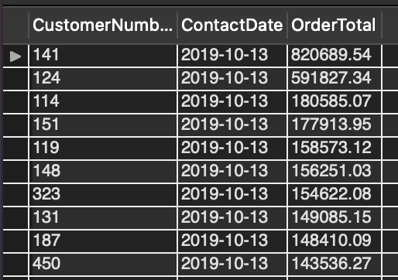

1. ALTER table topCustomers

ADD COLUMN OrderCount integer;

1. UPDATE TopCustomers

SET OrderCount=floor((rand()*18));

1. SELECT * FROM TopCustomers ORDER BY OrderCount desc;

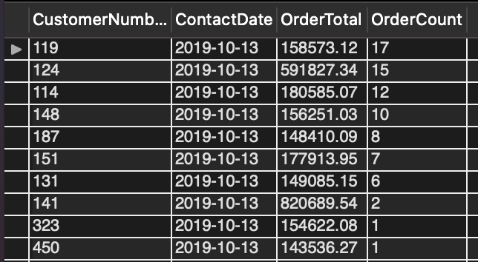

1. DROP table topCustomers;