SIMATS ENGINEERING
ASSESSMENT TOOL 1

Name : Akil Abhinav K
Reg no : 192411029
COURSE NAME: INTERNET PROGRAMMING
COURSE CODE: CSA43

COURSE OUTCOME COVERED

CO-1 : Develop well-structured, standards-compliant web pages using HTML/XHTML and XML, and apply Internet protocols and HTTP communication mechanisms for web content delivery. (L2)

Assessment Tool : Application-Based Questions

Weightage: 40%

ONLINE SYMPOSIUM PORTAL
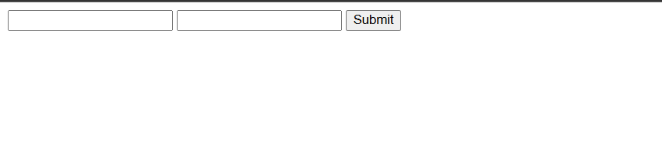
Q1: Missing HTML5 Semantic Elements
- <!DOCTYPE html> - Declares HTML5 document
- <html lang="en"> - Root element with language
- <head> - Contains metadata
- <meta charset="UTF-8"> - Character encoding
- <meta viewport> - Mobile responsiveness
- <title> - Page title
- <header> - Page header
- <main> - Main content area
- <article> - Content wrapper
- <fieldset> & <legend> - Form grouping
- <label for=""> - Label linked to input
- <footer> - Page footer
- required attribute - Form validation
- aria-required="true" - Accessibility

Q2: Standards-Compliant Changes
- Added DOCTYPE declaration
- Added complete HTML structure (html, head, body)
- Added meta tags (charset, viewport)
- Added semantic tags (header, main, article, footer)
- Linked labels to inputs using id and for attributes
- Grouped form fields with <fieldset> and <legend>
- Added required attribute for validation
- Added type="email" for email validation
- Added clear button text type="submit"
- Added accessibility attributes (aria-required)
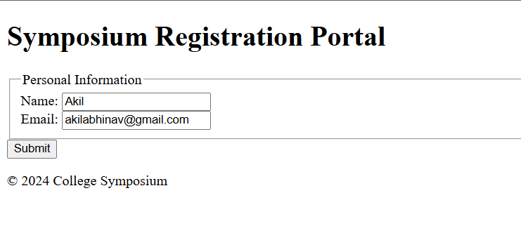

Q3: HTTP Request Generated
POST /register HTTP/1.1
Host: www.college.edu
Content-Type: application/x-www-form-urlencoded
Content-Length: 45

name=John+Doe&email=john%40college.edu
Breakdown:
- POST = Sends data in body (hidden from URL)
- /register = Server endpoint
- Content-Type = Form data format
- Body = form field values (space = +, @ = %40)
Why POST:
- Data is hidden (secure)
- No URL length limit
- Better for sensitive data
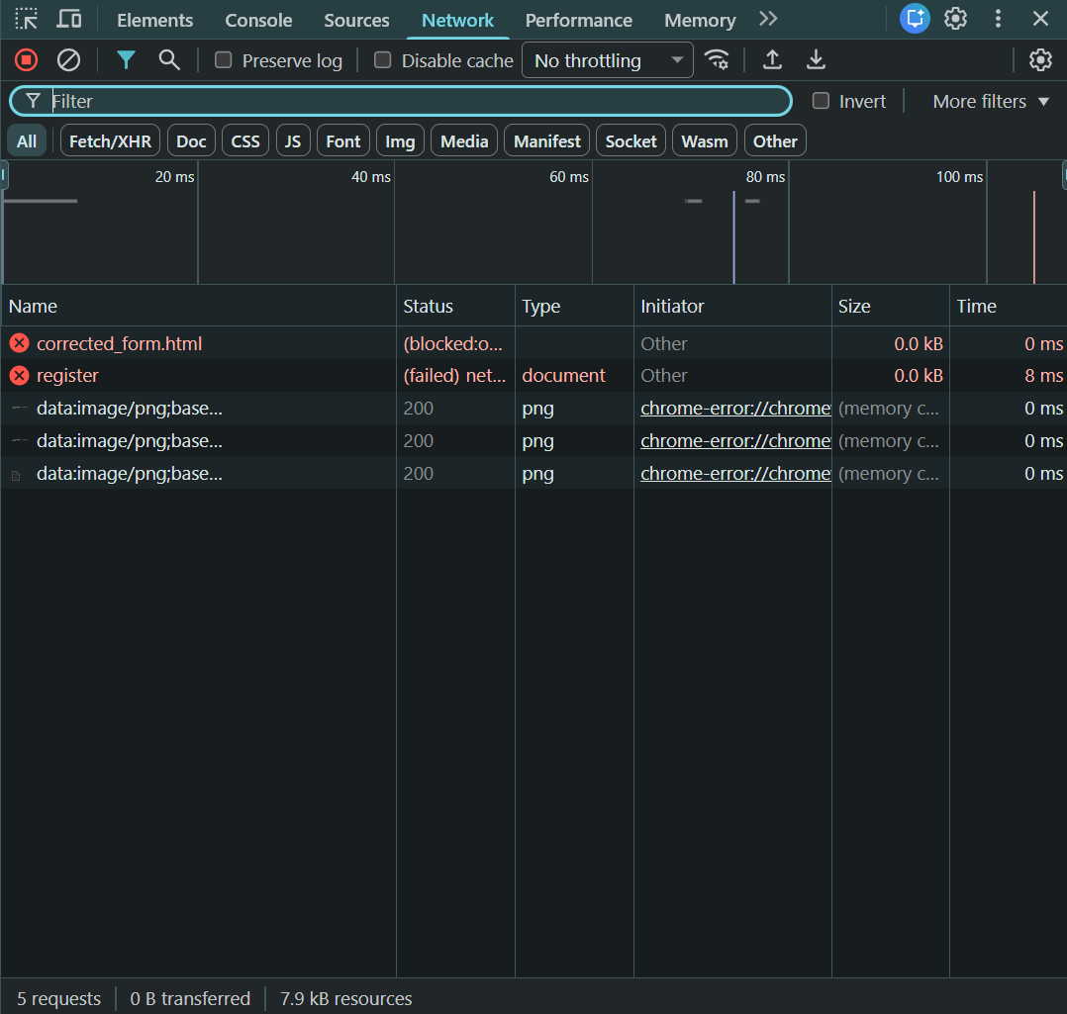

Q4: HTTP Response Cycle
Steps:
- Browser sends POST request with form data
- Server receives and validates data
- Server checks database
- Server stores registration
- Server generates response (200 OK or error)
- Browser receives response
- Browser displays result to user
Success Response:
HTTP/1.1 200 OK
Content-Type: text/html

Registration successful! ID: REG-001234
Error Response:
HTTP/1.1 400 Bad Request

Invalid email format
Status Codes:
- 200 = Success
- 400 = Bad request
- 409 = Email already exists
- 500 = Server error

Q5: Improvements for Usability & Accessibility
Usability:
- Add placeholder text showing example format
- Add helper text explaining field purpose
- Mark required fields with *
- Show validation error messages
- Display success confirmation after submit
- Use clear button text "Register Now"
- Group related fields in fieldset
- Add responsive design (viewport meta tag)
Accessibility:
- Always use <label for=""> linked to input id
- Add aria-required="true" on required fields
- Use semantic HTML (header, main, footer)
- Support keyboard navigation (Tab, Enter)
- Add focus indicators with CSS
- Use type="email" for email validation
- Ensure good color contrast
- Provide clear error messages
Result: Accessible to all users (blind, deaf, motor issues, elderly, etc.)

Cross-Browser Compatibility Issue

1. Identify improper nesting and missing closing tags:
The original HTML has several critical issues:
- The <h1> tag is not properly closed. It should be <h1>Welcome</h1> but appears as just <h1>Welcome without the closing </h1>.
- The <p> tag is not closed. It should be <p>About us</p> but only has the opening tag <p>About us.
- These unclosed tags can cause browsers to auto-correct them, but the interpretation varies by browser, leading to inconsistent rendering.
- The closing </div> tag is present, but the hierarchy becomes ambiguous due to missing closing tags for <h1> and <p>.
<!DOCTYPE html>
<html lang="en">
<head>
<meta charset="UTF-8">
<meta name="viewport" content="width=device-width, initial-scale=1.0">
<title>Company</title>
</head>
<body>
<header>
<h1>Welcome</h1>
</header>
<main>
<section>
<h2>About Us</h2>
<p>About us</p>
</section>
</main>
</body>
</html>
2. Analyze how different browsers may interpret this structure:
Different browsers handle malformed HTML differently:
- Chrome/Edge (Chromium-based): These browsers are more forgiving and will auto-close unclosed tags. Chrome might render the structure as <h1>Welcome</h1><p>About us</p> automatically, placing content where it assumes tags should close.
- Firefox: Firefox has its own HTML parser that attempts error correction. It may interpret the unclosed tags similarly to Chrome but might handle nesting slightly differently in edge cases.
- Safari: Safari's WebKit engine also auto-corrects, but the point at which it closes tags might differ, potentially causing subtle layout shifts.
- Internet Explorer (legacy): IE would attempt corrections but might place elements in unexpected locations, especially with nested divs and unclosed tags.
- The result: identical source code produces different DOM trees across browsers, leading to inconsistent CSS application, text wrapping, spacing, and overall visual layout.
3. Identify missing semantic elements:
The current structure uses only a generic <div> wrapper, which lacks semantic meaning:
- Missing <header> element: The welcoming content should be wrapped in a <header> tag to indicate the introductory section of the page.
- Missing <main> element: The primary content should be wrapped in a <main> tag to identify the central content of the document.
- Missing <section> or <article> elements: The "About us" content could benefit from being in a <section> or <article> to provide semantic structure.
- Missing <nav> element: If there are navigation links (though not shown), they should use <nav>.
- These semantic elements help screen readers, search engines, and browsers understand the document structure, improving accessibility and SEO.
4. Provide a corrected W3C-compliant HTML structure:
A properly structured, semantic HTML5 document should include:
- Proper DOCTYPE declaration (<!DOCTYPE html>) at the very beginning.
- Correct <html>, <head>, and <body> tags with proper closing.
- A <meta charset="UTF-8"> tag for character encoding.
- A <meta name="viewport"> tag for responsive design.
- Semantic elements like <header>, <main>, <section>, or <article>.
- All tags properly opened and closed in correct nesting order.
- Meaningful heading hierarchy (e.g., <h1> followed by <h2> or <h3>, not mixing levels).
5. Suggest techniques to ensure cross-browser compatibility:
- Use a DOCTYPE declaration: Always start with <!DOCTYPE html> to trigger standards mode in all browsers.
- Include viewport meta tag: Add <meta name="viewport" content="width=device-width, initial-scale=1.0"> for responsive design across devices.
- Validate your HTML: Use the W3C HTML Validator to ensure your code is standards-compliant.
- Test across browsers: Use tools like BrowserStack or cross-browser testing services to verify rendering.
- Use CSS resets or normalization: Apply a CSS reset (e.g., Normalize.css) to ensure consistent default styling across browsers.
- Avoid browser-specific hacks: Write clean, standards-compliant code rather than targeting specific browsers.
- Progressive enhancement: Build a solid HTML foundation first, then enhance with CSS and JavaScript.
- Use semantic HTML5: Semantic elements are more consistently supported and help browsers render content correctly.
- Test with developer tools: Use browser DevTools to inspect the DOM and identify differences in how browsers parse your HTML.

Form Submission Failure
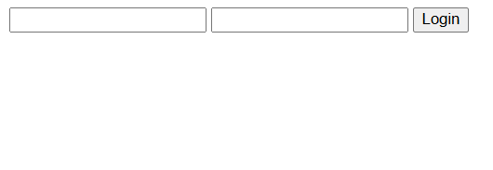
1. Identify issues in the form configuration:
- Wrong button type: type="button" does not submit the form. Should be type="submit".
- Insecure method: method="GET" exposes sensitive data (passwords) in the URL and browser history.
- Missing labels: No <label> elements reduce accessibility.
- No validation: Missing required attributes on inputs.
- No CSRF protection: Vulnerable to Cross-Site Request Forgery attacks.

<form action="/submit" method="POST" name="loginForm">
<div>
<label for="username">Username:</label>
<input type="text" id="username" name="username" required autocomplete="username">
</div>

<div>
<label for="password">Password:</label>
<input type="password" id="password" name="password" required autocomplete="current-password">
</div>

<button type="submit">Login</button>
</form>

2. Analyze why the HTTP request is not triggered:
- The button has type="button" instead of type="submit", so it doesn't submit the form by default.
- Without a submit button, the form data is never collected or sent to the server endpoint.
- Clicking the button fires no action unless JavaScript is attached.
3. Interpret the role of GET method in this scenario:
- Exposes credentials: GET appends all data to the URL (e.g., /submit?password=secret123), visible in the address bar, history, and logs.
- Security risk: Passwords and sensitive data are exposed to anyone viewing the screen.
- URL length limit: GET has maximum URL length, restricting large form submissions.
- Caching issue: Browsers cache GET requests, storing sensitive data in cache.
- Wrong use case: GET should only retrieve data, not transmit sensitive information like credentials.
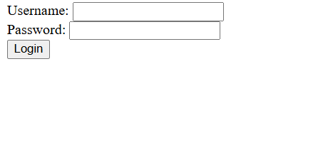
4. Propose a corrected implementation:
- Change method="GET" to method="POST" to send data in the request body (hidden from URL).
- Change type="button" to type="submit" to enable form submission.
- Add id attributes to inputs and <label> elements for accessibility.
- Add required attribute to mandatory fields.
- Add autocomplete attributes for password manager support.
5. Suggest improvements for secure data transmission:
- Use HTTPS: Encrypt all data in transit.
- Server-side validation: Always validate data on the server, not just client-side.
- Hash passwords: Use bcrypt or Argon2 on the server.
- Add CSRF token: Include a unique token in the form to prevent unauthorized submissions.
- Implement rate limiting: Prevent brute-force login attacks.
- Use HttpOnly cookies: Prevent JavaScript from accessing session data.
- Sanitize input: Clean user input to prevent SQL injection and XSS attacks.
- Add Content Security Policy: Protect against cross-site scripting attacks.

