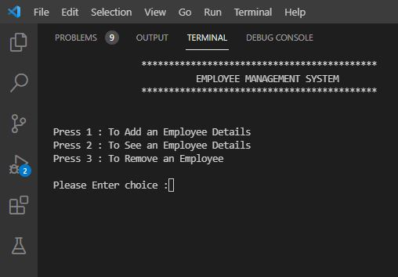

Fig 1 :- Enter Choices…

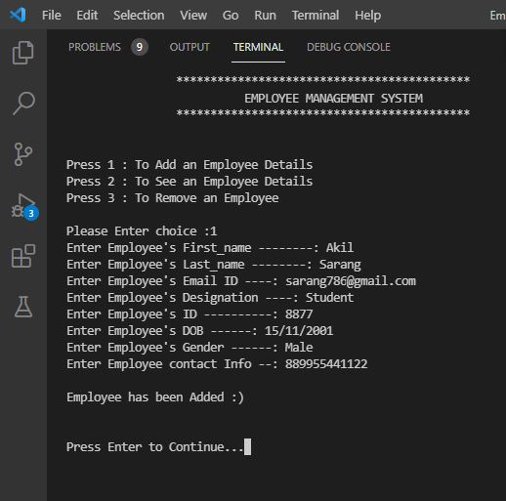

Fig 2 :- Add Employee Details..

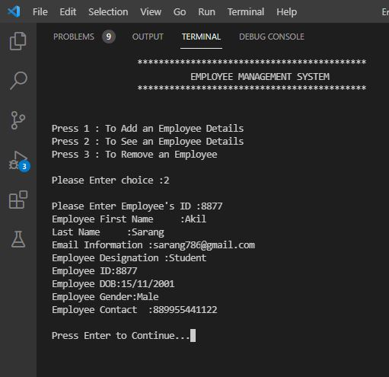

Fig 3:- To See Employees Details..

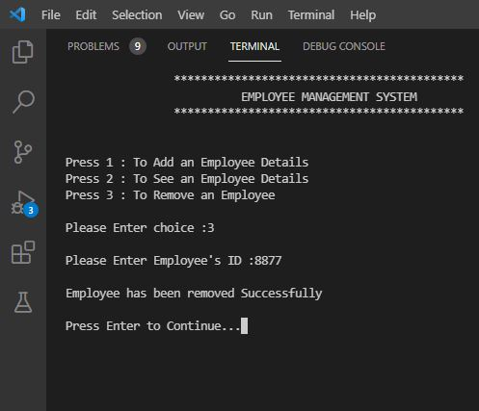

Fig 3:- To Remove Employee Details..