**ENSF-381**: **Full Stack Web Development Laboratory**

**Lab03**

**Section:**

**Group information:**

Akila Fernando (30169955)

Tanvi Mahalwar (30210358)

**GitHub Link:**

https://github.com/Akila-Fernando/ENSF381-Lab-3

**Exercise 1 Output:**

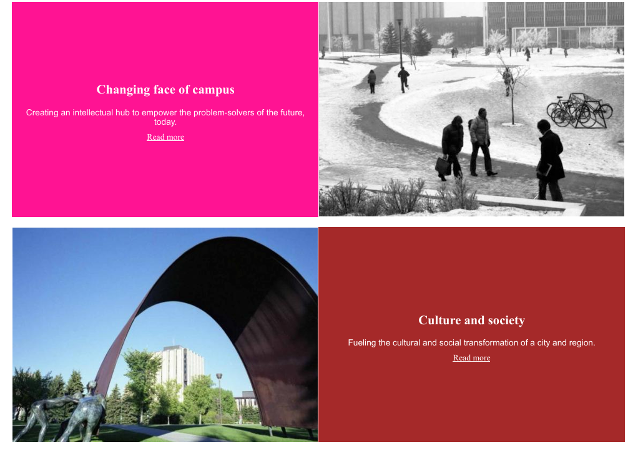

**Exercise 2 Output:**

Step 5:





Step 8

****Step 10

Step 13

Step 15

Step 17



**Exercise 3 Output:**