Object Oriented Software Design - CS2062

Group Project

Assignment 2

**Team 10 - Deck of Aces**

Akila Induranga (190239A)

Aruna Senanayake (190576D)

Bhanuja Sasanka (190152B)

Samadhi Divyanjalee (190159D)

**Class diagram**

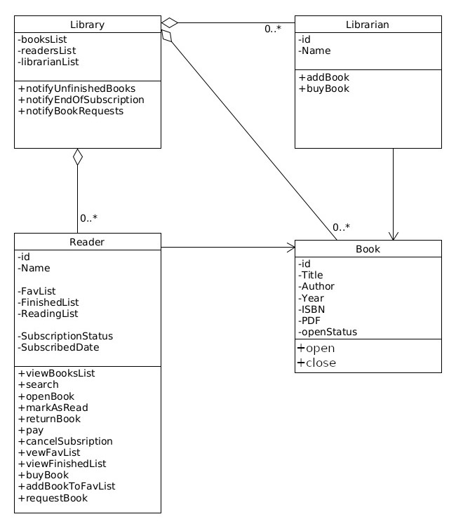

**State chart diagram for open/close status of a book**

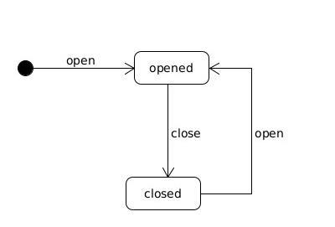

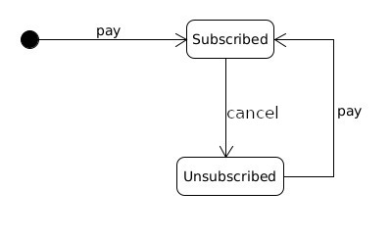**State chart diagram for subcription status of a reader**