1. **DO NOT SET SIZE OF YOUR RENDER IN THE INIT FUNCTION:**

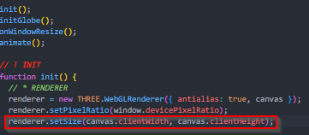

Setting the size of the renderer in the init function makes it such that even when there’s a code to resize renderer when the viewport resizes, the renderer still won’t resize until you reload the page.