Assignment-4 Hotel Booking System

Debugging Logs

Git Repository: <https://github.com/AkilaKanishka/HotelApp>

UAT Test Script: <https://github.com/AkilaKanishka/HotelApp/blob/master/UAT%2BTest%2BScript.docx>

Debugging Log: <https://github.com/AkilaKanishka/HotelApp/blob/master/debugging-log.docx>

1. All Service charges are reported as 0.00 when checking out

* In checkoutCTL.java set the debug point at line number 66

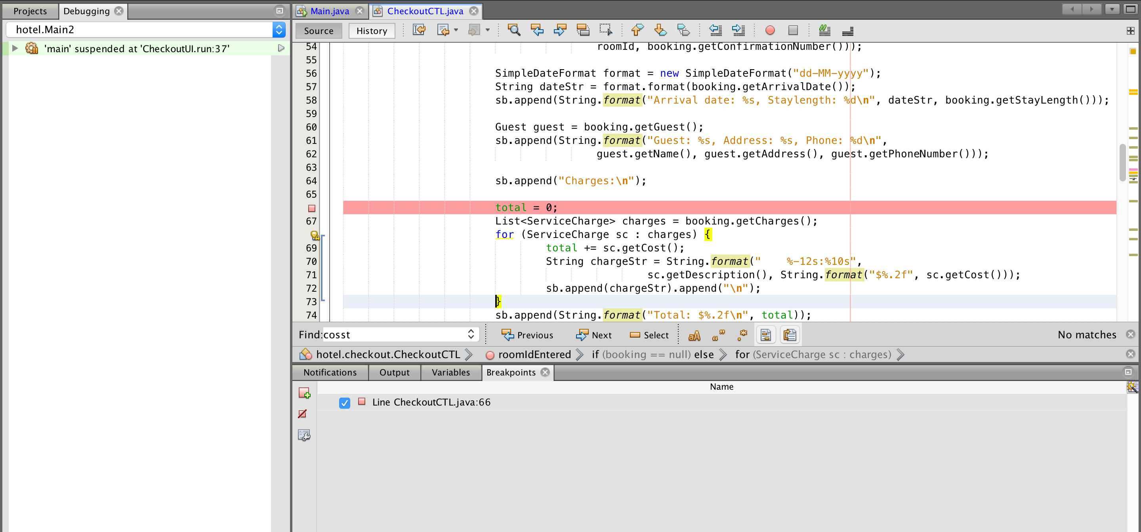

* when I Debug the file I could notice that the variable “*total*” wasn’t updated because ‘*charges’* object list always returns the 0.00 for the ‘*cost’* variable

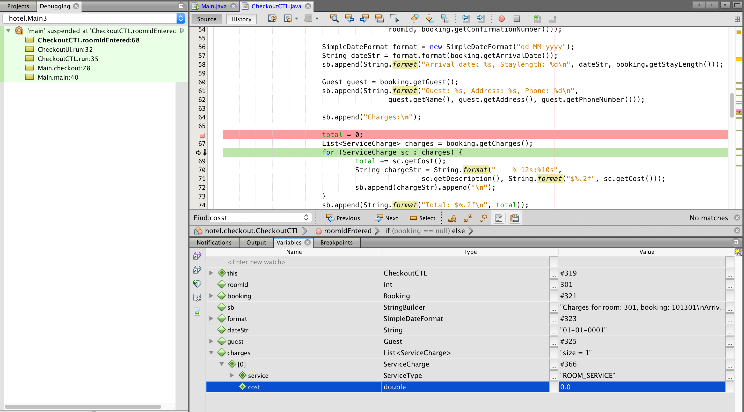

* The reason for this issue should be ‘*cost’* variable is not being set the value so then I set the debug point Booking.java file where set the value for ‘*cost’* variable
* Set the debug point in Booking.java file at *addServiceCharge* method (line number 142)

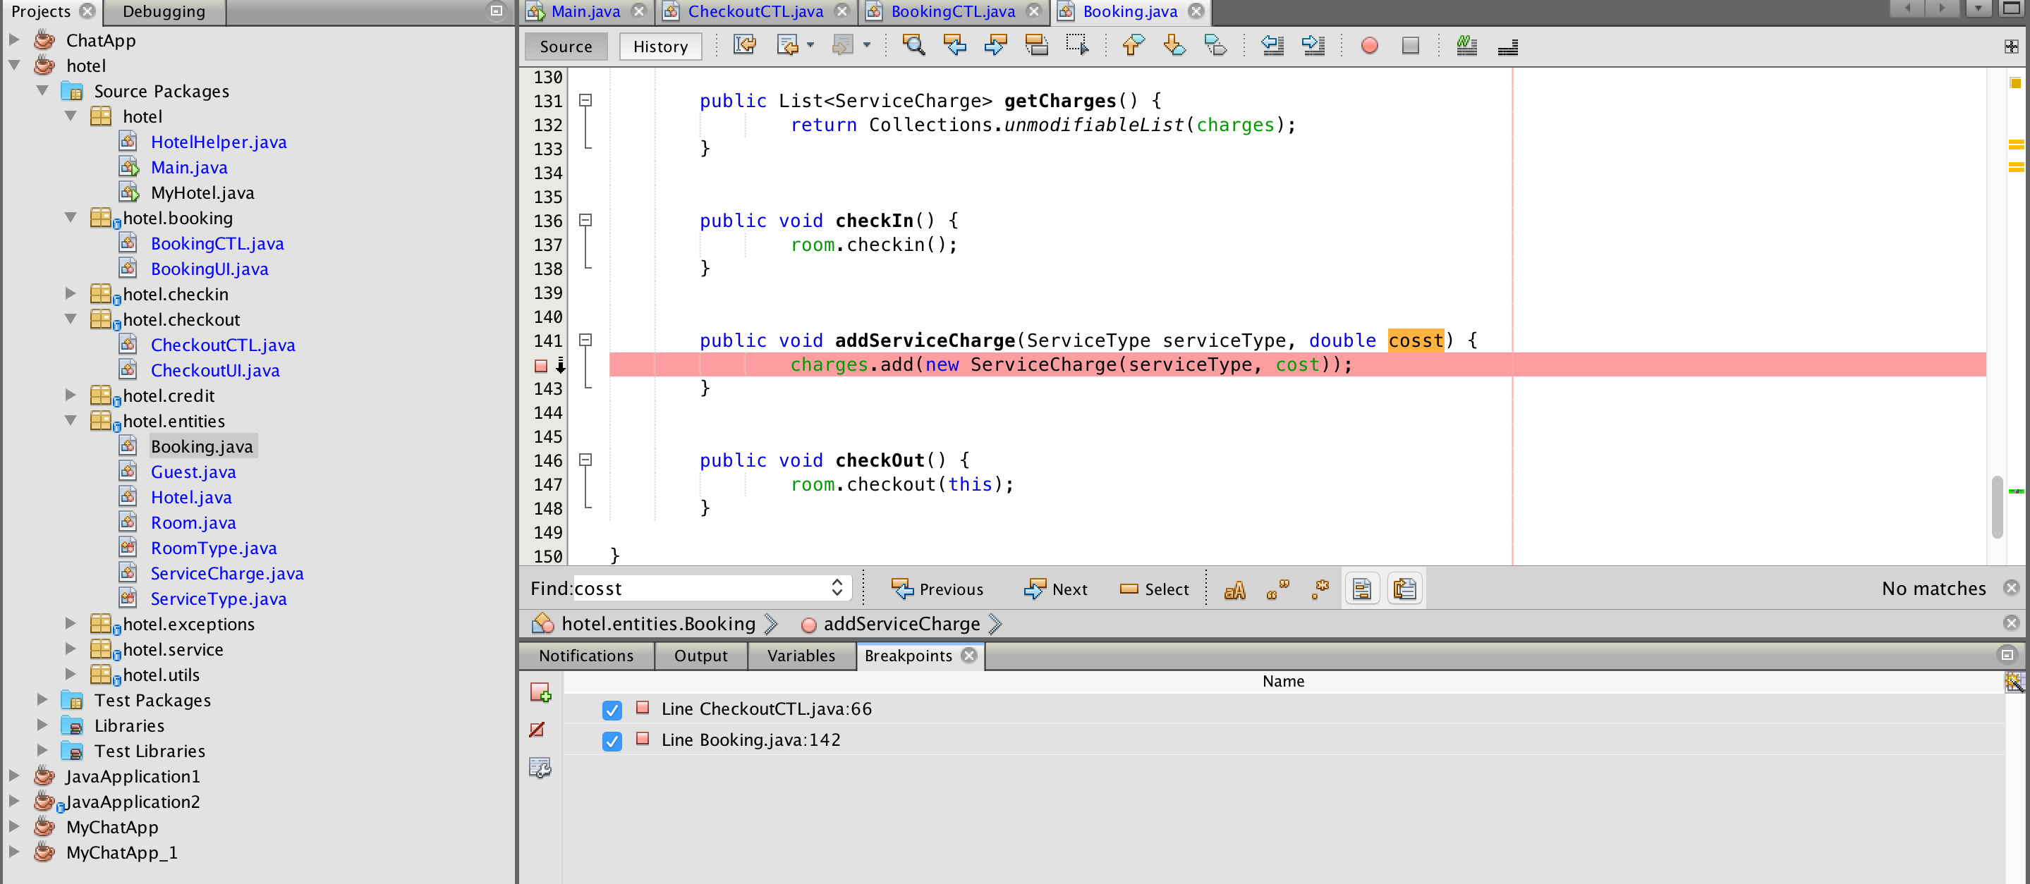

while debugging the Booking.java file we can see in the variable list as following

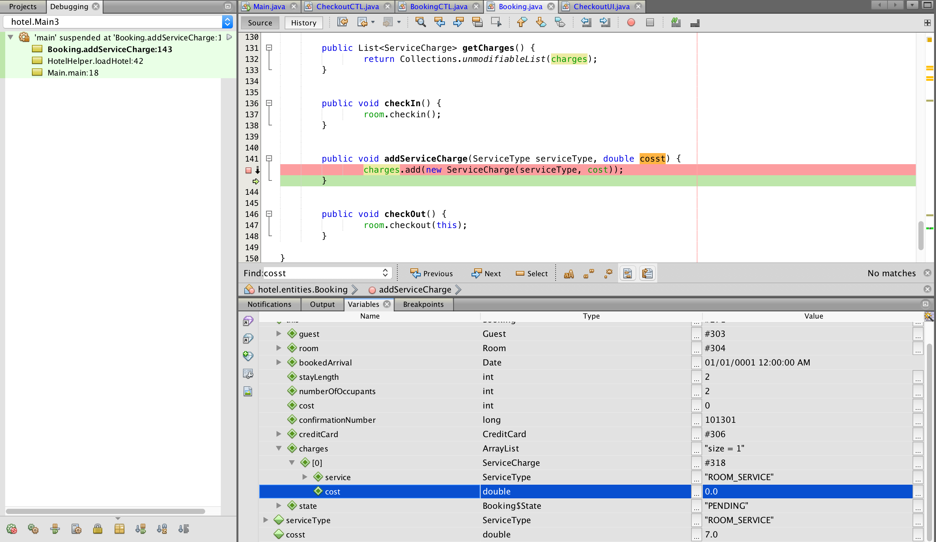

* In the variable list we can see clearly the parameter that pass the to the *addServiceCharge* method is not used inside the method because variable names are deferent

cosst = 7.0

cost = 0.0

* As above explain bug can be identified through the process



Figure 1: Before fixing error

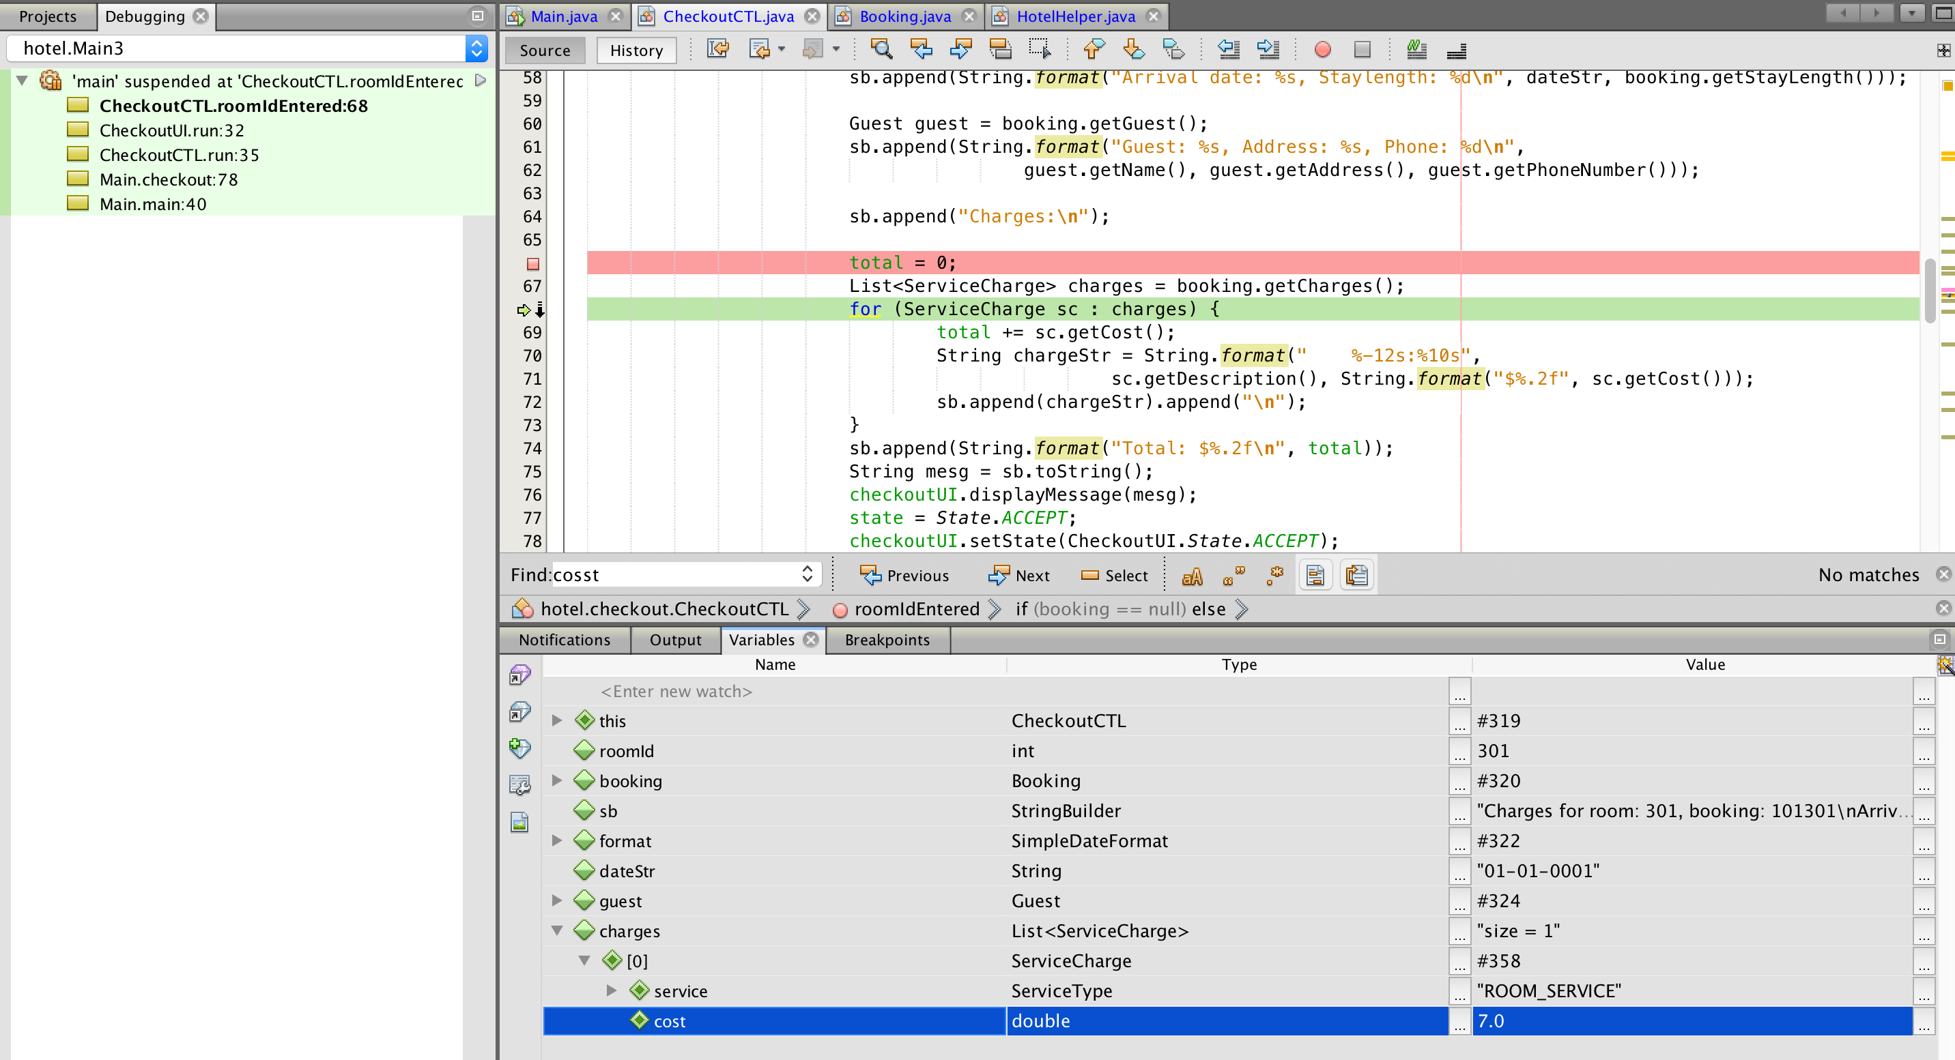

Figure 2: After fixing error



Figure 3: Before fixing error

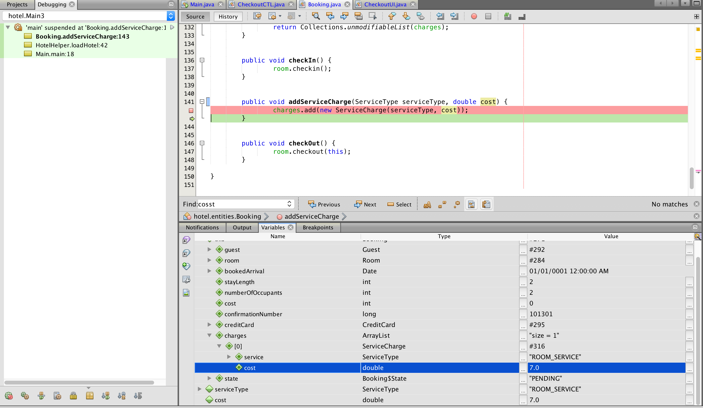

Figure 4: After fixing error

* Bug fixed and committed to the git repository

Committed link : <https://github.com/AkilaKanishka/HotelApp/commit/78e0b00f983117639a99ecc6514278127ca95806>

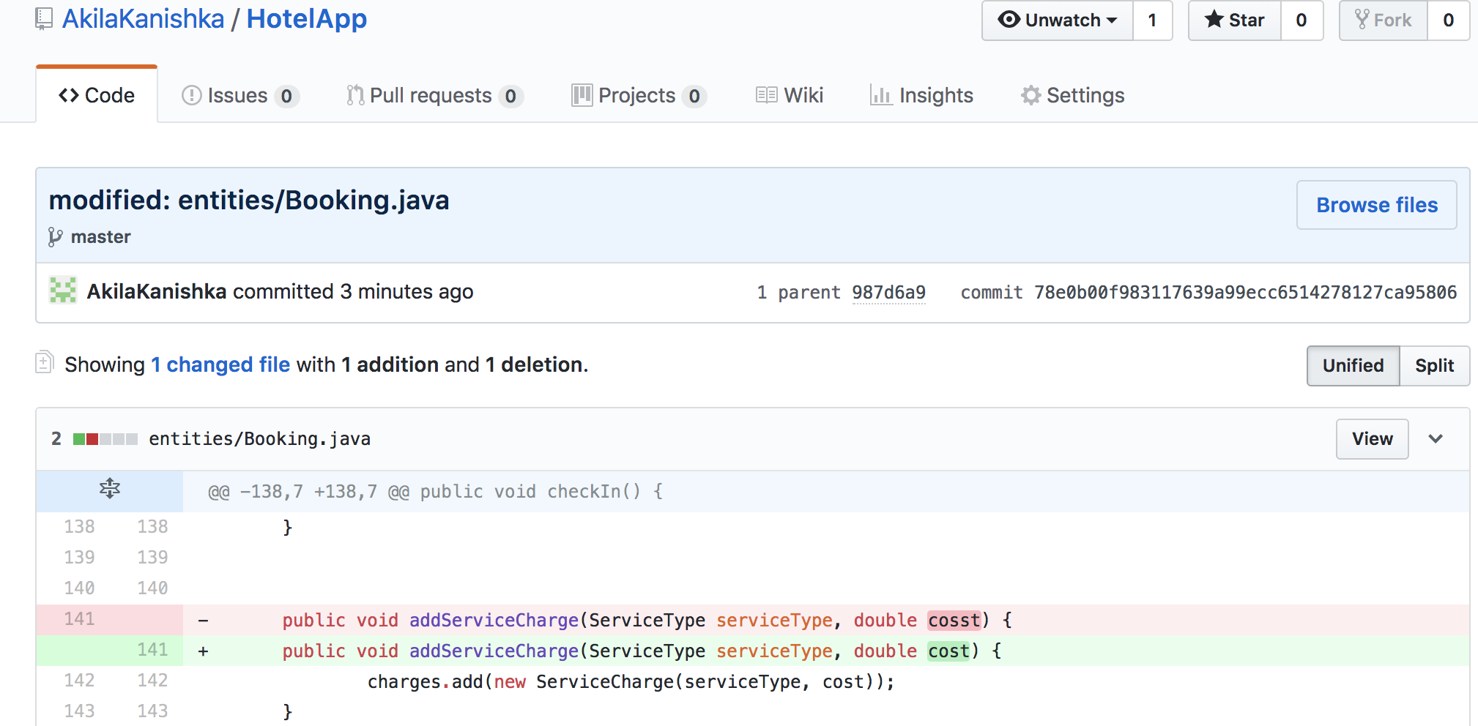

* Test case : <https://github.com/AkilaKanishka/HotelApp/commit/6cfb4d38c7edfa518fa4e2204376e8804ba272dd>

1. It is possible to charge a room for service after the guest has checked out