Problem 2

1)

TOA Radiation balance: Absorbed SW = Surface LW emission + Atmospheric LW emission

𝛼 j\* / 4 = 𝛤a 𝜎 Ts4 + (1 – 𝛤a) 𝜎 Ta4

Surface Radiation balance: Absorbed SW = Surface LW emission – Atmospheric LW emission

𝛼 j\* / 4 = 𝜎 Ts4 – (1 – 𝛤a) 𝜎 Ta4

Therefore, Ts = (𝛼 j\* / (2 𝜎 (1 + 𝛤a)))1/4 = (0.55 \* 1366 / (2 \* 5.67\*10-8 \* (1 + 0.15)))1/4 = 275.5 K

Ta = (1/2)1/4 Ts = 231.7 K

2)

Ts = (𝛼(Ts) j\* / (2 𝜎 (1 + 𝛤a)))1/4 = T0 𝛼(Ts)1/4

constant T0 = (j\* / (2 𝜎 (1 + 𝛤a)))1/4 = 319.9 K is the equilibrium surface temperature when 𝛼 = 1.

𝛼(Ts) = (Ts / T0)4 = 𝛼i + 0.5 (𝛼f – 𝛼i) (1 + tanh 𝜅(Ts – 273.15))

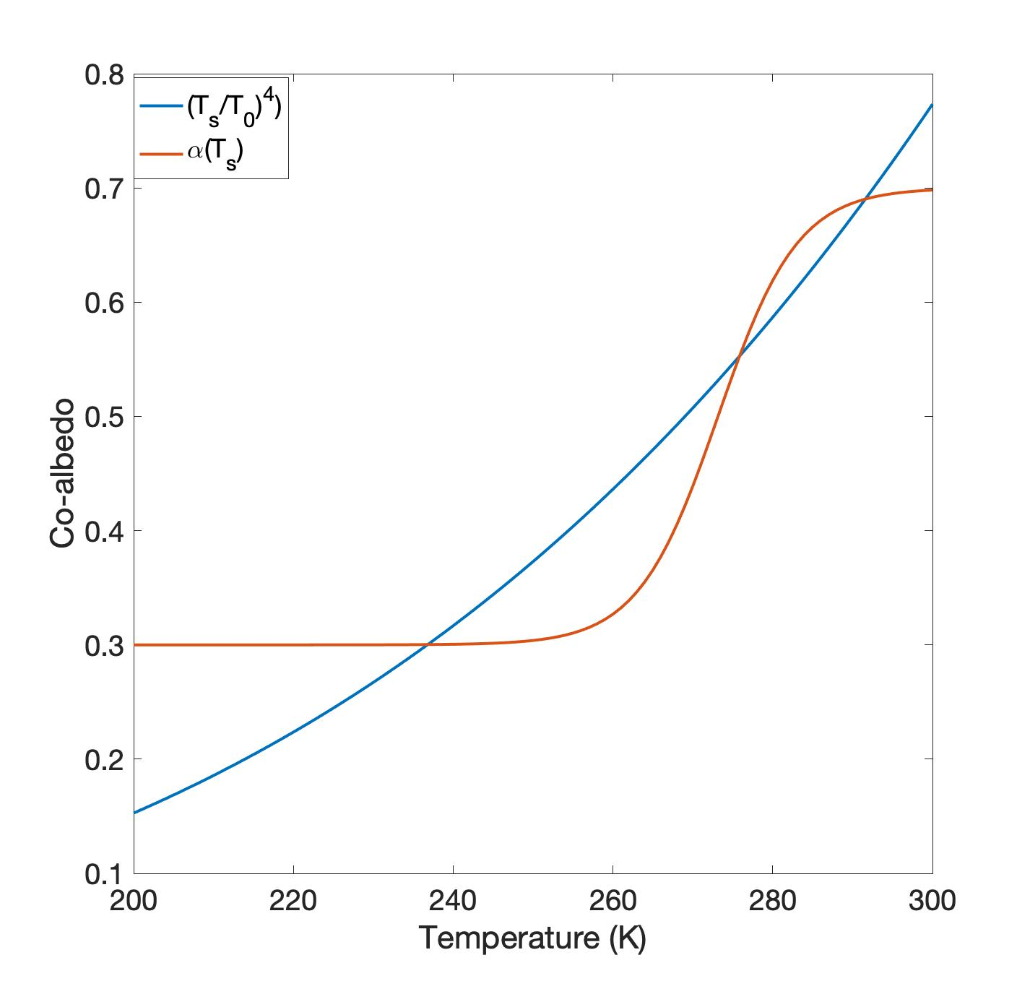

There are 3 solutions: T1 = 236.8 K, T2 = 275.8 K, and T3 = 291.5 K.

3)

When 𝛼 > (Ts / T0)4, surface temperature increases; when 𝛼 < (Ts / T0)4, surface temperature decreases.

Therefore, if 𝛼 increases by 5%, then surface temperature increases from the equilibrium.

For T1 and T3, this temperature increase leads to 𝛼(Ts) < (Ts / T0)4, so temperature decreases back to the original equilibrium.

For T2, this temperature increase leads to 𝛼(Ts) > (Ts / T0)4, so temperature will keep rising until reaching the new equilibrium T3.

Similarly, if 𝛼 decreases by 5%, equilibria T1 and T3 will go back to the starting point in the end while T2 will shift to the new equilibrium T1.