**GBS BASED ATTENDENCE SYSTEM**

**1.INTRODUCTION**

Nowadays, attendance monitoring and working hour calculation is very essential for almost every institution or organization. Typically there are two types of attendance system available, i) Manual and ii) Automated. Manual system involves the use of sheets of paper or books in taking attendance where employees fill out and managers oversee for accuracy. This method could be erroneous because sheets could be lost or damaged. Also the extraction of relevant data and the manual computation of working time is very time consuming. It takes an extra employee to check for the attendance and timing of other employees which includes cost overhead for the organization as well [1]. On the other hand, automated time and attendance systems implies the use of electronic tags, barcode badges, magnetic stripe cards, biometrics (hand, fingerprint, or facial), and touch screens [2] in place of paper sheets. In these aforementioned techniques, employees touch or swipe in order to provide their identification and also the entering and leaving time to calculate working hours. The provided information are recorded and automatically transferred to a computer for processing. Using an automated system for time and attendance monitoring reduces the errors of manual system and conserv1e optimal amount of time. But these automated systems require heterogeneous devices need to be located in the organization which is costly. In this paper, considering the wide popularity of web application s, we introduce the use of web application for this time and attendance tracking purpose. We have proposed a location based smart time and attendance tracking system based on the concept of web services which is implemented as an Android mobile application that communicates with the remote server in which the database is located. Internet connectivity (Wi-Fi/3G) is needed for connecting to database residing in the remote server. Our proposed smart system does not require any kind of peripheral device other than web application which will reduce computational time and cost of placing an extra device.

CMRTC 1

GPS BASED ATTENDANCE SYSTEM

**2. SYSTEM ANALYSIS**

#### SYSTEM ANALYSIS

System Analysis is the important phase in the system development process. The System is studied to the minute details and analyzed. The system analyst plays an important role of an interrogator and dwells deep into the working of the present system. In analysis, a detailed study of these operations performed by the system and their relationships within and outside the system is done. A key question considered here is, “what must be done to solve the problem?” The system is viewed as a whole and the inputs to the system are identified. Once analysis is completed the analyst has a firm understanding of what is to be done.

**2.1 PROBLEM DEFINITION**

A general statement of face recognition problem can be formulated as the given still or video images of a scene, identify or verify one or more persons in the scene or in any live capturing devices using a stored database of those authorised faces.

##### **2.2 EXISTING SYSTEM**

Existing system is a manual entry for the students. Here the attendance will be carried out in the hand written registers. It will be a tedious job to maintain the record for the user. The human effort is more here. The retrieval of the information is not easy as the records are maintained in hand written registers.

###### **2.2.1 DISADVANTAGES OF EXISTING SYSTEM**

Following are the disadvantages of existing system:

* The human effect is more.
* The retrival of the information is not easy.
* Here the attendance will be registered in the handwritten format.

CMRTC 2

GPS BASED ATTENDANCE SYSTEM

##### **2.3 PROPOSED SYSTEM**

To overcome the drawbacks of the existing system the proposed system has been evolve. This project aims to reduce the paper work as well as faculty work and saving time to generate accurate results from student’s attendance. The system provides with the best user interface**.**

###### **2.3.1 ADVANTAGES OF THE PROPOSED SYSTEM**

* It is trouble free to use.
* It is relatively fast approach to enter attendance.

* It is used to find the exact exact location of a student from where he/she posting the attendance.
* It is employed by using GPS of a mobile of a student.

##### **2.4 FEASIBILITY STUDY**

Feasibility study is conducted once the problem is clearly understood. The feasibility study which is a high level capsule version of the entire system analysis and design process. The objective is to determine whether the proposed system is feasible or not and it helps us to the minimum expense of how to solve the problem and to determine, if the problem is worth solving. The following are the three important tests that have been carried out for feasibility study.

* Economic Feasibility
* Technical Feasibility
* Operational Feasibility

.

CMRTC 3

GPS BASED ATTENDANCE SYSTEM

###### **2.4.1 ECONOMIC FEASIBILITY**

As a part of this, the costs and benefits associated with the proposed system are to be compared. The project is economically feasible only if tangible and intangible benefits outweigh the cost. We can say the proposed system is feasible based on the following reasons.

* The costs of developing the full system is reasonale.
* The cost of hardware and software for the application is less.

###### **2.4.2 TECHNICAL FEASIBILITY**

In the technical feasibility study, one has to test whether the proposed system can be developed using existing technology or not. It is planned to implement the proposed system in JSP. The project entitled is technically feasible because of te following reasons.

* All necessary technology exists to develop the system.
* The existing system is so flexible that it can be developed further.

**2.4.3 OPERATIONAL FEASIBILITY**

The project is operationally feasible because there is sufficient support from the project management and the users of the proposed system. Proposed system definitely does not harm and will not produce the bad results and no problem will arise after implementation of the system.

CMRTC 4

##### GPS BASED ATTENDANCE SYSTEM

##### **2.5 HARDWARE & SOFTWARE REQUIREMENTS**

**2.5.1 HARDWARE REQUIREMENTS:**

Hardware interfaces specify the logical characteristics of each interface between the software product and the hardware components of the system. The following are some hardware requirements.

* Hard disk : 20GB and above
* Hardware : Pentium and above
* RAM : 1GB and above
* Input devices : Keyboard, mouse.

**2.5.2 SOFTWARE REQUIREMENTS:**

Software Requirements specifies the logical characteristics of each interface and software components of the system. The following are some software requirements,

* Operating system : Windows Family and above
* Languages : Java,J2EE and Python 3.7, Html, CSS, JavaScript.
* Tools : Apache Tomcat 8.0,My SQL 5.5 or Higher.

CMRTC 5

GPS BASED ATTENDANCE SYSTEM

**3. ARCHITECTURE**

##### **3.1 PROJECT ARCHITECTURE**

This project architecture shows the procedure followed for classification, starting from input to final prediction. The admin will login through user and password. The main task of admin is to add departments and set the location based on latitude and longitude values. Then admin will logout. The students has to register themselves by entering their details. After registering, then can login using roll number and password. The student will mark their attendance. If the student location and the admin stored location matches, then the student can get the attendance. The faculty will login using email id and password. Here, faculty can verify the reports about the attendance on that particular day. Then they can logout.

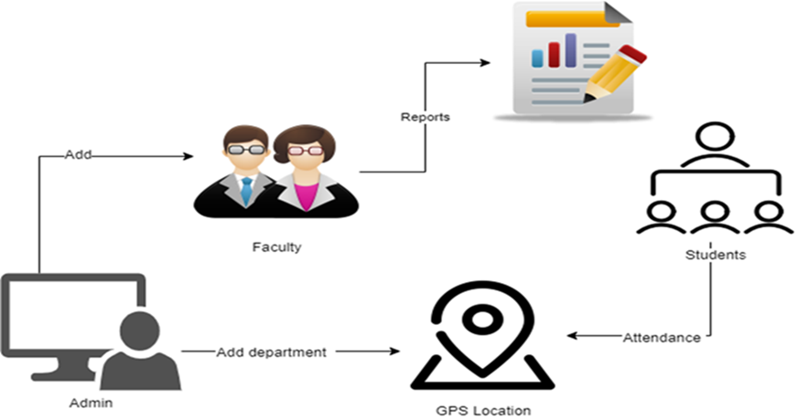

Figure 3.1: Project Architecture of GPS Based Attendance System.

CMRTC 6

GPS BASED ATTENDANCE SYSTEM

###### **3.2 DESCRIPTION**

This project is totally based upon identifying the recognised authorized faces. The model is built to recognize faces as part of the biometric security system and then produce a voice message for every recognized face. The model is built with libraries like face recognition, pyttsx, os, opencv, pandas, numpy etc. Each library is used for a specific purpose for example face recognition is used for face detection and manipulation of images. The pyttsx library is used to convert text to speech which is the reason the model produces voice output.

###### **3.3 USE CASE DIAGRAM**

In the use case diagram, we have basically one actor who is the user in the trained model.

A use case diagram is a graphical depiction of a user's possible interactions with a system. A use case diagram shows various use cases and different types of users the system has. The use cases are represented by either circles or ellipses. The actors are often shown as stick figures.

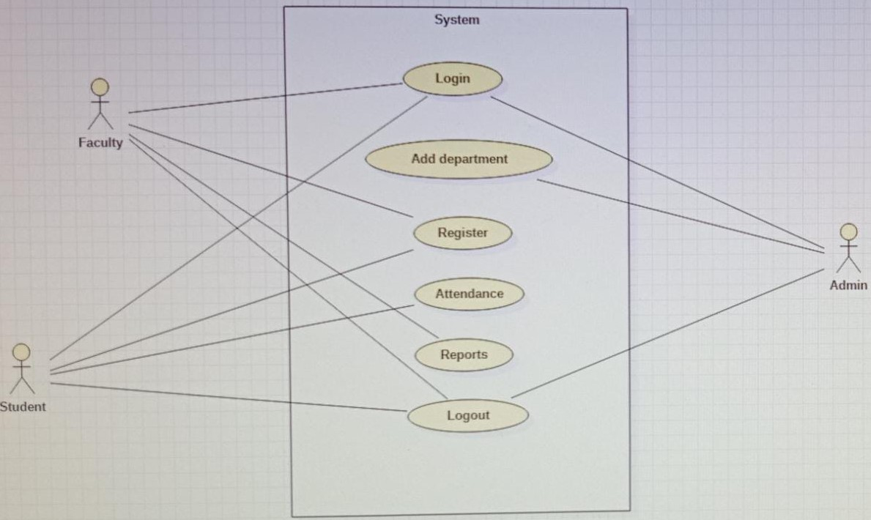

Figure 3.2: Use Case Diagram for GPS Based Attendance System.

CMRTC 7

GPS BASED ATTENDANCE SYSTEM

##### **3.4 CLASS DIAGRAM**

Class diagram is a type of static structure diagram that describes the structure of a system by showing the system’s classes, their attributes, operations(or methods), and the relationships among objects.



Figure 3.3: Class Diagram for GPS Based Attendance System.

**3.5 SEQUENCE DIAGRAM**

A sequence diagram shows object interactions arranged in time sequence. It depicts the objects involved in the scenario and the sequence of messages exchanged between the objects needed to carry out the functionality of the scenario. Sequence diagrams are typically associated with use case realizations in the logical view of the system under development.

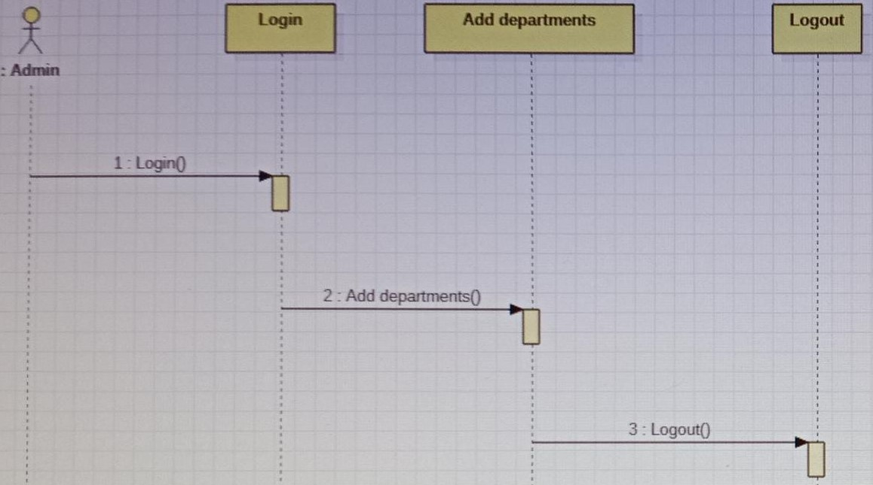

CMRTC 8

GPS BASED ATTENDANCE SYSTEM

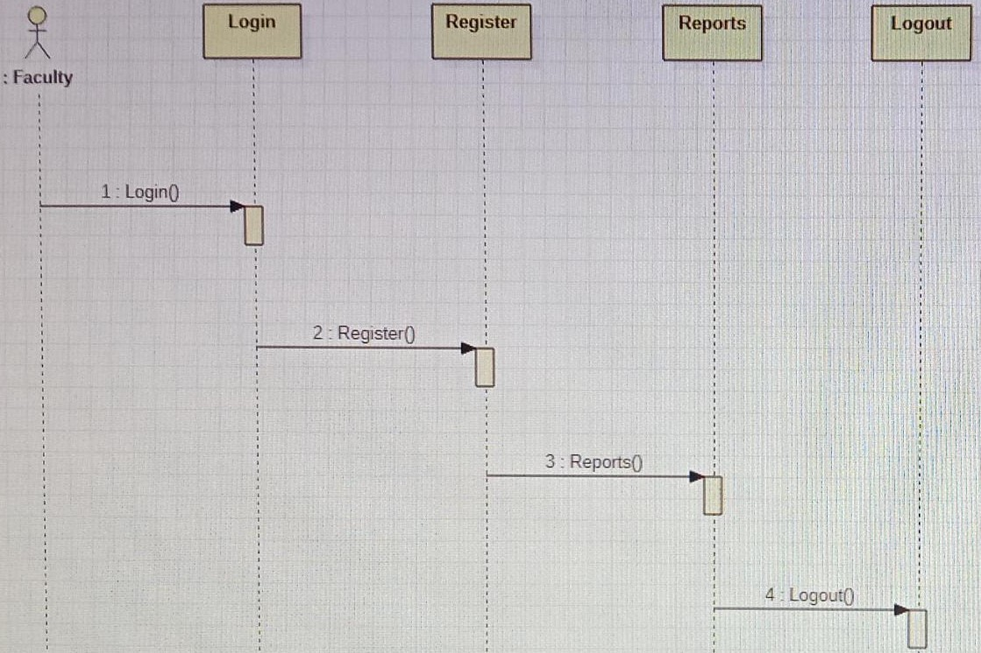

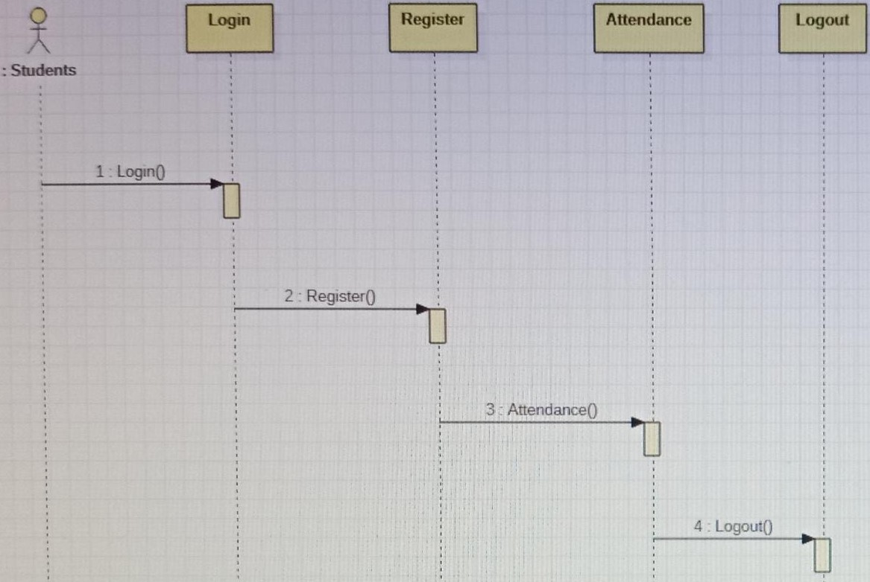 Figure 3.4: Sequence Diagram for GPS Based Attendance System.

CMRTC 9

GPS BASED ATTENDANCE SYSTEM

###### **3.6 ACTIVITY DIAGRAM**

Activity diagrams are graphical representations of workflows of stepwise activities and actions with support for choice, iteration and concurrency. They can also include elements showing the flow of data between activities through one or more data stores.



Figure 3.5: Activity Diagram for GPS Based Attendance System.

CMRTC 10

GPS BASED ATTENDANCE SYSTEM

**4.1 SAMPLE CODE**

**databasecon.java**

package databaseconnection;

import java.sql.*;

public class databasecon

{

static Connection co;

public static Connection getconnection()

{

try

{

Class.forName("com.mysql.jdbc.Driver");

co=

DriverManager.getConnection("jdbc:mysql://localhost:2022/A

TTENDANCE","root","root");

}

catch(Exception e)

{

System.out.println("Database Error"+e);

}

return co;

}

CMRTC 11

GPS BASED ATTENDANCE SYSTEM

**Distance.java**

package details;

public class Distance

{

public static double calc(String s1, String s2, String s3,

String s4, String unit) {

double lat1=Double.parseDouble(s1);

double lon1=Double.parseDouble(s2);

double lat2=Double.parseDouble(s3);

double lon2=Double.parseDouble(s4);

double theta = lon1 - lon2;

double dist = Math.sin(deg2rad(lat1)) *

Math.sin(deg2rad(lat2)) + Math.cos(deg2rad(lat1)) *

Math.cos(deg2rad(lat2)) * Math.cos(deg2rad(theta));

dist = Math.acos(dist);

dist = rad2deg(dist);

dist = dist * 60 * 1.1515;

if (unit == "K") {

dist = dist * 1.609344;

dist=dist;

if(dist>1)

{

dist=dist+2;

}

} else if (unit == "N") {

dist = dist * 0.8684;

}

return (dist);

}

public static double deg2rad(double deg) {

CMRTC 12

GPS BASED ATTENDANCE SYSTEM

return (deg * Math.PI / 180.0);

}

public static double rad2deg(double rad) {

return (rad * 180 / Math.PI);

}

public static void main(String[] args)

{

System.out.println(calc("17.4677964",

"78.42527919999998", "17.4677964",

"78.32527919999998", "K") + " Nautical Miles");

}

}

CMRTC 13

GPS BASED ATTENDANCE SYSTEM

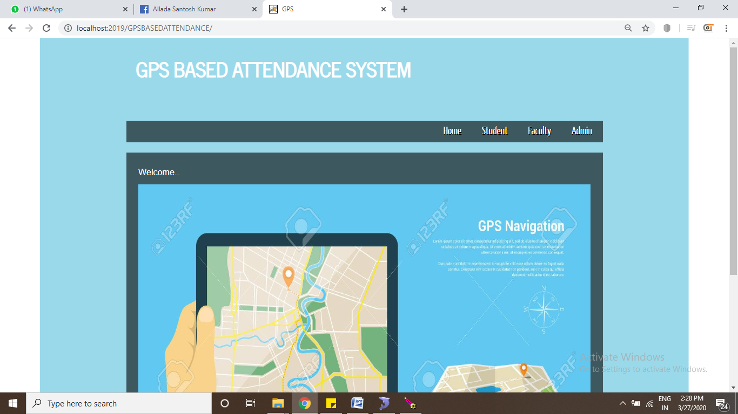

Screenshot 5.1: Home Page

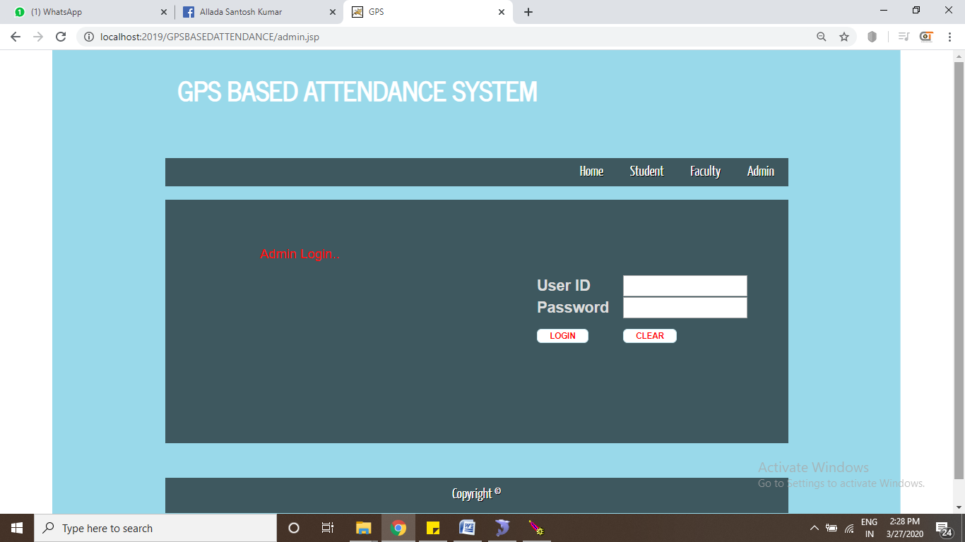

Screenshot 5.2: Admin Login page

CMRTC 14

GPS BASED ATTENDANCE SYSTEM

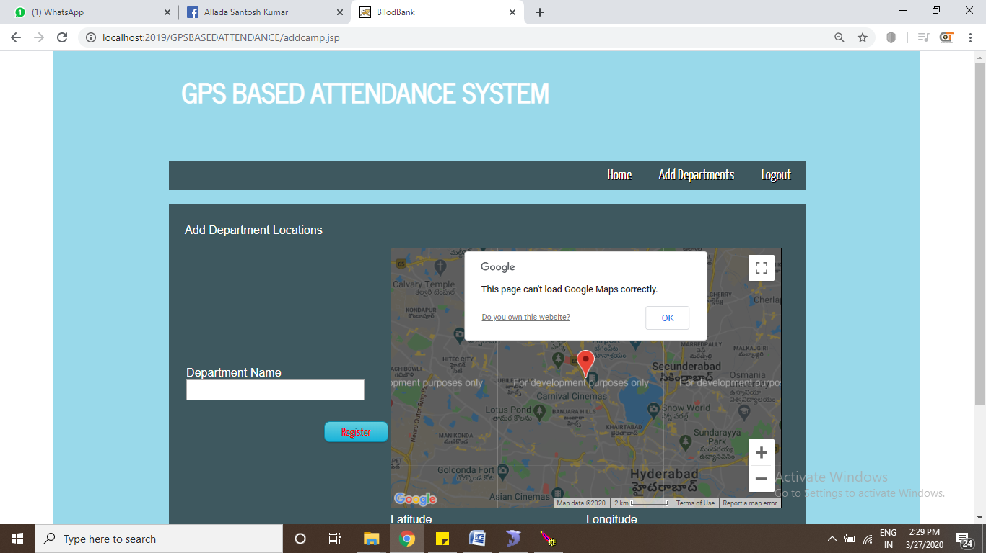

Screenshot 5.3: Add Department Locations Page

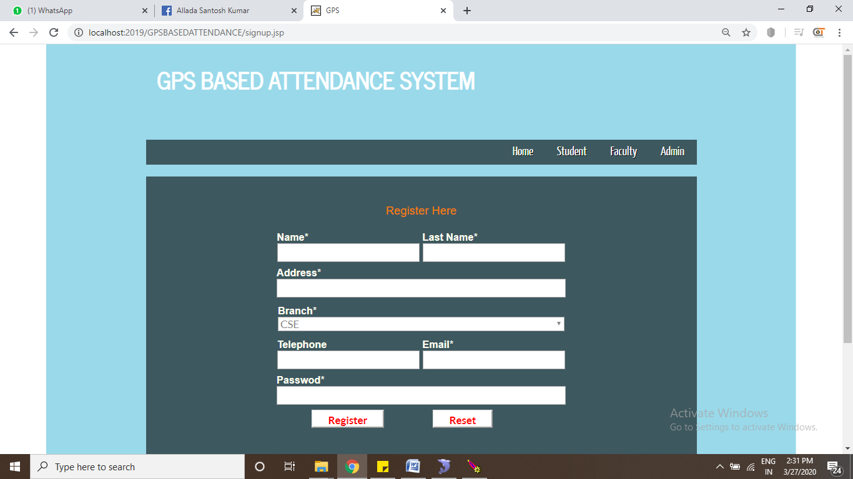

Screenshot 5.4: Register Here page for Student

CMRTC 15

GPS BASED ATTENDANCE SYSTEM

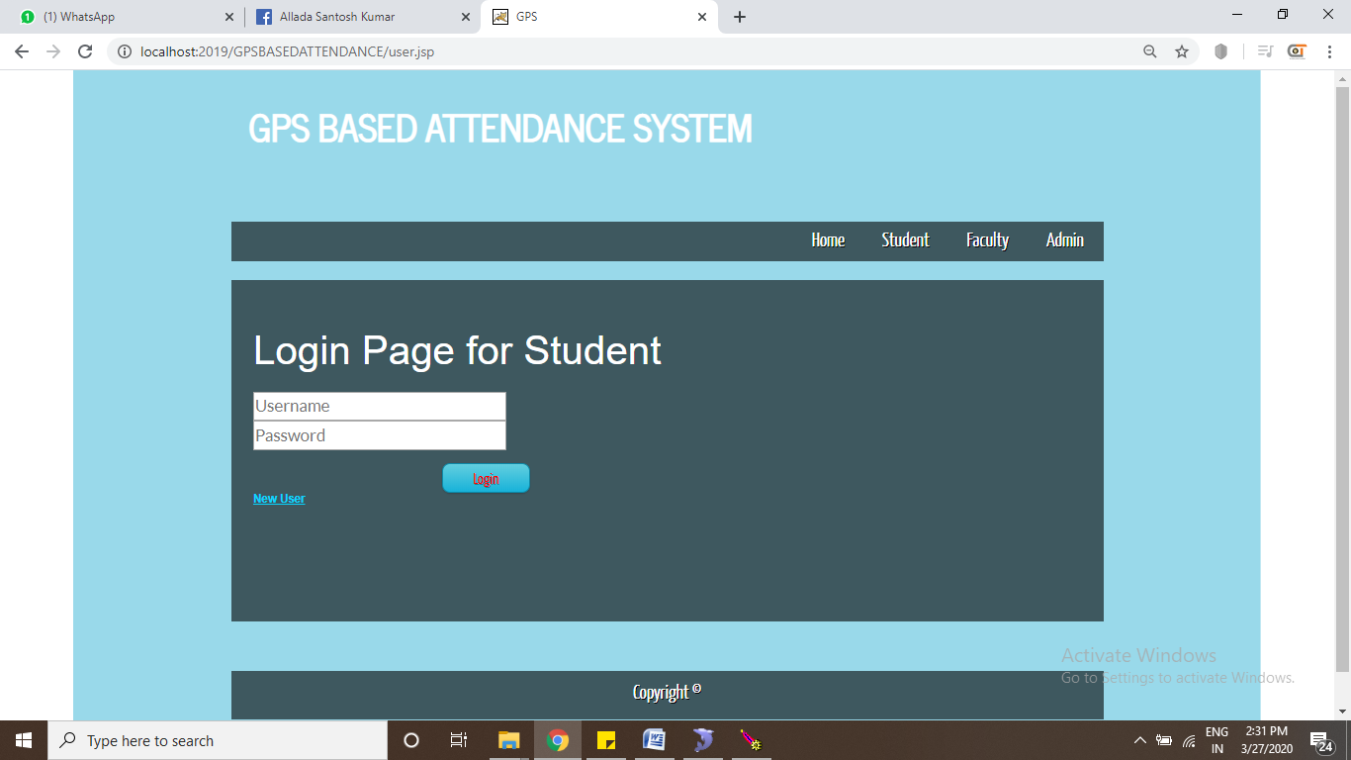

Screenshot 5.5:Login page for student

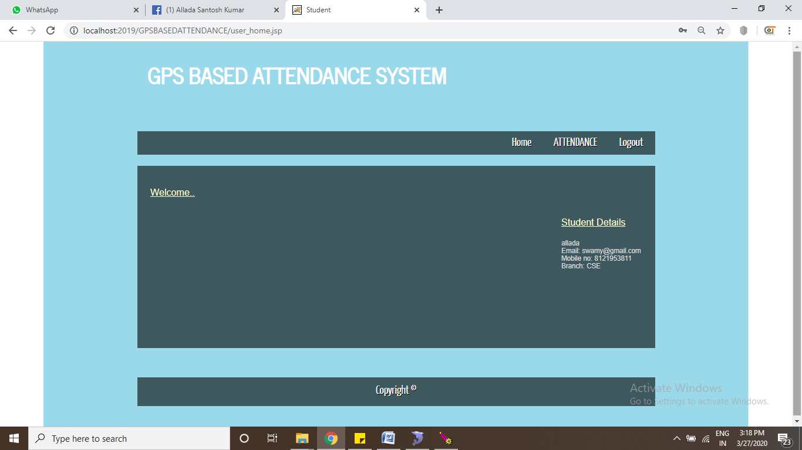

Screenshot 5.6:Student Home page

CMRTC 16

GPS BASED ATTENDANCE SYSTEM

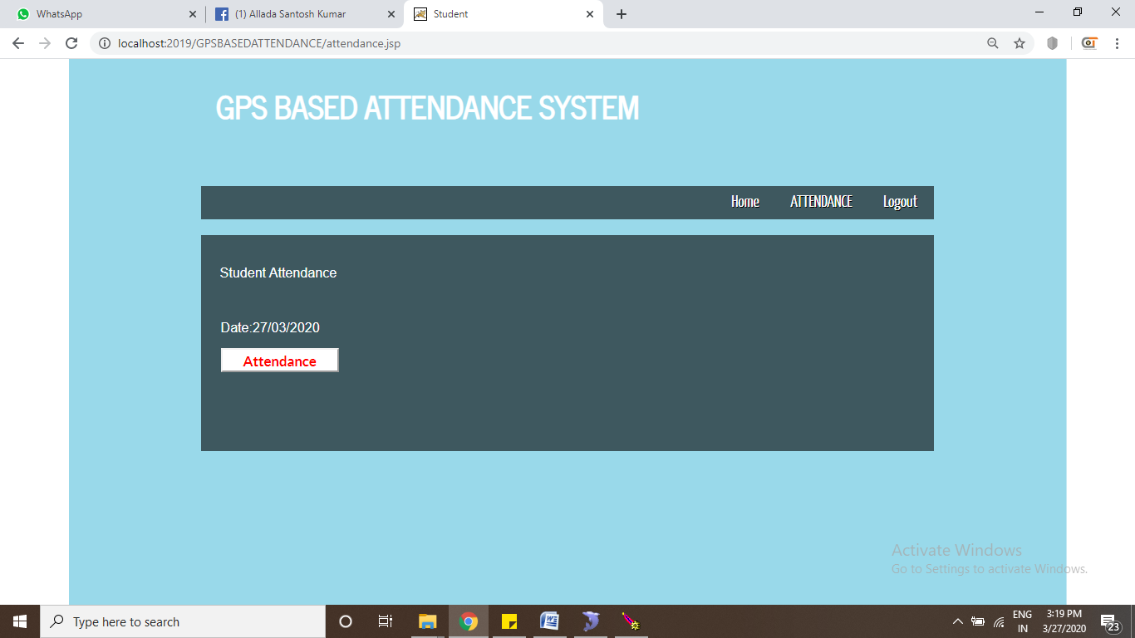

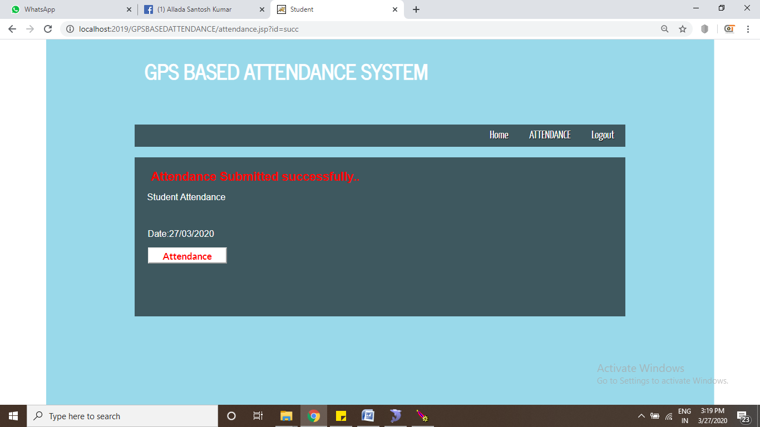

Screenshot 5.7: Student Attendance

CMRTC 17

GPS BASED ATTENDANCE SYSTEM

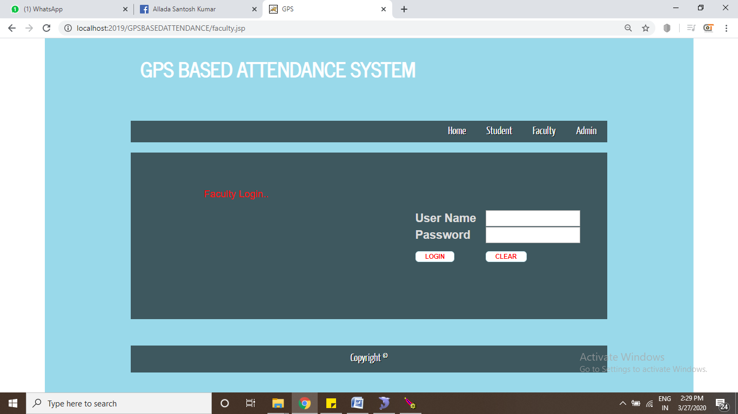

Screenshot 5.8:Faculty Login page

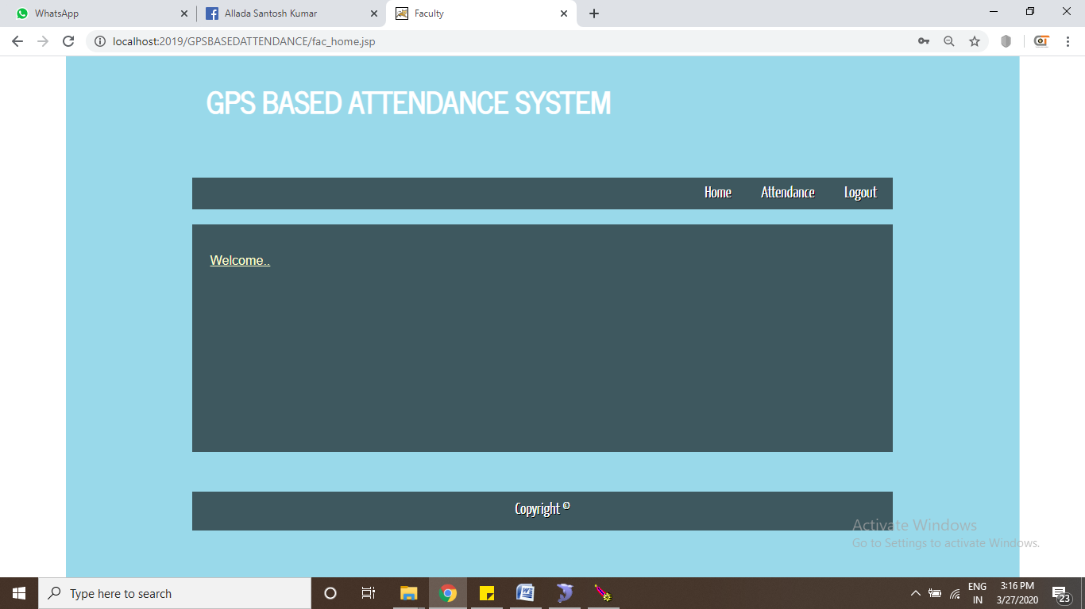

Screenshot 5.9: Faculty welcome page

CMRTC 18

GPS BASED ATTENDANCE SYSTEM

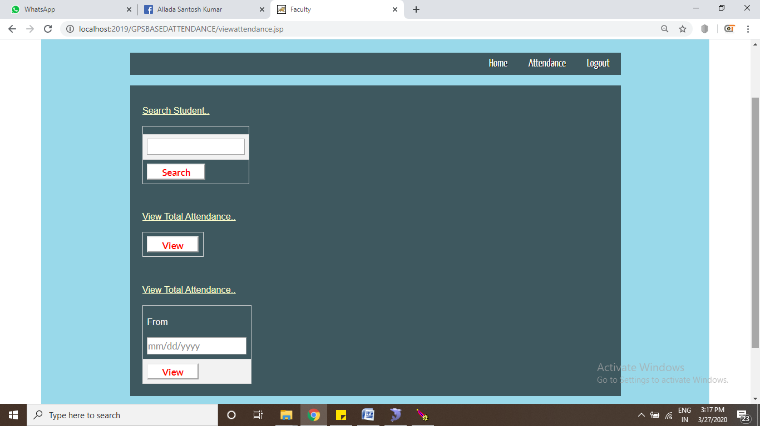

Screenshot 5.10: Reports

CMRTC 19

GPS BASED ATTENDANCE SYSTEM

**6.1 SOFTWARE TESTING**

Software testing is one of the main stages of project development life cycle to provide our cessation utilizer with information about the quality of the application and ours, in our Project we have under gone some stages of testing like unit testing where it’s done in development stage of the project when we are in implementation of the application after the Project is yare we have done manual testing with different Case of all the different modules in the application we have even done browser compatibility testing in different web browsers in market, even we have done Client side validation testing on our application .

**6.2 TYPES OF TESTING**

###### **6.2.1 UNIT TESTING**

The unit testing is done in the stage of implementation of the project only the error are solved in development stage some of the error we come across in development are given below

**Testing done when application is in development stage**

**Class version Error in our application**

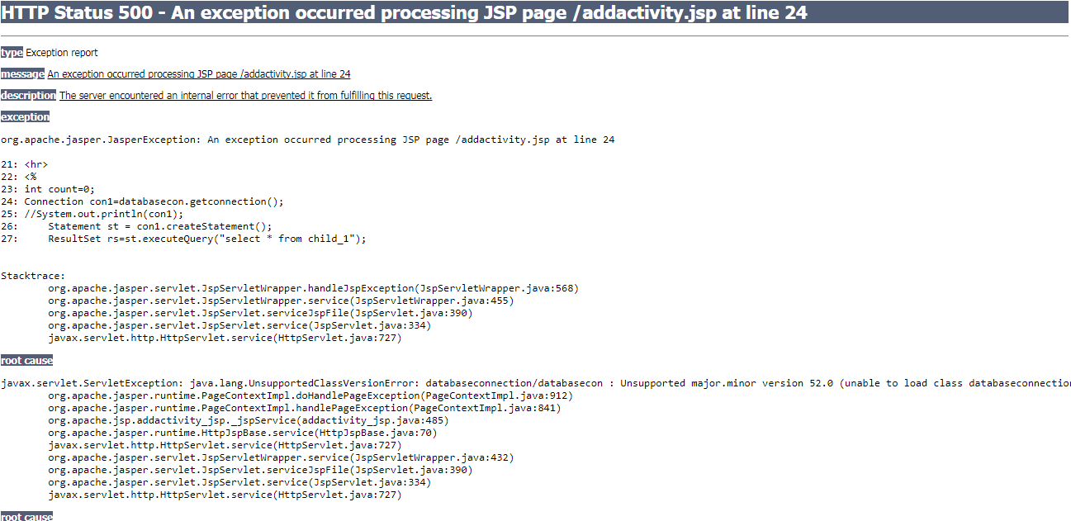

This Error Come when we move our application from one system to other and mainly when we version issues in the software’s we us

CMRTC 20

GPS BASED ATTENDANCE SYSTEM

**Path related error in our application**

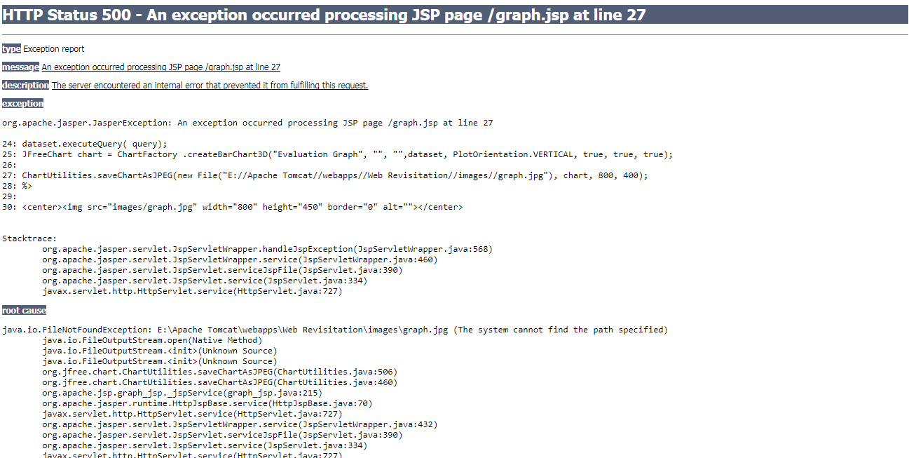

This Error Came when I have Performance Metrics to show in graph when I missed my server directly path in the system so we got this error in the applicant in development stage

**Server Connection Error**

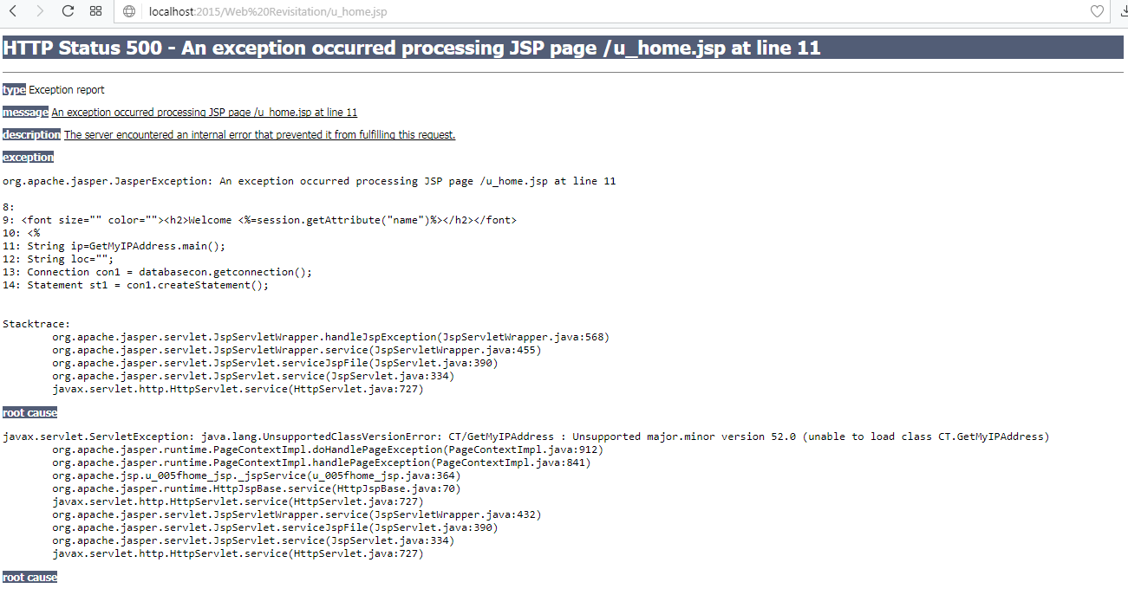

CMRTC 21

GPS BASED ATTENDANCE SYSTEM

##### **6.3 TESTCASES**

|  |  |  |  |  |  |
| --- | --- | --- | --- | --- | --- |
| **Test Case ID** #1 | | **Test Case Description** - Validations in Registration Form | | | |
| **S#** | **Prerequisites** | | **S#** | **Test Data Requirement** | |
| 1 | User should be Registered | | 1 | Data should be valid | |
| **Test Condition** | | | | | |
| Entering data in registration form | | | | | |
| **Step #** | **Step Details** | **Expected Results** | | **Actual Results** | **Pass/Fail/Not Executed/Suspended** |
| 1 | User gives First and Last Name | Pop showing email verification message | | Enter valid email/password | Fail |
| 2 | Submitting the form without entering any details | Pop showing email verification message | | Enter email /password | Fail |
| 3 | User enters invalid format of email id | Pop showing email verification message | | Enter valid email id | Fail |
| 4 | User enters a phone number with < 10 digits | Pop showing email verification message | | Enter valid phone number | Fail |
| 5 | Entering valid username and password | Pop showing email verification message | | Pop showing email verification message | Pass |

Table 1 Registration test case

CMRTC 22

GPS BASED ATTENDANCE SYSTEM

|  |  |  |  |  |  |
| --- | --- | --- | --- | --- | --- |
| **Test Case ID** #2 | | **Test Case Description** - Validations in Login Form | | | |
| **S#** | **Prerequisites** | | **S#** | **Test Data Requirement** | | |
| 1 | User should have an email id | | 1 | Data should be valid | |
| **Test Condition** | | | | | |
| Entering data in login form | | | | | |
| **Step #** | **Step Details** | **Expected Results** | | **Actual Results** | **Pass/Fail/Not Executed/Suspended** |
| 1 | User gives aemail or password of <6 characters | User logged in | | Enter valid email/password | Fail |
| 2 | Submitting the form without entering any details | User logged in | | Enter email /password | Fail |
| 3 | User enters wrong Email and (or) password | User logged in | | Enter correct email /password | Fail |

Table 2 Login test case

CMRTC 23

GPS BASED ATTENDANCE SYSTEM

#### 7. CONCLUSION & FUTURE SCOPE

##### **7.1 PROJECT CONCLUSION**

This paper introduce a smart, location based time and attendance tracking system using android application which use location as the core component of attendance tracking using web application. The area is set for tracking using GPS and Students coordinate inside the area border depicts that employee is present in the organization.

##### **7.2 FUTURE SCOPE**

In Future we a smart, location based time and attendance tracking system using android application which use location as the core component of attendance tracking using smartphone. The area is set for tracking using GPS and employee coordinate inside the area border depicts that employee is present in the organization. We developed this system for android platform, But we focusing on developing this system for IOS platform as well in neat future.

CMRTC 24

GPS BASED ATTENDANCE SYSTEM

#### 8. BIBLIOGRAPHY

##### **8.1 REFERENCES**

[1] Kumbhar, A. A., Wanjara, K. S., Trivedi, D. H., Khairatkar, A. U., & Sharma, D. (2014). “Automated Attendance Monitoring System using Android Platform.”, International Journal of Current Engineering and Technology, Vol. 4, No. 2, pp1096-1099.

[2] Pankanti, S., Prabhakar, S., & Jain, A. K. (2002). “On the individuality of fingerprints”, Pattern Analysis and Machine Intelligence, IEEE Transactions on, 24(8), 1010-1025.

[3] Shoewu, O. O. M. Olaniyi, and Lawson (2011), “Embedded Computer-Based Lecture Attendance Management System”, African Journal of Computing and ICT (Journal of IEEE Nigeria Computer Section), 4(3):27 – 36.

[4] Cheng, K., L. Xiang, T. Hirota, and K. Ushijimaa (2005), “Effective Teaching for Large Classes with Rental PCs by Web System WTS”, Pro. Data Engineering Workshop (DEWS2005), 1D – d3 (in Japanese).

[5] Shoewu, O. and O.A. Idowu (2012), “Development of Attendance Management System using Biometrics”, Pacific Journal of Science and Technology, 13(1):300-307.

[6] Kadry, S., & Smaili, M. (2013). ”Wireless attendance management system based on iris recognition”, Scientific Research and essays, 5(12), 1428-1435.

[7] Android Developer Guide: http://developer.android.com/guide/index.html accessed at 18th January.

[8] Android API: http://developer.android.com/reference/packages.html accessed at 20th January.

[9] Android Developers blog: http://android-developers.blogspot.com/ accessed at 15th January.

CMRTC 25

GPS BASED ATTENDANCE SYSTEM

##### **8.2 GITHUB LINK**

CMRTC 26