Object Oriented Design and Programming

Tutorial-1

NAME: Akilan R
REG NO.: RA2411024010057
SUBJECT CODE: 21CSC101T
FACULTY: Mythili R
DEPT: COMPUTER SCIENCE AND BUSINESS SYSTEMS
SECTION: AO2
SEMESTER: 2

- Scenario 1: Pointers to Class Members
You’re developing a vehicle management system with a class Vehicle that has several data members (for example, an integer speed and a float fuel Level) and a member function displayStatus(). Parts of the system need to dynamically modify and display these attributes using pointers to class members.
  - How would you declare a pointer to the speed data member and a pointer to the member function displayStatus()?
  - Provide a code snippet that uses these pointers to set the speed of a Vehicle object and then calls displayStatus().
c) What are some potential pitfalls when using pointers to class members, and how can they be mitigated?
Solution:
- A pointer to the speed data member: int Vehicle:: *ptrToSpeed
A pointer to the member function; displayStatus:
main (Vehicle:: ptrToDisplayStatus)();

b)

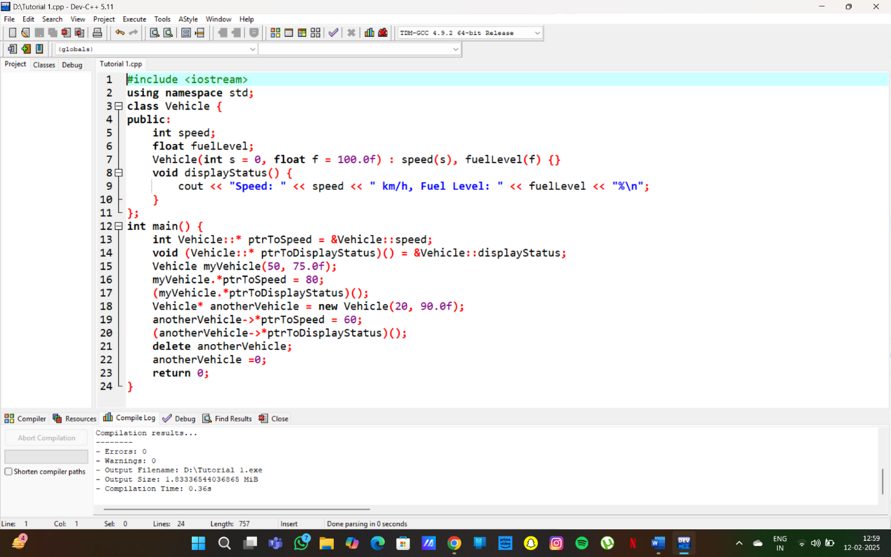

c) Potential pitfalls and mitigation:
- Dangling Pointers: If the object that a pointer to member refers to is destroyed, the pointer becomes a dangling pointer. Using it leads to undefined behavior (crashes, data corruption).
  - Mitigation: Be very careful about object lifetimes. If you are using pointers to members with dynamically allocated objects, ensure proper memory management (using delete when the object is no longer needed). Avoid storing pointers to members of temporary objects.
- Incorrect Pointer Type: It's easy to make a mistake with the type of the pointer, especially with complex class structures. For example, accidentally assigning a pointer to a different member or a member of a different class.
  - Mitigation: Use typedefs to create aliases for pointer-to-member types, improving code readability and reducing the chance of type errors. Carefully review the types when assigning or using these pointers. Modern C++ features like auto can also help.
- Complexity: Pointers to members can make code harder to read and understand, especially when they are used extensively. They introduce an extra layer of indirection.
  - Mitigation: Use them judiciously. Consider if there are simpler alternatives (like regular member function calls or using references). Document the code clearly to explain the purpose of the pointers to members. Use meaningful names for the pointers.
- Non-Static Members: Pointers to members must be used with an object (or a pointer to an object), because non-static members are associated with a specific instance of the class. Forgetting to use .* or ->* will lead to compiler errors.
  - Mitigation: Remember the correct syntax (.* for objects, ->* for pointers to objects). Pay attention to the context in which the pointer to member is used.
- Inheritance and Virtual Functions: Pointers to members behave differently with virtual functions. If you use a pointer to a member function of a base class, and that function is virtual, the actual function called will be determined at runtime based on the object's type (polymorphism).
  - Mitigation: Be aware of this behavior when working with inheritance. If you need to access the specific base class version of a virtual function, you might need to use scope resolution (BaseClass::memberFunction).

- Imagine you are designing a student class. In this class, the student’s name should be directly accessible (public), but the id should be private and accessible only through a getter function.
  - How would you declare the student class with a public name member and a private id member?
  - Provide a code snippet that demonstrates creating a student object, directly modifying the name, and accessing the id via its getter function.
  - Why might a designer choose to allow direct access to some members while restricting others?

Solution :

a)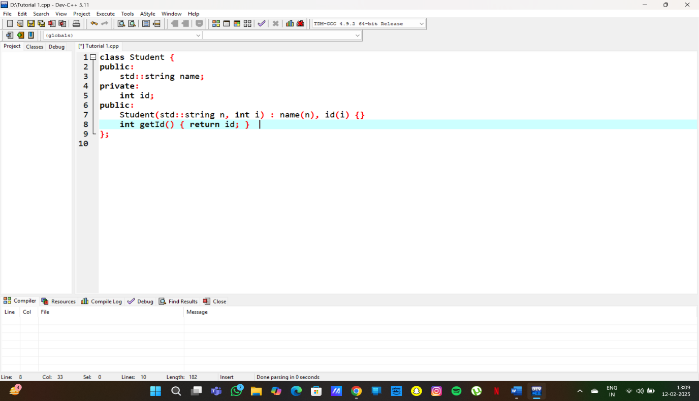

b)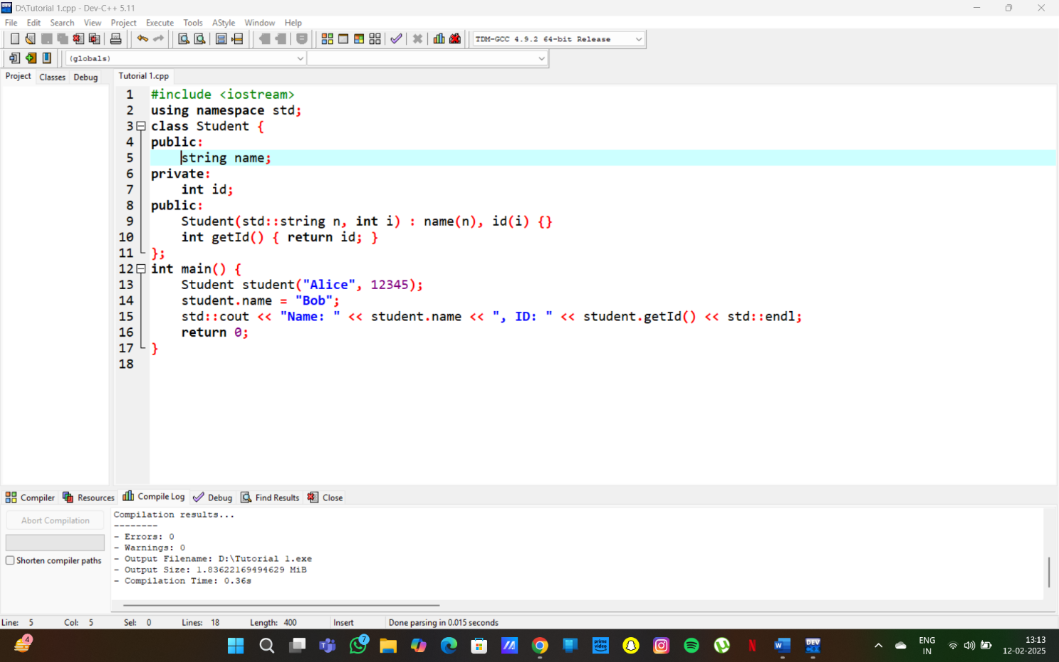

c) Why Restrict Some Members?
- Encapsulation: Keeps sensitive data (like id) secure and prevents accidental modification.
- Controlled Access: Using a getter ensures id is read-only (cannot be changed outside the class).
- Flexibility: Allows adding validation or modifications later without changing the interface.

- Design a C++ class named Bank Account with the following attributes:
account Number (integer) balance (double) accountholder Name (string) Methods:
deposit(amount): Adds the specified amount to the balance. withdraw(amount): Deducts the specified amount from the balance, if sufficient funds are available.
displayBalance(): Displays the current balance. Write a program that:
Creates a Bank Account object.
Prompts the user to enter account details and initial balance. Allows the user to perform deposit and withdrawal operations. Displays the final balance.

Solution :
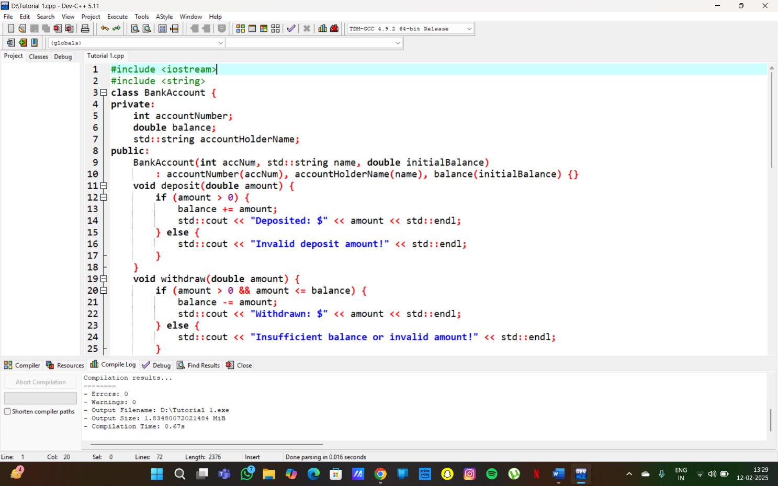

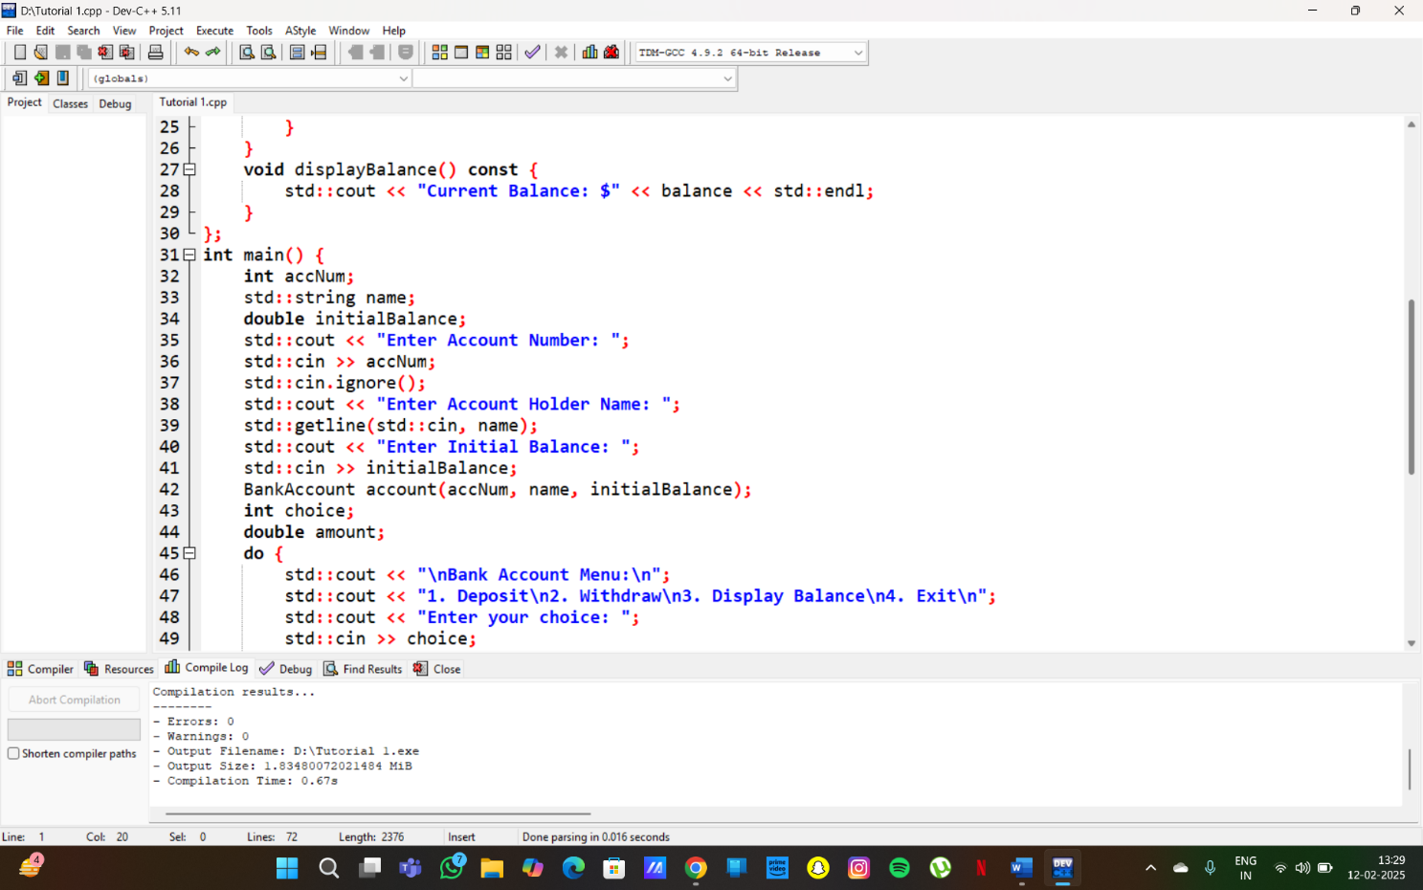

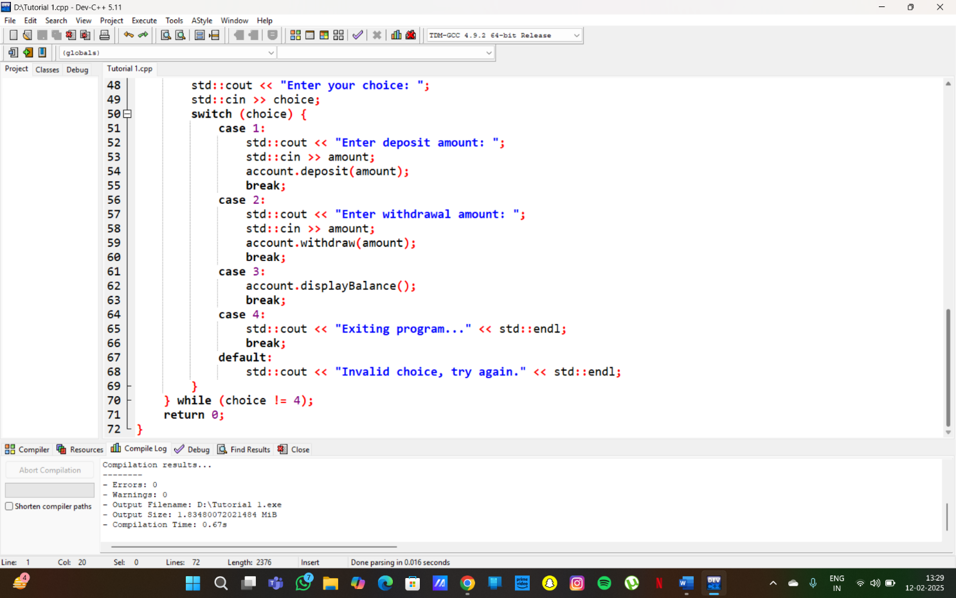
Output:
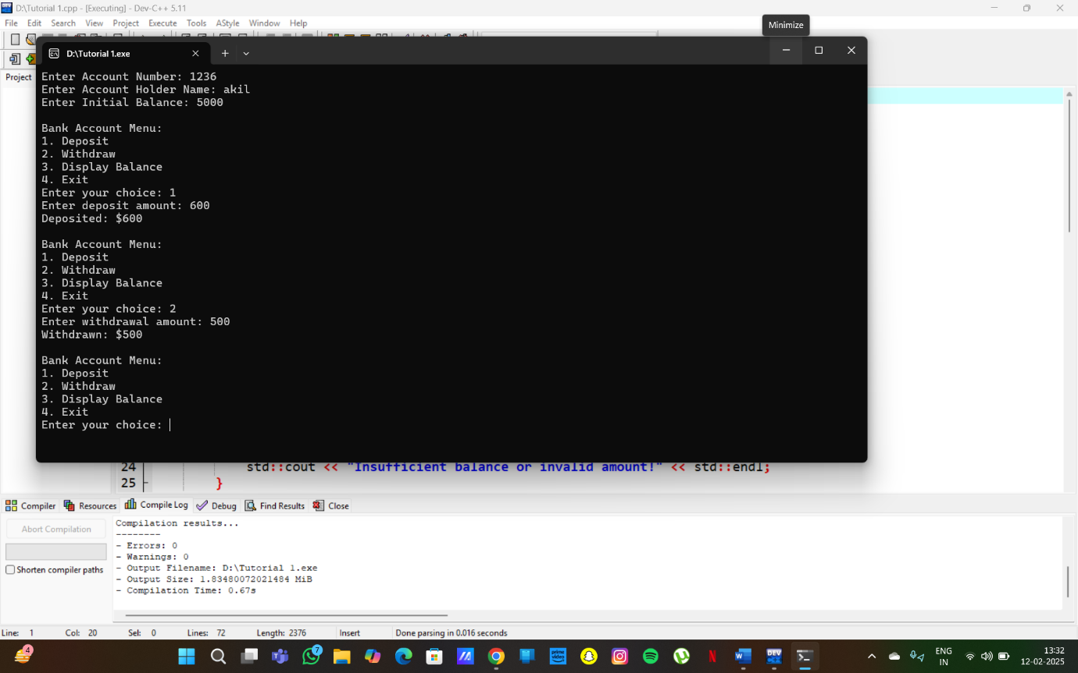

4) Design a C++ class named Book with the following attributes: title (string)
author (string)isbn (string) available (Boolean)
Design a class named Library with the following attributes: books (an array or vector of Book objects)

Methods:
add Book(book): Adds a new book to the library. searchBookByTitle(title): Searches for a book based on its title. borrow Book(isbn): Marks a book as unavailable if it's available. return Book(isbn): Marks a book as available

Solution :

#include <iostream>
#include <vector>
#include <string>

class Book {
public:
std::string title;
std::string author;
std::string isbn;
bool available;

// Constructor
Book(std::string t, std::string a, std::string i)
: title(t), author(a), isbn(i), available(true) {}

// Display book details
void displayBook() const {
std::cout << "Title: " << title << ", Author: " << author
<< ", ISBN: " << isbn
<< ", Available: " << (available ? "Yes" : "No") << std::endl;
}
};

class Library {
private:
std::vector<Book> books;

public:
// Add a book to the library
void addBook(const Book& book) {
books.push_back(book);
std::cout << "Book added: " << book.title << std::endl;
}

// Search for a book by title
void searchBookByTitle(const std::string& title) const {
for (const auto& book : books) {
if (book.title == title) {
book.displayBook();
return;
}
}
std::cout << "Book not found!" << std::endl;
}

// Borrow a book using ISBN
void borrowBook(const std::string& isbn) {
for (auto& book : books) {
if (book.isbn == isbn) {
if (book.available) {
book.available = false;
std::cout << "You borrowed: " << book.title << std::endl;
} else {
std::cout << "Book is already borrowed!" << std::endl;
}
return;
}
}
std::cout << "Book with ISBN " << isbn << " not found!" << std::endl;
}

// Return a book using ISBN
void returnBook(const std::string& isbn) {
for (auto& book : books) {
if (book.isbn == isbn) {
if (!book.available) {
book.available = true;
std::cout << "You returned: " << book.title << std::endl;
} else {
std::cout << "Book was not borrowed!" << std::endl;
}
return;
}
}
std::cout << "Book with ISBN " << isbn << " not found!" << std::endl;
}
};

int main() {
Library library;

// Adding books
library.addBook(Book("C++ Programming", "Bjarne Stroustrup", "12345"));
library.addBook(Book("Clean Code", "Robert C. Martin", "67890"));

// Searching for a book
std::cout << "\nSearching for 'Clean Code'...\n";
library.searchBookByTitle("Clean Code");

// Borrowing a book
std::cout << "\nBorrowing book with ISBN 12345...\n";
library.borrowBook("12345");

// Trying to borrow again
std::cout << "\nBorrowing book with ISBN 12345 again...\n";
library.borrowBook("12345");

// Returning a book
std::cout << "\nReturning book with ISBN 12345...\n";
library.returnBook("12345");

// Searching again
std::cout << "\nSearching for 'C++ Programming'...\n";
library.searchBookByTitle("C++ Programming");

return 0;
}

