Real-Time URL-Based Cyber Threat Classifier Using Multi-Model Architecture

An Ensemble Machine Learning Framework for URL-Based Cyber Threat Classification

Akilesh G A
3rd MSc Software Systems
Kongu Engineering College, Erode
akileshga.23msc@kongu.edu

ABSTRACT

Phishing attacks continue to pose significant threats to internet users by exploiting human psychology to steal sensitive credentials and financial information. Traditional blacklist- and rule-based detection methods are ineffective against modern zero-day phishing campaigns that use advanced evasion techniques. This paper presents a real-time phishing detection system based on a multi-modal machine learning architecture that analyzes URL patterns using ensemble classifiers including LightGBM, XGBoost, Logistic Regression, Naive Bayes, and Gradient Boosting Decision Trees. The system is evaluated on a dataset of 651,191 websites covering benign, defacement, phishing, and malware categories. Experimental results show that the Gradient Boosting model achieves 93.6% accuracy, with 96% precision for benign sites and 90% precision for phishing detection, achieving an F1-score of 85% for phishing instances. The results demonstrate that combining URL lexical features with ensemble learning enables effective detection of sophisticated attacks such as domain spoofing and URL obfuscation, making the system suitable for real-time browser and email security applications.

Keywords—Phishing Detection, Multi-Modal Learning, Machine Learning, Cybersecurity, URL Analysis, Content Classification, Gradient Boosting, Real-Time Security.

- INTRODUCTION

The proliferation of internet services has revolutionized global communication, commerce, and information sharing. However, this digital transformation has simultaneously created fertile ground for cybercriminals to launch increasingly sophisticated social engineering attacks. Among various cyber threats, phishing remains one of the most pervasive and damaging attack vectors, responsible for over 32% of confirmed data breaches in recent years. these attacks manipulate human trust rather than exploiting technical vulnerabilities., making them particularly challenging to mitigate through conventional security measures.

Phishing attacks typically involve creating fraudulent websites or emails that impersonate legitimate entities such as banks, government agencies, or popular online services. The primary objective is to deceive victims into divulging sensitive information including login credentials, credit card numbers, social security numbers, or other personal data. The financial impact is staggering, with estimated global losses exceeding $10 billion annually. Beyond monetary damages, successful phishing campaigns compromise user privacy, erode trust in digital services, and can serve as entry points for more severe attacks like ransomware deployment or corporate espionage.
Traditional phishing detection approaches have relied heavily on blacklist databases maintained by organizations like PhishTank and Google Safe Browsing. These systems catalog known malicious URLs and block access when users attempt to visit listed sites. While effective against previously identified threats, blacklist-based methods suffer from critical limitations. First, they are inherently reactive, requiring attacks to be discovered, reported, verified, and distributed before protection is available. This creates a vulnerability window that attackers actively exploit, with many phishing sites remaining active for only 24-48 hours before being abandoned. Second, attackers employ various evasion techniques including URL obfuscation, domain generation algorithms, fast-flux networks, and short-lived hosting on compromised servers to circumvent blacklist detection.

Heuristic-based approaches attempt to address these shortcomings by defining rule sets that identify suspicious characteristics in URLs or webpage content. These rules might check for suspicious keywords, unusual domain lengths, presence of IP addresses instead of domain names, or mismatched SSL certificates. However, manually crafted rules struggle to keep pace with evolving attack strategies and often generate high false positive rates when legitimate websites exhibit similar characteristics. The arms race between attackers and defenders necessitates more adaptive, intelligent detection mechanisms.

Recent advances in machine learning have enabled data- driven approaches that automatically learn discriminative features from examples rather than relying on predefined rules. Our work leverages multiple machine learning algorithms including LightGBM, XGBoost, Logistic Regression, Naive Bayes, and Gradient Boosting Decision Trees to build a robust multi-modal phishing detection system.

The contributions of this paper include:

  - We design and implement a comprehensive feature extraction pipeline that analyzes URL lexical patterns, domain characteristics, and structural properties.
  - We construct and evaluate multiple machine learning models on a dataset of 651,191 websites with four categories: benign, defacement, phishing, and malware.
  - We demonstrate that Gradient Boosting Decision Trees achieve superior performance with 93.6% accuracy and effective phishing detection capabilities.
  - We provide extensive experimental evaluation
comparing LightGBM, XGBoost, Logistic Regression, Naive Bayes, and Gradient Boosting approaches with detailed performance metrics.

- LITRATURE REVIEW
The domain of automated phishing detection has undergone substantial evolution over the past two decades. Early research focused on identifying discriminative features through manual analysis of phishing characteristics. Mohammad et al. proposed a feature-based approach utilizing 46 different URL and
content features fed into traditional machine learning classifiers like Random Forest and Support Vector Machines. Their work established baseline performance metrics but required extensive feature engineering expertise and struggled with novel attack patterns.

The application of machine learning to cybersecurity problems gained momentum with the availability of large labeled datasets and computational resources. Bahnsen et al. introduced one of the first approaches for phishing detection, employing neural networks on hand-crafted features. While demonstrating potential, their method still relied on manual feature extraction, limiting generalization capabilities.
Sahingoz et al. advanced the field by applying natural language processing techniques to URL analysis. They treated URLs as sequential character strings and employed machine learning models to learn patterns automatically. Their approach achieved 98.8% accuracy on URL classification, demonstrating that character-level learning could capture sophisticated obfuscation patterns that rule-based systems missed.
Recent studies have emphasized the importance of temporal dynamics in phishing campaigns. Chiew et al. analyzed how phishing techniques evolve over time and proposed adaptive learning systems that continuously update based on emerging patterns. Their longitudinal study revealed that models trained on historical data degrade in performance within 6-12 months without retraining, necessitating continuous learning mechanisms. Despite of these advances, several challenges remain. Most existing systems struggle with class imbalance in real-world deployments where legitimate traffic vastly outnumbers phishing attempts. Additionally, multi-class classification scenarios involving various threat types require robust feature breypresentations. Our work addresses these gaps incorporating balanced training strategies, multiple model comparisons, and comprehensive feature extraction from URL patterns.

- METHODOLOGY

- Dataset Construction
We constructed a comprehensive dataset comprising 651,191 URLs across four categories. The dataset includes 428,103 benign instances, 96,457 defacement cases, 32,520 phishing samples, and 94,111 malware instances. Phishing samples were collected from PhishTank and OpenPhish repositories, both maintained by cybersecurity communities that verify reported phishing instances.
To ensure data quality, we implemented rigorous verification procedures. Legitimate samples were sourced from verified domains and filtered to remove parked domains, under-construction pages, and error pages. The dataset provides diverse representation across different attack types and legitimate website categories.

- Feature Extraction Pipeline

Logistic Regression Performance: Logistic Regression The progression from Naive Bayes, which achieved an accuracy of 81.5%, to Logistic Regression resulted in a significant improvement, reaching 87.2% accuracy. Further enhancement was observed with the use of Gradient Boosting, which achieved an accuracy of 93.6%, demonstrating the effectiveness of more sophisticated non-linear modeling approaches. In terms of class-wise performance, benign URL classification attained 89% precision and 97% recall, while defacement detection achieved 84% precision and 94% recall. Phishing detection showed improvement with 80% precision and 72% recall, yielding an F1-score of 76%. Malware detection remained the most challenging category, recording 77% precision but only 41% recall. These results highlight that while Naive Bayes serves as a fast baseline model with reasonable recall for certain classes, it suffers from lower precision. Logistic Regression provides a better balance between precision and recall; however, its performance is constrained by linear decision boundaries, reinforcing the need for advanced ensemble-based models.

- Gradient Boosting Performance
Our Gradient Boosting Decision Trees model achieved the best and balanced performance with 93.6% accuracy. Benign sites were classified with 96% precision and 99% recall. Defacement achieved 90% precision and 97% recall. Critically for our phishing detection focus, the model achieved 93% precision and 78% recall for phishing with an F1-score of 85%. Malware detection showed 88% precision and 74% recall.
The tree-based ensemble methods (Gradient Boosting, LightGBM, XGBoost) all exceeded 93% accuracy, with LightGBM and XGBoost achieving the highest performance at ~96%. However, Gradient Boosting provides the most balanced performance across all four classes, making it suitable for multi-class threat detection where each category requires reliable identification.

- Feature Important Analysis
Analysis of feature importance from the LightGBM and XGBoost models revealed the URL characteristics that contribute most to classification decisions. The most influential features include:
• URL length and hostname length (structural indicators)
• Presence of suspicious keywords in URLs
• Count of special characters such as dots, hyphens, @, and %
• Use of IP addresses instead of domain names
• HTTP/HTTPS protocol indicators
• Directory depth and embedded domain patterns
These features align with commonly observed phishing tactics, including the use of lengthy URLs to conceal malicious intent, embedding legitimate brand names within deceptive domains, and employing IP-based addressing to bypass traditional domain-level detection mechanisms.
Evaluating five different classification approaches, the Gradient Boosting Decision Trees model achieved an overall accuracy of 93.6%, demonstrating particularly strong performance in phishing detection with 93% precision, 78% recall, and an F1-score of 85%. The system also successfully classified benign websites with a recall of 99%, thereby minimizing false positives that could otherwise disrupt legitimate user activities. A comparative analysis of Naive Bayes, Logistic Regression, Gradient Boosting, LightGBM, and XGBoost models provides valuable insights into the trade-offs between model complexity and classification performance.
Analysis of the Gradient Boosting confusion matrix reveals that the primary confusion occurs between malware and phishing classes, which is expected given their similar deceptive tactics. Benign sites are classified with very high accuracy (99% recall), minimizing user disruption from false alarms. The model successfully differentiates defacement from other attack types with 97% recall.
- Confusion Matrix Observation
GRADIENT BOOSTING DETAILED PERFORMANCE
Table 1

Class | Precision | Recall | F1-Score | Support
Benign (0) | 0.96 | 0.99 | 0.97 | 85,621
Defacement (1) | 0.90 | 0.97 | 0.93 | 19,292
Phishing (2) | 0.93 | 0.78 | 0.85 | 6,504
Malware (3) | 0.88 | 0.74 | 0.80 | 18,822

The Table 1 presents the classification performance of the model across four classes—benign, defacement, phishing, and malware—using precision, recall, F1-score, and support as evaluation metrics. The model performs exceptionally well for the benign class, achieving a precision of 0.96 and a recall of 0.99, resulting in a high F1-score of 0.97. This indicates that legitimate websites are both accurately identified and rarely misclassified. Similarly, the defacement class shows strong performance with a precision of 0.90 and a recall of 0.97, yielding an F1-score of 0.93, demonstrating effective detection of defacement attacks.
However, the performance for phishing and malware classes is comparatively lower. For phishing, the model achieves a high precision of 0.93, meaning most predicted phishing instances are correct, but the recall drops to 0.78, indicating that a significant number of phishing URLs are not detected. This results in an F1-score of 0.85 and highlights a critical concern, as undetected phishing attacks pose serious security risks. A similar pattern is observed for malware, where the precision is 0.88 but recall is only 0.74, leading to an F1-score of 0.80. This suggests that while the model is fairly accurate when it predicts malware, it fails to identify a notable portion of actual malware instances.
An overall view of the table indicates that the model is slightly biased toward correctly identifying the majority class (benign), which has the highest support, while comparatively underperforming on minority or more complex attack classes like phishing and malware. Although the precision values for phishing and malware remain reasonably high, the lower recall suggests that the model is conservative in predicting these classes, leading to missed detections. This imbalance between precision and recall highlights the need for improving sensitivity toward malicious classes without significantly increasing false positives. Techniques such as class balancing, feature enhancement, or integrating more advanced models could help improve recall and achieve a better balance across all classes, ultimately making the system more reliable for real-world cybersecurity applications.
- Performance Analysis Using Visual Metrics

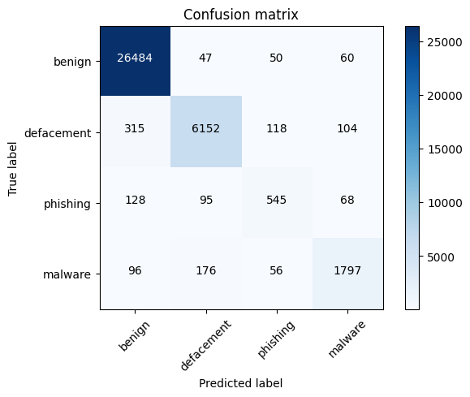
Figure 1 Confusion Matrix
The Figure 1 illustrates the performance of the classification model across four classes: benign, defacement, phishing, and malware. The model demonstrates very strong performance in correctly identifying benign websites, with 26,484 instances accurately classified, indicating high reliability in recognizing legitimate traffic. Similarly, defacement attacks are well detected with 6,152 correct predictions. Malware detection is also reasonably effective, with 1,797 instances correctly classified. However, the model shows comparatively weaker performance in detecting phishing attacks, with only 545 correct classifications. A notable concern is the misclassification of phishing instances as benign (128 cases), which represents a critical security risk, as such false negatives allow malicious websites to go undetected. Additionally, there is observable confusion between defacement and malware classes, as well as between phishing and other categories, suggesting overlapping feature patterns among these attack types. Overall, while the model achieves high accuracy for benign and defacement classes, it requires improvement in phishing detection to enhance its robustness and reliability in real-world cybersecurity applications.
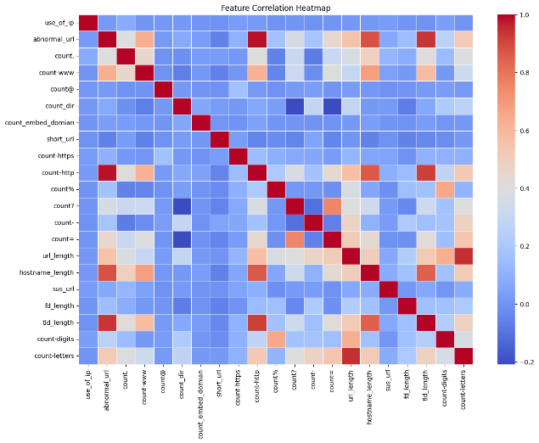
Figure 2 Correlation Heatmap Matrix
The Figure 2 illustrates the relationships among the extracted URL-based features used in the phishing detection model. Most feature pairs exhibit low to moderate correlation, indicating that the features are largely independent and contribute uniquely to the model’s learning process. However, a few strong positive correlations are visible among structurally related features, such as URL length, hostname length, and counts of special characters (e.g., digits, hyphens, and parameters), suggesting that longer URLs tend to contain more complex patterns often associated with malicious behavior. Similarly, features like the count of HTTP/HTTPS tokens and the presence of suspicious words show moderate correlation with other lexical attributes, reinforcing their relevance in identifying abnormal URLs. Negative correlations are minimal, indicating no strong inverse relationships between features. Overall, the heatmap confirms that the feature set is well-distributed with limited redundancy, while still capturing meaningful patterns necessary for distinguishing between benign, phishing, defacement, and malware URLs.
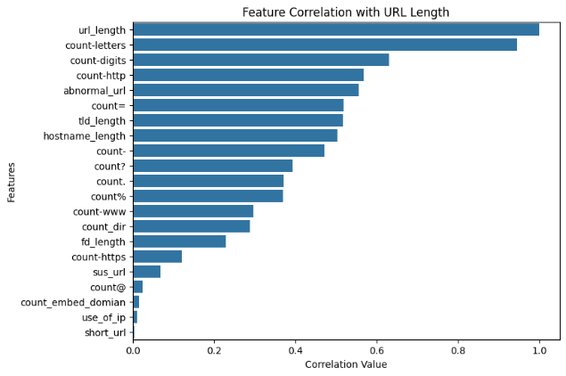
Figure 3 Feature Correlation
The Figure 3 illustrates the correlation of various URL-based features with URL length, highlighting how different characteristics of a URL scale with its size. As expected, the number of letters shows the strongest positive correlation, followed closely by the number of digits and special characters, indicating that longer URLs tend to be more complex and contain a higher mixture of alphanumeric and symbolic elements. Features such as abnormal URL patterns, hostname length, and top-level domain length also exhibit moderate positive correlation, suggesting that longer URLs often involve extended domain structures and potentially suspicious formatting. Additionally, counts of symbols like hyphens, percentage signs, and query parameters increase with URL length, reflecting the tendency of malicious URLs to embed extra information or obfuscation techniques. On the other hand, features like the presence of IP addresses, shortened URLs, and embedded domains show very low or negligible correlation, indicating that they are independent of URL length and contribute distinct information for classification. Overall, the visualization demonstrates that URL length is strongly associated with structural complexity, which is a key indicator leveraged by the model to detect malicious and phishing URLs.

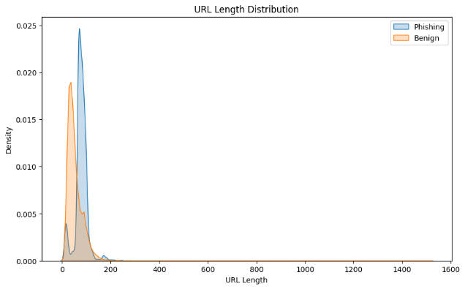
Figure 4 Feature Distribution
The Figure 4 Kernel Density Estimate (KDE) plot illustrates that URL Length is a significant discriminator between malicious and legitimate links. Benign URLs (orange) exhibit a sharp, concentrated peak at shorter lengths (typically under 50 characters), reflecting the concise nature of standard web domains. In contrast, Phishing URLs (blue) show a broader distribution with a peak shifted toward longer lengths (75–100+ characters), likely due to the use of long subdomains and obfuscation tokens intended to mask the true destination. While the overlapping region suggests that length alone isn't a perfect predictor, the distinct separation of the peaks confirms that increased URL length is a strong statistical indicator of phishing activity.
- CONCLUSION
- Feature Extraction Pipeline
Our feature extraction pipeline converts raw URLs into numerical vectors that serve as input to the classification models. A total of 21 distinct features are extracted and grouped into the following categories:
- URL Structure Features:
Detection of IP address usage, abnormal URL patterns, overall URL length, hostname length, directory count, embedded domain count, and first directory length.
- Character-Based Features:
Counts of special characters and patterns including dots (.), occurrences of “www”, @ symbols, hyphens (-), equals signs (=), percentage signs (%), question marks (?), as well as total digits and letters.
- Protocol Features:
Presence of HTTP and HTTPS protocols within the URL.
- Domain-Based Features:
Top-Level Domain (TLD) length, detection of URL shortening services, and presence of suspicious keywords such as PayPal, login, signin, bank, account, update, and free.
All features are extracted using a combination of regular expressions and URL parsing libraries. The resulting feature vectors are then used as inputs for training and evaluating the machine learning classification models.
- Machine Learning Modals
The LightGBM classifier is a gradient boosting framework based on tree-based learning using the GBDT boosting type with a multi-class objective function. It achieved 95.9% accuracy on the test dataset.
The XGBoost classifier employs Extreme Gradient Boosting with 100 estimators and provides robust performance through regularization. It achieved performance comparable to LightGBM in terms of overall accuracy and class-wise results.
The Naive Bayes model, implemented using Gaussian Naive Bayes, serves as a probabilistic baseline classifier. It achieved 81.5% accuracy, with notably high recall for the defacement class.
Logistic Regression is a linear classification model trained with L2 regularization and a maximum of 1000 iterations. This approach achieved 87.2% accuracy with balanced performance across all classes.
The Gradient Boosting Decision Trees model is an ensemble-based approach using 100 estimators with square-root feature selection. It delivered the best overall performance, achieving 93.6% accuracy with strong detection capability across all attack categories.
- Training Strategy
The dataset was split into 70% training and 20% testing and 10% validation sets with stratified sampling to maintain class distribution. We used standard scikit-learn implementations for all models. For gradient boosting models, we employed early stopping and cross-validation to prevent overfitting. The training process was optimized for multi-class classification with appropriate loss functions for each model type.

- RESULTS AND DISCUSSION

- Experimental Setup
All experiments were conducted using Python 3.x with scikit- learn, XGBoost, and LightGBM libraries. Feature extraction was performed using pandas, regular expressions, and URL parsing utilities. Models were trained on the full feature set of 21 extracted features.

- Performance Measure
We evaluated our system using standard classification metrics, including Accuracy, Precision, Recall, and F1-Score for each class, to ensure a comprehensive assessment of model performance. These metrics provide insights into both overall correctness and class-wise detection capability, which is particularly important in multi-class security classification tasks. Accuracy measures the general effectiveness of each model, while Precision and Recall highlight the trade-off between false positives and false negatives. The F1-Score offers a balanced evaluation by combining Precision and Recall into a single metric. The experimental results demonstrate varying performance across different model architectures, reflecting differences in model complexity, learning capacity, and their ability to generalize across diverse attack categories.
Table 2

Model Accuracy
Weighted
Avg
Weighted Weighted
Avg Recall
Avg F1
Naive Bayes

Logistic Regression

Gradient Boosting
LightGBM

XGBoost

81.5% | 82% | 82% | 81%
87.2% | 86% | 87% | 86%
93.6% | 94% | 94% | 93%
95.9% | 96% | 96% | 95%
95.8% | 96% | 96% | 95%

The Table 2 presents a comparative evaluation of multiple machine learning models, including Naïve Bayes, Logistic Regression, Gradient Boosting, LightGBM, and XGBoost, based on key performance metrics such as accuracy, weighted precision, weighted recall, and weighted F1-score. Among the evaluated models, Naïve Bayes exhibits the lowest performance with an accuracy of 81.5%, indicating its limited capability in capturing complex patterns in the dataset. Logistic Regression shows an improvement, achieving an accuracy of 87.2%, demonstrating better linear decision boundary learning.

Gradient Boosting significantly enhances performance, reaching an accuracy of 93.6% along with balanced weighted metrics, highlighting its strength in handling non-linear relationships. The best-performing models are LightGBM and XGBoost, achieving accuracies of 95.9% and 95.8%, respectively. Both models also maintain high weighted precision, recall, and F1-scores (approximately 95–96%), indicating consistent and reliable classification across all classes. The marginal difference between LightGBM and XGBoost suggests that both ensemble boosting techniques are highly effective for phishing detection tasks, with LightGBM slightly outperforming others in terms of overall accuracy.

- Detailed Modal Performance
Naive Bayes Performance: The Gaussian Naive Bayes model achieved 81.5% overall accuracy. For benign sites, it showed 91% precision and 89% recall. Notably, it achieved perfect recall (100%) for defacement detection but with lower precision (64%). Phishing detection showed 59% precision and 55% recall, while malware detection had 71% precision but only 38% recall.

Future work will focus on several directions. First, we plan to incorporate HTML content analysis to create a truly multi- modal system combining URL and webpage features. Second, we will explore deep learning architectures that can automatically learn feature representations from raw URL strings. Third, we aim to develop continuous learning mechanisms that adapt to emerging phishing techniques without requiring full model retraining. Finally, we will investigate adversarial robustness to ensure the system remains effective against evasion attempts.

The proposed system provides a practical foundation for browser security extensions and email filtering systems. The lightweight feature extraction process and efficient inference enable real-time deployment, while the strong performance across multiple threat categories ensures comprehensive protection.

SYSTEM ARCHITECTURE VISUALIZATION

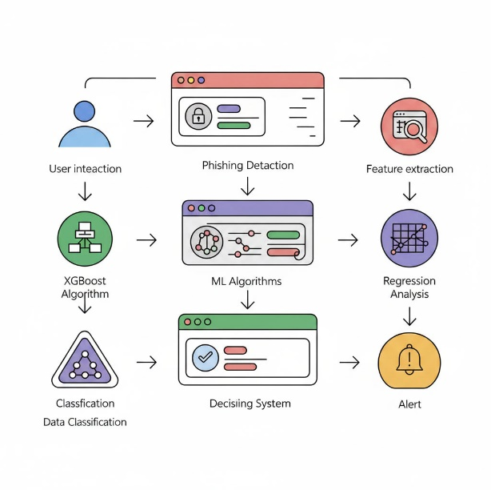

The system architecture illustrates the workflow of the proposed phishing detection framework, beginning with user interaction and progressing through multiple processing stages to generate the final classification outcome. Initially, the user provides input in the form of a URL or web request, which is then passed to the phishing detection module. In this stage, feature extraction is performed to derive relevant lexical and structural attributes from the URL, such as length, presence of special characters, and domain-related properties.

The extracted features are then fed into machine learning algorithms, including XGBoost and other classification models, where regression and classification analyses are performed to determine the likelihood of the URL being malicious or benign. The model processes the input features and produces classification outputs corresponding to different categories such as benign, phishing, defacement, or malware.

Subsequently, the decision system evaluates the model predictions and assigns the final class label. Based on the classification result, an alert mechanism is triggered if a malicious URL is detected, thereby notifying the user or system of potential threats. This architecture ensures a systematic flow from data input to intelligent decision-making, enabling accurate and efficient phishing detection in real-time environments.
DATA AVAILABILITY
The dataset and source code used in this study are available at: [Link]
https://www.kaggle.com/datasets/akileshga/phishing-legitimate-urls

- REFERENCES
[1] A State-of-the-Art Review on Phishing Website Detection Techniques. Wenhao li 1, (graduate student member, ieee), selvakumar manickam 1, (member, ieee), yung-wey chong 2, weilan leng3, and priyadarsi nanda 4, (Senior Member, IEEE).
[2] Z. Alshingiti, R. Alaqel, J. Al-Muhtadi, Q. E. ul Haq, K. Saleem, and M. H. Faheem, "A deep learning-based phishing detection system using CNN, LSTM, and LSTM-CNN," Jan. 3, 2023.
[3] K. Subashini and V. Narmatha, "Detecting phishing websites using recent techniques: A systematic literature review," ITM Web of Conferences, vol. 57, 2023.
[4] D. Kalla and S. Kuraku, "Phishing website URLs detection using NLP and machine learning techniques," Dec. 18, 2023.
[5] R. Jayaraj, A. Pushpalatha, K. Sangeetha, T. Kamaleshwar, S. Udhaya Shree, and D. Damodaran, "Intrusion detection based on phishing detection with machine learning," Dec. 21, 2023.
[6] S. Kapan and E. S. Gunal, "Improved phishing attack detection with machine learning: A comprehensive evaluation of classifiers and features," Dec. 15, 2023.
[7] A. H. Aljammal, S. Taamneh, A. Qawasmeh, and H. Bani Salameh, "Machine learning based phishing attacks detection using multiple datasets," Int. J. Interactive Mobile Technologies, vol. 17, no. 5, 2023.
[8] A. A. Albishri and M. M. Dessouky, "A comparative analysis of machine learning techniques for URL phishing detection," vol. 14, no. 6, pp. 18495–18501, 2024.
[9] K. S. Jishnu and B. Arthi, "Real-time phishing URL detection framework using knowledge distilled ELECTRA," vol. 65, no. 4, pp. 1621–1639, 2024.
[10] M. A. Tamal, M. K. Islam, T. Bhuiyan, and A. Sattar, "Dataset of suspicious phishing URL detection," Data Report, Mar. 6, 2024.
[11] A. U. Rehman, I. Imtiaz, S. Javaid, and M. Muslih, "Real-time phishing URL detection using machine learning," 2024.
[12] H. Ghalechyan, E. Israyelyan, A. Arakelyan, G. Hovhannisyan, and A. Davtyan, "Phishing URL detection with neural networks: An empirical study," 2024.
[13] F. Rashid, B. Doyle, S. C. Han, and S. Seneviratne, "Phishing URL detection generalisation using unsupervised domain adaptation," Apr. 6, 2024.
[14] "Leveraging machine learning algorithms for phishing website URL detection," Proc. National Conf. Emerging Computer Applications (NCECA), vol. 1.5, no. 1, 2024.
[15] S. K. Ahammad, S. D. Kale, G. D. Upadhye, S. D. Pande, E. V. Babu, A. V. Dhumane, and D. K. Bahadur, "Phishing URL detection using machine learning methods," 2024.
[16] Q. E. ul Haq, M. H. Faheem, and I. Ahmad, "Detecting phishing URLs based on a deep learning approach to prevent cyber-attacks," 2024.
[17] U. Zara, K. Ayyub, H. U. Khan, A. Daud, T. Alsahfi, and S. G. Ahmad, "Phishing website detection using deep learning models," Oct. 25, 2024.
[18] M. Abdolrazzagh-Nezhad and N. Langarib, "Phishing detection techniques: A review," vol. 9, no. 1, pp. 32–46, 2025.
[19] K. Barik, S. Misra, and R. Mohan, "Web-based phishing URL detection model using deep learning optimization techniques," published online Feb. 8, 2025.
[20] G. S. Nayak, B. Muniyal, and M. C. Belavagi, "Enhancing phishing detection: A machine learning approach with feature selection and deep learning models," Feb. 19, 2025.
[21] M. Murhej and G. Nallasivan, "Multimodal framework for phishing attack detection and mitigation through behavior analysis using EM-BERT and SPCA-based EAI-SC-LSTM," Jul. 8, 2025.
[22] H. Li, J. Yang, Y. Li, and K. Li, "Email phishing attack detection based on BERT transformer model," The Institute for Network Sciences and Cyberspace, Tsinghua University, Beijing, China.
[23] M. A. A. Abdelrahman, H. M. A. Alblooshi, A. A. Ibrahim, F. Outay, and H. Malik, "WhatsPhish: AI powered WhatsApp phishing detector chatbot," Zayed University, Dubai, UAE.
[24] E. K. J, V. Surendhiran, S. Karuppusamy, and P. Vijayakumar, "An ensemble approach to phishing URL detection using supervised machine learning."
[25] M. V. Teja, N. Vyshnavi, N. Bhavni, V. Indrani, and A. Prashanthi, "Phishing URL detection using gradient boosting classifier."
[26] R. Alzubi, T. Bishtawi, and H. Kassem, "Improving web security through machine learning: A feature-based methodology for detecting phishing URLs."
[27] H. Fares, J. Kilani, F. Fagroud, H. Toumi, F. Lakrami, Y. Baddi, and N. Aknin, "Machine learning approach for email phishing detection."
[28] F. Salahdine, Z. El Mrabet, and N. Kaabouch, "Phishing attacks detection: A machine learning-based approach."
[29] J. L. Wilk-Jakubowski, L. Pawlik, G. Wilk-Jakubowski, and A. Sikora, "Machine learning and neural networks for phishing detection: A systematic review (2017–2024)."
[30] K. Barik, S. Misra, and R. Mohan, "Web-based phishing URL detection model using deep learning optimization techniques," published online Feb. 8, 2025.

