**Design Data Warehouses For Given Below Products:**

**Note : While designing any Data Warehouse make sure to cover given below points.**

a. Design Fact & Dimension tables

b. Create meaningful Primary & Foreign keys

c. Try to follow Star/SnowFlake Schema Design

d. Try to write few SQL queries to generate insightful business metrics (This is the critical point because you need to understand the Data & Business both)

**1. Design a Data Warehouse for IPL Cricket Tournament (Asked in Flipkart Interview for Senior Data Engineer role)**

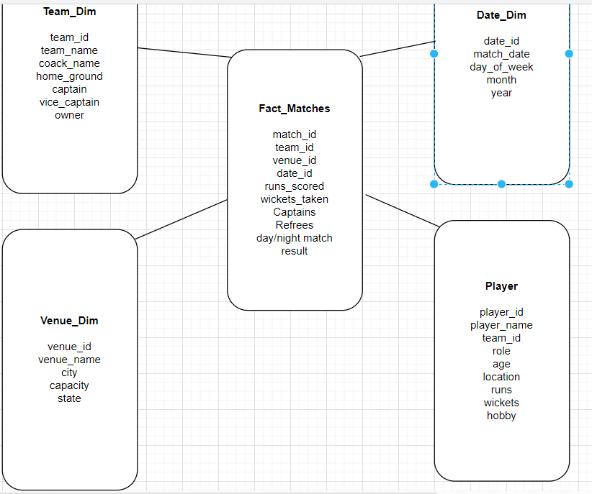

**2 . Design a Data Warehouse for Food delivery app like Swiggy, Zomato (Asked in Grab for Data Engineer role)**

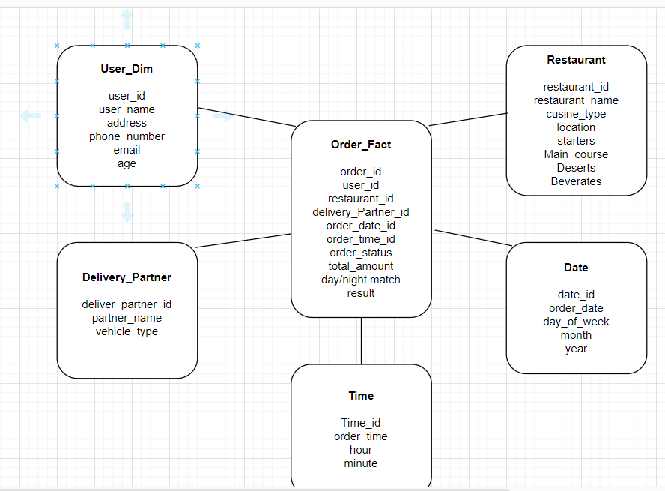

**3. Design a Data Warehouse for cab ride service like Uber, Lyft (Asked in Google for Data Engineer role)**

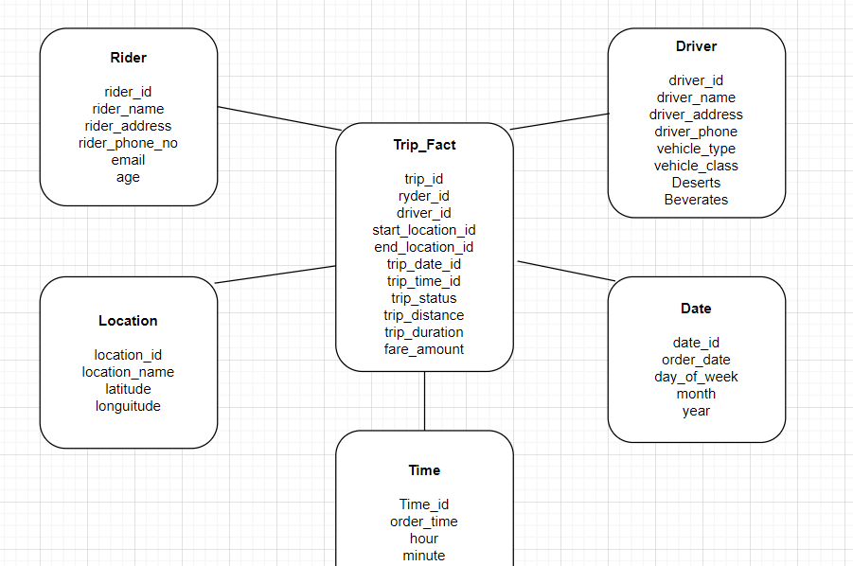

**4. Design a Data Warehouse for Restaurent table booking app like Dineout (Asked in McKinsey for Consultant Data Engineer role)**

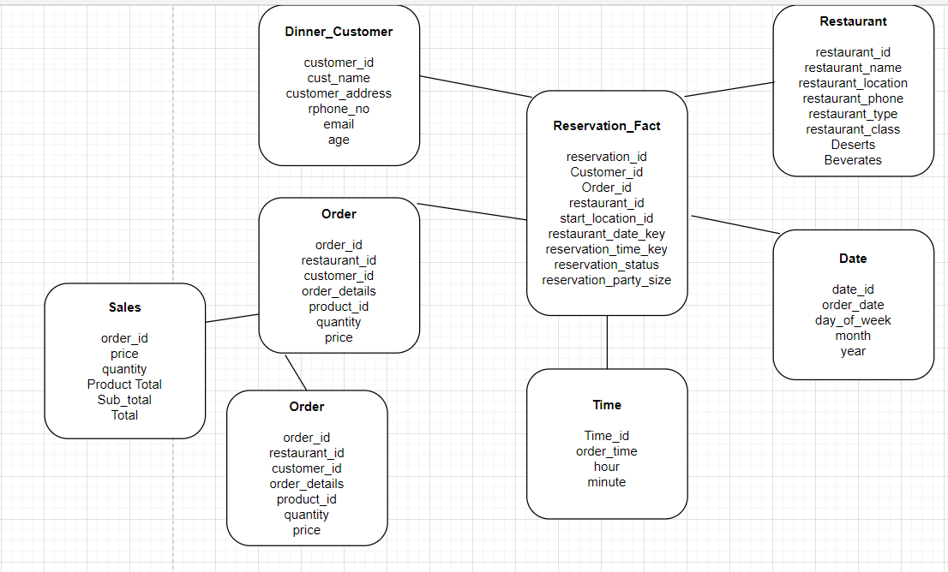

**5. Design a Data Warehouse for Covid Vaccination Application (Asked in Livsapce for Data Engineer role**

