**SQL Section-1 – Solution’s**

**Name: Akilesh Vishnu Mohan Raj**

**Email:** [**akileshvishnu10@gmail.com**](mailto:akileshvishnu10@gmail.com)

**Batch 2 : Full Stack Big Data Analytics**

1. `

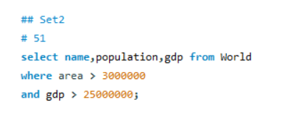

1. `

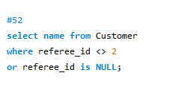

1. `

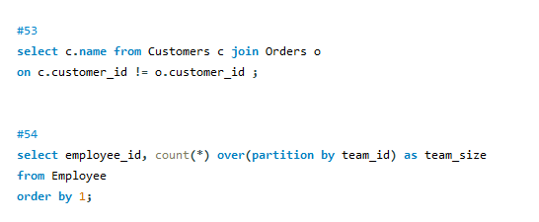

1. `



1. `

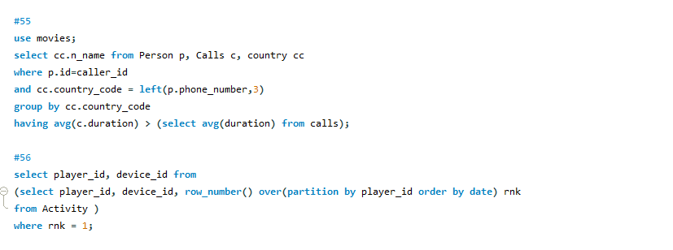

1. `



1. `

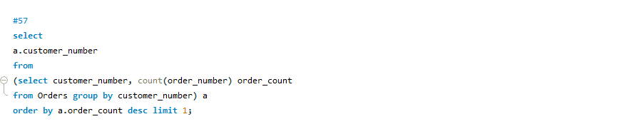

1. `

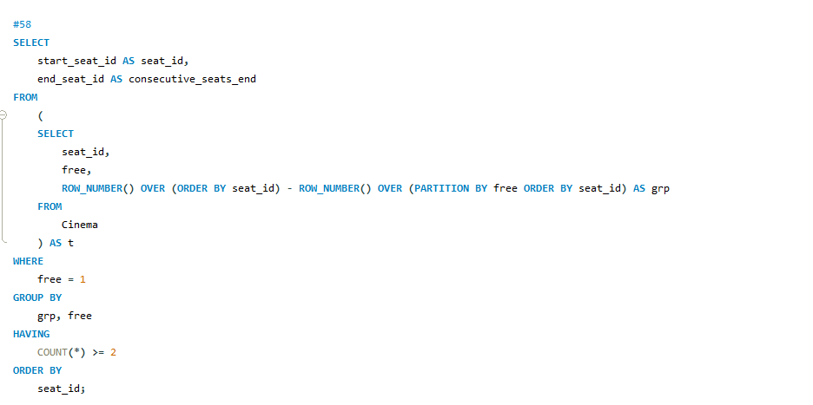

1. `

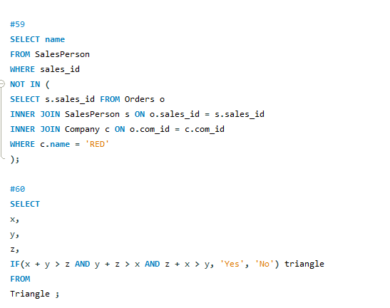

1. `



1. `

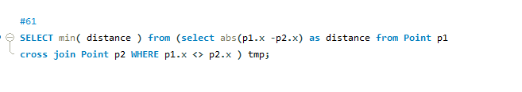

1. `

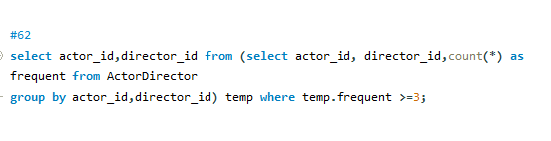

1. `

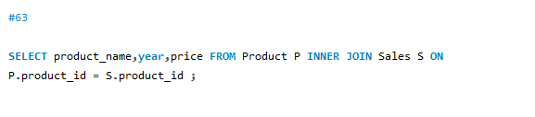

1. \

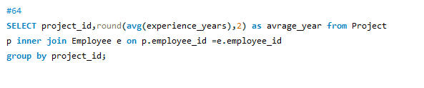

1. `

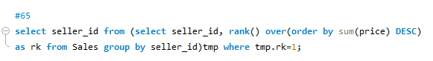

1. \

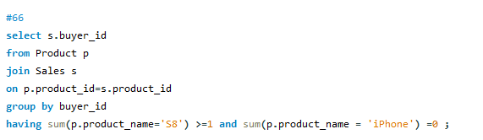

1. `

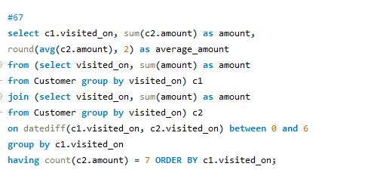

1. `

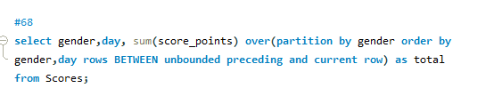

1. `

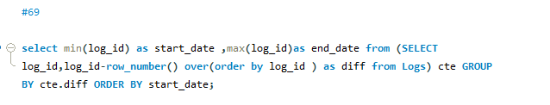

1. `

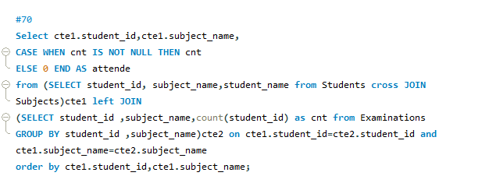

1. `

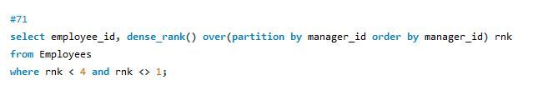

1. `

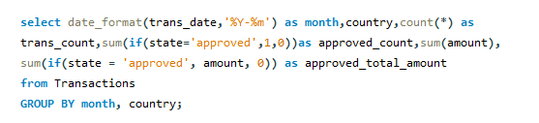

1. `
2. `

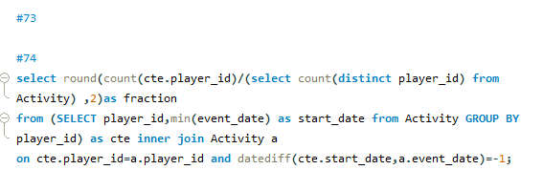

1. `

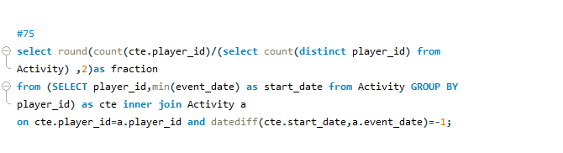

1. `

select company_id, employee_id, employee_name, round(salary - salary*tax, 0)

as salary

from

(

select *,

case when max(salary) over(partition by company_id) < 1000 then 0

when max(salary) over(partition by company_id) between 1000

and 10000 then 0.24

else 0.49 end as tax

from Salaries

) x ;

1. `
2. `
3. `

(select name from

MovieRating m left join Users u on m.user_id=u.user_id

GROUP BY name order by count(*) desc, name LIMIT 1

)

UNION

(SELECT

m.title

FROM MovieRating as mr JOIN Movies as m

ON mr.movie_id = m.movie_id

WHERE DATE_FORMAT(created_at, '%Y-%m') = '2020-02'

GROUP BY 1

ORDER BY AVG(rating) DESC, 1

LIMIT 1)

1. `
2. `
3. `

select * from EMPLOYEE order by name;

1. `
2. `

SELECT CASE

WHEN A + B <= C OR A + C <= B OR B + C <= A THEN 'Not A Triangle'

WHEN A = B AND B = C THEN 'Equilateral'

WHEN A = B OR B = C OR A = C THEN 'Isosceles'

ELSE 'Scalene'

END as result

FROM TRIANGLES;

1. `
2. `
3. `
4. `
5. `
6. `

WITH expanded AS(

SELECT searches

FROM search_frequency

GROUP BY searches, GENERATE_SERIES(1,num_users)

)

SELECT PERCENTILE_CONT(0.5) WITHIN GROUP (ORDER BY searches) AS median

FROM expanded

1. `
2. `
3. `
4. `
5. `
6. `
7. `
8. `
9. `
10. `