Revolutionizing Agriculture with Agri Edge Or-Mange Ltd
User story :
The Agri Edge Salesforce CRM is designed to support the needs of different business users by providing a centralized platform for managing agricultural inventory, customer orders, payments, and shipments. As a Warehouse Manager, the user can maintain inventory records, monitor stock quantities, reorder levels, and warehouse locations; as a Sales Representative, the user can create and manage customer orders and order items; as a Finance Team member, the user can monitor payment and order statuses; and as a Warehouse Manager, the user can manage shipment creation, tracking, and delivery status. The system also automates order total calculation, order status updates, shipment processing, and notifications while providing role-based access, reports, dashboards, and testing capabilities to improve operational efficiency, data accuracy, security, and decision-making.
1. INTRODUCTION
1.1 Project Overview :
AgriEdge – Agriculture Management System is a Salesforce-based CRM solution developed for AgriEdge Or-Mange Ltd. to streamline and centralize agricultural business operations. The system is designed to manage important business activities such as inventory management, customer orders, order items, payment status, and shipment tracking within a single Salesforce platform. By using Salesforce custom objects, relationships, automation, Apex development, security configurations, reports, and dashboards, AgriEdge provides a structured and efficient approach to managing business data. The system supports different users such as Sales Representatives, Finance Team members, Warehouse Managers, and administrators, allowing them to access and manage information according to their responsibilities.
1.2 Purpose:
The purpose of the AgriEdge Salesforce CRM is to provide a centralized platform for managing agricultural business operations, including inventory, customer orders, order items, payments, and shipments. The system brings these activities together within Salesforce, reducing the need for separate manual records and improving the overall organization of business information.
The purpose of the AgriEdge Salesforce CRM is to provide a centralized platform for managing agricultural business operations, including inventory, customer orders, order items, payments, and shipments. The system brings these activities together within Salesforce, reducing the need for separate manual records and improving the overall organization of business information.
The system is designed to reduce manual work and improve operational efficiency by automating important business processes. Automation helps calculate order totals, update order and payment statuses, manage shipment-related activities, and send order notifications. This allows users to complete their responsibilities more efficiently while maintaining accurate and consistent data.
1.3 Objectives:
The main objective of the AgriEdge Salesforce CRM is to develop a centralized platform that efficiently manages agricultural business operations. The system aims to organize inventory, customer orders, order items, payments, and shipments within a single Salesforce environment.
The project aims to automate important business processes such as order total calculation, order status updates, payment status management, shipment processing, and customer notifications. This helps reduce manual effort, improve data accuracy, and provide faster processing of business activities.
Another objective is to provide secure and role-based access for different users such as Sales Representatives, Finance Team members, Warehouse Managers, and administrators. The system also aims to provide reports and dashboards that improve visibility into business operations and support effective decision-making.
2. PHASE 1: REQUIREMENT ANALYSIS & PLANNING
2.1 Understanding Business Requirements
The AgriEdge Salesforce CRM was planned to provide a centralized system for managing the major business activities of AgriEdge Or-Mange Ltd. The requirement analysis focused on identifying the need for managing inventory, customer orders, order items, payments, and shipments within Salesforce.
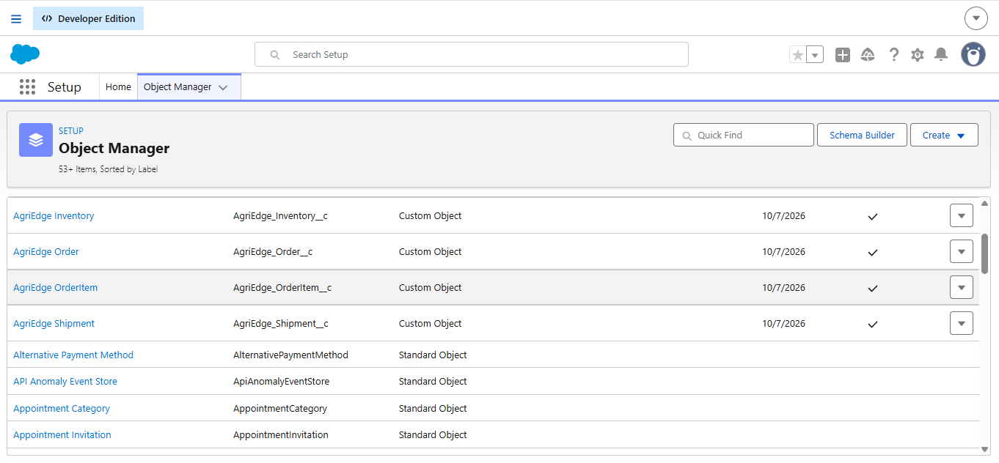

The system requires four main custom objects: AgriEdge Inventory, AgriEdge Order, AgriEdge OrderItem, and AgriEdge Shipment. Inventory management requires maintaining stock quantity, reorder level, and warehouse location. Order management requires maintaining customer orders, order items, order status, payment status, shipping address, and total amount. Shipment management requires maintaining order-related shipment information, tracking numbers, and shipment status.
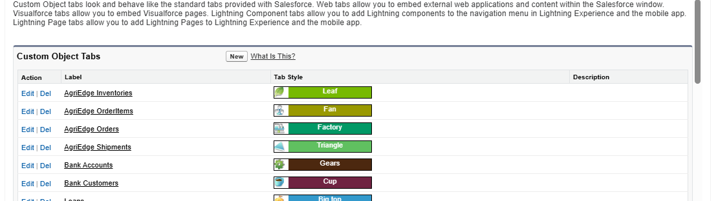

The requirements also identified the need for automated business processing. Apex classes and triggers were planned to calculate order totals, update order and payment statuses, create and update shipment information, handle failed orders, and send order-related email notifications. These requirements help reduce manual processing and maintain consistency across related Salesforce records.
2.2 Defining Project Scope and Objectives
The scope of the AgriEdge project covers the development and configuration of a Salesforce-based Agriculture Management System. The project includes the creation of custom objects, fields, relationships, custom tabs, user profiles, roles, Apex classes, Apex triggers, automation, reports, dashboards, and testing components.
The project is designed to support different business responsibilities. Sales Representatives manage customer orders and order items, the Finance Team handles payment-related information, and the Warehouse Manager manages inventory and shipment-related activities. The security configuration ensures that users receive access according to their assigned responsibilities.
The main objectives identified during planning are to centralize business data, reduce manual processing, automate order-related activities, improve inventory and shipment tracking, maintain secure user access, and provide better visibility into business operations through Salesforce reports and dashboards.
2.3 Design Data Model and Security Model
The AgriEdge data model was designed around four custom Salesforce objects: AgriEdge Inventory, AgriEdge Order, AgriEdge OrderItem, and AgriEdge Shipment. The AgriEdge OrderItem object is related to the AgriEdge Order object through the Order__c relationship. Shipment records are also associated with orders so that shipment status and tracking information can be managed along with the corresponding order.
The major data fields were identified according to the requirements of each business process. Inventory contains information such as Stock Quantity, Reorder Level, and Warehouse Location. Orders contain fields such as Customer, Order Status, Payment Status, Shipping Address, Total Amount, and Discounted Total. Order Items contain Quantity, Unit Price, and Total Price, while Shipment contains information such as Tracking Number and Status.
The security model was planned using Profiles and Roles. The project uses Platform 1, Platform 2, and Platform 3 profiles and a role hierarchy consisting of CEO, Sales Representative, Finance Team, and Warehouse Manager. Object-level access is configured according to user responsibilities, allowing appropriate users to create, view, or edit Inventory, Orders, Order Items, and Shipment records. This provides controlled access to business information while supporting the required Salesforce operations.

3. PHASE 2: SALESFORCE DEVELOPMENT – BACKEND & CONFIGURATIONS
3.1 Salesforce Environment Setup
The AgriEdge project was developed using the Salesforce Lightning Experience environment. The Salesforce organization was configured to support the requirements of AgriEdge Or-Mange Ltd. The development environment includes the required custom objects, fields, tabs, user profiles, roles, automation components, Apex classes, and triggers.
The Salesforce environment was structured to provide a centralized platform for managing inventory, orders, order items, and shipments. The required configurations were implemented according to the identified business requirements and user responsibilities.
3.2 DevOps Workflow
A structured development workflow was followed to manage the AgriEdge project components and project documentation. GitHub is planned to be used as the project repository for maintaining the project documentation and development-related resources.
The development process follows an organized approach where Salesforce configurations and Apex components are developed, tested, reviewed, and documented. This helps maintain project consistency and provides a centralized location for managing project-related files.
3.3 Custom Objects
Custom Object | Purpose
AgriEdge Inventory | Maintains stock quantity, reorder level, and warehouse location information.
AgriEdge Order | Stores customer order and payment-related information.
AgriEdge OrderItem | Maintains individual items associated with an order.
AgriEdge Shipment | Manages shipment and tracking information associated with orders.
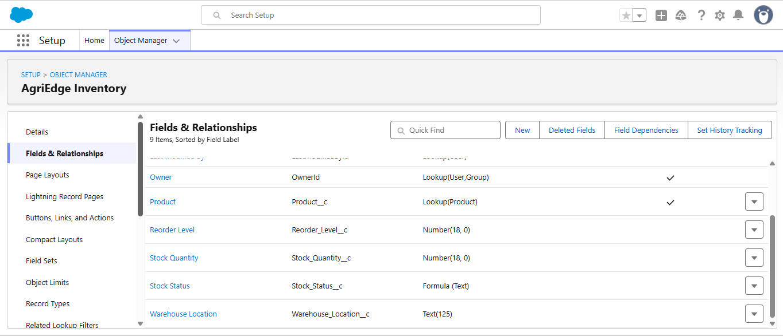
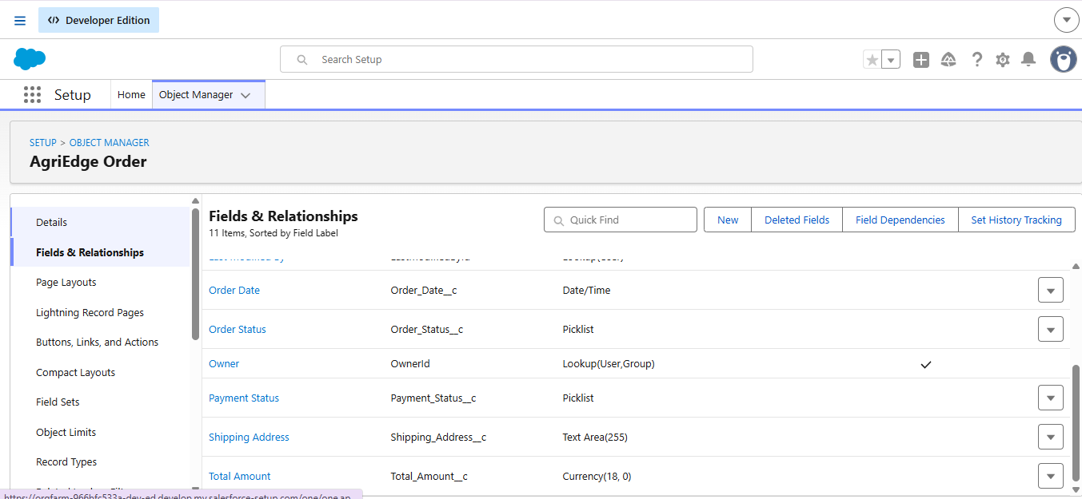
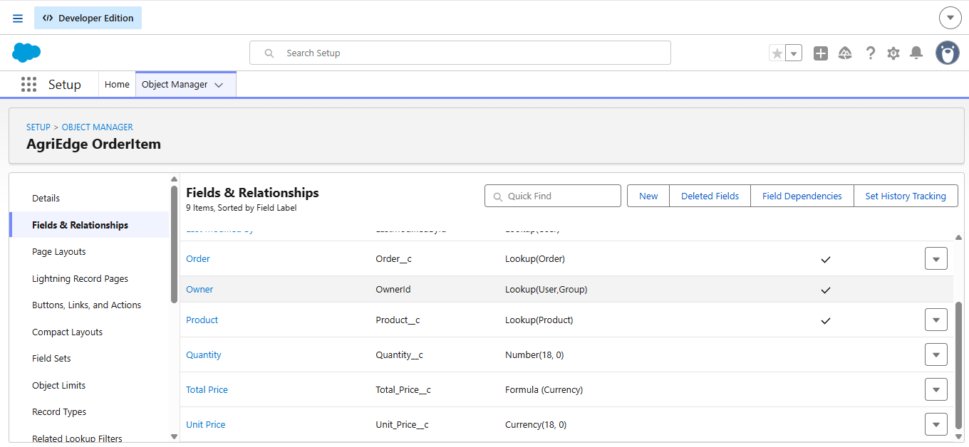
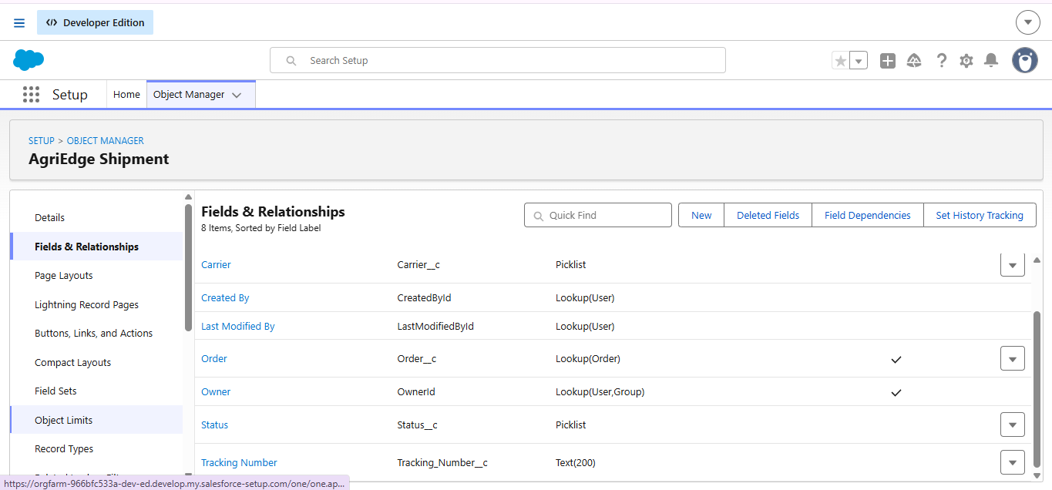
3.4 Custom Fields
Custom fields were created based on the requirements of each business process. Important fields include:
- Inventory: Stock Quantity, Reorder Level, Warehouse Location
- Order: Customer, Order Status, Payment Status, Shipping Address, Total Amount, Discounted Total
- OrderItem: Order, Quantity, Unit Price, Total Price
- Shipment: Order, Tracking Number, Status
These fields provide the information required for inventory management, order processing, payment tracking, and shipment management.
3.5 Relationships
Relationships were configured between the major business objects to maintain connections between related records. The AgriEdge OrderItem object is associated with the AgriEdge Order object through the Order__c relationship. Shipment records are also associated with their corresponding orders.
These relationships allow the system to connect individual order items and shipment information with the appropriate customer order, supporting automated processing and better record management.
3.6 Automation and Apex Development
The AgriEdge project uses Salesforce automation and Apex development to reduce manual processing. Apex classes and triggers were developed to support important business processes such as:
- Updating an order from New to Processing.
- Calculating the total amount from order items.
- Updating payment status based on order total.
- Creating and updating shipment records.
- Handling failed orders.
- Sending order-related email notifications.
- Preventing unnecessary trigger recursion.
The Apex implementation provides the backend logic required to connect order, payment, order item, and shipment processes within the AgriEdge system.
3.7 Apex Classes
Apex classes were developed in the AgriEdge Salesforce application to implement business logic that cannot be handled only through standard Salesforce configuration. The classes support order processing, order total calculation, shipment management, and customer notification.
The major Apex classes developed are:
- OrderStatusUpdater – Updates the order status from New to Processing when required.
- OrderTotalUpdater – Calculates the order total using the related OrderItem records and updates the payment status.
- OrderEmailSender – Sends order-related email notifications to customer contacts.
- AgriEdgeOrderShipmentHelper – Handles shipment creation and shipment status updates based on order and payment status.
- AgriEdgeOrderTriggerHelper – Maintains a trigger execution flag to help prevent recursive trigger execution.
These classes provide reusable backend logic and help maintain consistency across the related AgriEdge Salesforce objects.

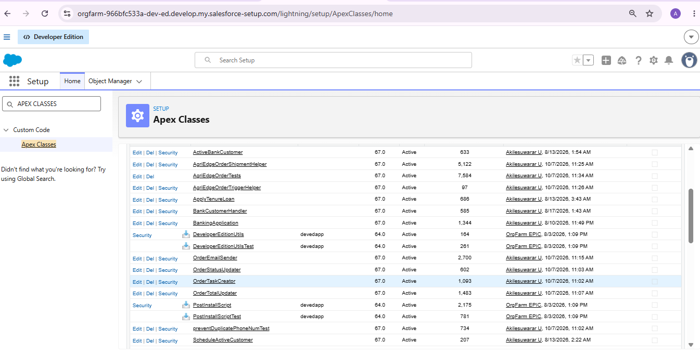

3.8 Apex Triggers
Apex triggers were implemented to automatically execute business logic when records are inserted or updated.
The AgriEdgeOrderItemTrigger executes after OrderItem records are inserted or updated. It identifies the related orders and calls the order status and order total processing classes.
The AgriEdgeOrderTrigger executes after AgriEdge Order records are inserted or updated. It monitors changes in payment and order status and performs the required processing, including shipment-related operations and handling failed orders.
A trigger helper class is used to control trigger execution and reduce the possibility of recursive processing.
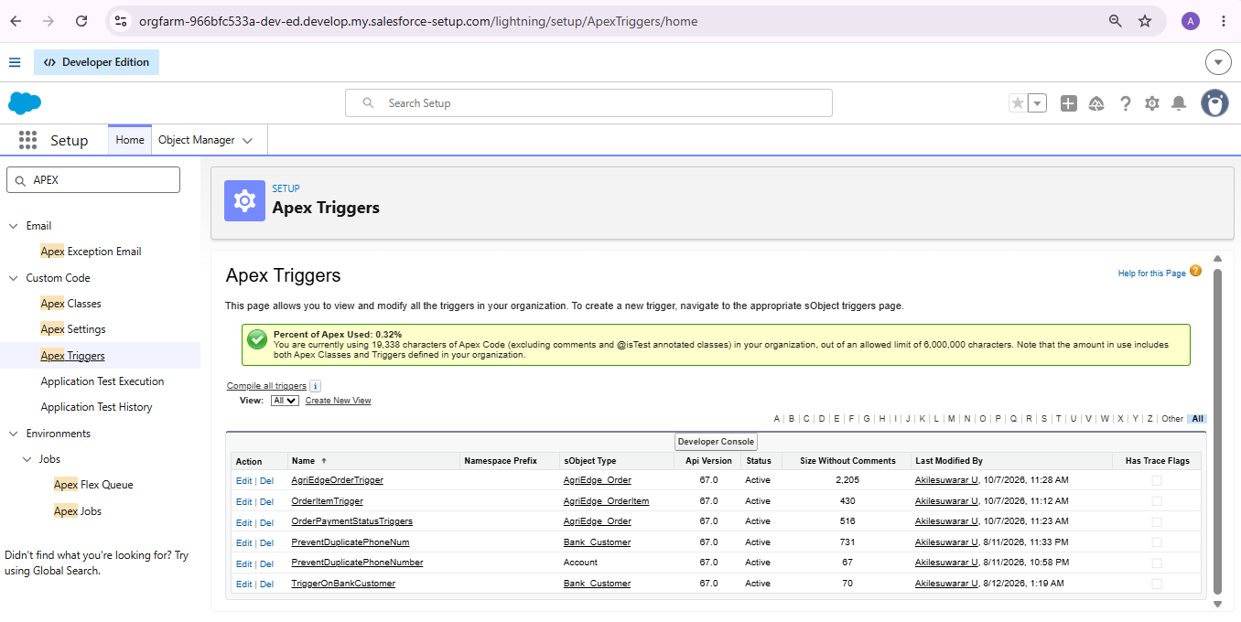
3.9 Order and Shipment Automation
The AgriEdge system includes automated processing between Orders, OrderItems, and Shipments. When order-related information changes, the Apex logic evaluates the current status and performs the required action.
For example, an order with a Pending payment status can be moved to Processing, while a successfully paid order can be moved toward Delivered based on the implemented business logic. Shipment records can be created for processing orders and their status can be updated when the corresponding order status changes.
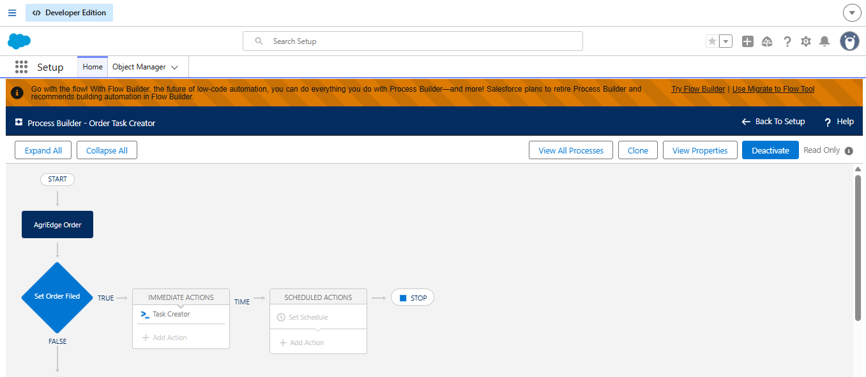
3.10 Apex Test Classes
An Apex test class named AgriEdgeOrderTests was developed to verify the functionality of the major Apex components. The test class covers order status updates, order total calculation, email processing, shipment creation, order trigger execution, and trigger helper functionality.
Testing the Apex components helps verify that the implemented business logic performs the expected operations and supports reliable Salesforce application development.

4. PHASE 3: UI/UX DEVELOPMENT & CUSTOMIZATION
4.1 Lightning App
A Salesforce Lightning application was configured for the AgriEdge Agriculture Management System to provide users with a centralized interface for accessing the required business records. The application brings together the major AgriEdge components, including Inventory, Orders, OrderItems, and Shipments, within the Salesforce Lightning Experience.
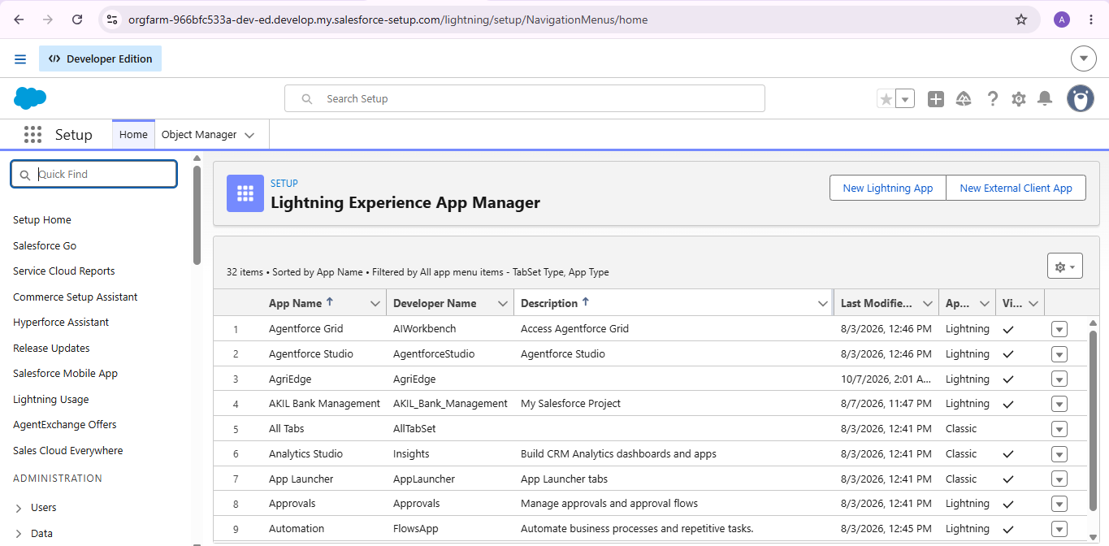

The Lightning interface is designed to make navigation easier for different users based on their business responsibilities. This provides a structured user experience for managing agricultural inventory, customer orders, payment information, and shipment records.
4.2 Page Layouts
Page layouts were configured for the AgriEdge custom objects to organize the fields displayed when users create, view, and edit records. The layouts are designed according to the information required for each business process.
The AgriEdge Inventory layout provides access to stock quantity, reorder level, and warehouse location. The AgriEdge Order layout contains customer, order status, payment status, shipping address, and amount-related information. Similar layouts are provided for OrderItem and Shipment records to support order item and shipment management.
4.3 User Management
User management was configured to provide controlled access to the AgriEdge application. The project uses different profiles and roles to represent the responsibilities of various business users.
The configured roles include:
- CEO
- Sales Representative
- Finance Team
- Warehouse Manager
Profiles such as Platform 1, Platform 2, and Platform 3 are used to control object-level permissions. This ensures that users receive the appropriate level of access required to perform their assigned activities.

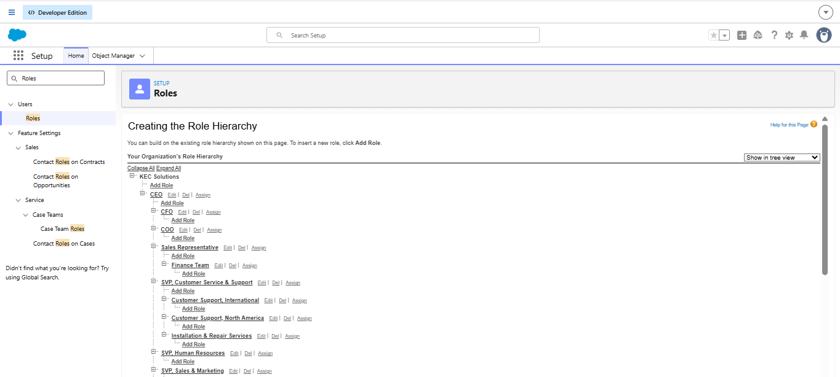
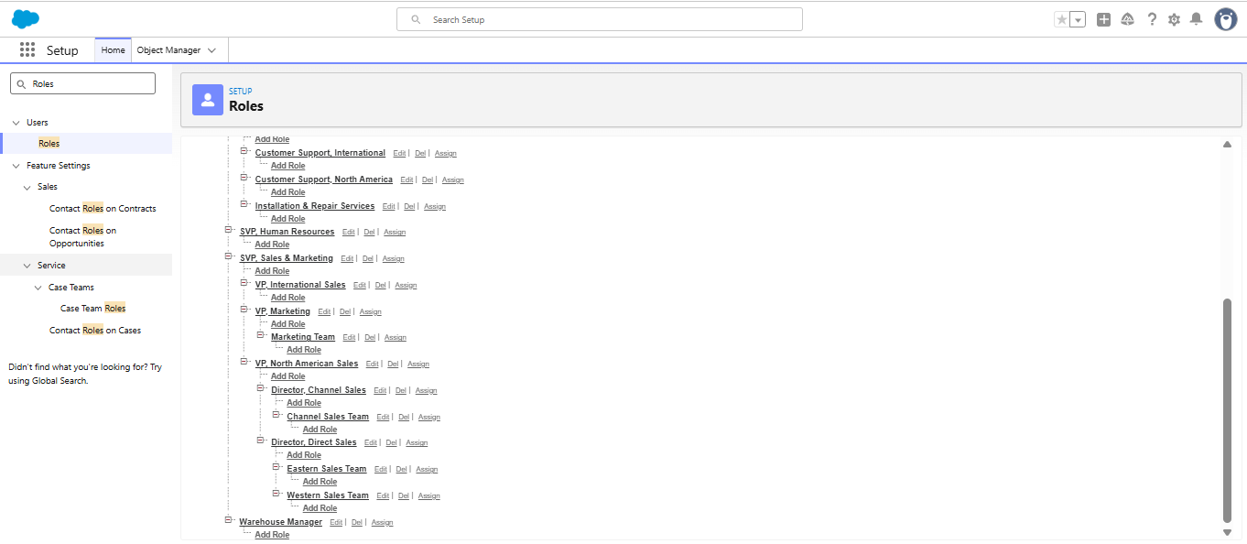

4.4 Reports and Dashboards
Reports and dashboards are used to provide better visibility into AgriEdge business operations. They can be configured to present important information related to inventory, orders, payments, and shipments.
These components help management monitor business activities and identify important information such as order status, payment status, inventory levels, and shipment progress. The dashboard provides a summarized view of key business information to support decision-making.
4.5 Lightning Pages
Lightning Pages provide a flexible interface for presenting AgriEdge information within Salesforce Lightning Experience. The relevant components can be arranged to provide users with convenient access to frequently used records and business information.
The Lightning interface supports the overall usability of the AgriEdge application by organizing important Salesforce components in a clear and accessible manner.

5. PHASE 4: DATA MIGRATION, TESTING & SECURITY
5.1 Data Loading and Migration
Sample data was prepared and entered into the AgriEdge Salesforce objects to verify the functionality of the application. Inventory records were used to test stock management, while order and order item records were used to verify order processing and total calculation.
The data loading process helps validate the relationships between Inventory, Order, OrderItem, and Shipment records. The loaded records were also used during testing of Apex classes, triggers, and related automation.

5.2 Field History Tracking
Field History Tracking can be used to monitor important changes made to business records in the AgriEdge system. Fields such as Order Status, Payment Status, and Stock Quantity are important candidates because changes to these values can affect business operations.
Tracking changes provides better visibility into record updates and can support monitoring and troubleshooting activities.
5.3 Duplicate Rules and Matching Rules
Duplicate Rules and Matching Rules can be used to help prevent duplicate business records, particularly for customer-related information. These features improve data quality by identifying records that may already exist in the Salesforce organization.
5.4 Profiles and Object-Level Security
Profiles were configured to control access to the AgriEdge objects based on user responsibilities. The project uses Platform 1, Platform 2, and Platform 3 profiles.
For example, Platform 2 provides appropriate access to Inventory, Account, and Shipment records while maintaining restricted access to Orders and OrderItems. Platform 3 provides create and edit access to Orders and OrderItems.
This profile-based security helps ensure that users can perform only the operations required for their business responsibilities.
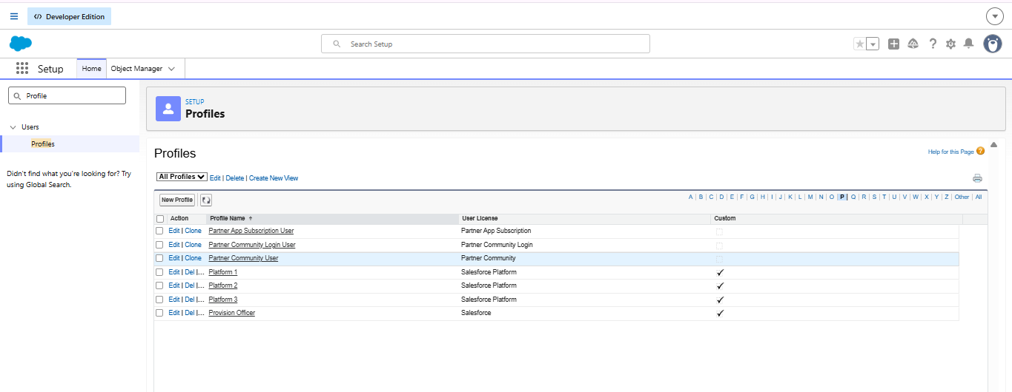

5.5 Roles and Role Hierarchy
A role hierarchy was configured to represent the organizational structure of AgriEdge. The hierarchy consists of:
CEO
→SalesRepresentative
→ Finance Team
and
CEO
→ Warehouse Manager
The hierarchy supports the organization's reporting structure and helps Salesforce determine record visibility according to the responsibilities of different users.
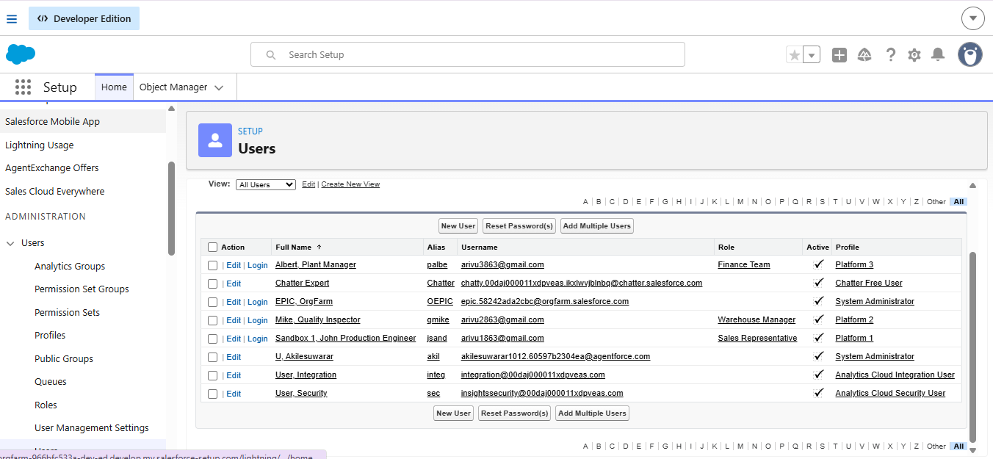
5.6 Testing and Validation
Testing was performed to verify the functionality of the developed Apex classes and triggers. The AgriEdgeOrderTests test class covers major business operations including:
- Order status update
- Order total calculation
- Payment status update
- Order email processing
- Shipment creation
- Order trigger execution
- Trigger helper functionality
The test results are used to confirm that the implemented business logic produces the expected output and that the related Salesforce components work together correctly.

6. PHASE 5: DEPLOYMENT, DOCUMENTATION & MAINTENANCE
6.1 Deployment Strategy
The AgriEdge Salesforce application was developed and configured within the Salesforce environment. The deployment strategy focuses on ensuring that the configured objects, fields, relationships, Apex classes, triggers, and security settings work correctly before the application is used for business operations.
The Apex components are tested to verify their functionality and identify errors. Before deploying changes to another Salesforce environment, the required metadata and dependencies should be reviewed to ensure that all related components are included.
6.2 Documentation
Project documentation is prepared to describe the architecture, business requirements, Salesforce configurations, data model, security model, Apex implementation, and testing approach of the AgriEdge system.
The documentation provides a structured overview of the project's development and helps developers and administrators understand the purpose of each component. Screenshots of important Salesforce configurations, object fields, Apex classes, triggers, and test results can be included as supporting evidence.
6.3 Maintenance and Monitoring
Maintenance is important for ensuring the continued reliability of the AgriEdge Salesforce application. Regular reviews of inventory records, order processing, payment statuses, and shipment information can help identify data inconsistencies and operational issues.
Apex test classes should be executed when changes are made to the related code. Salesforce errors, failed automation, and unexpected record updates should be investigated and corrected to maintain the stability of the application.
6.4 Troubleshooting Approach
Troubleshooting focuses on identifying and resolving issues in Salesforce configurations and Apex components. Errors related to custom fields, object relationships, triggers, permissions, and record updates should be reviewed using Salesforce error messages and debug logs.
The troubleshooting process includes checking field API names, verifying object relationships, reviewing user permissions, testing Apex logic, and confirming that related components operate as expected. This approach helps maintain the accuracy and reliability of the AgriEdge system.

7. CONCLUSION
The AgriEdge Salesforce CRM provides a centralized solution for managing important agricultural business operations, including inventory, customer orders, order items, payments, and shipments. The project uses Salesforce custom objects, fields, relationships, user profiles, roles, Apex classes, and triggers to organize business information and support automated processing.
The implementation aims to reduce manual effort, improve data accuracy, and provide controlled access to business records. The integration of order processing and shipment-related logic supports better coordination between different business activities.
Overall, the AgriEdge project demonstrates how Salesforce can be customized to meet business requirements through backend development, security configuration, and organized data management. Further improvements and testing can enhance the system's functionality, usability, and reliability.
8. FUTURE ENHANCEMENTS
The AgriEdge Salesforce system can be enhanced in the future by introducing additional features to improve automation, user experience, and business insights.
- AI-Powered Recommendations: Use AI to analyze inventory and order data and provide useful business recommendations.
- Inventory Alerts: Introduce automated notifications when stock quantities fall below the defined reorder level.
- Customer Service Chatbot: Add a chatbot to answer customer questions about orders and shipment status.
- Advanced Reports and Dashboards: Develop additional visualizations for inventory trends, sales performance, payment status, and shipment progress.
- Mobile-Friendly Experience: Improve access to important inventory and order information through a convenient mobile interface.
- Enhanced Testing and Security: Expand automated testing and review access permissions regularly to improve application reliability and data protection.
These enhancements can help AgriEdge evolve into a more intelligent, efficient, and user-friendly agricultural business management solution.

