Post-task questionnaire
Please answer the following questions about the task. There is no need to think too hard about each answer – answering should take no more than 5 minutes.

Write the number that most reflects your feelings now, thinking back to the task you completed in the scanner today.
For each question, please answer the following questions from 1 to 10
1 Not at all ------------------- 10 Completely

I felt like I could remember the objects from last time.

I felt like I had to re-learn the objects from the beginning.

I felt like I just had to remind myself of the names of the objects, I remembered them from earlier.

I imagined objects were from an alien planet or non-human.

I tried to link the objects to common objects I know.

For each object, please answer the following questions from 1 to 10
1 Not at all ------------------- 10 Completely
If you connected the image to another object during the task, please write this in the box

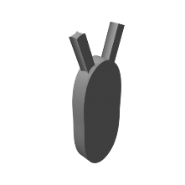
Some other object?
Number

I imagined this object to be a rubber eraser
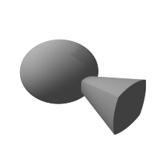
I imagined this object to be a refrigerator
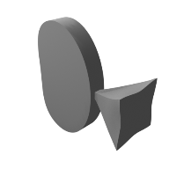
I imagined this object to be a table lamp
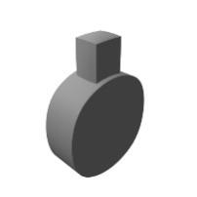
I imagined this object to be a crib
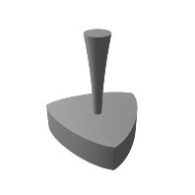
I imagined this object to be a radio
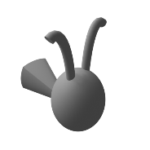
I imagined this object to be a teapot
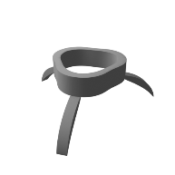
I imagined this object to be a wallet
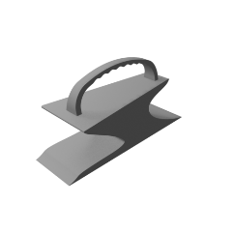
I imagined this object to be a hammer
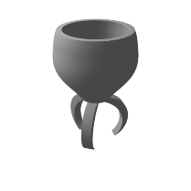
I imagined this object to be a cup

