Cloud is not buzz word

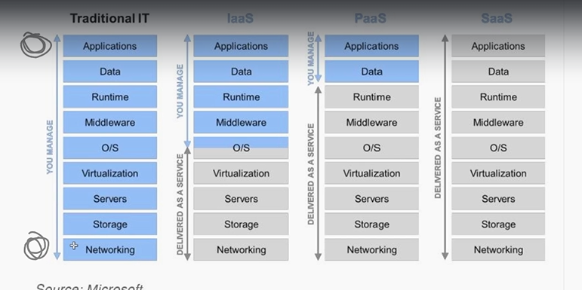

Cloud service models

**IaaS:** Infrastructure as service

**PaaS:** Platform as service

**SaaS:** Software as service.

**IaaS:**

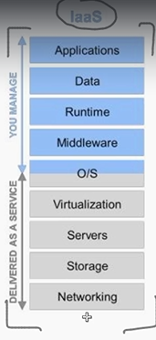

Part of service provided by the provider marked in grey basically act as data centres. All the heavy lifting task will be done by the service provider networking data storage etc.

Virtual machines are running in the server for project handling

PasS:

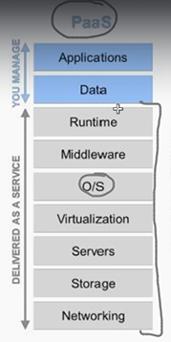

Only code and db schema is maintained by us rest all provided in the infrastructure.

SaaS:

Entire stack Is maintained by the Service provider best example is Gmail

**Characteristics:**

1. On-demand self-service: server time, network storage is previsioned automatically without human’s involvement.

pay and automatically top up your storage

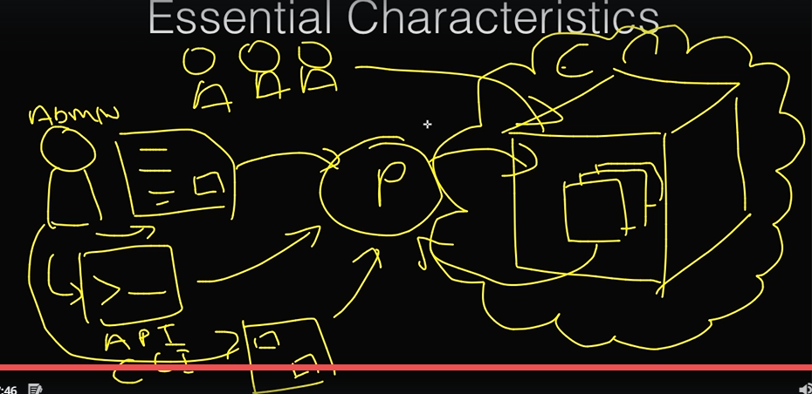

1. Broad network access: Access to the cloud over the network using any devices (mobile, computer, tab)

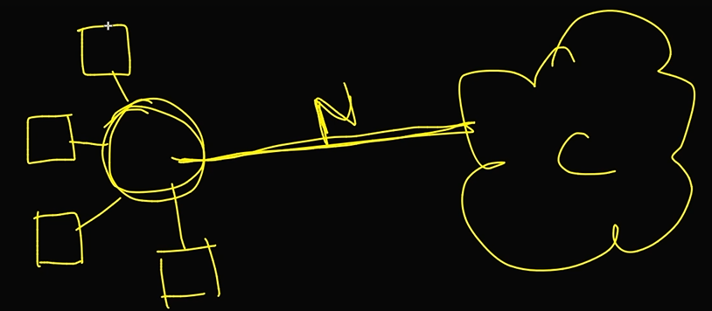

1. Resource pooling

Resources are pooled to service multiple customer using multi tenant model. Physical and virtual resources are assigned and reassigned based on the customers demand.

If anybody leaves the provider its not reserved it will be freed so that new customer can be served.

In large data centre storage is sliced into small pieces that will be allocated for the customer as slices hic he don’t have idea of.

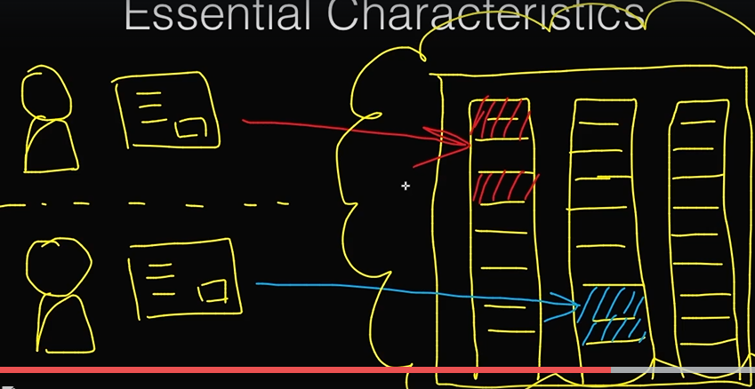

1. Rapid elasticity

Capability can be elastically provisioned and released. That means based on customer need resources can be scaled up and down.

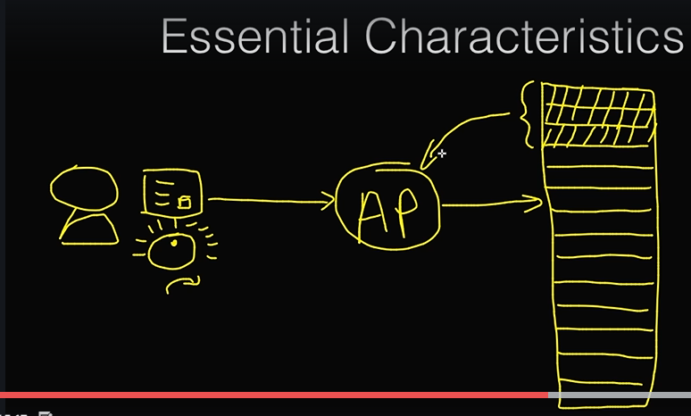

1. Measured service:

Graphs metrics available to track/measure the service based on that some decision can be taken to scale up and scale down the services.

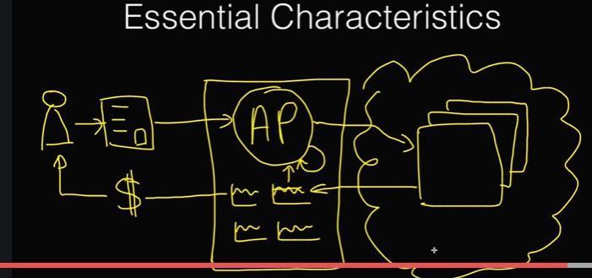

Deployment model:

1. Private cloud : designed for large organization which has multiple client of their own
2. Public cloud: Most common cloud aws, google
3. Hybrid cloud: Cloud which is a combination of other cloud module
4. Community cloud: