Basic Css 1 selector:

1. Class selector (.)

Eg: .className {styles}

1. Id selector (*)

Eg: #id{styles}

1. Child selector (p span)

P span{style}

#id span{style}

.class span{style}

Css2 selector:

1. Universal selector *

Eg *{style}

Div * span{style} (All span element under div tag)

Linking and action selector:

Pseudo class (there are no actual class but set when some manipulation happens in the code)

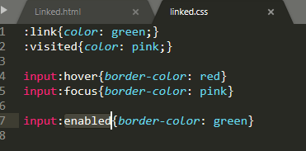

Attribute selector:

CSS2:

**[data-type]** selects the element with mentioned attribute

**[data-type=””]** selects the element with mentioned attribute value

**[data-type~=””]** select the element with exact value and string containing this value separated with space.

**[data-type|=””]** select the element start with whole word to match and ends with –

CSS3:

**[data-type^=””] : Select the element starts with the specified value to be matched and need not be complete word match**

**[data-type$=””] Select the element ends with the specified value to be matched and need not be complete word match**

**[data-type*=””] Select the element that contains specified value to be matched and need not be complete word match**

**Pseudo selector with bracket:**

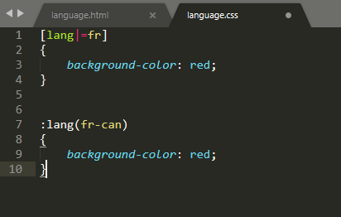

**Not selector (compliment negating):**

**:not(simple selector)**

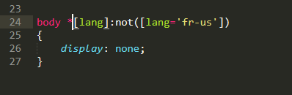

**Combinator selector:**

Immediate Child selector p>span

Adjacent selector p+span element next to (immediate sibling)

Sibling selector p~span element is sibling of p and precedes p (all preceding sibling

Zs)

UI selectors:

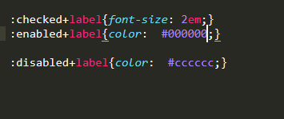

Configure ui from css,

Dynamic selector

Add content before and after

Element::after{content:’content for test’}

Element::before{content:’content for test’}

Manipulate inner content

Focusing on the target with css3:

:target{color:red}

Section:not(:target)

{

}

Span:nth-child(3n)

3,6,9 …. Will be selected