Way of organizing data so that it can be used efficiently.

Why:

Essential ingredients to make powerful algorithms

Organize your data

Makes code cleaner and easier to understand.

Abstract data types.

Provides only the interface to which the data type has to adhere to

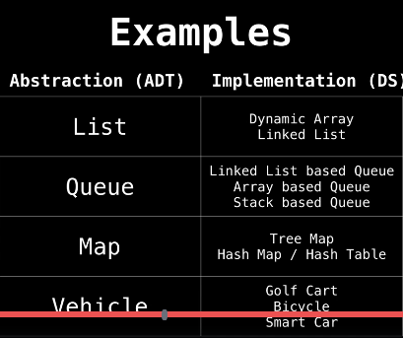

Time and space complexity:

BIG – o notation

Only cares about the worst case scenarios.

Array:

Building block for all other data structure

Fixed size static array with fixed number of elements accessed through index.